Sanitation Safety Planning
Training for regulators
Step-by-step risk management for safely managed sanitation systems
Participants Worksheets

Name of participant:

Organization:

Date:

Place:

Group Exercise 1: Differences between WSP and SSP
The table below provides 7 characteristics of Water Safety Plans (WSP) and Sanitation Safety Plans (SSP). It also provides suggestions for key features of these characteristic for WSPs and SSPs. In your group, discuss the given characteristics and features. Make a group consensus if the characteristic is essentially a similarity or a difference. Record your answer and write any clarification in notes.

Characteristics to be compared | Relevant feature of the characteristic as related to WSPs or SSP: |  | Group consensus: is the characteristic classified as a similarity or a difference? | Notes
 | WSPs | SSP
Link to WHO Guidelines | Based on WHO Guidelines for Drinking-water Quality | Based on WHO 2006 Guidelines for safe use of wastewater, excreta and greywater
How WSP and SSP systematically address their system risks | Using an incremental risk management approach.  Instead of conducting only end-of-pipe monitoring, WSP provides a framework for managing hazardous events along the entire water supply system. | Using an incremental risk management approach.  Instead of conducting only end-of-pipe monitoring, SSP provides a framework for managing hazardous events along the entire sanitation system.
Key actions or steps undertaken in process | -Assessment of system and risks.  -Operational monitoring of control measures.  -Management and verification. | -Assessment of system and risks.  -Operational monitoring of control measures.  -Management and verification
The extent of the system considered | It follows the drinking-water supply chain | Follows the entire sanitation service chain
Exposure groups | Considers single exposure group (drinking-water consumer) for microbiological, physical, chemical and radiation hazards. | Considers multiple routes of exposure for microbiological, physical and chemical hazards for multiple exposure groups.
Regulatory framework context | Normally quite clear who is responsible for the various segments (with common exception of catchment management) | Unclear and fragmented roles and responsibilities
Objectives | Ensure safety and acceptability of a drinking water supply and to reduce the risk of drinking-water contamination. | Ensure that the entire sanitation service chain is safely managed, diminishing the incidence and impact of sanitation-related diseases caused by unsafe sanitation systems.

Group Exercise 2: Understanding the value of Sanitation Safety Planning
You and your group are members of the Management Board of the Newtown W&S Utility. The SSP team, led by the Operations Manager, conducted a health risk assessment of the sanitation system. The following table shows the highest risk and the proposed measures. Based on the risk assessment and knowing that there is a budget of 10 Money Units for the next year, suggest which improvements should be prioritized.

Sanitation step | Hazardous event | Exposure groups | Existing control  measures | Under current climate scenario |  | Under the most probable climate scenario: floods | Improvement options | Resources required  [In Money Units] | Indicate with an “x” if it is selected
 |  |  |  | Risk assessment¹  (L x S = R) | Risk | + = increased risk  - = decreased risk  = = same risk
Collection/  Storage/ Treatment | Exposure to wastewater from overflowing cesspools or septic tank. This intensifies due to damaged or blockage following heavy rainfall. | 30,000 individuals using on-site systems | None | L=3 Possible  S=4 Moderate  3x4= 12 | Medium Risk | + | Issuing a municipal decree/by-law to oblige the connection to the sewer system | 1
 |  |  |  |  |  |  | Community education program encouraging the population to connect to the sewer system | 2
 |  |  |  |  |  |  | Expand the sewer network to unserved areas | 10
 |  |  |  |  |  |  | Installation of sealed covers for septic tanks and non-return valves on pipes to prevent back flows. | 5
Disposal | Exposure to pathogens caused by illegal dumping of fecal sludge in open land, open drains and river adjacent to residential areas. | 100,000 individuals living in Newtown | None | L= 5 Almost certain  S= 4 Moderate  5x4= 20 | Very high | + | Issuing a municipal decree/by-law for fecal sludge mgmt. | 1
 |  |  |  |  |  |  | Designation of an off-site dumping area for fecal sludge | 1
 |  |  |  |  |  |  | Monitoring and controlling sludge private operators (for instance, through GPS systems). | 3
 |  |  |  |  |  |  | Strengthening surveillance and enforcement authorities | 3
 |  |  |  |  |  |  | Implement sludge transfer stations for private operators, with intermediate transport to the WWTP to be co-treated with wastewater. | 5
Treatment  (Wastewater treatment plant) | Ingestion of pathogens while using river water contaminated with discharged untreated wastewater. This intensifies during extreme rainfall events causing discharge of excess, untreated wastewater into environment. | 500 individuals living adjacent to treatment plant.  10,000 individuals living in village downstream | Wastewater treatment plant working ok with minor incidents | L= 4 Likely  S=4 Moderate  4x4= 16 | Medium Risk | + | Develop an SOP for the correct O&M, train and supervise workers | 2
 |  |  |  |  |  |  | Implement an immediate maintenance program to remove the accumulated sludge | 1
 |  |  |  |  |  |  | Construct a feacal sludge pre-treatment unit (settling tank and drying beds) to avoid malfunctioning of the WWTP | 4
 |  |  |  |  |  |  | Install flood, inundation, and run-off defenses (e.g., dikes) and undertake sound catchment management | 8
 |  |  |  |  |  |  | Invest in early warning systems and emergency response equipment (e.g., mobile pumps stored off-site, non-electricity-based treatment systems) | 5
 |  |  |  |  |  |  | Additional holding pond to buffer high flows and reduce overflow or bypass to river | 6
Semi-quantitative risk assessment method
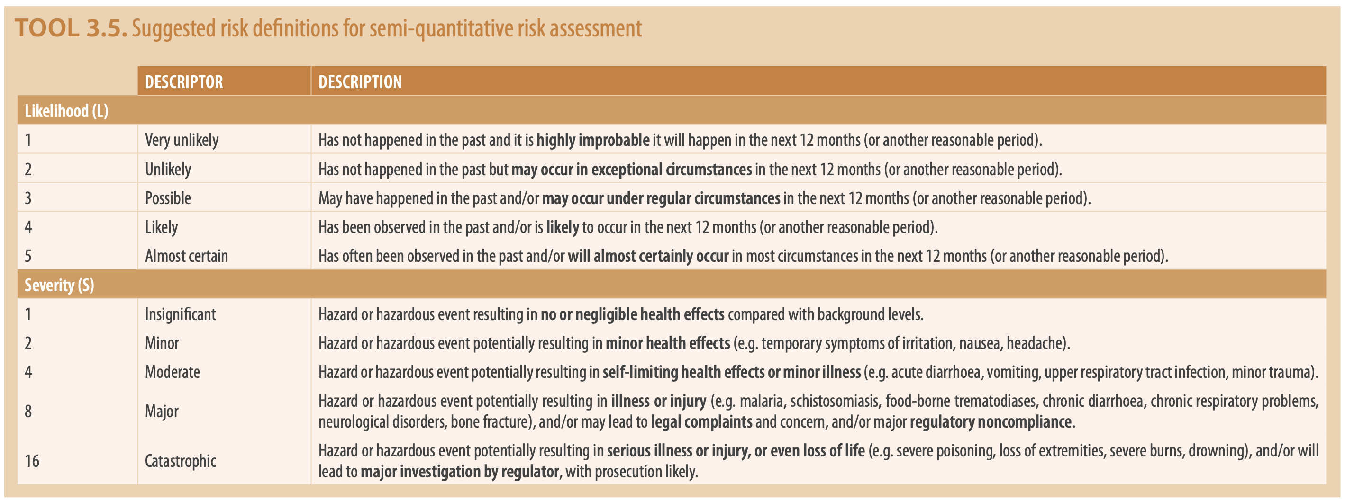
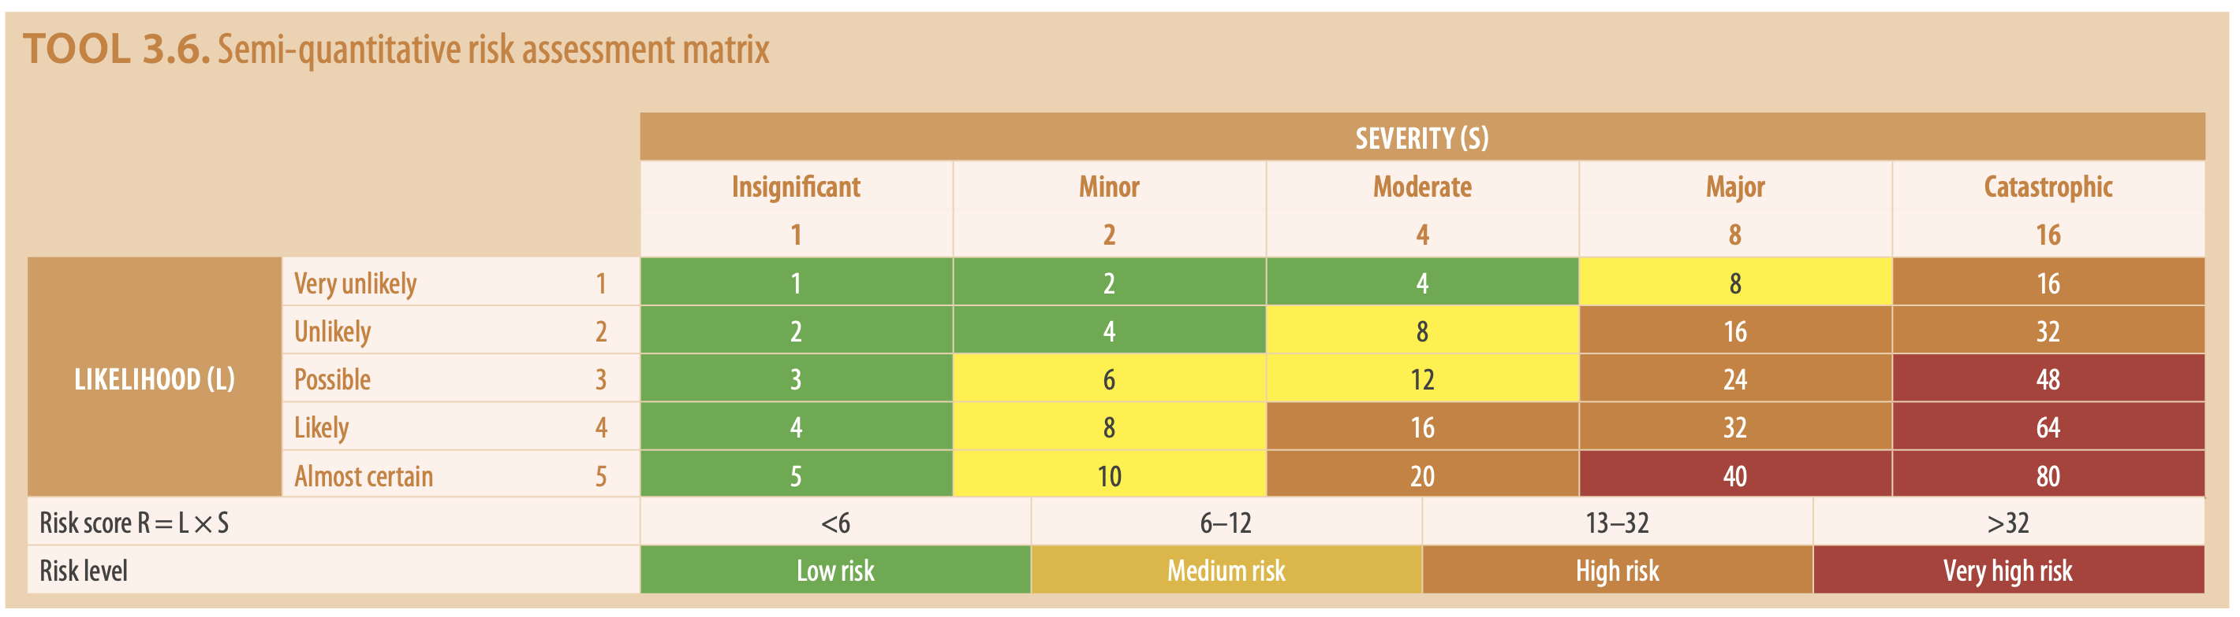
Group Exercise 3: Who should be involved in SSP?
Imagine that you work for a Newtown Water and Sanitation Utility that is responsible of providing sanitation services in a geographical area. You have been assigned as the SSP leader. Discuss with your colleagues: who are the individuals, departments of the utility or other organizations/stakeholders that should be involved in the SSP? Remember to ask the question: who can tell if a step in the sanitation service chain is managed safely and if it poses health risks to users, communities, workers, consumers, farmers, etc.?

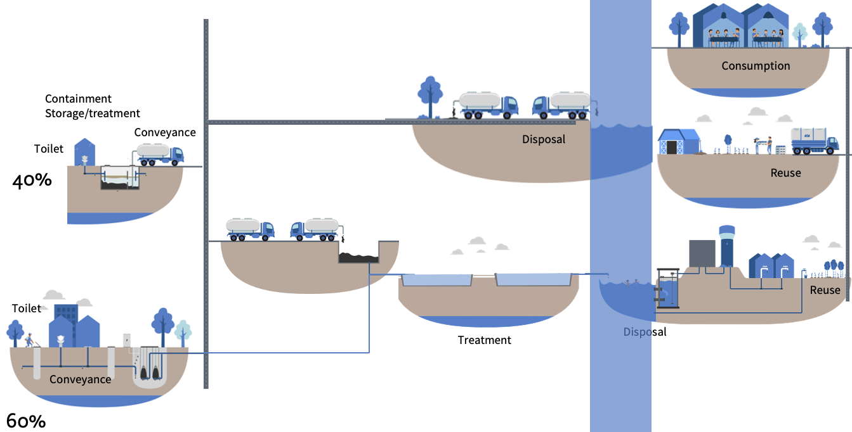
Write your answer here:

Group Exercise 4: What information is needed in SSP?

The figure below shows the sanitation system of Newtown. Looking at the system, write down what pieces of information the SSP team will require to identify the actual biological, chemical or physical hazards of the system. Don’t forget to list out the key climate information that you will need while considering the climate change scenario.
Write your answer here:

Group Exercise 5: How does the semi-quantitative risk assessment work?

Together with your group, decide if you would like to work with system 1 (non-sewered sanitation) or system 2 (sewered sanitation). You will find the system flow diagrams in pages 6 and 7. Choose, at least 2 hazardous events and conduct a health risk assessment. You need to make assumptions.

Remember that Tool 3.5 Suggested risk definitions for semi-quantitative risk assessment and Tool 3.6 Semi-quantitative risk assessment matrix are in page 56 of your SSP manual. You can also find them in page 3 of these sheets.

Component | Hazard Identification |  |  |  | Existing Control(s) |  | Risk Assessment |  |  |  |  |  | Comments justifying risk assessment, under current conditions or climate change scenarios, or effectiveness of the control
 |  |  |  |  |  |  | Under current conditions |  |  |  | Under the most likely climate change scenarios:  + means increased risk  - means decreased risk  = means the same risk
 |  |  |  |  |  |  | L=Likelihood; S=Severity; R=Risk
Sanitation step | Hazardous event | Hazard | Exposure Groups | Number of persons at risk | Description of existing control | Validation of control | L | S | Score | R | Drought | More intense precipitations

Notes:

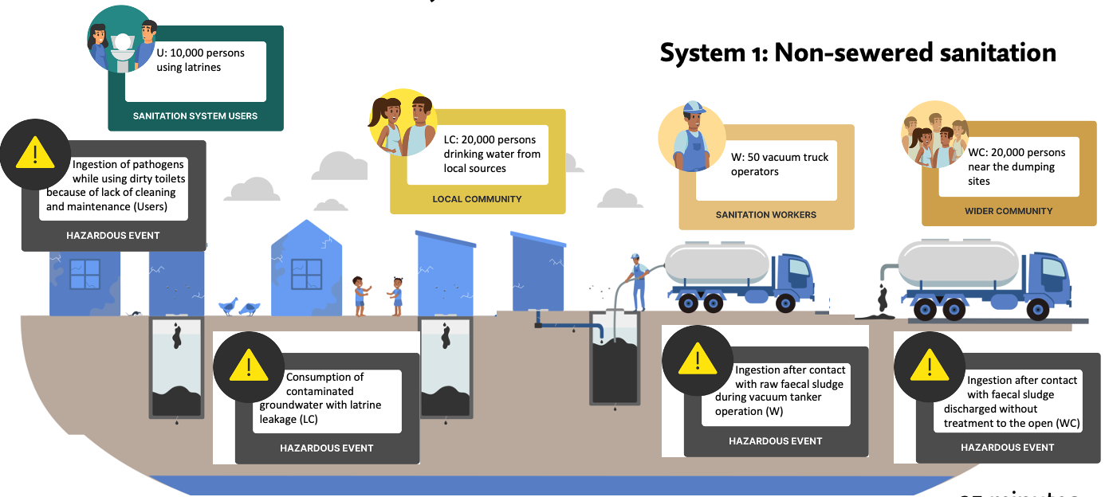

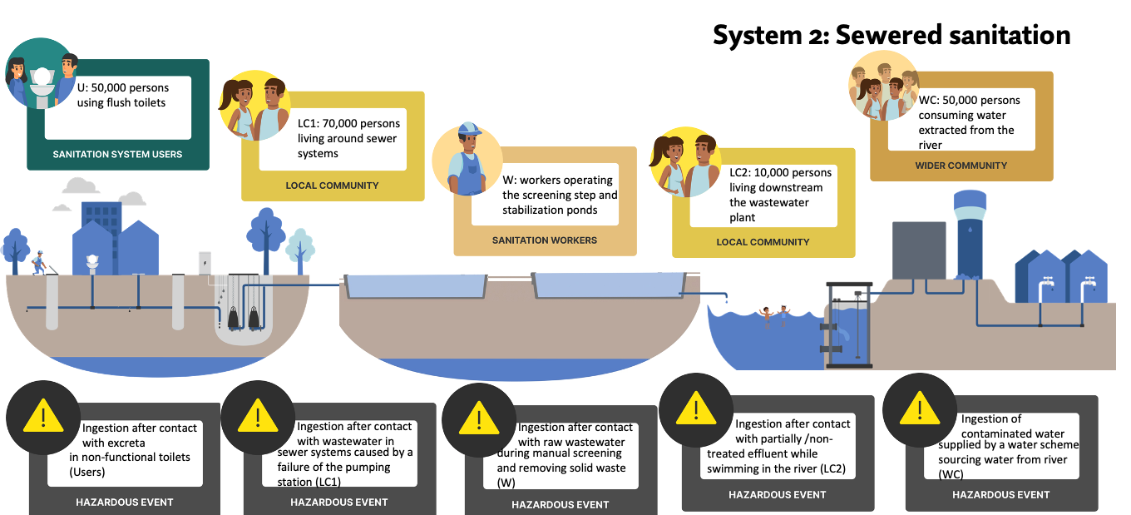

Group Exercise 6: How to use sanitation safety inspections?
Imagine that you work as an Environmental Health Officer in a Newtown province. You have been tasked to conduct a sanitation safety inspection in communal toilets located at Maleke township. Pictures below show the first sanitation system, which is a Flush to pit latrine. You will find that section I GENERAL INFORMATION and part C of section II SANITATION SAFETY INSPECTION are already filled (marked in green). You are asked to complete the sanitation safety inspection PART D and the ASSESSMENT SUMMARY. Decide if the system PASSES (no risks detected and no corrective action needed), PASSES (CONDITIONAL) (subject to correction of minor risks), FAILS - MAJOR RISK(S) (detected for corrective actions) or FAILS – RISKS ARE TOO MAJOR FOR REPAIR. Abandon and construct a new facility. Indicate what are the corrective actions.
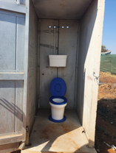
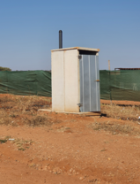
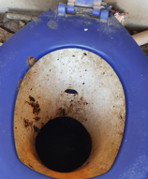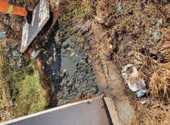

WHO Sanitary Inspections for Sanitation Systems
I. GENERAL INFORMATION
A. Location
Provide the following information on the location of the toilet facility.
A1. Village/town _____ Maleke township__________________  A2. District _____ Punika__________________________  A3. Province __________Kokima_____________________  A4. State _____________Pukule __________________ | A5. GPS coordinates _______23.8962° S, 29.4486° E____________  A6. Householder name __None, it is a communal toilet in a slum_______  A7. Contact no. _________123456789_______________  A8. Inspector name/ID _________Jane Dole_______________
B. Setting
The following factors describe the potential for risks or challenges to be present in the local area surrounding the toilet. Select the appropriate level for each setting factor based on the descriptions provided.
Risk | Low | Med. | High
B1. Population density – Density of people living in the immediate area
- Low – Rural or low-density settlement with significant open space between houses – sufficient space for a properly functioning pits or septic system with soak pit or leach field
- Medium –neighborhood, small town or village center - dwellings are spaced far enough apart to accommodate pits or septic tanks but many are too close together for proper soak pit or leach field or space to dig additional pits to bury faecal sludge.
- High – urban areas with multistory buildings and houses with minimal open land between them – not enough land area for a properly functioning septic system and soak away and no space to dig additional pits to bury faecal sludge
B2. Difficulty accessing the toilet – How difficult is it for a service provider to access the toilet to remove sludge using a manual or motorized emptying method
- Low – the pit / septic tank is easy to reach by truck or gulper device; access is available through a removable cover
- Medium – the pit / septic tank can be reached but with some degree of difficulty due to the location or the design of the tank
- High – household is difficult to reach by truck due to high density or narrow streets; or, the pit / septic tank itself is difficult to access due to its location on the property or lack of a removable cover
B3. Reliance on groundwater used for drinking – the potential for local groundwater sources to be contaminated by inadequate sanitation and fecal sludge management practices
- Low – households in this area do not use groundwater for drinking
- Medium – groundwater is used in the area but the sources used for drinking and bathing are located far away and are well-protected
- High – households in this area use shallow groundwater (dug wells, tube wells, springs)
B4. Water scarcity – Insufficient water supply for sanitation purposes (such as toilet flushing and cleaning, anal cleansing, hand hygiene, etc.) during all or part of the year
- Low – Most households have sufficient water year-round for toilet flushing and cleaning, anal cleansing and hand hygiene, or do not require water for sanitation purposes
- Medium – Water is scarce during the dry season or due to frequent outages
- High – Water is scarce most of the year and households do not have enough for flushing or cleansing
B5. Risk of flooding – Frequent and severe floods that could cause damage or washout (a breach or overflow due to flooding) to sanitation facilities
- Low – Flooding does not typically occur in the area
- Medium – Flooding that caused damage or washout to structures has occurred within the past 5 years
- High – Flooding that caused damage or washout has occurred within the past year or usually occurs every year
B6. Soil hardness (rocky soil) – Hard or rocky soil that makes it difficult to dig
- Low – Soil is sandy or loamy and pits are easy to dig using hand tools
- Medium – Clay or rocky soil that makes it slow to dig by hand tools
- High – Rocky soil or shallow bedrock layer makes it difficult or impossible to dig without using heavy machinery
B7. Soil impermeability – Inability for water to drain or seep into the soil
- Low – Water drains rapidly into the soil (sand, gravel, fractured rock)
- Medium – Water drains slowly into the soil (silty soil, mixed clay / sand / loam)
- High – Water drains very slowly or not at all into the soil (mostly clay, rock formations)
Raw score total | 2 / 7 | 4 / 7 | 1 / 7
Weighting | 1 | 2 | 3
B8. Total (sum of weighted scores) (minimum 7, maximum 21) (7-10 low, 11-16 med, 17-21 high) | 13 /21  Low

II. SANITATION SAFETY INSPECTION
C. System type and use
C1. Observe the type of sanitation facility
If ‘Flush’ probe: Where does it flush to? (refer annexes for system drawings and risk factors)
At least basic
- Flush to piped sewer system  - Flush to septic tank  - Flush to pit latrine  - Flush to twin pits | - Twin pit latrine with slab  - Ventilated improved pit latrine  - Pit latrine with slab | - Composting toilet  - Container based sanitation
Unimproved or other
- Flush to open drain  - Flush to don't know where | - Pit latrine without slab / open pit | - Hanging toilet / hanging latrine  - Other (specify) _______________
None If C1 is ‘no facility’ or ‘observation not possible’, the inspection cannot be completed. End the survey here.
- No facility | - Observation not possible

C2. Users
Question user on the number of households using the facility and the number f people in each household to calculate the total number of users.
Number of households served by this facility | ____15_____
Total number of users | ____50_____
Number of users with physical disability | _____3____

D. Toilet and containment risks
Category | Risk |  |  | Corrective action  (select all that apply)
 | None/ Low | Minor | Major
D1. Security and privacy
Ingress of rainwater may cause the pit to fill up and overflow. Animals, rodents, insects, etc. entering the toilet and/or pit can damage the facility and carry excreta to the community. A door lockable from the inside and a working light will help provide privacy and security to the user.
1a. What is the condition of the toilet superstructure?  The toilet superstructure or enclosure refers to the walls, roof, and door of the toilet. Ingress of rainwater may cause the pit to fill up and overflow. Animals, rodents, insects etc. entering the toilet and/or pit can damage the facility and carry excreta to the community. | - No problems observed | Household toilet  - Incomplete  - Damaged | Shared toilet  - Incomplete  - Damaged  - Absent or missing | - None  - Repair existing superstructure  - Roof  - Walls  - Door  - Other (specify)_____
1b. Does the design of the toilet prevent other people from seeing what someone is doing when they use it? | - Yes | Household toilet  - No  - Don’t know | Shared toilet  - No  - Don’t know | - None  - Install visual barrier  - Curtain/blind/shutter  - Wall  - Door  - Other (specify)_____
1c. Does the toilet provide security to the intended users?  A door that can be locked from the inside and a working light will help provide security. * (there is not working light) | - Yes | Household toilet  - No  - Don’t know | Shared toilet  - No  - Don’t know | - None  - Install lock  - Install light  - In assistance for users with physical disability  - Handrail  - Wheelchair access
D2. Toilet cleanliness
If the toilet is not kept clean, the users may be exposed to excreta when using the toilet and/or this may discourage toilet use.
2a. Is the toilet dirty with visible excreta on surfaces?  If the toilet is not kept clean, the users may be exposed to excreta when using the toilet and/or this may discourage toilet use. | - No | Household toilet  - Yes  - Don’t know | Shared toilet  - Yes  - Don’t know | - None  - Household cleaning products and schedule  - Shared or public supply of cleaning products and schedule.
2b. Is water available for toilet cleaning and flushing?  (C1 flush toilets only) * (there is not water for flushing) | - Yes |  | - No  - Don’t know | - Install water supply ___(specify type)___________
D3. Handwashing facilities
Handwashing facilities consist of the presence of water and soap. They may be fixed or mobile and include a sink with tap water, buckets with taps, tippy-taps, and jugs or basins designated for handwashing. Soap includes bar soap, liquid soap, powder detergent, and soapy water.
3a. Is there a handwashing facility inside or near the toilet?  A handwashing facility is a fixed or mobile device designed to contain, transport, or regulate the flow of water to facilitate handwashing. They may be fixed or mobile and include a sink with tap water, buckets with taps, tippy-taps, and jugs or basins designated for handwashing. To be considered near the toilet, the handwashing facility should be located within 5 meters. | - Yes | - | - No  - Don’t know | - None  - Install handwashing facility. Suggested facility:  - Bucket and scoop  - Tippy tap  - Sink piped from nearly water supply  - Other (specify) _____
If 3a is Yes:  3b. Is water available at the handwashing facility?  Verify by turning on the tap or checking the basin, bucket, or water container for the presence of water. | - Yes | - | - No  - Don’t know | - None  - Repair water supply (e.g. taps, pipes) (specify): ________  - Install water supply:(specify type): ________  - Other (specify) ____________
If 3a is Yes:  3c. Is soap or detergent available at the handwashing facility?  Soap may include bar soap, liquid soap, powder detergent, or soapy water. Ash, soil, sand, or other traditional handwashing agents are less effective and do not count as soap. | - Yes | Household toilet  - No  - Don’t know | Shared toilet  - No  - Don’t know | - None  - Ensure regular supply of soap or detergent
D4. Flies, insects and rodents
Flies, insects and rodents can carry disease from the excreta in the pit/container/tank to the local community.
4a. Can flies and other insects easily enter and leave the pit/container/tank? | - No | - | - Yes  - Don’t know | - None  - Install fly, insect, rodent barrier  - Screen on vent  - Screen on windows  - Lid  - Repairs to damage and sources of surface water and ground contamination (refer 5 and 6 below)  - Other (specify) _____
D5. Damage
If any part of the toilet or containment (i.e., slab, pit, septic tank, connection and outlet pipes) are damaged, cracked or unstable there is a risk of leaks, access for flies, insects and rodents and collapse during use or emptying.
If C1 is Pit latrine without slab / open pit, then mark this risk as present and skip the questions in this section.
If C1 is flush to pit latrine, flush to twin pits, pit latrine with slab, twin pit latrine with slab, ventilated improved pit latrine, or composting toilet:  5a. Is the cover of the pit or the slab cracked or damaged? | - No | - | - Yes  - Don’t know | - None  - Repair slab/pan/pedestal  - Replace slab/pan/pedestal  - Other (specify) _____
If C1 is flush to pit latrine, flush to twin pits, pit latrine with slab, twin pit latrine with slab, ventilated improved pit latrine, or composting toilet:  5b. Are the side walls of the pit damaged or collapsed?  If the walls are not stable, there may be a risk that the pit will collapse putting users and sanitation workers at risk (e.g. falling into pit or pit collapse during emptying). | - No | - | - Yes  - Don’t know | - None  - Line pit  - Repair pit lining  - Relocate and construct new lined pit  - Other (specify) _____
If C1 is flush to piped sewer system, flush to septic tank, flush to open drain, flush to elsewhere, flush to don’t know where:  5c. Is there visible damage to the septic tank /pit / outlet pipes, such as cracks, corrosion, deformation, or leakage? | - No | - | - Yes  - Don’t know | - None  - Repair cracks and damage to tank  - Repair damage to pipes  - Other (specify) _____
If C1 is Container-based sanitation:  5d. Are the toilet and cartridges poorly maintained with broken components, visible cracks or defects in the side walls?  If the walls are cracked, there may be a risk that the cartridge will leak exposing users, sanitation workers, and the local community to excreta. | - No | - | - Yes  - Don’t know | - None  - Replace cartridge  - Other (specify) _____
D6. Surface water and ground contamination
If effluent is flowing to an open drain, water body, or open ground, then the local community may be exposed to excreta.
Note: if C1 is flush / pour flush to open drain, or hanging toilet / hanging latrine, then mark this risk as present and skip the questions in this section.
6a. Is there any evidence of leakage or overflow to the surrounding area from the toilet or the containment?  Evidence may of leakage may include ponds of effluent, damp earth, or lush vegetation nearby. | - No | - | - Yes  - Don’t know | - None  - Empty faecal sludge (solids) and transport to treatment offsite  - Empty faecal sludge (solids) and safely bury nearby  - Repair or replace slab/pan/pedestal (refer 5a)  - Repair cracks and damage to tank  - Repair damage to pipes  - Other (specify) _____
If C1 is one of: Flush / pour flush to septic tank, Flush / pour flush to pit latrine, Flush / pour flush to twin pits, or Other (specify):  6b. Does the tank or pit have an outlet pipe for liquid effluent?  Outlet is an external pipe through which liquid effluent from the containment is discharged. | - Yes | - No | - Unable to observe | -
If 6b is Yes:  6c. Where does the outlet pipe discharge to? | - Leach field or soak pit  - Sewer or closed drain that leads to a wastewater treatment plant (WWTP) | - | - Sewer or closed drain that leads to a water body (canal, river, pond, etc.)  - Open drain  - Water body or the ground surface  - Land or gardens used to grow food crops  - Sewer or closed drain that leads to unknown place (don’t know where)  - Other (specify): ––––––  - Don’t know | - None  - Install leach field or soak pit away for infiltration to soil  - Connect outlet to nearby sewer  - Connect outlet to covered drain  - Repair cracks and damage to tank and pipes (refer 6a)  - Ensure thorough washing and cooking of produce grown using liquid effluent

ASSESSMENT SUMMARY
(Duplicate copy to be left with householder)
A. Location | Village/town Maleke township  District Punika  Province Kokima  State Pukule | GPS coordinates 23.8962° S, 29.4486° E  Householder name None, it is a communal toilet in a slum  Contact no. 123456789  Inspector name/ID Jane Dole
B. Setting risk score | ____________13/ 21___
C. System type and use | Type of facility: Flush to pit latrine  Number of households ____15___ | Total number of users: ___50___  Number of users with physical disability: ___3___
D. Toilet and containment risks
- Pass - no risks detected and no corrective action needed | - Pass (conditional) - subject to correction of minor risks | - Fail - major risk(s) detected for corrective action above.  - Fail – risks are too major for repair. Abandon and construct a new facility.
Corrective actions needed and suggested service providers to assist:  (e.g., Hardware (slabs, pans, pipes, fittings, tanks), toilet construction, faecal sludge emptying and transport, water supply installation) | Corrective actions needed: (Insert from D1-6):  1. ________________________________  2. ________________________________  3. ________________________________  4. ________________________________  5. ________________________________ | Service provider(s):  -Don’t complete-___________________________  _______________________________________  _______________________________________  _______________________________________  _______________________________________
Due date for reinspection of corrected actions: | ____________dd//mm/yyyy___________

Group Exercise 7: Using ESAWAS Guidelines to identify measures

Together with your group, decide if you would like to work with system 1 (non-sewered sanitation) or system 2 (sewered sanitation). You will find the system flow diagrams in the following page with the prioritized hazardous events.

Choose one hazardous event. Revise your ESAWAS’ Guidelines for Inclusive Urban Sanitation Service Provision, and identify potential control measures for the selected hazardous event.

Step of the sanitation service chain: [please insert]
Name of the hazardous event: [please insert]

Improvement options:

Option of new or modified control measure for this hazardous event | What is the likely effectiveness of this control measure option?  (High, medium, low) | What is the level of resources required (financial, human resources, political support, etc.)?  (High, Medium, Low) | Priority for improvement plan  (Immediate, short,  medium or long term)

Group Exercise 8: How the regulating agency can use SSP? What is needed?

After learning about the entire SSP methodology, discuss with your colleagues:
- How can you (the regulator) use the developed SSPs to regulate sanitation systems?

- What is needed internally, so the regulator can use SSP as a tool to regulate sanitation systems?

