Sanitation Safety Plan
Alwar, Rajastan
developed by
participants of the C-R SSP Training

Sanitation System analyzed:

Group participants:
- XXX
- XXX
- XXX
- XXX
- XXX

Date:

Place:

MODULE 1: Preparing for Sanitation Safety Planning

STEP 1.1. Define the SSP area and lead organization
The Sanitation Safety Planning will be conducted in Alwar City.

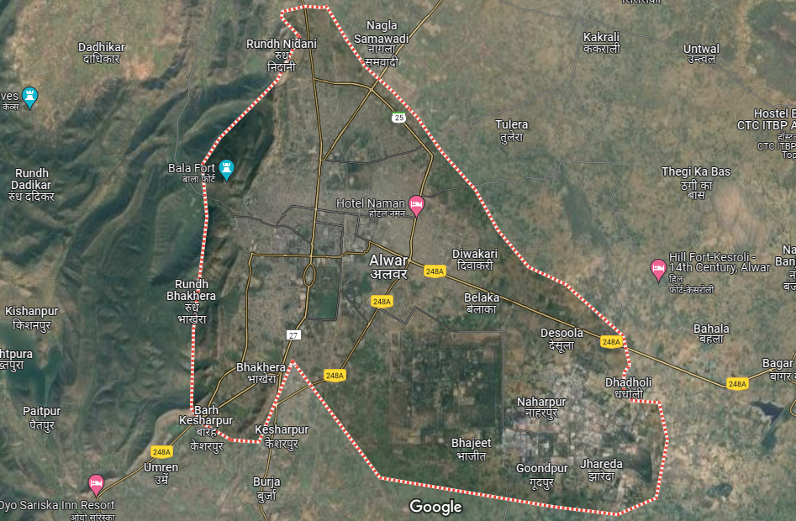
Alwar City is located on 27º 32' 30‟‟ N latitude and 76º 37‟ 30‟‟ E longitude in North-eastern Rajasthan. The city covers an area of 48.14 sq.km catering around 4,50,000 population. The population has increased considerably in the past years, particularly because of the steady migration from other parts of the state. This rapid increase in the population size has come with a number of challenges for the Alwar Nagar Nigam, particularly the development of the infrastructure required to support this increase in population.

It is estimated that about 10% of the population is living in poverty.

Alwar has a monsoon-influenced hot semi-arid climate with long, extremely hot summers and short, mild to warm winters. The climate here is a local steppe climate. The city experiences a short monsoon with annual rainfall of about 67 cm which mostly falls in July & August due to monsoon.

City’s most of the local population is employed in modern economic activities such as industry (22%), business and commercial domains (22%), services (39%) and transport and communication sectors (9%). Apart from these activities, agriculture is also considered one of the prominent activities in the peri urban areas of Alwar city. They produce crops such as bajra, maize, jowar, karif pulses, arhar, sesamum, cotton, guar, wheat, barley, gram, mustard, and rabi pulses.

Legal framework
The sanitation sector in Alwar city is governed by the following pieces of legislation:
- Manual on Sewerage and Sewage Treatment Systems, 2013.
- Environmental (Protection) Act, 1986.
- The Environment (Protection) rules, 1986.
- The water (Prevention and control of pollution) Act, 1974.
- The water (Prevention and control of pollution) cess Act, 1974.
- The water (Prevention and control of pollution) Amended rules, 2011.
- The water (Prevention and control of pollution) Cess rules, 1978.
- The water (Prevention and control of pollution) Rules, 1975.
- National Urban Sanitation Policy 2008.
- National Water Policy 2012.
- Rajasthan Municipalities Act, 2009
- Quality standards suggested by Central Pollution Control Board and Rajasthan State Pollution Control Board

Institutional framework in Alwar City
The central and state government are the key entities in developing and updating policies, deciding strategic direction, setting targets, supporting master plans developed by local authorities and monitoring the achievement of goals.

According to the Constitution of India, sanitation is a state subject, therefore municipalities have the mandate for the provision of water and sanitation services to its citizens. Therefore, the Alwar Nagar Nigam and Urban Improvement Trust are the agency in charge of the overall strategy, planning and execution of expansion and improvement projects related to water and sanitation in Alwar.

All the development projects in the city is funded and monitored under state and central schemes/Missions such as Swachh Baharat Abhiyan, Amrut 2.0 etc.

Description of the water supply system
Alwar is served by three sub-basins, namely Sabi, Rooprail and Banganga of Yamuna basin. Major surface water is from flood water of rivers basins, diversion structures, lakes, and ponds. Groundwater is main source to meet the diverse nature of demand in the city.

Climate projections
Climate change is causing rising temperatures in Alwar, potentially resulting in more frequent and intense heatwaves. These temperature changes, along with shifts in precipitation patterns, could lead to alterations in the timing and distribution of rainfall, impacting the traditional monsoon season. Additionally, the increased frequency and intensity of extreme weather events associated with climate change, such as storms, cyclones, and floods, may pose a significant threat to Alwar's infrastructure and communities.

- Which organization should be the leader of the SSP process in Alwar? Why?
[enter you answer here]
XXXXX

STEP 1.2. Assemble the SSP team
- Which person should be the SSP team leader?
Remember that the team leader should have the authority, the organizational and interpersonal skills, and sufficient time and management resources to ensure that the process can be implemented effectively.

[enter you answer here]
XXXXX

- Which organizations will be part of the SSP team?
The usual process is to: (1) conduct a stakeholder analysis and (2) select team membership to suit the SSP purpose. Limit the number of team members to keep the working group functional.

[enter you answer here]
XXXXX

MODULE 2 Describe the sanitation system

STEP 2.1 Map the system
Sanitation services provided in Alwar can be divided in two types of systems:
-System 1: Flush toilet with sewerage and offsite wastewater treatment
-System 2: Flush toilets with septic tanks and effluent infiltration and offsite fecal sludge disposal

Description of sanitation system 1
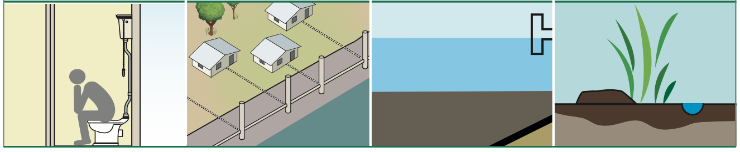
Toilet: about 100% households located in the city are using flush toilets. The average wastewater production in this area is about 100 l/pp per day.

Conveyance: 30% of the population are connected to a public sewerage system, constructed decades ago. This is a combined system that conveys domestic wastewater with stormwater. Currently about 13 Ml/d of wastewater flows through underground sewers to pumping stations, from where it is then pumped to the wastewater treatment plant. The sewer system as well as the corresponding wastewater treatment plant is operated by private entity assigned by the Alwar Nagar Nigam. The private entity counts with a Sewerage Department in charge of operation and maintenance of the system, characterized by sewer leakages (about 20% is lost), breakdowns of the pumps and sometimes chamber overflows.

Treatment: The Alwar Sewage Treatment Plant (STP), established in 2009 with a designed capacity of 20 million liters per day (Ml/d), is presently experiencing underutilization. The plant is currently receiving an average of 13 Ml/d, encompassing both wastewater and fecal sludge transported by desludging operators. Structurally, the sewage treatment facility is configured as a Waste Stabilization Ponds (WSP), comprising an inlet chamber, two screens, two anaerobic ponds, and three facultative ponds.

Despite its initial design, the system's operational efficiency stands at 65%, primarily attributed to the aging infrastructure and recurrent structural breakdowns. Notably, the removal of Biological Oxygen Demand (BOD) is hindered by structural deficiencies, resulting in suboptimal treatment performance. The effluent quality, regulated by the Rajasthan State Pollution Control Board, is a concern, as the levels of Total Suspended Solids (TSS), Total Nitrogen (TN), and Total Phosphorus (TP) surpass the prescribed state and central effluent standards. The need for structural improvements is evident to enhance the treatment process and bring the plant in compliance with regulatory standards.

Disposal/reuse: The treated wastewater is disposed of in the man-made channel which flows along the nearby farmlands. Legally, there is no direct, institutionalized set-up for reusing the treated wastewater. However, the treated wastewater is used by farmers for irrigation purpose.

Description of sanitation system 2
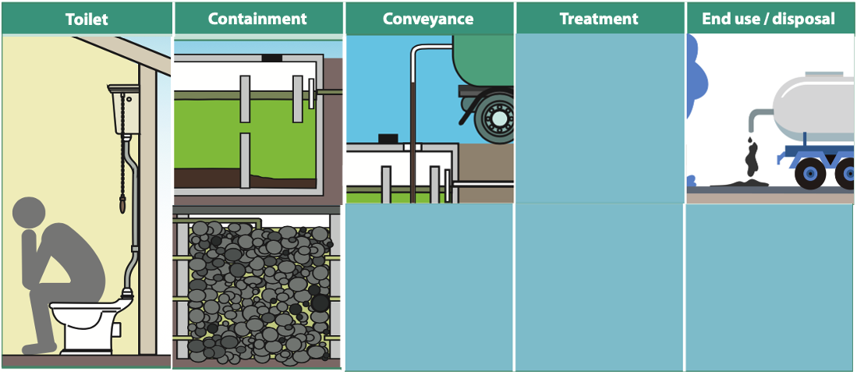
Toilet: about 100% households located in the city are using flush toilets. The average wastewater production in the city is about 100 l/pp per day.

Containment/storage- treatment: 70% of the toilets in the city are with septic tanks and effluent infiltration and offsite fecal sludge disposal. On average the size of septic tank in the city is about 10*10*3 ft. Usually the citizens desludge their septic tank once 5-6 years.

Conveyance: when the septic tanks or cesspools are full, they are emptied by private local vacuum truck operators. There are total 3 vacuum trucks operated by Nagar Nigam, where privately operated trucks are unknown. Operators do not follow any safety guidelines for the handling of excreta, nor are they monitored or supervised by any regulatory agency. The price of the service is set by market competition, and it is charged to the client after the service is performed. Households have reported that the operators do not wear any type of protection equipment and are messy in their operations, spilling excreta all over. ‘

Treatment: Currently there is no any treatment systems available in the city.

Disposal/reuse: All the sludge collected is either disposed in the trunk sewer or in the open drains/fields.

- Which system is your team responsible of analyzing?
Indicate in the box below what is the system that you and your team are analyzing:

[enter you answer here]
XXXXX

STEP 2.1: Map the system
Based on the description provided, and using the brown paper and markers given to you and your team, prepare a sanitation map of the sanitation system that was assigned to you.

STEP 2.2: Characterize system flows
Use the following table to characterize system flows (for instance, feces, urine, excreta, wastewater, greywater, sludge collected, sludge emptied, dried feces, solid waste dumped in the pit etc.). Read guidance note 2.2 and tool 2.1 for more information. Include all the quantitative information you have and identify if the system flow might have a biological, chemical or/and physical hazards.

System flow code | Sanitation step | Description of the system flow | Key information of the system flow | Expected variations | Type of potential hazard

STEP 2.3: Identify exposure groups
In your maps, identify the exposure groups, using the letters U, L, W, WC, F and C are as symbols. You might want to define sub-groups, such as U1: users of latrines, U2: users of flush toilets. Use SSP manual Tool 2.2 to characterize the exposure groups. Remember the exposure groups are:
U: Sanitation system users L: Local community W: Sanitation workers
WC: Wider community F: Farmers C: Consumers:

Sanitation step | Exposure Group ID | Who are the exposure groups? | How many are there? | What are they doing there? | What are they exposed to? | How often are they exposed to this?

STEP 2.4: Gather supporting information
Write down any information you will want to obtain to characterize the system. Indicate the source of the information. Record below:

Regulatory requirements | Demographics and land use patterns
System management and performance | Changes related to climate and weather

MODULE 3: IDENTIFY HAZARDOUS EVENTS, AND ASSESS EXISTING CONTROL MEASURES AND EXPOSURE RISKS

In the following table, you will conduct a health risk assessment of the sanitation system you have described in Module 2.

STEP 3.1: Identify hazards and hazardous events
When applying step 3.1, only complete the columns Component and Hazard identification. Make sure you describe the Hazardous event telling the story of how the hazards cause harm, including the exposure route (ingestion after contact with excreta, ingestion of contaminated water, consumption of contaminated produce, dermal contact, vector-borne, inhalation). Revise the Newtown worked case study, the example 3.2 and guidance note 3.4 for examples).

STEP 3.2: Identify hazards and hazardous events
When applying step 3.2, only complete the columns related to Existing Controls. Remember that “Validation of control(s)” refers to the method how you are able to verify if the existing control is working or not. For example, field visits, interviews, tests, revision of reports, etc.

STEP 3.3: Assess and prioritize the exposure risk
When applying step 3.3, complete the columns related to the risk assessment. Use tools 3.5 and 3.6 of your SSP manual (page 56) for definitions and scores of likelihood, severity and risks. Decide two most likely climate change scenarios and decide with your team if the risk will increase, decrease or will remain the same. Make sure you write in the comments box, the reasons that justify your choice.

Component | Hazard Identification |  |  |  | Existing Control(s) |  |  | Risk Assessment |  |  |  |  |  | Comments justifying risk assessment, under current conditions or climate change scenarios, or effectiveness of the control
 |  |  |  |  |  |  |  | Under current conditions |  |  |  | Under the most likely climate change scenarios:  + means increased risk  - means decreased risk  = means the same risk
 |  |  |  |  |  |  |  | L=Likelihood; S=Severity; R=Risk
Sanitation step | Hazardous event | Hazard | Exposure Groups | Number of persons at risk | Description of existing control |  | Validation of control | L | S | Score | R

After discussions with your team, write in the following table which are the hazardous events that you will prioritize.

Sanitation step | Hazardous event | Exposure Group | Number of persons at risk | Risk | Projection of changes in risks with climate change scenarios | Priority given

MODULE 4: DEVELOP AND IMPLEMENT AN INCREMENTAL IMPROVEMENT PLAN

STEP 4.1: Consider options to control identified risks
For each hazardous event prioritized, analyze the possible control measures using the following table:

Step of the sanitation service chain:
Description of the hazardous event:
Exposure group:
Improvement options
Option of new or modified control measures for this hazardous event | What is the likely effectiveness of this control measure option?  (High, medium, low) | What is the level of resources required?  (Including financial, human resources, political support: high, medium, low) | To what extent will this control measure be effective under the most likely climate change scenarios?  (Effective, ineffective, detrimental) | Comments/  discussion | Priority for improvement plan  (Immediate, short term, medium term, long term)
X
Step of the sanitation service chain:
Description of the hazardous event:
Exposure group:
Improvement options
Option of new or modified control measures for this hazardous event | What is the likely effectiveness of this control measure option?  (High, medium, low) | What is the level of resources required?  (Including financial, human resources, political support: high, medium, low) | To what extent will this control measure be effective under the most likely climate change scenarios?  (Effective, ineffective, detrimental) | Comments/  discussion | Priority for improvement plan  (Immediate, short term, medium term, long term)
X
Step of the sanitation service chain:
Description of the hazardous event:
Exposure group:
Improvement options
Option of new or modified control measures for this hazardous event | What is the likely effectiveness of this control measure option?  (High, medium, low) | What is the level of resources required?  (Including financial, human resources, political support: high, medium, low) | To what extent will this control measure be effective under the most likely climate change scenarios?  (Effective, ineffective, detrimental) | Comments/  discussion | Priority for improvement plan  (Immediate, short term, medium term, long term)

STEP 4.2: Develop an incremental improvement plan
Use the following Gantt Chart to plan the implementation of your improvement measures. During the training, we will conduct this exercise, if we have time.
Improvement measure | Cost | Source of funds | Lead organization | Year 1 |  |  |  |  |  |  |  |  |  |  |  | Year 2 |  |  |  | Year 3
 |  |  |  | 1 | 2 | 3 | 4 | 5 | 6 | 7 | 8 | 9 | 10 | 11 | 12 | Q1 | Q2 | Q3 | Q4 | Q5 | Q6 | Q7 | Q8
Improvement measures to control prioritized hazardous event 1
Improvement measures to control prioritized hazardous event 2
Improvement measures to control prioritized hazardous event 3

MODULE 5: Monitor control measures and verify performance

STEP 5.1: Define and implement operational monitoring
For each prioritized hazardous event and their improvement measures, choose 1 improvement measure that should have an operational monitoring plan.

Prioritized hazardous event | Sanitation step | Choose one control measure that will have a detailed operational monitoring plan

Using the following tables, prepare the operational monitoring plan for the chosen control measures:

Operational monitoring plan

Operational monitoring plan for:
Operational limits | Operational monitoring of the control measure:  Control measure: |  | Corrective action when the operational limit is exceeded
 | What is monitored? |  | What action is to be taken?
 | How is it monitored?
 | Where is it monitored? |  | Who takes the action?
 | Who monitors it? |  | When is it taken?
 | When is it monitored? |  | Who needs to be informed of the action?
X
Operational monitoring plan

Operational monitoring plan for:
Operational limits | Operational monitoring of the control measure:  Control measure: |  | Corrective action when the operational limit is exceeded
 | What is monitored? |  | What action is to be taken?
 | How is it monitored?
 | Where is it monitored? |  | Who takes the action?
 | Who monitors it? |  | When is it taken?
 | When is it monitored? |  | Who needs to be informed of the action?
x
Operational monitoring plan

Operational monitoring plan for:
Operational limits | Operational monitoring of the control measure:  Control measure: |  | Corrective action when the operational limit is exceeded
 | What is monitored? |  | What action is to be taken?
 | How is it monitored?
 | Where is it monitored? |  | Who takes the action?
 | Who monitors it? |  | When is it taken?
 | When is it monitored? |  | Who needs to be informed of the action?
x

STEP 5.2: Verify system performance
For each prioritized hazardous event and their improvement, identify the verification plan.

What is the control measure? | What is the objective of implementing this control measure? | How would you measure it? | Verification
 |  |  | What indicator will you use? | What is the maximum value you will accept? | When are you going to measure it? | Who will measure it? | How will it be measured?

MODULE 6: DEVELOP SUPPORTING PROGRAMMES AND REVIEW PLANS

STEP 6.1: Identify and implement supporting programs
Write in the box below two supporting programs that should be implemented in the framework of Sanitation Safety planning.

 | Supporting program 1 | Supporting program 2
Title of the program
Objective of the program
Description of the program
Key partners to implement the program

FINAL NOTES

