**Local Sanitation System**

**Bantul Regency**

# Description General

## 

## Figure 1. Landscape of Bantul Regency Photo credit: Jhon Paul 99_pinterest

## **Location and Governance**

Bantul Regency is one of the regencies in the Special Region of Yogyakarta, located in the southern part of the region and directly bordering the Indian Ocean. The total area of Bantul Regency is 511.706 km². It shares borders with the City of Yogyakarta and Sleman Regency to the north, Gunungkidul Regency to the east, Kulon Progo Regency to the west, and the Indian Ocean to the south.

Geographically, Bantul has a diverse topography, ranging from lowland plains in the central and northern areas to hills in the east and southwest, and a southern coastline that makes it a leading tourist destination, such as Parangtritis Beach.

In terms of governance, Bantul Regency is led by a Regent and Deputy Regent, who are directly elected by the people every five years. The local government consists of various regional apparatuses, including regional secretariats, technical services, regional agencies, and 17 sub-districts as administrative areas, which oversee villages and hamlets as the smallest units of government.

Additionally, as part of the Special Region of Yogyakarta (DIY), governance in Bantul also adheres to the region’s special status as regulated by Law Number 13 of 2012 concerning the Special Status of the Special Region of Yogyakarta. This includes aspects such as institutions, culture, land, spatial planning, and the appointment of the Governor.

The legislative function in Bantul Regency is carried out by the Bantul Regency Regional People's Representative Council (DPRD), which is responsible for drafting regional regulations, overseeing policy implementation, and approving the regional budget [1].

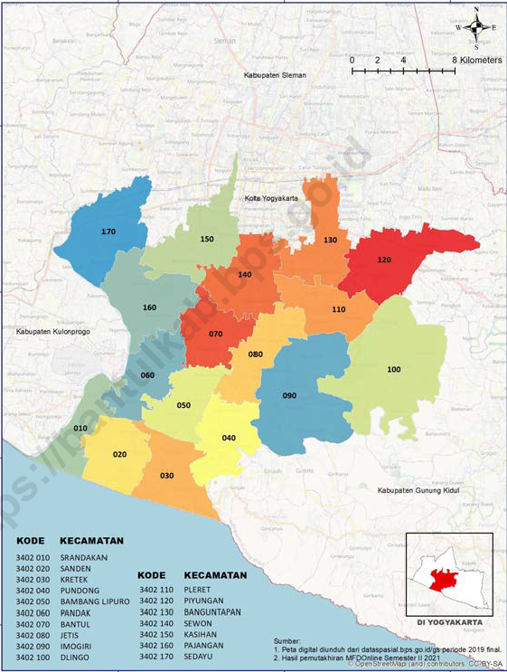

Figure 2: Map of Bantul Regency , 2023[2]

## **Population and Demographics**

Bantul Regency has a relatively large population and is one of the most populous regencies in the Special Region of Yogyakarta (DIY) Province. According to data from the Central Statistics Agency (BPS) of Bantul Regency in 2023, the total population reached approximately 1.01 million people. The sub-district (Kapanewon) with the highest population is Banguntapan.

Population density is high, especially in the northern areas that directly border the City of Yogyakarta. In 2023, the average population density of Bantul Regency was 1,890 people per km², with the highest density in Kapanewon Banguntapan (4,088 people/km²) and the lowest in Kapanewon Dlingo (680 people/km²).

The population of Bantul Regency consists of approximately 49% male and 51% female, with a nearly balanced sex ratio. The majority of residents adhere to Islam, living harmoniously alongside followers of other religions such as Christianity, Catholicism, Hinduism, and Buddhism, forming a strong multicultural community.

In terms of age structure, the population shows a trend toward aging, although the productive age group (15–64 years) still dominates. The urbanization rate is increasing, driven by the growth of suburban areas and the development of the creative economy, trade, and tourism sectors.

In terms of ethnicity, the majority of residents belong to the Javanese ethnic group, with the Javanese language and culture playing a significant role in shaping the region’s identity 2 .

## **Activities and Regional Income**

In 2023 Growth economy Bantul Regency is 5.06 percent , slowing down by 0.13 percent compared to 2022. Based on the trend of the last ten years. Structure The economy in Bantul Regency is dominated by three business sectors namely a) Sector Industry Processing , b) Sector Agriculture , Forestry and Fisheries , and c) Provision Accommodation and Food and Beverages . In 2023 Sector Industry processing Still hold role largest by contribution as much as 14.11%.

In 2023 Sector Agriculture , Forestry and Fisheries contribute as much as 13.80% in the economy in Bantul Regency . Although own a significant contribution will but when viewed from ADHK GRDP growth , growth sector agriculture in 2023 by 0.92 percent

tends to be slower than growth in the last 2 years. This decline was caused by the El Nino which had an impact on the dry season long that occurred in some areas of Bantul Regency . As a result This drought is production agriculture in Bantul Regency is experiencing decline .

Amount Poor population in Bantul Regency is 128.51 thousand people in 2023.

Sector agriculture is one of the development priorities Bantul Regency . This sector has important role in economy Bantul Regency , because is one of sectors that provide contribution big to GRDP. Commodity plant food The main thing in Bantul Regency is rice , corn and soybeans . Commodities Horticulture main is onion red , chili and banana. Commodities plantation main is coconut , sugar cane , tobacco people and cocoa.

## **Climate and Environmental Factors**

Bantul has a tropical monsoon climate. Like other districts in Indonesia, the rainy season in Bantul Regency typically occurs from October to March, while the dry season lasts from April to September.

Based on data from the BPP Bantul rainfall station located in Bantul District, the highest rainfall in Bantul Regency in 2023 occurred in February, with 545.3 mm of precipitation. The greatest number of rainy days also occurred in February, totaling 23 days.

The lowest air humidity in Bantul Regency was recorded at 81% in October, while the highest was 91% in February. The minimum temperature was 21°C in August, and the maximum temperature reached 33.1°C in October.

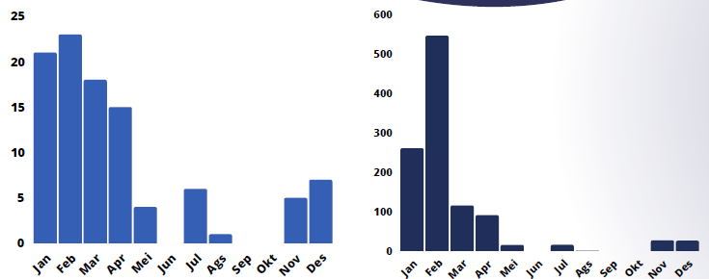

Figure 3. Number rainy day 2023 Bantul Regency Figure 4. Total rainfall in Bantul Regency, 2023

Based on Regional Regulation Number 4 of 2011 concerning the Spatial Planning Plan of Bantul Regency for 2010–2030, there are five types of potential disasters identified in the area:

* Earthquakes – All sub-districts in Bantul Regency are considered vulnerable to seismic activity.
* Landslides – Areas prone to landslides include Piyungan, Pleret, Dlingo, Imogiri, Pundong, Sedayu, and Pajangan.
* Flooding, tidal waves, and coastal abrasion – These risks are concentrated in the southern coastal areas, particularly Kretek, Srandakan, and Sanden.
* Drought – Drought-prone areas include Dlingo, parts of Piyungan, Pajangan, Pleret, Imogiri, Pundong, Sedayu, Kasihan, and Kretek.

## **Water resources , wastewater and challenges**

The land area of Bantul Regency is 51,171 hectares, which is divided into several land use classifications.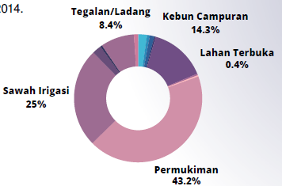

Figure 5. Usage land in Bantul district

In 2023, approximately 43% of the land in Bantul Regency was used for settlements, 25% for irrigated rice fields, 14% for mixed gardens, and 8.4% for moorland or fields.

Bantul Regency is part of two river basins (DAS): the Progo River Basin and the Opak River Basin. The construction of irrigation canals is essential to support food security. According to the Regulation of the Minister of Public Works and Public Housing Number 14/PRT/M/2015 concerning the Criteria and Determination of Irrigation Area Status, Bantul Regency has authority over 118 irrigation areas, consisting of 100 surface irrigation areas (8,633 ha) and 18 groundwater irrigation areas (735 ha), with a total irrigated area of 9,368 hectares.

In 2023, 80.66% (6,964.03 ha) of the irrigated rice fields under Bantul Regency’s authority were classified as well-irrigated.

In 2023, there were 7,000 household wastewater connections (SR) in Bantul. The Sewon Wastewater Treatment Plant (IPAL Sewon) serves households from Bantul, Sleman, and Yogyakarta City. However, the number of installed SRs in 2023 across these three regions only reached 36.27% of the plant’s upgraded capacity of 75,000 SRs. Therefore, intervention is needed from the respective districts and cities to expand the wastewater network connected to the centralized IPAL Sewon.

By 2023, there were 154 communal wastewater treatment plants operating in Bantul Regency.[3]

## **Health Problems**

In 2019, Bantul Regency was designated by the central government as a special location (locus) for Phase 2 stunting intervention. The stunting prevalence rate increased in 2020 to 9.74%, but then declined to 8.36% in 2021, 6.42% in 2022, and slightly rose again to 6.45% in 2023.

Regarding diarrheal disease, there was a significant increase in the number of cases, particularly between 2021 and 2023, rising from 4,136 cases to 8,548 cases.

The following is a chart showing the number of diarrhea cases reported and handled in Bantul Regency from 2019 to 2023 :

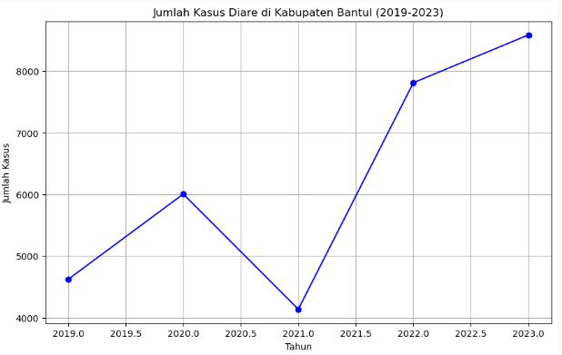

Figure 6. Diarrhea cases found and treated in Bantul Regency from 2019 to 2023

# Description onsites anitation system

The onsite Sanitation system in the study case Bantul Regency iis depicted below :

Septic tank

Pembuangan / Penggunaan Akhir

Pengolahan

Penyedotan

Toilet

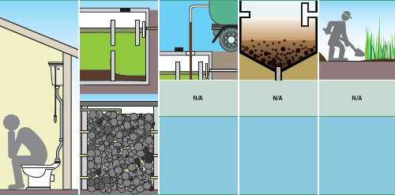

**following description explains chain service sanitation system , with all components functional (toilet – containment-conveyance – treatment – disposal / reuse).**

**Toilet**

Safe sanitation access in the area is at 50%, while adequate (decent) access reaches 98%. Toilet structures that meet the standards of the Ministry of Public Works are designed to ensure user comfort, cleanliness, and safety. These toilets—either squat or sitting types—must comply with the following specifications:

* The toilet bowl must be equipped with a water-sealed trap with a diameter of 50 mm to 100 mm.
* Footrests must be provided for squat toilets.
* The diameter of the waste outlet hole must be at least 75 mm.
* The distance between the toilet and the wall of the building must be a minimum of 20–25 cm.
* The squat toilet platform must be raised at least 10 cm above the floor, with a floor slope of 1%, and must be equipped with a floor drain.
* Sitting toilets must be equipped with a built-in water tank with a maximum capacity of 10 liters [4].

Based on the Environmental Health Risk Assessment (EHRA) study in Bantul conducted by Bappeda Bantul Regency in 2023, the main sanitation risk factors identified were: unsafe septic tanks (91.41%), pollution from septic tank disposal (79.51%), pollution from household wastewater channels (SPAL) (69.61%), and open defecation practices (1%).

The EHRA survey also found that, in Bantul Regency, 57.26% of the population use swan-neck toilets connected to self-constructed septic tanks, 38.61% use prefabricated septic tanks that comply with the Indonesian National Standard (SNI), 1.87% still use traditional cubluk (unlined earthen pits), and 0.20% use plengsengan combined with cubluk as the underground structure [5].

**Containement / Tank Septic**

Based on the EHRA survey, 91.41% of the population in Bantul Regency are suspected to have unsafe septic tanks. Regarding the final disposal of fecal waste, the majority of residents in Bantul Regency (80.51%) use infiltration wells, 9.94% do not have a final disposal site or allow it to seep into the ground or walls, 2.70% discharge it into rivers or other water bodies, and 2.27% channel it into drainage systems 5 .

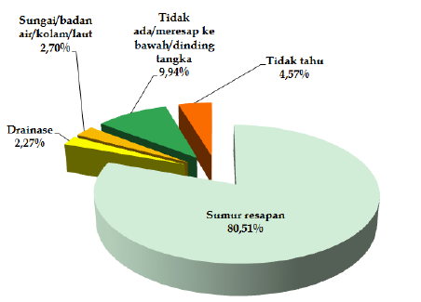

Figure 7. Percentage Distribution of Final Fecal Disposal Locations

Septic tank emptying is carried out using government or private fecal sludge suction truck services by 69.06% of households, while 13.50% pay a local handyman, and 13.08% empty the tank themselves.

Based on the data above, the government of Bantul Regency has mapped areas at risk of domestic wastewater contamination.

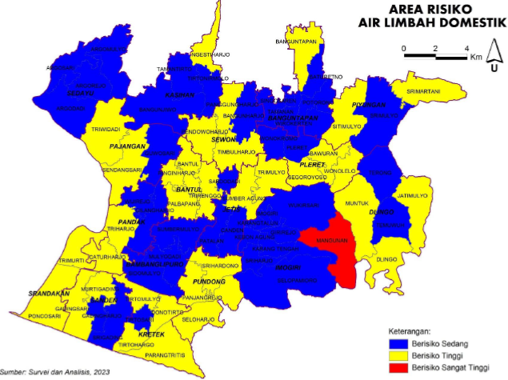

Figure 8. Domestic Wastewater Risk Map – Bantul Regency .

**Conveyence**

Based on the analysis, the majority of households (62.76%) have never emptied their septic tanks. Meanwhile, 8.71% emptied them within the last 0–3 years, 5.64% within 3–5 years, 4.77% within 5–10 years, 5.11% more than 10 years ago, and 13.01% reported that they did not know .

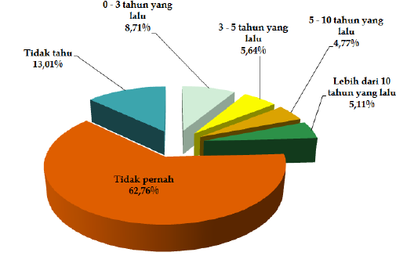

Figure 8. Septic Tank Emptying History

Based on the sludge retribution database, there are 108 fecal sludge trucks owned by both the local government and the private sector. However, the exact number of licensed private trucks is unknown. Regulations regarding fecal sludge management businesses are outlined in the Ministry of Environment Regulation No. 3 of 2021, which include requirements such as GPS tracking and vehicle standards.

Private suction service rates vary depending on the location. In the Bantul area, the cost of private fecal sludge suction services ranges from IDR 400,000 to 500,000.

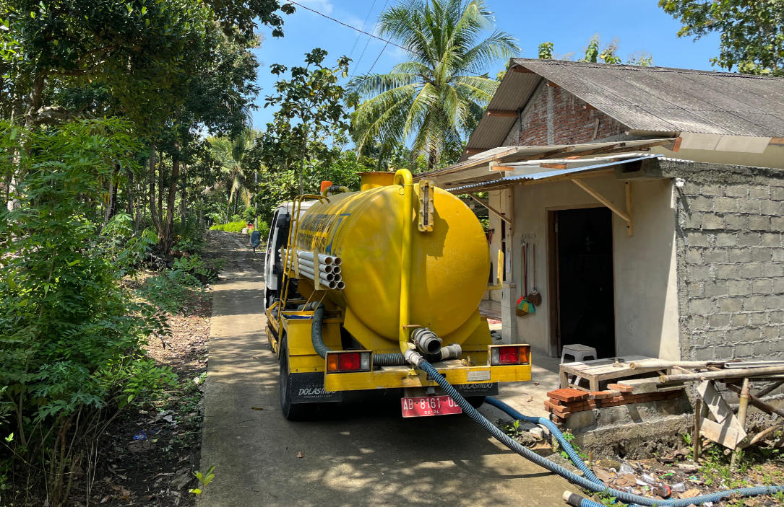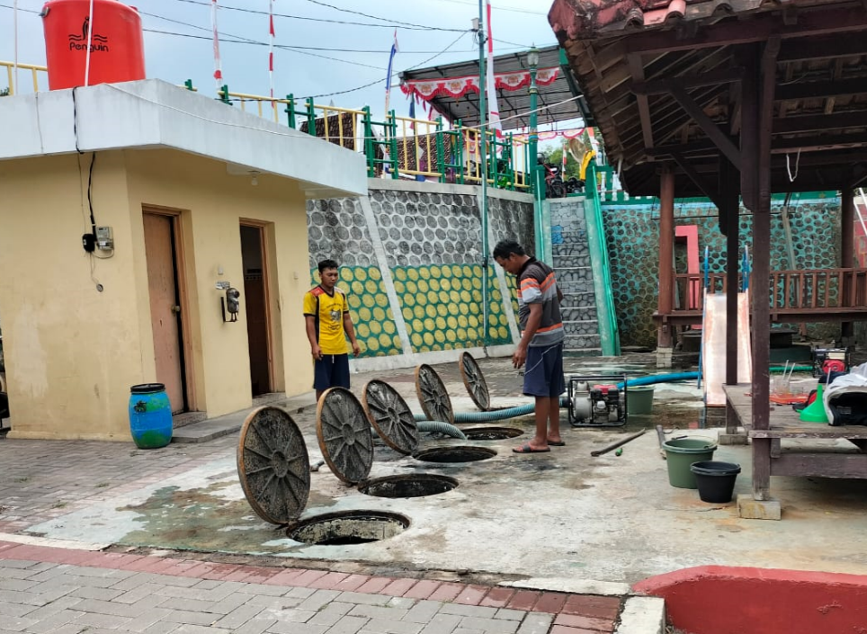 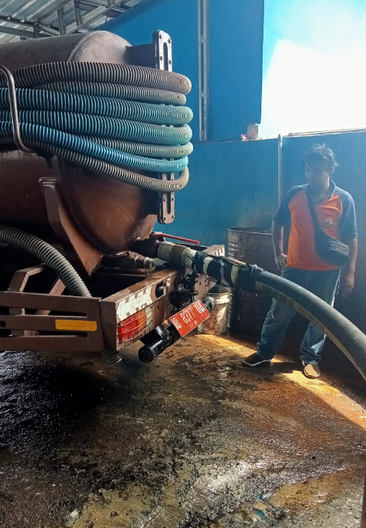 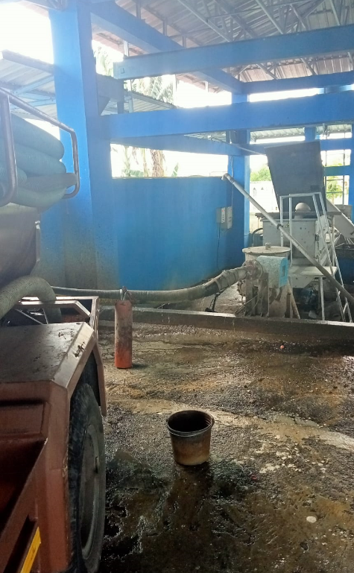

Figure 9. The fecal sludge suction process in Bantul Regency can serve as learning material for identifying risks in domestic wastewater management.

**Treatment – Sewon Fecal Sludge Treatment Plant**

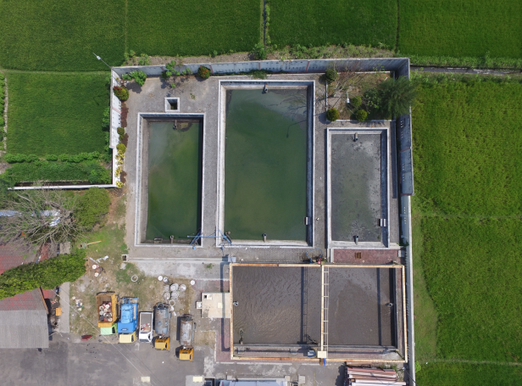

Figure 10. Sewon FSTP . Photo credit: Dilla Erlina

The Fecal Sludge Treatment Plant (IPLT) processes fecal sludge from individual and communal septic tanks, both private and government-owned (district/city), which cannot be connected to a sewer network.

The construction of the IPLT was carried out in two phases. Phase I was completed in 2014 with funding from the DIY Regional Government (APBD), and included the construction of an Imhoff tank and Anaerobic Pond I. Phase II was completed in 2015 with national budget (APBN) funding through the PSPLP Work Unit of the Ministry of Public Works and Housing (PUPR), and included the construction of Anaerobic Pond II, a Facultative Pond, and a Maturation Pond. In 2019, a new Fecal Sludge Treatment Installation (IPLT) was built using grant funds from the Ministry of PUPR.

Currently, the IPLT serves customers from the Special Region of Yogyakarta (DIY) and a small number from surrounding areas.

Criteria for Fecal Sludge Disposal at the PALPJK Facility

Only fecal sludge that meets the following criteria is permitted for disposal at the PALPJK facility:

Waste must originate from household septic tanks;

* pH level must be within the allowable range of 6–9;
* Waste must not contain oil or grease;
* The sludge should have a typical septic tank color (black or brown);
* Disposal cost: IDR 58,000 per 2 m³ tank.

Design Capacity: 100 m³/day

At the Sewon IPLT, fecal sludge trucks are received for service operations daily from 07:30 to 12:45.

Fecal Sludge Flow Process at IPLT

The process begins with the arrival of a fecal sludge truck, followed by a quality inspection of the waste. This inspection includes checking key parameters such as pH level, oil and fat content, and color. If the waste does not meet the established standards, the truck is rejected and not permitted to dispose of its contents at the facility.

If the waste passes the quality check, the truck is connected to a discharge point that is integrated with the SAP Hubber system. The sludge is then discharged, and its volume is recorded through a digital counter system. After disposal, the truck operator is required to pay a retribution fee based on the volume discharged. The process ends with the truck exiting the facility.

This system ensures that only sludge meeting processing standards is accepted, while also enabling effective monitoring and management of service costs.

The following is a flow diagram of the IPLT process

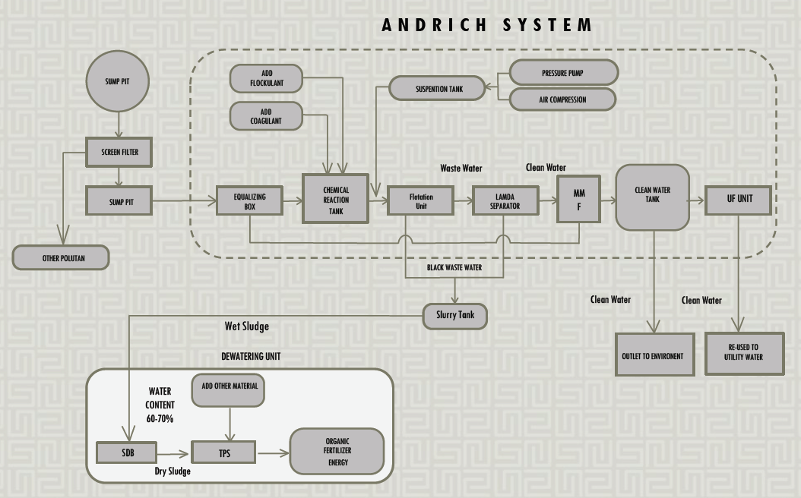

Figure 11. Flow Diagram Sewon IPLT

The schematic image of the IPLT process as follows

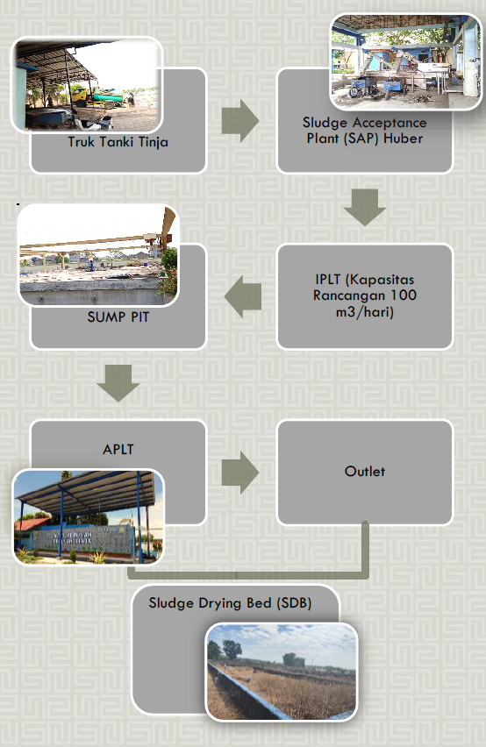

Figure 12: schematic operational system

1. Sludge Acceptance Plant (SAP) is a preliminary treatment unit that separates incoming materials before they continue to the stabilization tanks. The SAP at Sewon IPLT uses a device called the Hubber, which functions to separate sludge, water, and solid waste.

According to a research report on the performance of the Sewon IPLT, monitoring results found that the Hubber is still in usable condition, although some of its blades are damaged

**[6]**. The waste that comes out of the tool will collected and taken to Piyungan TPA whereas the mud will be streamed directly to Anaerobic Pool 1.

1. Anaerobic Pond is the first processing unit in the fecal sludge stabilization treatment. The designed BOD (Biochemical Oxygen Demand) removal efficiency for this pond is 60%. However, laboratory tests conducted on influent entering Anaerobic Pond 1 during the first and second trials showed no significant BOD reduction. This indicates that Anaerobic Pond 1 is not yet functioning optimally .
2. Anaerobic Pond 2

Anaerobic Pond 2 functions to extend the retention time of pollutants and further treat waste that was not fully processed in Anaerobic Pond 1. This pond is operating well, as evidenced by the reduced solid content in the sludge and the presence of abundant algae growth on the surface.

1. Facultative Pond

The wastewater entering the facultative pond has a lower organic loading rate compared to that in the anaerobic ponds. This is because the fecal sludge has already undergone prior treatment in the anaerobic ponds, resulting in fewer remaining organic substances.

1. Maturation Pond

The maturation pond is the final stage in the stabilization process. It is designed to further reduce suspended solids and BOD, and to eliminate pathogenic microorganisms through rapid environmental changes and elevated pH levels. In this pond, the sludge undergoes noticeable physical changes—such as a reduction in odor intensity and a shift in water color from dark and murky to clearer. These observations suggest that the maturation pond is performing quite well.

1. Sludge Drying Beds (SDB)

The Sewon IPLT has 22 sludge drying beds, which are used to dry sludge from the anaerobic ponds, facultative pond, and maturation pond. The drying process occurs naturally with the help of sunlight and wind, typically taking between 1 to 2 weeks, depending on the thickness of the sludge layer. Once dried, the sludge is transported to the Piyungan landfill (TPA). A major challenge in the SDB system is that the sludge storage area is already overloaded..

**Final disposal / end-use**

1. Compost Fertilizer / Soil Conditioner If dried sludge has undergone sufficient processing—such as drying and stabilization—it can be mixed with other organic materials to produce compost. However, this is only feasible if the heavy metal content and pathogen levels are within safe limits as defined by regulations.
2. Landfill / Backfill Material Dried sludge that does not meet the required standards for use as fertilizer is typically used as fill or backfill material in construction projects, especially at final disposal sites (TPA) or on non-productive land.

1. Profile book area Bantul district . Bappeda Bantul Regency , 2024.
2. Bantul Regency in figures 2024. BPS 2024
3. Report Performance of the DIY PUPESDM Service, 2023
4. Pocket book instruction sanitation construction , Ministry of PUPR 2022
5. Report EHRA documents Bantul Regency
6. Evaluation performance installation processing mud Sewage treatment plant ( IPLT ) Sewon , district Bantul , DI. Yogyakarta. Dilla Arlina, Andik yulianto , Suphia Rahmawati . UII