Sanitation Safety Plan
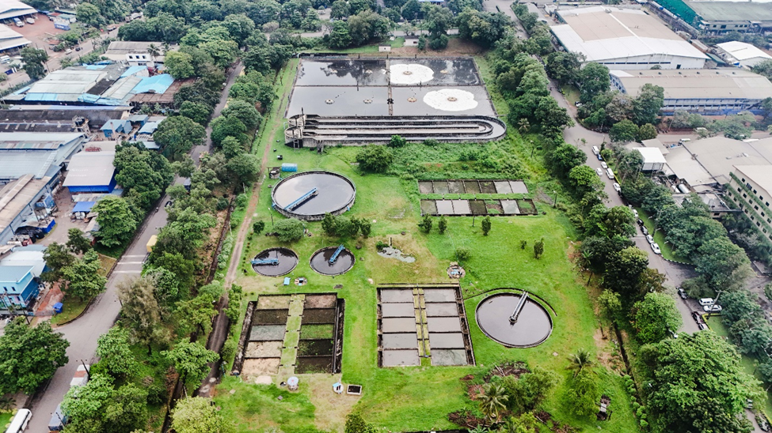
Biyagama Export Processing Zone

WATER RECLAMATION DIVISION
NATIONAL WATER SUPPLY AND DRAINAGE BOARD

August 2024

MODULE 1: PREPARING FOR SANITATION SAFETY PLANNING

1.1: SSP area and lead organization
Development of the Sanitation Safety Plan (SSP) for Water Reclamation (WR) Section – Biyagama Export Processing Zone (BEPZ) in Ja-ela Manager region of National Water Supply and Drainage Board (NWSDB)

- Locality.

The BEPZ is located in Biyagama divisional secretariat area of the Gampaha district and eastern suburb of western region of Sri Lanka, 21 km away from Colombo and 18 km from Gampaha.. Total Extent 450.95 Acres Industrial Area 268.95 Acres. It is the 2nd largest zone in the country with the largest Common Waste Water Treatment Plant having a treatment capacity of 20,000 m3 per day. The Biyagama Export Processing Zone (BEPZ) could be recognized as the Sri Lankas only Industrial Estate designed to accommodate high polluting type industries. The BEPZ is located upstream of the raw water intake of the Greater Colombo Water Supply Scheme and therefore it is utmost important that the CWTP is operated strictly in compliance with the environmental norms as relevant.

- key information
The Zone employees total 34,000 and hosts 56 enterprises. The already connected 56 industries consists of 84
connections in the Export Processing Zone at Biyagama There are eighteen apparel sector industries, thirteen rubber products manufacturing and twenty-five other sector industries like electronics, granite, water sports, security printing etc...Biyagama Divisional Secretariat is 60 square kilometres in size and has a total population of 207,714. From this population, it represents 92% of the population are Sinhalese, 7% are Muslims, 1% are Sri Lankan Tamil and other nations. In Biyagama, the total number of families are 53,750 with 47,952 housing units

- Average income, agriculture activity in the region
Biyagama EPZ is a significant contributor to the national economy with an export value estimated at Rs. 134 billion ($ 849 million) and importing Rs. 58 billion ($ 368 million) worth of raw materials in 2017.
There are well connected tributaries and canal system with Kelani river and sensitive wetlands and paddy fields in Biyagama area. Six hundred hectares paddy lands are continuously cultivated as per the agrarian statistics of Biyagama. Before the establishment of the EPZ, the people in the area mainly depended on agriculture-based economic activities. But with the establishment of the zone, most of the people have been engaging in occupation activities within the zone. Industrial sector had a major impact on the social, economic and physical development of the Biyagama area over the past and that led a unique sequence of Biyagama industrial development.

- Monthly average temperature
Biyagama recorded a average annual rainfall of 1500 mm and average annual temperature of 80°F (26.7 °C).

- Climate change scenario projected for the near future.
Main problem faced by the Biyagama area is the socio - economic impact of the annual flood in the Kelani River When compared with the past and recent food situations of the area, the impact of the affected population is increasing mainly due to unauthorised construction within the river reservation as well as filing wetlands.

- Prevalence of excreta-related diseases
Diarrhoea, Leptospirosis and Dengue are common diseases that affect the general public after the rainy season.
In addition to the epidemics that could spread because of animals, diseases could also spread due to faecal matter mixing with water. Skin Diseases and Respiratory disorders are common among them.

- Main water supply source.
Biyagama is one of the twenty sub basins of Kelani River and belongs to the wetland zone as per the geographical location. BEPZ boarders the Kelani river which is the main source of the water for the area. Water treatment facility is located at the right bank of the river. It is the second largest water treatment facility in the country. The plant provides drinking water to Gampaha district including Biyagama area. Water consumption of BEPZ is around 22,000m3/day.

  - Lead organization
National Water Supply and Drainage Board (in collaboration with the Board Of Investment, Biyagama) is the lead organization.

1.2: Assemble the SSP team
- SSP team leader
- Manager Jayawadanagama as SSP team leader so that he is aware and somewhat engaged, and understands the rationale for investment in proposed improvements.
- The SSP Core Team is composed of employees from NWSDB waste Water disposal Section of BEPZ.
SSP team .
Organization | Job title | Role in SSP team
National Water Supply and Drainage Board | Manager (Jayawadanagama) | Effective implementation of the process as team leader
National Water Supply and Drainage Board | Engineer (O&M)- BEPZ | Coordinates, facilitates and perform necessary support duties.
National Water Supply and Drainage Board | OIC (BEPZ) | Monitoring the system,  Responsible for material stock maintenance, Leak repairs,
National Water Supply and Drainage Board | Engineering Assistant (Mec)  Electrician | M &E activities
National Water Supply and Drainage Board | Plant Operators | Making sure the process of treating the waste water is effective and they make sure that official guide lines are followed
Board Of Investment- Biyagama | Senior Deputy Director (Engineering Services) | Timely supply of material, spares & other resources etc..,
Board Of Investment- Biyagama | Engineer  (Engineering Services) | Making sure system operates within the required standards.
Board Of Investment- Biyagama | Laboratory Analyst | Monitoring and communicating process and quality issues.  Monitors illegal waste discharges to the environment
PHI - Biyagama |  | Coordinates environmental health programmes in the area. Ensure community involvement necessary for the SSP  Protect nearby communities from exposure to untreated wastewater.

1.3: Establish SSP priorities

Collection Transport Treatment Disposal

Effluent
94%

WWTP

WW contained delivered to treatment 96%

Pumping stations -WWTP
Contained 98%

Pipe Network
WW treated

Sludge

2% WW not delivered to treatment 2% WW not treated

Excreta flow diagram

Green arrows in Excreta flow diagrams represent the proportions of excreta that are “safely managed” along the sanitation chain.
Red arrows show where the excreta flows are not safely managed. Red arrows represent the leakage of wastewater from the sewer pipe system into the surrounding soil or groundwater and the, untreated or partially treated waste water discharge in to the inland water bodies due to the release of non-standard waste water in to the WWTP by the industries.
By identifying the thickest red arrows, the SSP steering committee can quickly agree on risk-based priorities

MODULE 2: DESCRIBE THE SANITATION SYSTEM

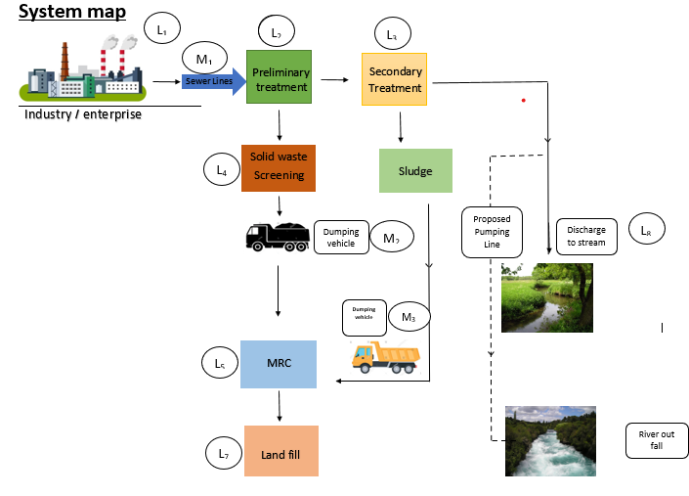

Land fill????????? Wetland should be added, well describe the system !!

2.2: Characterize system flows

System flow code | Sanitation step | Description of the system flow | Key information of the system flow | Expected variations | Type of potential hazard
L1 M1 | Conveyance | Waste water/ sewage from industries/Institutions | Collection of waste water through network |  | Contact with raw sewage during maintenance work of pipe network. Leakages / overflows in pipe and manholes.
L2 | Conveyance | Pumping stations, Coarse Screens. | Pushes wastewater towards the WWTP. Removing medium / large floating particles. |  | Contact wastewater, solid waste and pathogens/ helminth eggs in transporting and maintenance process’  Open for animals when open dumping.
L3, L4 | Treatment | Grit channel,  Fine screens | Separate grit from waste water.  Removing small scale floatingl5 waste. |  | Contact wastewater, solid waste and pathogens/ helminth eggs in transporting and maintenance process’  Open for animals when open dumping.
L5 | Treatment | Equalize and mix incoming wastewater |  |  | Contact with pathogens/ helminth eggs when repairing and maintaining
L5 | Treatment | Aerated Lagoons | Biological Oxidation |  | Inhaling aerosol due to surface aeration. Contact with pathogens/ helminth eggs when repairing and maintaining. Falling Potential
L5 | Treatment | Oxidation Ditch | Remove bio-degradable organics |  | Inhaling aerosol due to surface aeration. Contact with pathogens/ helminth eggs when repairing and maintaining. Falling Potential
L5 | Treatment | Clarifier tanks | Separating sludge from effluent and Removing scum | L5 | Repair/Maintenance/cleaning–  Contact with pathogens/ helminth eggs. Falling Potential. Potential physical damages
L5 | Treatment | Sludge drying beds | Water is removed from the sludge |  | Contact wet sludge/ helminth eggs
M3 L6 L7 | Disposal |  | Safe Disposal dried sludge for land fill |  | Contact with sludge when loading and unloading. Leachate mixes with ground water during rainy season
L5 | Treatment | Chlorine dosing arrangement | Mixing chlorine to the water for disinfection |  | Expose to chlorine gas
L8 | Disposal | Treated effluent | Discharge into stream |  | High Chlorine level, Heavy metals  Release non comply effluent
L3, L5, L8 |  | Sample collecting | Quality monitoring and Process control |  | Contact with waste water, Spilling when sample carrying

2.3: Identify exposure groups

Below is the list of exposure groups and its corresponding code.

W | Maintenance workers | W1
W | Pump Operators | W2
W | Machine Operators / Drivers | W3
W | Treatment plant operator | W4
W | Staff of the Waste water treatment scheme | W5
L | Employees of Industries located adjacent to Treatment plant / Contractors | L!
L | Local community living downstream from the TP | L2
L | Plant visitors | L3

 | Exposure Group ID | Who are the exposure groups? | How many are there? | What are they doing there? | What are they exposed to? | How often are they exposed to this?
Conveyance | W | W1:  Maintenance  workers  W2: Pump  Operators | 13  15 | Operation maintenance and repairs in Pump houses and sewer pipe network | Handling of faecal sludge and raw wastewater and equipment used in repairs, emptying, conveyance, of waste water. work in confined spaces, cuts and abrasions, chemical and physical risks from use of hazardous cleaning agents | Daily
Treatment  (Grit channel, Fine screens) | W | W1:  Maintenance  Workers  W3: Machine  Operator  W4: Treatment  plant operators | 13  2  3 | Grit removal, Screen cleaning | faecal sludge and raw wastewater, equipment used in repairs, cuts and abrasions , exposed to chemicals and pathogens | Daily  Once in Two months  Daily
Treatment  (Equalize and mix incoming wastewater) | W | W1: Maintenance  Workers  W3: Machine  Operators  W4: Treatment  plant operators | 13  2  3 | Maintenance and repairs of aerators,  Collect waste water samples for testing | Aerosol gases / Contact with pathogens/ helminth eggs when repairing and maintaining | Daily  Once a month  Daily
Treatment  Aerated lagoons | W | W1: Maintenance  Workers  W2: Pump  Operators  W3: Machine  Operators | 13  2  3 | Maintenance and repairs of aerators,  Collect waste water samples for testing | Aerosol gases / Contact with pathogens/ helminth eggs when repairing and maintaining | Daily  Once a month  Daily
Treatment  Oxidation Ditch | W | W1: Maintenance  Workers  W3: Machine  Operators  W4: Treatment  plant operators | 13  2  3 | Maintenance and repairs of aerators,  Collect waste water samples for testing | Aerosol gases / Contact with pathogens/ helminth eggs when repairing and maintaining | Daily  Once a month  Daily
Treatment  Clarifier Tanks | W | W1: Maintenance  Workers  W4: Treatment  plant operators | 13  3 | Maintenance and repairs of scraper bridges, sludge pumps,  Collect waste water samples for testing | Contact with pathogens/ helminth eggs when repairing and maintaining | Once a month  Daily
Treatment  Sludge drying beds | W,L | W1: Maintenance  Workers  W4: Treatment  plant operators | 13  3 | Maintenance and repairs of sludge tank pumps, valves, Removing dried sludge from beds. | Contact with pathogens/ helminth eggs when repairing and maintaining | Twice a week  Daily
Treatment  Chlorination | W | W1: Maintenance  Workers | 2 | Prepare, feed calcium hyper chloride solution | Exposed to chlorine gas | Three times a week
Collecting Samples | W | W4: Treatment  plant operators  W5: Staff of the  Waste water  treatment  scheme | 3  3 | Collect samples from factories and WWTP and hand over to the laboratory | Chemicals and pathogens | Daily
Disposal  Transport Dried sludge | L1 | Employees of Industries located adjacent to Treatment plant / Contractors |  | Transport and dispose dried sludge for land fill | Contact with pathogens/ helminth eggs/ chemicals.  when loading and unloading | Once in three months

2.4: Supporting information

Regulatory requirements | Demographics and land use patterns
Tolerance limits for the discharge of wastewater or effluent into Inland Surface Waters  GAZETTE EXTRAORDINARY OF THE DEMOCRATIC SOCIALIST REPUBLIC OF SRI LANKA – 27.01.2022  Tolerance limits for the discharge of wastewater or effluent into public sewer network, connected either to a common treatment plant or a sea outfall or a combination of both  Environmental norms BOI ENVIRONMENT STANDARDS WASTEWATER DISCHARGE QUALITY STANDARDS | As of the 2011 census, Biyagama Divisional Secretariat had a population of 186,862, which increased to 192,000 by 2017. The demographic breakdown is 92% Sinhalese, 7% Muslims, and 1% Sri Lankan Tamils and others. The area has 48,151 families and 47,636 housing units. The Grama Niladhari Divisions near the Colombo-Kandy main road, including Sapugaskanda, Makola Ihala, Gonawala West, Pamunuwila, and Mawaramandiya, have a higher housing density compared to other divisions in the area. The natural population growth rate in Biyagama is currently 1.4%. If this rate continues, the population is expected to reach around 247,000 by 2030. Historically, from 1981 to 1999, the growth rate was 2.08% due to industrial development. Presently, the population density is 32 people per hectare, and there are approximately 150,000 daily commuters in the region due to industrial activities.
System management and performance | Changes related to climate and weather
 | The obstruction due to the flood situation in the area is directly affecting the industrial sector as well as the livelihood of the people. This situation affects the employees in factories as well as many labourers from outside. Also industrial economy has been disrupted and directly affected due to break down of transportation system of industrial production and raw material. .

2022.1.27 GAZETTE EXTRAORDINARY 2022.1.27

Tolerance limits for the discharge of wastewater or effluent into public sewer network, connected either to a common treatment plant or a sea outfall or a combination of both.
No. | Parameter | Unit, type of limit | Tolerance limit values
1. | Total suspended solids | mg/1, max. | 500
2. | Total dissolved solids | mg/1, max. | 3000
3. | pH at the ambient temperature | - | 5.5 – 9.0
4. | Biochemical oxygen demand  (BOD₅ in 5 days at 20⁰ C) | mg/1,max. | 400
5. | Temperature at the discharge point | ⁰C, max | 45
6. | Oils and greases | mg/1, max. | 20
7. | Phenols (as C₆H₅OH) | mg/1, max. | 5.0
8. | Chemical oxygen demand (COD) | mg/1, max. | 800
9. | Total Phosphorous (as P) | mg/1, max. | 3.5
10. | Total Kjeldhal nitrogen (as N) | mg/1, max. | 350
11. | Free ammonia (as N) | mg/1, max. | 50
12. | Ammoniacal nitrogen (as N) | mg/1, max. | 50
13. | Cyanide (as CN) | mg/1, max. | 2.0
14. | Total residual chlorine (as Cl₂) | mg/1, max. | 2.0
15. | Chlorides (as Cl) | mg/1, max. | 1200
16. | Fluorides (as F) | mg/1, max. | 10
17. | Sulphides (as S) | mg/1, max. | 2.0
18. | Arsenic, total (as As) | mg/1, max. | 0.1
19. | Cadmium, total (as Cd) | mg/1, max. | 0.1
20. | Chromium, total (as Cr) | mg/1, max. | 2.0
21. | Chromium, hexavalent (as Cr⁶⁺) | mg/1, max. | 0.5
22. | Copper, total (as Cu) | mg/1, max. | 3.0
23. | Lead, total (as Pb) | mg/1, max. | 0.1
24. | Mercury, total (as Hg) | mg/1, max. | 0.005
25. | Nickel, total (as Ni) | mg/1,max. | 3.0
26. | Selenium, total (as Se) | mg/1,max. | 0.1
27. | Zinc, total (as Zn) | mg/1,max. | 5.0
28. | Pesticides (Total) | mg/1,max. | 0.005
29. | Surfactants (Total) | mg/l, max. | 50
30. | Sulphates (as S) | mg/l, max. | 350
31. | Radioactivity Gross alpha activity + | Bq/l maximum | 0.5
32. | Radioactivity Gross beta activity + | Bq/l maximum | 1.0

Colour Parameters

No. | Parameter | Unit, type of limit | Tolerance limit values
1.  2.  3. | Colour  400-499 nm- (Yellow range)  500-599 nm- (Red range)  600-750 nm- (Blue range) | m-1  m-1  m-1 | Maximum spectral absorption  coefficient  7 max  5 max  3 max

Tolerance limits for the discharge of wastewater or effluent into Inland Surface Waters

No. | Parameter | Unit, type of limit | Tolerance limit values for Inland surface waters
1. | Total suspended solids | mg/1, max. | 50
2. | Total dissolved solids | mg/1, max. | 1000
3. | pH at ambient temperature | - | 6.0 – 8.5
4. | Biochemical oxygen demand  (BOD₅ in 5 days at 20⁰ C) | mg/1,max. | 30
5. | Temperature at the point of discharge | ⁰C, max. | Ambient water temperature ± 5 or 40 whichever is lesser
6. | Oils and greases | mg/1,max. | 10
7. | Phenols (as C₆H₅OH) | mg/1,max. | 1.0
8. | Chemical oxygen demand (COD) | mg/1,max. | 250
9. | Dissolved phosphates (as P) | mg/1,max. | 5
10. | Total Kjeldhal nitrogen (as N) | mg/1,max. | 150
11. | Ammoniacal nitrogen (as N) | mg/1,max. | 50
12. | Nitrate (as N) | mg/1,max. | 10
13. | Cyanide (as CN) | mg/1,max. | 0.05
14. | Total residual chlorine (as Cl₂) | mg/1,max. | 0.5
15. | Chlorides (as Cl) | mg/1,max. | 400
16. | Fluorides (as F) | mg/1,max. | 2.0
17. | Sulphides (as S) | mg/1,max. | 0.5
18. | Arsenic, total (as As) | mg/1,max. | 0.05
19. | Cadmium, total (as Cd) | mg/1,max. | 0.03
20. | Chromium, total (as Cr) | mg/1,max. | 0.05
21. | Chromium, hexavalent (as Cr⁶⁺) | mg/1,max. | 0.01
22. | Copper, total (as Cu) | mg/1,max. | 0.05
23. | Iron, total (as Fe) | mg/1,max. | 3.0
24. | Lead, total (as Pb) | mg/1,max. | 0.05
25. | Mercury, total (as Hg) | mg/1,max. | 0.001
26. | Nickel, total (as Ni) | mg/1,max. | 0.2
27. | Selenium, total(as Se) | mg/1,max. | 0.05
28. | Zinc, total (as Zn) | mg/1,max. | 2.0
29. | Silver, total (as Ag) | mg/1,max. | 0.035
30. | Pesticides (Total) | mg/1,max. | 0.005
31. | Surfactants (Total) | mg/l, max. | 5.0
32. | Faecal coliform | MPN/100ml, max. | 150
33. | Sulphates (as S) | mg/l, max. | 250
34. | Radioactivity Gross alpha activity + | Bq/l maximum | 0.5
35. | Radioactivity Gross beta activity + | Bq/l maximum | 1.0

Colour Parameters

No. | Parameter | Unit, type of limit | Tolerance limit values for inland surface waters
1.  2.  3. | Colour  400-499 nm- (Yellow range)  500-599 nm- (Red range)  600-750 nm- (Blue range) | m-1  m-1  m-1 | Maximum spectral absorption  coefficient  7 max  5 max  3 max

BOI Norms
ENVIRONMENT STANDARDS

WASTEWATER DISCHARGE QUALITY STANDARDS
BOD (5 days at 20oC) (mg/1)
COD (mg/1)
pH
Total Suspended solids (mg/l)
Total dissolved solids (inorganic) (mg/1)
Temperature (0C)
Phenolic compounds (as phenolic OH) (mg/1)
Oil and grease (mg/1)
Total Chromium (mg/1)
Copper (as Cu) (mg/1)
Lead (as Pb) (mg/1)
Mercury (as Hg) (mg/1)
Nickel (as Ni) (mg/1)
Zinc (as Zn) (mg/1)
Arsenic (as As) (mg/1)
Boron (as B) (mg/1)
Ammonical Nitrogen (as N) (mg/1)
Sulphides (as S2-) (mg/1)
Sulphates (as SO42- (mg/1)
Chlorides (as CI-) (mg/1)
Cyanides (as CN-) (mg/1)
Free Residual Chlorine (as Chlorine) (mg/1)
200
600
6.0-8.5
500
2100
40
5
30
(Chromium VI
0.5)
2
3
1
0.001
3
10
0.2
2
50
2
1000
900
0.2
Nil
Parameters
Maximum Tolerance Limit
Tolerance Limits for
Industrial Wastewater (Effluents) Discharged Into the Common
Wastewater Treatment Plant
Environment Management Department

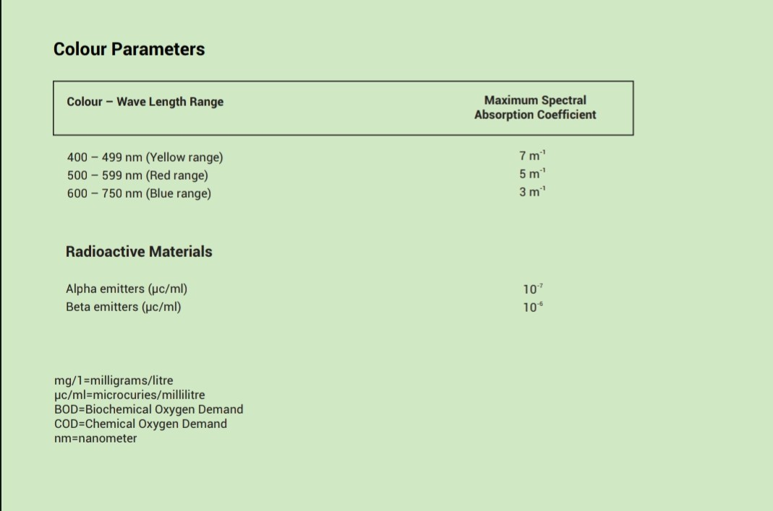

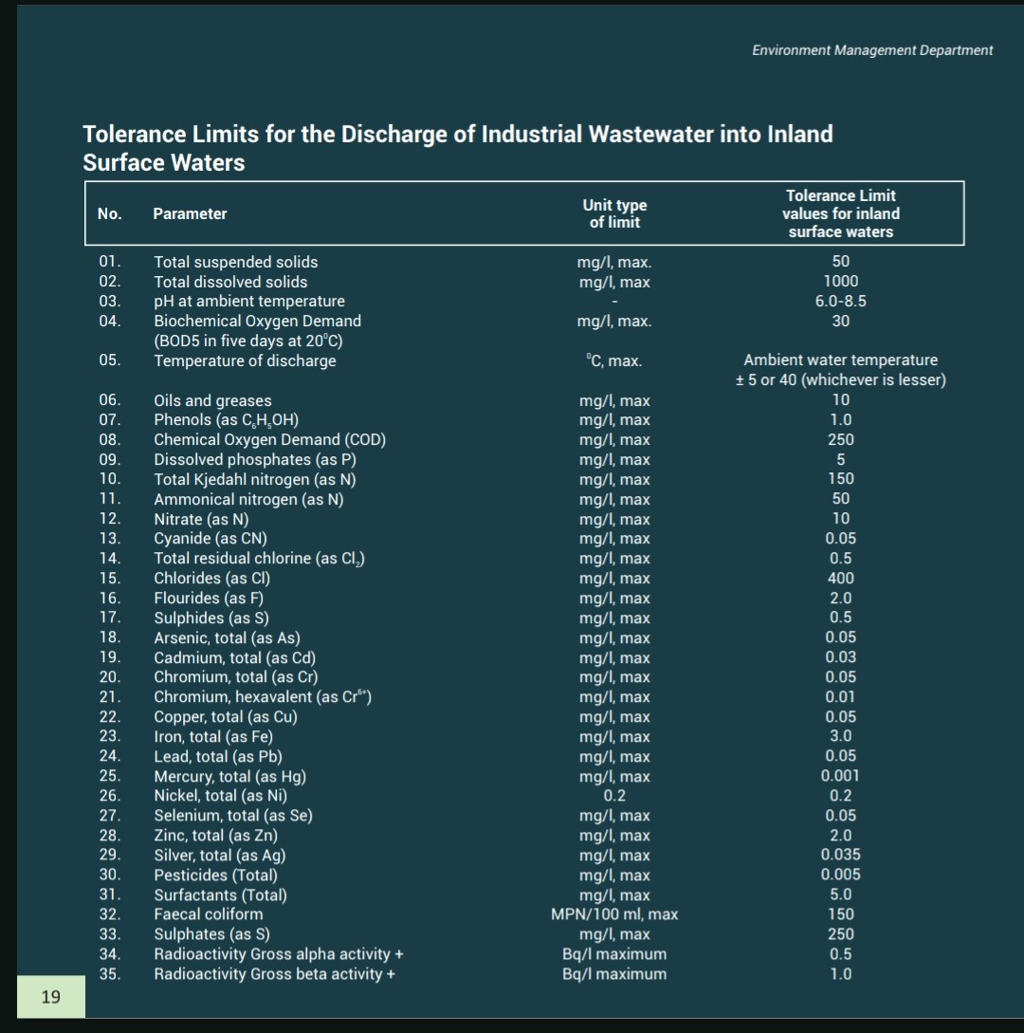
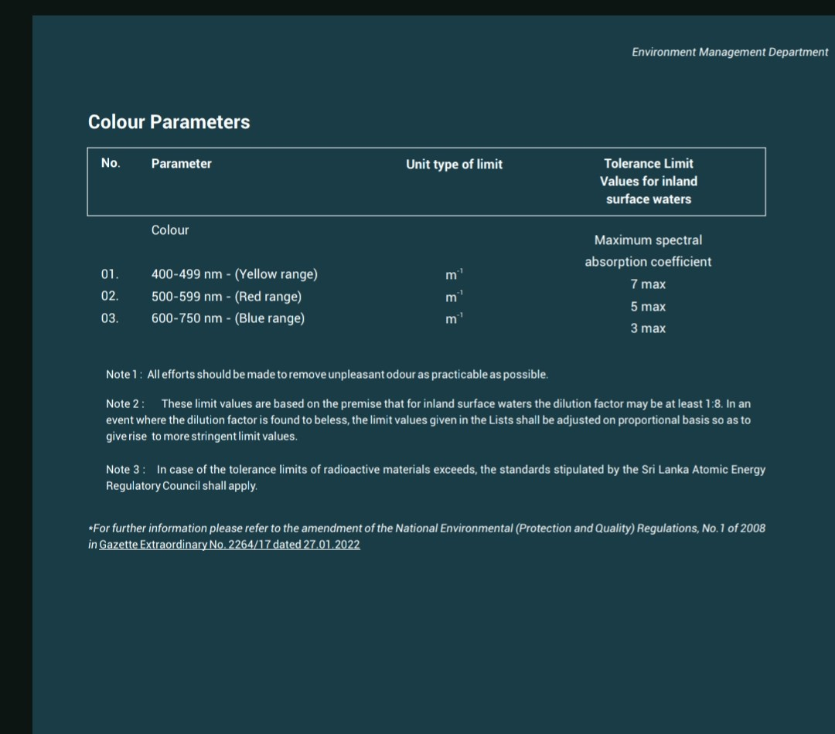
MODULE 3: IDENTIFY HAZARDOUS EVENTS, AND ASSESS EXISTING CONTROL MEASURES AND EXPOSURE RISKS

Descriptor | Description
kelihood (L)
1 | Very Unlikely | Has .t happened in the past and it is highly improbable it will happen in the next 12 months (or a.ther reasonable period).
2 | Unlikely | Has .t happened in the past but may occur in exceptional circumstances in the next 12 months (or a.ther reasonable period).
3 | Possible | May have happened in the past and/or may occur under regular circumstances in the next 12 months (or a.ther reasonable period).
4 | Likely | Has been observed in the past and/or is likely to occur in the next 12 months (or a.ther reasonable period). 5 Almost Certain Has often been observed in the past and/or will almost certainly occur in most circumstances in the next 12 months (or a.ther reasonable period).
5 | Almost Certain | Has been observed in the past and/or is likely to occur in the next 12 months (or a.ther reasonable period). 5 Almost Certain Has often been observed in the past and/or will almost certainly occur in most circumstances in the next 12 months (or a.ther reasonable period).
Severity (S)
1 | Insignificant | Hazard or hazardous event resulting in . or negligible health effects compared to background levels
2 | Minor | Hazard or hazardous event potentially resulting in minor health effects (e.g. temporary symptoms like irritation, nausea, headache).
4 | Moderate | Hazard or hazardous event potentially resulting in a self-limiting health effects or mi.r illness (e.g. acute diarrhea, vomiting, upper respiratory tract infection, mi.r trauma).
8 | Major | Hazard or hazardous event potentially resulting in illness or injury (e.g. malaria, schistosomiasis, food-borne trematodiases, chronic diarrhea, chronic respiratory problems, neurological disorders, bone fracture); and/or may lead to legal complaints and concern; and/or major regulatory .n-compliance.
16 | Catastrophic | Hazard or hazardous event potentially resulting in serious illness or injury , or even loss of life (e.g. severe poisoning, loss of extremities, severe burns, , drowning); and/or will lead to major investigation by regulator with prosecution likely

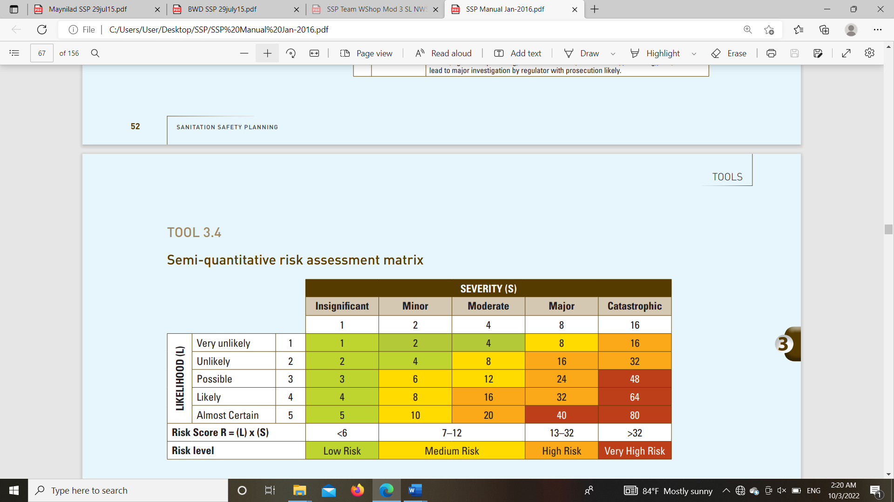

RISK DESCRIPTOR | .TES
Very High and High Risk | Actions need to be taken to minimize the risk. Possible options (short ,medium and long term options) should be documented (as part of the improvement plan developed in the next Module) and implemented based on priorities and available resources.
Medium Risk | Currently low or very unlikely impact on exposure groups. The situation can be improved with operational changes or system improvement over the medium to long term.
Low Risk | Actions may be taken but .t a priority, or . action is needed at this time. The risk should be revisited in the future as part of the review process.
Unk.wn priority | Further data is needed to categorize the risk. Some action can be taken to reduce risk while more data is gathered.

3.1: Identify hazards and hazardous events

Component | Hazard Identification |  |  |  | Existing Control(s) |  | Risk Assessment |  |  |  |  |  | Comments justifying risk assessment, under current conditions or climate change scenarios, or effectiveness of the control
Component |  |  |  |  |  |  | Under current conditions |  |  | Under the most likely climate change scenarios:  + means increased risk  - means decreased risk  = means the same risk
Component |  |  |  |  |  |  | L=Likelihood; S=Severity; R=Risk
Sanitation step | Hazardous event | Hazard | Exposure Groups | Number of persons at risk | Description of existing control | Validation of control | L | S | Score | R
Pipe Network  Maintenance work of pipe network. Leakages / overflows in pipe and manholes. | Potential health risk due to exposure to wastewater during existing sewerage line handling | Exposure to Helminth eggs, Pathogen, Ingestion after contact with excreta  Chemicals Dermal contact | W1 |  | Wearing masks, gloves and Gumboots | Visual inspection | 5 | 2 | 10 | M | + |  | Likelihood will increase with flooding due to climate change.
 | Accidents due to use of heavy machines, Soil conditions,  Road accidents | Physical injury,  Dermal contact | W1 | ?????? | PPE  Traffic cones  Barricades | Safety Awareness programmes | 2 | 8 | 16 | H | + ???? | ???? | Likelihood will increase with heavy  rainfall and flooding
 | Falling in to Manholes | Exposure to pathogens  and injuries | W1 |  | PPE, Manhole fence, Barricades, SOP | Inspection and monitoring | 1 | 16 | 16 | H | =
 | Exposures to the waste water due to manhole overflowing & leaking air valves | Exposure to Helminth eggs, Pathogen, Ingestion after contact with excreta | W1,L1 |  | PPE, | Inspection and monitoring | 4 | 2 | 8 | M | + |  | Likelihood will increase with heavy  rainfall and flooding
Pumping stations  Repair and maintenance  work of Pumping stations | exposure to raw wastewater during repairs and screen cleaning | Helminth eggs, Pathogen, Ingestion after contact with excreta. | W1, W2,  W3 |  | PPE | Visual inspection  Awareness programmes | 5 | 2 | 10 | M | + |  | Likelihood will increase with heavy  rainfall and flooding
 | Inhalation of raw sewage (odour) | Toxic gases | W1, W2,  W3 |  | safety masks  Ventilators | Inspection | 3 | 4 | 12 | M | =
 | Accidents due to falling in to wet well, Slipping, tripping | Drowning,  Physical injury, Exposure to  pathogens | W1, W2,  W3 |  | PPE, Sign boards | Awareness programmes | 2 | 16 | 32 | H | + |  | Likelihood will increase with heavy  rainfall and flooding
 | Accidents due to Working in Confined spaces | Exposed to gases | W1, W2,  W3 |  | Ventilator Fans | Inspection | 3 | 4 | 12 | M | =
 | Accidents during Maintenance of electrical equipment and panels | Electrical shock and  injuries |  | 3 | PPE | Inspection and monitoring |  |  |  | M | + |  | Likelihood will increase due to lightning strikes
Grit Channel | Exposure to raw waste water while cleaning screens, grit channels and handling of accumulated grit and screenings | Pathogen  Helminth  Eggs.  Ingestion after contact with excreta | W3 |  | PPE | Inspection and monitoring | 5 | 2 | 10 | M | + |  | Likelihood will increase with heavy  rainfall and flooding
 | Exposure to the harmful gases during  repair and maintenance | Toxic gases |  |  | Safety masks  Ventilators | Inspection | 3 | 4 | 12 | M | =
Equalization  Tanks | Exposure to raw waste water while lifting, Repairing & Maintaining Surface aerators | Helminth eggs, Pathogen, Ingestion after contact with excreta. | W1,W3, W4 |  | PPE | Inspection | 5 | 2 | 10 | M | =
Equalization  Tanks | Accidents due to falling in to tanks, ,slipping, tripping  & incorrect operation of high-speed aerators | Drowning,  Physical injury, Exposure to  pathogens, | W1,W3, W4 |  | Lifesaving jackets. Safety harness.  Electrical Lockout equipment | Inspection and testing | 2 | 16 | 32 | H | + |  | Likelihood will increase with heavy  rainfall and flooding
Equalization  Tanks | Exposed to aerosol gases | Respiratory damage & health impacts | W1,W3, W4 |  | Safety masks | Issuance of PPE ,  Inspection | 5 | 4 | 20 | H | =
Aeration  Aerated Lagoons | Exposure to raw waste water during Lifting, Repairing & Maintaining Surface aerators | Helminth eggs, Pathogen, Inadvertent ingestion after contact with excreta | W1,W3, W4 |  | PPE | Inspection | 5 | 2 | 10 | M | =
Aeration  Aerated Lagoons | Accidents due to falling in to water, slipping, tripping  & incorrect operation of high-speed aerators | Drowning,  Physical injury, Exposure to  pathogens inadvertent ingestion | W1,W3, W4 |  | Lifesaving jackets. Safety harness.  Electrical Lockout equipment | Inspection and testing | 2 | 16 | 32 | H | + |  | Likelihood will increase with heavy  rainfall and flooding
 | Exposed to aerosol gases | Respiratory damage & health impacts | W2, W3 |  | Safety masks | Issuance of PPE ,  Inspection | 5 | 4 | 20 | H | =
Oxidation Ditch | Exposure to raw waste water during Lifting, Repairing & Maintaining Surface aerators | Helminth eggs, Pathogen, Inadvertent ingestion after contact with excreta,  Skin contact | W2, W3 |  | PPE | Inspection | 5 | 2 | 10 | M | =
Oxidation Ditch | Accidents due to falling in to water ,slipping, tripping  & incorrect operation of high speed aerators | Drowning,  Physical injury, Exposure to  pathogens inadvertent ingestion | W2,W3 |  | Lifesaving jackets. Safety harness.  Electrical Lockout equi pment | Inspection and testing | 2 | 16 | 32 | H | + |  | Likelihood will increase with heavy  rainfall and flooding
Oxidation Ditch | Exposed to aerosol gases | Respiratory damage & health impacts | W2,W3 |  | Safety masks | Issuance of PPE ,  Inspection | 5 | 4 | 20 | H | =
Clarifier tanks | exposure to wastewater while cleaning of weirs & Scraper bridge repairs | Helminth eggs, Pathogen, Inadvertent ingestion after contact with excreta | W2,W3 |  | PPE | Issuance of PPE ,  Inspection | 4 | 2 | 8 | M | =
Clarifier tanks | Accidents due to falling in to water & slippery floors, | Physical injury  Drowning Inadvertent ingestion, skin contact | W2,W3 |  | Lifesaving jackets, Safety harness,  Gumboots | Issuance of PPE  Inspection | 2 | 16 | 32 | H | + |  | Likelihood will increase with heavy  rainfall and flooding
Sludge drying beds | Health risk due to contact with sludge or solid waste | Chemical, Pathogens,  Physical. | W2,W3 |  | PPE | Inspection | 3 | 4 | 12 | M | =
 | Accident during the transport of the  dewatered sludge to the dumping yard | Physical injury | W1,W3
Chlorine dosing arrangement | Inhalation of harmful gases during chlorine mixing process | Chemical, | W2,W3 |  | Safety Masks | Inspection | 3 | 4 | 12 | M | = |  | ??????
Treated effluent | Health risk due to exposure to effluent during collection of samples | Chemical,  Physical  Biological | W1, W4,  W5 |  | PPE | Inspection,  Conducting Awareness programs | 3 | 4 | 12 | M | =

3.3: Assess and prioritize the exposure risk
.

Sanitation step | Hazardous event | Exposure Group | Number of persons at risk | Risk | Projection of changes in risks with climate change scenarios | Priority given
Pipe Network  Maintenance work of pipe network. Leakages / overflows in pipe and manholes |  | W1, W3, L1
 | Accidents due to use of heavy machines, Soil conditions,  Road accidents | W1, W3, L1 | 17 | High | Increases during heavy rains | High
 | Falling in to Manholes | W1, W3, L1 | 17 | High | Same | High
Pumping stations  Repair, Operation & maintenance |  | W1,W2,W3
Pumping stations  Repair, Operation & maintenance | Accidents due to falling in to wet well, Slipping, tripping | W1,W2,W3 | 18 | High | Increases during heavy rains | High
Pumping stations  Repair, Operation & maintenance | Exposed to aerosol gases | W1,W2,W3 | 18 | High | Same | High
Equalization  Tanks  Repair, Operation & maintenance | Accidents due to falling in to tanks, slipping, tripping  & incorrect operation of high-speed aerators | W1,W3, W4 | 18 | High | Increases during heavy rains | High
Equalization  Tanks  Repair, Operation & maintenance | Exposed to aerosol gases | W1,W3, W4 | 18 | High | Same | High
Aerated Lagoons | Accidents due to falling in to water, slipping, tripping  & incorrect operation of high-speed aerators | W1,W3, W4 | 18 | High | Increases during heavy rains | High
Repair, Operation & maintenance | Exposed to aerosol gases | W1,W3, W4 |  | High | Same | High
Repair, Operation & maintenance | Exposed to aerosol gases | W1,W3, W4 | 18 | High | Same | High
Oxidation Ditch | Accidents due to falling in to water ,slipping, tripping  & incorrect operation of high speed aerators | W1,W3, W4 | 18 | High | Increases during heavy rains | High
Repair, Operation & maintenance | Exposed to aerosol gases | W1,W3, W4 | 18 | High | Same | High
Clarifier tanks  Repair, Operation & maintenance | Accidents due to falling in to water,  Slippery floors. | W4,W1,W3, | 18 | High | Increases during heavy rains | High

MODULE 4: DEVELOP AND IMPLEMENT AN INCREMENTAL

Step of the sanitation service chain: Pipe Network

Description of the hazardous event: Accidents due to use of power tools, heavy machines, Soil conditions, Road accidents

Exposure group: W1, W3, L1
Improvement options
Option of new or modified control measures for this hazardous event | What is the likely effectiveness of this control measure option?  (High, medium, low) | What is the level of resources required?  (Including financial, human resources, political support: high, medium, low) | To what extent will this control measure be effective under the most likely climate change scenarios?  (Effective, ineffective, detrimental) | Comments/  discussion | Priority for improvement plan  (Immediate, short term, medium term, long term)
Minimize continuous work- shifts for heavy equipment operators.  Keep a stand by a vehicle at site for emergency use in pipe network repair.  Engage a full-time traffic controller at site | Medium  Medium  Medium | Low  High  Low | Effective  Effective  Effective |  | Medium term  Medium term  Short term

IMPROVEMENT PLAN

4.1: Consider options to control identified risks
For each hazardous event prioritized, analyse the possible control measures using the following table:
Step of the sanitation service chain: Pipe Network

Description of the hazardous event: Falling in to Manholes

Exposure group: W1, W3, L1
Improvement options
Option of new or modified control measures for this hazardous event | What is the likely effectiveness of this control measure option?  (High, medium, low) | What is the level of resources required?  (Including financial, human resources, political support: high, medium, low) | To what extent will this control measure be effective under the most likely climate change scenarios?  (Effective, ineffective, detrimental) | Comments/  discussion | Priority for improvement plan  (Immediate, short term, medium term, long term)
Installation of portable manhole railings during maintenance. | High | Low | Effective |  | Short term

X

Step of the sanitation service chain: Pumping stations

Description of the hazardous event: Accidents due to falling in to wet well, Slipping, tripping

Exposure group: W1,W2,W3
Improvement options
Option of new or modified control measures for this hazardous event | What is the likely effectiveness of this control measure option?  (High, medium, low) | What is the level of resources required?  (Including financial, human resources, political support: high, medium, low) | To what extent will this control measure be effective under the most likely climate change scenarios?  (Effective, ineffective, detrimental) | Comments/  discussion | Priority for improvement plan  (Immediate, short term, medium term, long term)
Install new warning boards for the critical locations.  Fencing around openings | Medium  High | Low  Medium | Effective  Effective |  | Short term  Short term

Step of the sanitation service chain: Pumping stations

Description of the hazardous event: Exposed to aerosol gases

Exposure group: W1,W2,W3
Improvement options
Option of new or modified control measures for this hazardous event | What is the likely effectiveness of this control measure option?  (High, medium, low) | What is the level of resources required?  (Including financial, human resources, political support: high, medium, low) | To what extent will this control measure be effective under the most likely climate change scenarios?  (Effective, ineffective, detrimental) | Comments/  discussion | Priority for improvement plan  (Immediate, short term, medium term, long term)
Introduce check list to ensure the use of properly fitted masks  Introduce additional manhole ventilators for repair works in confined areas  Fixing new extractor fans for pump house buildings | Medium  High  High | Low  Medium  High | Effective  Effective  Effective |  | Immediate  Medium term  Long term

Step of the sanitation service chain: Equalization Tanks

Description of the hazardous event: Accidents due to falling in to tanks, slipping, tripping & incorrect operation of high-speed aerators

Exposure group: W1,W3, W4
Improvement options
Option of new or modified control measures for this hazardous event | What is the likely effectiveness of this control measure option?  (High, medium, low) | What is the level of resources required?  (Including financial, human resources, political support: high, medium, low) | To what extent will this control measure be effective under the most likely climate change scenarios?  (Effective, ineffective, detrimental) | Comments/  discussion | Priority for improvement plan  (Immediate, short term, medium term, long term)
Introduce new safety harnesses with a rope attachment during aerator repair.  Introduce walkie-talkies for communication between Ele. Pannel room. and work supervisors | Medium  High | Low  Medium | Effective  Effective |  | Medium term  Medium term

Step of the sanitation service chain: Equalization Tanks

Description of the hazardous event: Exposed to aerosol gases

Exposure group: W1,W3, W4
Improvement options
Option of new or modified control measures for this hazardous event | What is the likely effectiveness of this control measure option?  (High, medium, low) | What is the level of resources required?  (Including financial, human resources, political support: high, medium, low) | To what extent will this control measure be effective under the most likely climate change scenarios?  (Effective, ineffective, detrimental) | Comments/  discussion | Priority for improvement plan  (Immediate, short term, medium term, long term)
Introduce check list to ensure the use of properly fitted masks and goggles. | Medium | Low | Effective |  | Immediate

Step of the sanitation service chain: Aerated Lagoons
Description of the hazardous event: Accidents due to falling in to water, slipping, tripping & incorrect operation of high-speed aerators
Exposure group: W1,W3, W4
Improvement options
Option of new or modified control measures for this hazardous event | What is the likely effectiveness of this control measure option?  (High, medium, low) | What is the level of resources required?  (Including financial, human resources, political support: high, medium, low) | To what extent will this control measure be effective under the most likely climate change scenarios?  (Effective, ineffective, detrimental) | Comments/  discussion | Priority for improvement plan  (Immediate, short term, medium term, long term)
Introduce new safety harnesses with a rope attachment during aerator repair.  Introduce walkie-talkies for communication between Ele. Pannel room. and work supervisors | Medium  High | Low  Medium | Effective  Effective |  | Short term  Medium term
Step of the sanitation service chain: Aerated Lagoons
Description of the hazardous event: Exposed to aerosol gases
Exposure group: W1,W3, W4
Improvement options
Option of new or modified control measures for this hazardous event | What is the likely effectiveness of this control measure option?  (High, medium, low) | What is the level of resources required?  (Including financial, human resources, political support: high, medium, low) | To what extent will this control measure be effective under the most likely climate change scenarios?  (Effective, ineffective, detrimental) | Comments/  discussion | Priority for improvement plan  (Immediate, short term, medium term, long term)
Introduce check list to ensure the use of properly fitted masks and goggles. | Medium | Low | Effective |  | Immediate

Step of the sanitation service chain: Oxidation Ditch
Description of the hazardous event: Accidents due to falling in to water, slipping, tripping & incorrect operation of high-speed aerators
Exposure group W1,W3, W4
Improvement options
Option of new or modified control measures for this hazardous event | What is the likely effectiveness of this control measure option?  (High, medium, low) | What is the level of resources required?  (Including financial, human resources, political support: high, medium, low) | To what extent will this control measure be effective under the most likely climate change scenarios?  (Effective, ineffective, detrimental) | Comments/  discussion | Priority for improvement plan  (Immediate, short term, medium term, long term)
Introduce new safety harnesses with a rope attachment during aerator repair.  Introduce walkie-talkies for communication between Ele. Pannel room. and work supervisors | Medium  High | Low  Medium | Effective  Effective |  | Short term  Medium term

Step of the sanitation service chain Oxidation Ditch
Description of the hazardous event: Exposed to aerosol gases
Exposure group: W1, W3, W4
Improvement options
Option of new or modified control measures for this hazardous event | What is the likely effectiveness of this control measure option?  (High, medium, low) | What is the level of resources required?  (Including financial, human resources, political support: high, medium, low) | To what extent will this control measure be effective under the most likely climate change scenarios?  (Effective, ineffective, detrimental) | Comments/  discussion | Priority for improvement plan  (Immediate, short term, medium term, long term)
Introduce check list to ensure the use of properly fitted masks and goggles. | Medium | Low | Effective |  | Immediate

Step of the sanitation service chain Clarifier tanks
Description of the hazardous event: Accidents due to falling in to water- Slippery floors,

Exposure group: W1, W3, W4

Improvement options
Option of new or modified control measures for this hazardous event | What is the likely effectiveness of this control measure option?  (High, medium, low) | What is the level of resources required?  (Including financial, human resources, political support: high, medium, low) | To what extent will this control measure be effective under the most likely climate change scenarios?  (Effective, ineffective, detrimental) | Comments/  discussion | Priority for improvement plan  (Immediate, short term, medium term, long term)
Provide high quality PPE’s to protect personnel from direct contact with effluent | High | Medium | Effective |  | Immediate

STEP 4.2: Develop an incremental improvement plan
Use the following Gantt Chart to plan the implementation of your improvement measures.
Improvement measure | Cost | Source of funds |  | Lead organization | Year 1 |  |  |  |  |  |  |  |  |  |  |  |  | Year 2 |  |  |  | Year 3
 |  |  |  |  | 1 | 2 | 3 |  | 4 | 5 | 6 | 7 | 8 | 9 | 10 | 11 | 12 | Q1 | Q2 | Q3 | Q4 | Q5 | Q6 | Q7 | Q8
Accidents due to use of power tools, heavy machines, Soil conditions, Road accidents
Minimize continuous work shifts for heavy equipment operators in pipe network. | - | - |  | NWSDB
Keep a stand by a vehicle at site for emergency use in pipe network. |  |  |  | NWSDB
Engage a full-time traffic controller at site |  |  |  | NWSDB
Installation of portable manhole railings during maintenance in pipe network. | Rs.10000.00 | O&M |  | NWSDB
Accidents due to falling in to wet well, Slipping, tripping
Install new warning boards for the critical locations in Pumping stations. | Rs.15000.00 | O&M |  | NWSDB
Fencing around openings in Pumping stations. | Rs.30000.00 | O&M |  | NWSDB
Exposed to aerosol gases
Introduce check list to ensure the use of properly fitted masks in Pumping stations. | - |  |  | NWSDB
Introduce additional manhole ventilators during repairs in confined areas in Pumping stations. | Rs.30000.00 | O&M |  | NWSDB
Fixing new extractor fans for pump house buildings in Pumping stations. | Rs.36000.00 | BOI |  | BOI
Accidents due to falling in to tanks, slipping, tripping & incorrect operation of high-speed aerators.

Introduce new safety harnesses with a rope attachment during aerator repair in Equalization Tanks. | Rs.15000.00 | O&M |  | NWSDB
Introduce walkie-talkies for communication between Ele. Pannel room and work supervisors during repairs in Equalization Tanks. | Rs.50000.00 | O&M |  | NWSDB
Exposed to aerosol gases

Introduce check list to ensure the use of properly fitted masks and goggles during repairs in Equalization Tanks. |  | O&M |  | NWSDB
Accidents due to falling in to water, slippery surfaces, tripping & incorrect operation of high-speed aerators.
Introduce new safety harnesses with a rope attachment during aerator repair in Aerated Lagoons. | Rs.15000.00 | O&M |  | NWSDB
Introduce walkie-talkies for communication between Ele. Pannel room and work supervisors during repairs in Aerated lagoons. | Rs.50000.00 | O&M |  | NWSDB
Exposed to aerosol gases
Introduce check list to ensure the use of properly fitted masks and goggles during O&M activities in Aerated Lagoons. |  | O&M |  | NWSDB
Accidents due to falling in to water, slipping, tripping & incorrect operation of high-speed aerators
Introduce new safety harnesses with a rope attachment during aerator repair in Oxidation Ditch. | Rs.15000.00 | O&M |  | NWSDB
Introduce walkie-talkies for communication between Ele. Pannel room and work supervisors during repairs in Oxidation ditch. | Rs.50000.00 | O&M |  | NWSDB
Exposed to aerosol gases
Introduce check list to ensure the use of properly fitted masks and goggles during O&M activities oxidation ditch. |  | O&M |  | NWSDB
Accidents due to falling in to water- Slippery floors
Provide high quality PPE’s to protect personnel from direct contact with effluent of clarifier tanks. | Rs.8000.00 | O&M |  | NWSDB
Introduce new safety harnesses with a rope attachment during repair & maintenance in clarifier tanks

MODULE 5: Monitor control measures and verify performance

STEP 5.1: Define and implement operational monitoring
For each prioritized hazardous event and their improvement measures, choose 1 improvement measure that should have an operational monitoring plan.

Prioritized hazardous event | Sanitation step | Choose one control measure that will have a detailed operational monitoring plan
Accidents due to use of power tools, heavy machines, Soil conditions, Road accidents | Pipe Network | Engage a full-time traffic controller at site
Falling in to Manholes | Pipe Network | Installation of portable manhole railings during maintenance in pipe network
Accidents due to falling in to wet well, Slipping, tripping | Pumping Stations | Install new warning boards for the critical locations in Pumping stations.
Exposed to aerosol gases | Pumping Stations | Introduce additional manhole ventilators during repairs in confined areas in Pumping stations.
Accidents due to falling in to tanks, slipping, tripping & incorrect operation of high-speed aerators | Equalization Tanks | Introduce a pontoon and safety harnesses with a rope attachment during the repairs of the aerators in Equalization Tanks.
Exposed to aerosol gases | Equalization Tanks | Introduce check list to ensure the use of properly fitted masks and goggles during repairs in Equalization Tanks.
Accidents due to falling in to water, slipping, tripping & incorrect operation of high-speed aerators | Aerated lagoons | Introduce a pontoon and safety harnesses with a rope attachment during the repairs of the aeratoris in Aerated lagoons
Exposed to aerosol gases | Aerated lagoons | Introduce check list to ensure the use of properly fitted masks and goggles during repairs in Aerated lagoons
Accidents due to falling in to water, slipping, tripping & incorrect operation of high-speed aerators | Oxidation Ditch | Introduce a pontoon and safety harnesses with a rope attachment during the repairs of the aerators in Oxidation Ditch
Exposed to aerosol gases | Oxidation Ditch | Introduce check list to ensure the use of properly fitted masks and goggles during repairs in Oxidation Ditch
Accidents due to falling in to water- Slippery floors, | Clarifier Tanks | Introduce new safety harnesses with a rope attachment during repair & maintenance in clarifier tanks

Using the following tables, prepare the operational monitoring plan for the chosen control measures:
Operational monitoring plan

Operational monitoring plan for: |  | Engage a full-time traffic controller at site
Operational limits | Operational monitoring of the control measure:  Control measure: |  | Corrective action when the operational limit is exceeded
 | What is monitored? | Availability at site. | What action is to be taken? | Engage another suitable person
 | How is it monitored? | Checking the number of workers in the craw. | What action is to be taken? | Engage another suitable person
 | Where is it monitored? | At the site. | Who takes the action? | OIC
 | Who monitors it? | OIC | When is it taken? | At the beginning.
 | When is it monitored? | During the activity. | Who needs to be informed of the action? | Engineer

X

Operational monitoring plan

Operational monitoring plan for: |  | Installation of portable manhole railings during maintenance in pipe network.
Operational limits | Operational monitoring of the control measure:  Control measure: |  | Corrective action when the operational limit is exceeded
 | What is monitored? | Availability of manhole railings. | What action is to be taken? | Immediately arrange railings for manhole openings.
 | How is it monitored? | Observing | What action is to be taken? | Immediately arrange railings for manhole openings.
 | Where is it monitored? | Road | Who takes the action? | OIC
 | Who monitors it? | OIC | When is it taken? | Immediately
 | When is it monitored? | During the activity. | Who needs to be informed of the action? | Engineer
x

Operational monitoring plan

Operational monitoring plan for: |  | Install new warning boards for the critical locations in Pumping stations
Operational limits | Operational monitoring of the control measure:  Control measure: |  | Corrective action when the operational limit is exceeded
 | What is monitored? | Availability of sign boards. | What action is to be taken? | Immediately fix temporary sign boards and make arrangements for permanent sing board.
 | How is it monitored? | By inspection. | What action is to be taken?
 | Where is it monitored? | Pumping stations. | Who takes the action? | OIC
 | Who monitors it? | OIC & Pump operators. | When is it taken? | Immediately
 | When is it monitored? | Daily | Who needs to be informed of the action? | Engineer
x

Operational monitoring plan

Operational monitoring plan for: |  | Introduce additional manhole ventilators during repairs in confined areas in Pumping stations.
Operational limits | Operational monitoring of the control measure:  Control measure: |  | Corrective action when the operational limit is exceeded
 | What is monitored? | Availability of ventilators. | What action is to be taken? | Barrow from another office / site.
 | How is it monitored? | Inspection | What action is to be taken? | Barrow from another office / site.
 | Where is it monitored? | Pumping Stations | Who takes the action? | OIC
 | Who monitors it? | OIC, EA | When is it taken? | Before start repair works.
 | When is it monitored? | Before start work | Who needs to be informed of the action? | Engineer

Operational monitoring plan

Operational monitoring plan for: |  | Introduce a pontoon and safety harnesses with a rope attachment during the repairs of the aerators in Equalization Tanks.
Operational limits | Operational monitoring of the control measure:  Control measure: |  | Corrective action when the operational limit is exceeded
 | What is monitored? | Availability and whether safety harnesses are worn. | What action is to be taken? | Temporary stop works, until the safety  harnesses are available.  Barrow from another office / site.
 | How is it monitored? | Inspection | What action is to be taken?
 | Where is it monitored? | Equalization Tanks. | Who takes the action? | OIC
 | Who monitors it? | OIC, EA (Mech.) | When is it taken? | Before start repair works
 | When is it monitored? | Before start repair works in EQ tanks | Who needs to be informed of the action? | Engineer

Operational monitoring plan

Operational monitoring plan for: |  | Introduce check list to ensure the use of properly fitted masks and goggles during repairs in Equalization Tanks.
Operational limits | Operational monitoring of the control measure:  Control measure: |  | Corrective action when the operational limit is exceeded
 | What is monitored? | Availability, quality and whether PPE are worn | What action is to be taken? | Temporarily stop carrying outworks, until the required quantity and quality PPE are available.  Barrow from another office / site.
 | How is it monitored? | Inspection | What action is to be taken?
 | Where is it monitored? | Equalization tanks | Who takes the action? | OIC
 | Who monitors it? | OIC, EA (Mech.) | When is it taken? | At the beginning.
 | When is it monitored? | Just before the start of the repair  work | Who needs to be informed of the action? | Engineer

Operational monitoring plan

Operational monitoring plan for: |  | Introduce a pontoon and safety harnesses with a rope attachment during the repairs of the aerators in in Aerated Lagoons
Operational limits | Operational monitoring of the control measure:  Control measure: |  | Corrective action when the operational limit is exceeded
 | What is monitored? | Availability and whether safety harnesses are worn. | What action is to be taken? | Temporary stop works, until the safety  harnesses are available.  Barrow from another office / site.
 | How is it monitored? | Inspection | What action is to be taken?
 | Where is it monitored? | Aerated Lagoons. | Who takes the action? | OIC
 | Who monitors it? | OIC, EA (Mech.) | When is it taken? | At the beginning.
 | When is it monitored? | Before start repair works in Lagoon tanks | Who needs to be informed of the action? | Engineer

Operational monitoring plan

Operational monitoring plan for: |  | Introduce check list to ensure the use of properly fitted masks and goggles during repairs in Aerated lagoons
Operational limits | Operational monitoring of the control measure:  Control measure: |  | Corrective action when the operational limit is exceeded
 | What is monitored? | Availability, quality and whether PPE are worn. | What action is to be taken? | Temporarily stop carrying outworks, until the required quantity and quality PPE are available.  Barrow from another office / site.
 | How is it monitored? | Inspection. | What action is to be taken?
 | Where is it monitored? | Aerated lagoons. | Who takes the action? | OIC.
 | Who monitors it? | OIC, EA (Mech.) | When is it taken? | At the beginning.
 | When is it monitored? | Just before the start of the repair  Work. | Who needs to be informed of the action? | Engineer.

Operational monitoring plan

Operational monitoring plan for: |  | Introduce a pontoon and safety harnesses with a rope attachment during the repairs of the aerators in Oxidation Ditch
Operational limits | Operational monitoring of the control measure:  Control measure: |  | Corrective action when the operational limit is exceeded
 | What is monitored? | Availability, and whether the safety harnesses are worn. | What action is to be taken? | Temporary stop works, until the safety  harnesses are available.  Barrow from another office / site.
 | How is it monitored? | Inspection | What action is to be taken?
 | Where is it monitored? | Oxidation Ditch | Who takes the action? | OIC
 | Who monitors it? | OIC, EA (Mech.) | When is it taken? | At the beginning.
 | When is it monitored? | Before start repair works in Oxidation Ditch tank. | Who needs to be informed of the action? | Engineer

Operational monitoring plan

Operational monitoring plan for: |  | Introduce check list to ensure the use of properly fitted masks and goggles during repairs in Oxidation Ditch
Operational limits | Operational monitoring of the control measure:  Control measure: |  | Corrective action when the operational limit is exceeded
 | What is monitored? | Availability, quality and whether the PPE are worn. | What action is to be taken? | Temporarily stop carrying outworks, until the required quantity and quality PPE are available.  Barrow from another office / site.
 | How is it monitored? | Inspection. | What action is to be taken?
 | Where is it monitored? | Oxidation Ditch | Who takes the action? | OIC.
 | Who monitors it? | OIC, EA (Mech.) | When is it taken? | At the beginning.
 | When is it monitored? | Just before the start of the repair  Work. | Who needs to be informed of the action? | Engineer.

Operational monitoring plan

Operational monitoring plan for: |  | Introduce new safety harnesses with a rope attachment during repair & maintenance in  Clarifier tanks
Operational limits | Operational monitoring of the control measure:  Control measure: |  | Corrective action when the operational limit is exceeded
 | What is monitored? | Availability, and whether the safety harnesses are worn. | What action is to be taken? | Temporary stop works, until the safety  harnesses are available.  Barrow from another office / site.
 | How is it monitored? | Inspection | What action is to be taken?
 | Where is it monitored? | Clarifier tanks | Who takes the action? | OIC
 | Who monitors it? | OIC, EA (Mech.) | When is it taken? | At the beginning.
 | When is it monitored? | Before start repair works in Oxidation Ditch tank. | Who needs to be informed of the action? | Engineer

STEP 5.2: Verify system performance

For each prioritized hazardous event and their improvement, identify the verification plan.

What is the control measure? | What is the objective of implementing this control measure? | How would you measure it? | Verification
What is the control measure? | What is the objective of implementing this control measure? | How would you measure it? | What indicator will you use? | What is the maximum value you will accept? | When are you going to measure it? | Who will measure it? | How will it be measured?
Minimize long working hours for heavy equipment operators in pipe network. | To reduce the Increased risk of injuries and accidents due to long working hours. | check the No of hours worked. | The standard work week for heavy equipment operators is 40 hours (8 hours a day, 5 days a week). | 10 hours a day
Keep a stand by vehicle at site for emergency use in pipe network repairs . | Ensures saving lives in critical situations. | Check availability |  | Availability
Engage a full-time traffic controller at site | Ensures the safety of workers, motorists and pedestrians. | Inspection | Availability at site | Availability at the right location | Before and during the activity | OIC | Check the availability
Installation of portable manhole railings during maintenance in pipe network | Prevent falling into Manholes | I  Inspection | Availability at site | Availability | Before and during the activity | OIC | Check the availability
Install new warning boards for the critical locations in Pumping stations | To draw attention to a nearby hazard | Inspection | Availability at the required locations | Clear, legible, visibly placed sign boards | During routine inspection | OIC,  Pump operator | Check the availability
Fencing around openings in Pumping stations | Stop falling into the pump well : (people and tools.) | Inspection | Availability at the openings | Strong, yellow painted railings | During routine inspection | OIC,  Pump operator | Check the availability
Introduce check list to ensure the use of properly fitted masks during repairs in Pumping stations. | Protect workers from airborne contaminants. | Inspection | Check list markings | Required quality and standards | Before and during the activity | OIC,  EA (mec.). | Check the availability
Introduce additional manhole ventilators during repairs in confined areas in Pumping stations. | Prevents the buildup of potentially dangerous fumes. | Gas detectors | Gas level | H2S Exposure Limit 10 ppm (eight-hour)  Min. O2 level 19.5% | Before and during the activity | OIC,  EA (mec.). | Gas detectors
Fixing new extractor fans for pump house buildings in Pumping stations. | Maintains the proper ventilation inside the pumphouse building | *Inspection  *Check air quality | *Availability  *Check gas level | At least one ventilator fan for each pumping station | Once a month-Check for operation | OIC,  EA (mec.). | Gas detectors
Introduce walkie-talkies for communication between Ele. Pannel room and work supervisors during repairs in Equalization Tanks. | Fast and One to many communications during emergencies. | Inspection | Availability | At least two units | Before and during the activity | EA (mec.).  Supervisor | Check the functionality  And availability
Introduce a pontoon and safety harnesses with a rope attachment during the repairs of the aerators in Aerated Lagoons. | Prevent falling in to Aeration tanks | Inspection | Check availability | Stable pontoon and Properly worn & properly attached safety harness | Before the start of the activity | OIC,  EA (mec.). | Check the availability
Introduce walkie-talkies for communication between Ele. Pannel room and work supervisors during repairs in Aerated lagoons. | Fast and One to many communications during emergencies. | Inspection | Availability | At least two units | Before and during the activity | EA (mec.).  Supervisor | Check the functionality  And availability
Introduce a pontoon and safety harnesses with a rope attachment during the repairs of the aerators in Oxidation Ditch. | Prevent falling in to oxidation ditch tank. | Inspection | Check availability | Stable pontoon and Properly worn & properly attached safety harness | Before the start of the activity | OIC,  EA (mec.). | Check the availability
Introduce walkie-talkies for communication between Ele. Pannel room and work supervisors during repairs in Oxidation ditch. | Fast and One to many communications during emergencies. | Inspection | Availability | At least two units | Before and during the activity | EA (mec.).  Supervisor | Check the functionality  And availability
Introduce check list to ensure the use of properly fitted masks and goggles during O&M activities in oxidation ditch | Protect workers from airborne contaminants. | Inspection | Check list markings | Required quality and standards | Before and during the activity | OIC,  EA (mec.). | Check the availability
Provide high quality PPE’s to protect personnel from direct contact with effluent of clarifier tanks. | Prevent the contamination with  pathogens and harmful chemicals | Inspection | Use of PPE | Make sure the protection is appropriate for the hazards and selected, use. | Before and during the activity | OIC,  EA | Check the availability
Introduce new safety harnesses with a rope attachment during repair & maintenance in clarifier tanks | Prevent falling in to clarifier tanks | Inspection of  the usage of  safety harnesses | Availability of safety harnesses | Wearing all team  members Safety harnesses | Before and during the activity | OIC,  EA (mec.). | Check the availability

MODULE 6: DEVELOP SUPPORTING PROGRAMMES AND REVIEW PLANS

STEP 6.1: Identify and implement supporting programs
Write in the box below two supporting programs that should be implemented in the framework of Sanitation Safety planning.

 | Supporting program 1 | Supporting program 2
Title of the program | Programme to establish a facility to monitor the basic parameters of the treatment process | Programme to prepare an operational manual for the Waste Water Treatment Plant.
Objective of the program | Achieving quality standards of treated waste water by careful process control.  Regularly monitoring of process control parameters in waste water is a crucial part of identifying any existing problems, or any issues that could emerge in the future. | Provide system operators with comprehensive guidance, procedures, and the necessary technical references to efficiently operate the facility.  It also provides the necessary detail to assist in the development of specific SOPs.
Description of the program | - Identify the minimum number of tests which needs to be carried out onsite, in order to run the treatment process successfully.  - Provide required analytical and supporting instruments.  - Identify proper spacing and furnishing for mini-Lab.  - provide training for plant operators / laboratory assistant.  - Monitoring and Evaluation of the treatment process and test results. | Collecting data related to the existing system and its operation, including equipment supplier’s manuals.  With the assistance of the P&D section of the water board Prepare an operational manual including staff responsibilities, guidance for emergency situations, Operating procedures, detailed description of each major treatment unit/process with relationship to related units, safe operating procedure for normal operation, common operating problems, safe operating procedures for operating during emergency conditions, and any fail-safe features, A program of regularly scheduled inspection and maintenance, and an emergency plan.
Key partners to implement the program | National water supply and drainage board.  Board Of Investments | .  National water supply and drainage board.  Board Of Investment- Biyagama

STEP 6.2: Review and update of the SSP output

SSP will be revised annually based on results of the SSP – auditing and performance of the waste water disposal system.

