Sanitation Safety Plan – Deh/ Mt.Lav
SSP –DEHIWALA/MT.LAVINIA
DEHIWALA- Mt.LAVINIA
SANITATION SAFETY PLAN
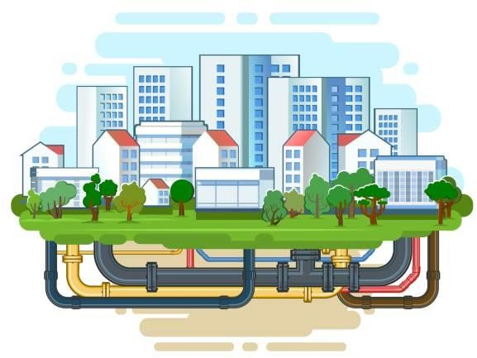

MODULE 1: PREPARING FOR SANITATION SAFETY PLANNING

Define the SSP area and lead organization
Dehiwala-Mount Lavinia is an urban area located in the Western Province of Sri Lanka. Situated to the south of the Colombo Municipal Council area, it is separated from Colombo by the Dehiwala canal, which forms the northern boundary of the Dehiwala-Mount Lavinia Municipal Council (DMMC). The southern boundary of this area is defined by Borupana Road, while the eastern boundary is marked by the Weras Ganga and its canal system, including some areas to its east such as Pepiliyana, Gangodawila, and Kohuwala.
Dehiwala-Mount Lavinia, a suburb of the Colombo Metropolitan Area, operates under a Municipal Council form of government. The area includes two Divisional Secretariats: Dehiwala and Ratmalana. Law enforcement is managed by the Sri Lanka Police, under the Ministry of Defence, with local coordination among three police stations: Dehiwala, Mount Lavinia, and Kohuwala. Judicial matters are handled by the magistrate court for criminal cases and the district court for civil cases.
Dehiwala-Mount Lavinia, with a population of 245,974 as of the 2012 census, comprises approximately 65,000 households, averaging around 3.8 people per household. The area boasts a high literacy rate, typical of urban regions in the Western Province, where literacy rates exceed 90%, reflecting the strong educational infrastructure. Ethnically diverse, the population includes Sinhalese, who are the majority, alongside significant minorities of Tamils (both Sri Lankan and Indian), Muslims (Moors), and smaller communities of Burghers, Malays, and others. Socio-economically, Dehiwala-Mount Lavinia presents a varied landscape with affluent neighborhoods, middle-class residential zones, and lower-income communities. The coastal proximity and rapid urbanization have led to development and gentrification in some areas, while others still face challenges such as inadequate housing and infrastructure.
Vulnerable communities within this suburb include low-income households and informal settlers, highlighting the need for targeted social and economic support in the sanitation safety plan.
The town has seen extensive population growth and rapid industrialization and urbanization in recent years. This region is characterized by a mix of residential, commercial, and recreational zones, with a significant emphasis on tourism due to its coastal location and popular beaches. This area lies along the Galle Road artery, a major coastal route running south of the country, further facilitating its urban and economic development.

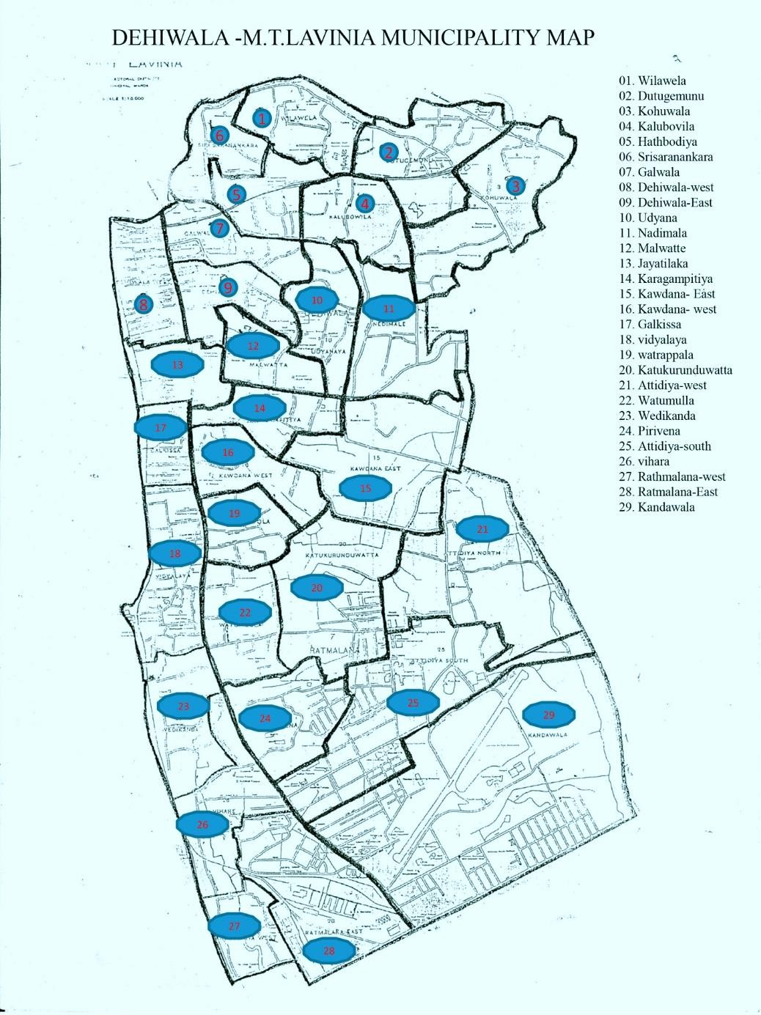

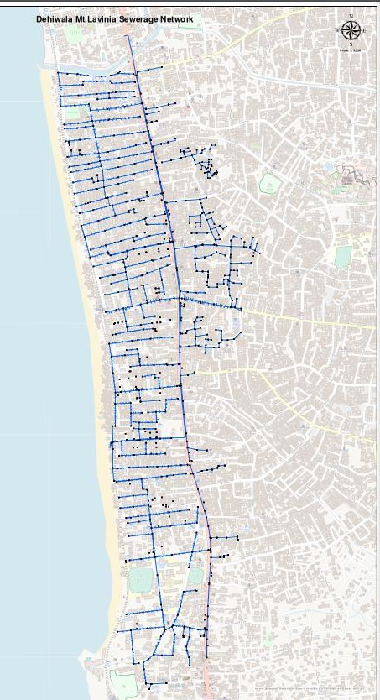

Main sources of household revenues and average income
In Dehiwala-Mount Lavinia, household revenues primarily come from employment in various sectors, with the service sector being a significant contributor. Many residents work in education, healthcare, finance, retail, and hospitality, leveraging the area's proximity to Colombo, the commercial capital of Sri Lanka. Trade and commerce also play a crucial role, with numerous small businesses and retail shops providing income for local families. The average household income reflects the urban setting, though it varies widely across different socio-economic strata. Despite its urban nature, there is limited agricultural activity in the region. Any agricultural practices are typically small-scale and may include home gardening or the cultivation of minor crops such as vegetables and fruits for personal use or local sale. The lack of extensive agricultural land in this densely populated urban area restricts significant agricultural pursuits.

Monthly average temperature,
Dehiwala-Mount Lavinia experiences a tropical rainforest climate, characterized by relatively consistent temperatures and significant rainfall throughout the year. The monthly average temperature hovers around 27°C (81°F), with minimal variation, ensuring warm and humid conditions year-round.
Precipitation is abundant, averaging approximately 2,400 mm annually. The region experiences two primary rainy seasons: the Southwest Monsoon from May to September and the Northeast Monsoon from October to February. The inter-monsoonal periods, particularly March to April, also see considerable rainfall. Despite the overall high humidity and rainfall, there are brief drier spells, typically in January and February, but these are short-lived and do not constitute a true dry season. This climatic pattern significantly influences local living conditions, urban planning, and infrastructure requirements, especially concerning sanitation and drainage systems.

Climate change scenario
Rainfall patterns are projected to shift, resulting in more intense and erratic precipitation events. Heavy monsoon rains could increase flood risks and strain urban drainage systems, while longer dry spells between rainfalls could challenge water management. . As a coastal urban area, rising sea levels are expected to intensify coastal erosion, leading to more frequent and severe flooding along the shoreline. Tidal action will likely become more pronounced, with higher tides and stronger waves exacerbating coastal defenses' vulnerability and potentially increasing saltwater intrusion into freshwater sources.

Prevalence of excreta-related diseases
Diseases such as diarrhea, dysentery, and cholera are prevalent. Hepatitis A and typhoid, which are transmitted through fecal-oral routes, also pose significant health risks. Additionally, parasitic infections, including worms, are observed.

Main water source and characteristics of the water supply.
The main water source is provided by the National Water Supply and Drainage Board (NWSDB), which supplies treated piped water to the área where they ensure it meets national drinking water standards before distribution

Assemble the SSP team
The Sanitation Safety Plan (SSP) for Dehiwala-Mount Lavinia is led by the National Water Supply and Drainage Board (NWSDB), with oversight from the manager of the Dehiwala-Mount Lavinia region. As the leading organization responsible for water supply and sanitation services in Sri Lanka, NWSDB plays a pivotal role in ensuring the provision of safe and sustainable water and sanitation infrastructure. The manager of the Dehiwala-Mount Lavinia region will serve as the SSP team leader, overseeing the implementation and coordination of sanitation safety measures tailored to the specific needs of the area. The team comprises professionals and experts dedicated to enhancing public health through effective sanitation practices, infrastructure management, and community engagement initiatives. Together, they work towards achieving comprehensive sanitation safety goals that address local challenges and promote sustainable development in Dehiwala-Mount Lavinia.

Organization | Job title | Role in SSP team
NWSDB | Manager Deh/Mt.Lavinia | Oversee SSP team operations in Dehiwala/Mt. Lavinia Coordinates with different organization  Allocation of budget and resources Attending b\public concerns
NWSDB | Engineer Civil | Implementation of the SSP Managing the sewer network. Attending the public concerns  Connecting more households and industries
NWSDB | Engineer Mechnical | Manage mechanical systems and equipment along with PPMs, Repairs and Upgrades
NWSDB | Network OIC | Attending to public complaints, Increasing the network coverage. Monitoring and managing the network
DMMC | Commissioner | Lead municipal coordination and policy-making. Enhancing the sanitation of the area  Allocation of budgets and resources
DMMC | PHI | Looking into health and sanitation related concerns Study disease patters and reporting  Conducting awareness programmes and health camps
DMMC | MOH | Looking into health and sanitation related concerns Study disease patters and reporting  Conducting awareness programmes and health camps Provides epidemiological data and expert input.
NWSDB | Sociologist | Addressing the social concerns Conducting awareness programmes
Police Station- Dehiwala | Officer | Conducting awareness programmes  Bringing public concerns to the SSP team Enforcing law where necessary
Police Station - Mt.Lav | Officer | Conducting awareness programmes Bringing public concerns to the SSP team  Enforcing law where necessary
Environmental Police | Officer | Conducting awareness programmes  Bringing public concerns to the SSP team Enforcing law where necessary
Gully service providing company | Owner | Representing the Gully service providing
NWSDB | Pump Operator | Actively engaging in implementing SSP
Industry in the area | Owner | Representing the industries in the area

DESCRIBE THE SANITATION SYSTEM
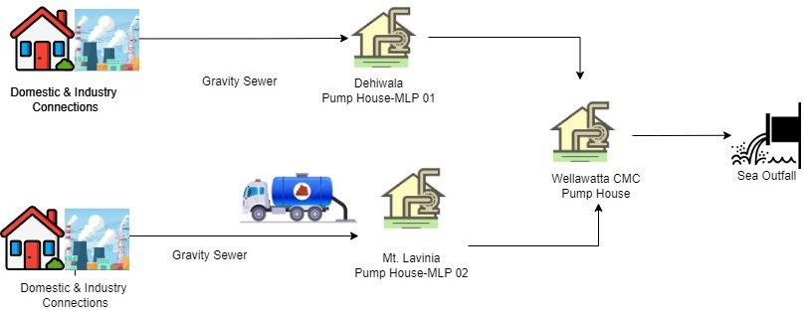
The sanitation system in Dehiwala-Mount Lavinia manages wastewater generated from households, commercial, and industrial entities through a comprehensive network. Waste flows into the public sewer system, where it is flows via gravity systems. In Mount Lavinia, wastewater gravitates towards MLP02 pump house before being pumped to CMC Pump house. Similarly, Dehiwala's gravity sewer system directs wastewater to MLP1, which then flows to the pump house in Wellawatta. Managed by the Colombo Municipal Council (CMC), this pump house facilitates the final discharge of wastewater into the sea through a long sea outfall . Additionally, vacuum emptier services operated by both the Dehiwala-Mount Lavinia Municipal Council (DMMC) and private companies aid in waste disposal, with discharge points available at MLP02 pump house for efficient management of sewage loads.
T3
P1
T3
T1
P1b
P2b
T2
P4
P3
T1
P2a
P1a

  - Characterize system flows

System flow code | Sanitation step | Description of the system flow | Key information of the system flow | Expected variations | Type of potential hazard
P1a & P1b | Generation of Wastewater Mt Lavinia and Dehiwala  in catchments | Wastewater generated from domestic, industrial, commercial, and public places | This includes black water, grey water, industrial wastewater with an average Ph value of 7, COD 650 of & BOD 300 | Variations in volume and composition | Biological, chemical, physical
T1 | Gravity network to collect sewer to pump houses | Wastewater generated at different places in the catchment is flow through gravity to pump houses. The network comprise of Interceptor Chambers at each premises and System Manholes along the network at least  in every 50m | The network consist of 40km of pipe laying, 1100 manholes connecting around 5500 premises to the system. Line diameters | Blockages, damages and infiltration | Biological, chemical, physical
T2 | Discharging vacuum  emptiers at MLP02 discharge point | Wastewater in un-sewered area collected by  vacuum trucks and discharged at MLP2 by service providers registered in NWSDB | This includes black water, grey water, industrial wastewater | Variations in volume and composition
P2a | Operation at MLP 1 (Dehiwala) pump  stations. | Wastewater flows to the pump house is pumped to the CMC pump house | Three 90kw pumps are used to pump an average flow of 300000 cubic meters per  month | Variations in volume and pump  performances
P2b | Operation at MLP 2 (Dehiwala) pump  stations. | Wastewater flows to the pump house is pumped to the CMC pump house | Three 90kw pumps are used to pump an average flow of 300000 cubic meters per  month | Variations in volume and pump  performances
P2c | Screening | Wastewater is passed through a coarse screen and then a fine screen to prevent any large  objects entering the pumps and network | PPM has to be done periodically | Variations in volume and performances
P2d | Grit Removal | Grit that comes along the gravity lines and through vacuum emptiers is separated using a  grit classifier | PPM has to be done periodically | Variations in volume and performances
T3 | Pumping wastewater from pump houses to  CMC pump through force main | Wastewater is pumped from MLP1 & MP2 to CMC sea out fall | 560mm dia. HDPE pipes with a total length of 5 km. | Variations in volume and conditions of the pipes
P3 | Pumping to Sea Out  fall | Wastewater of MLP1, MLP2 along with  CMC area is pumped to the sea out fall | Pipe dia, of pipe taking 2km into the sea  to discharge | Variations in volume.
P4 | Sea outfall | Wastewater is discharged to sea in wellawatta | 2km in to the sea and discharge  parameters are BOD,COD,pH | Variations in test  results.

  - Identify exposure groups

U: Sanitation system users | L: Local community | W: Sanitation workers
WC: Wider community | F: Farmers | C: Consumers:

Sanitation step | Exposure Group ID | Who are the exposure groups? | How many are there? | What are they doing there? | What are they exposed to? | How often are they exposed to this?
P1a & P1b | U1 | Domestic Users |  | Using bathrooms, toilets | Bad odour ,Sewer Water | Rarely
P1a & P1b | U2 | Industrial Users |  | Using bathrooms, toilet, disposing industrial wastewater | Bad odour ,Sewer Water & industrial wastewater | Rarely
T2 | U3 | Gully Service providers (Drivers and support  staff) |  | Providing gully service | Bad odour ,Sewer Water & industrial wastewater | Daily
T1 | L | Local Community in Dehiwal & Mt.Lav areas |  | Residing | Bad odour ,Sewer Water &  industrial wastewater due to blocks & damages | Occasionally
T1,P2a,P2b,P2c,P2d | W1 | Pump Operators |  | Operating and cleaning Pump house | Bad odour ,Sewer Water, industrial wastewater, grit & screen waste | Daily
T1,P2a,P2b,P2c,P2d | W2 | O&M Workers |  | Block cleaning, cleaning and repairs in network | Bad odour ,Sewer Water, industrial wastewater, grit & screen waste | Daily
T1,P2a,P2b,P2c,P2d | W3 | M&E support workers |  | PPM, Repairs | Bad odour ,Sewer Water, industrial wastewater, grit & screen waste | Monthly
T2,P2a,P2b, | WC1 | Neighbouring community around the pump houses |  | Residing | Bad odour | Occasionally
P4 | WC2 | Fishermen in the sea out fall area |  | Fishing | Discharge water | Rarely
P2d | C1 | People who uses grit collected at Pump houses |  | Collecting grit collected | Grit | Once in three Months

  - Gather supporting information

Write down any information you will want to obtain to characterize the system. Indicate the source of the information. Record below:

Regulatory requirements | Demographics and land use patterns
System management and performance | Changes related to climate and weather

IDENTIFY HAZARDOUS EVENTS, AND ASSESS EXISTING CONTROL MEASURES AND EXPOSURE RISKS
  - Identify hazards and hazardous events

Component | Hazard Identification |  |  |  |  | Existing Control(s) |  | Risk Assessment |  |  |  |  |  | Comments justifying risk assessment, under current conditions or climate change scenarios, or
Component |  |  |  |  |  |  |  | Under current conditions |  |  |  | Under the most likely climate change
Component |  |  |  |  |  |  |  | L=Likelihood; S=Severity; R=Risk |  |  |  | “+”Increas e “- “  Decrease "=" Same
Sanitation step | Hazard identification |  |  |  |  | Existing controls
Sanitation step | Hazard Exposure event | Hazard type |  |  | Exposure route | Description of existing control | Validation of control | L | S | Score | R
Wastewater Generation Leaks & Overflowing of ICs &MHs | Vector breading | Physical, Biological | W,P |  | Vector borne with flies | PPM | observatio n | 3 | 8 | 8 | M | + | -
Wastewater Generation Internal leakages at bathroomsand toilets | Exposure to raw sewage | Biological | P |  | Skin contact | Awareness programmes | observatio n | 3 | 2 | 8 | M | + | -
T1 P2a & T2 :  Transmission of Wastewater Block | Exposure to raw sewage | Biological | W,P,G,I, C |  | Inadvertent ingestion Dermal contact | Use of PPE, including gloves, boots and waterproof clothing | observatio n | 5 | 4 | 20 | H | + | -

Clearance (IC, MH & Pipe lines) | Inhalation of toxic Gases/ Odour | Biological | W,P,G,I, C |  | Respiratory Tract | Confined space entry protocols, training,PPE, Gas detection systems, proper ventilation | observatio n | 3 | 4 | 12 | M | + | -
Clearance (IC, MH & Pipe lines) | Falls into Open Manholes, confine space | Physical | W,P,G,I, C |  | Skin contact | Proper covering of manholes, barriers, and warning signs | observatio n | 3 | 8 | 24 | H | = | =
Clearance (IC, MH & Pipe lines) | Traffic Hazards | Physical | W,P |  | Skin contact | Traffic control measures, reflective clothing, and proper signs | observatio n | 3 | 8 | 24 | H | = | =
Clearance (IC, MH & Pipe lines) | Equipment Hazards | Physical | W |  | Skin contact | Training for equipment operators, regular equipment maintenance, and safety checks | observatio n | 3 | 8 | 24 | H | = | =
Clearance (IC, MH & Pipe lines) | Collapse of Sewer Structures | Physical | W,C,P |  | Inadvertent ingestion, Skin contact, physical | Regular inspections and proper maintenance | observatio n | 2 | 16 | 32 | H | = | =
Clearance (IC, MH & Pipe lines) | Chemical Contaminant s | Chemical | W,G,I |  | Respiratory Tract | Hazard identification, proper handling procedures, and PPE | observatio n | 1 | 8 | 8 | M | = | =
T1 P2a & T2 :  Transmission of Wastewater Repair & Maintenance of | Exposure to raw sewage during repairs and PPMs | Biological | W,G,C,I, P |  | Inadvertent ingestion Dermal contact | Use of PPE, including gloves, boots and waterproof clothing | observatio n | 5 | 4 | 20 | H | + | -

Net work and Pumphouses including Screen cleaning, sand remval, M&E PPMs | Inhalation of toxic Gases/ Odour during repairs and PPMs | Biological | W, G,I |  | Respiratory Tract | Confined space entry protocols, training,PPE, Gas detection systems, proper ventilation | observatio n | 4 | 4 | 16 | H | + | -
 | Falls into Open Manholes, confine space during repairsand PPMs | Physical | W,C,P |  | Skin contact | Proper covering of manholes, barriers, and warning signs | observatio n | 3 | 8 | 24 | H | = | =
 | Traffic Hazards during repairs and PPMs | Physical | W,P |  | Skin contact | Traffic control measures, reflective clothing, and proper signs | observatio n | 2 | 8 | 16 | H | = | =
 | Equipment Hazards | Physical | W |  | Skin contact | Training for equipment operators, regular equipment maintenance, and safety checks | observatio n | 2 | 8 | 16 | H | = | =
 | Collapse of Sewer Structures | Physical | W,C,P |  | Inadvertent ingestion,Skin contact | Regular inspections and proper maintenance | observatio n | 2 | 8 | 16 | M | = | =
 | Chemical Contaminant s | Chemical | W,G,I |  | Respiratory Tract | Hazard identification, proper handling procedures, and PPE | observatio n | 1 | 8 | 8 | M | = | =
T1 P2a & T2 :  Transmission of Wastewater | Exposure to raw septage | Biological (Pathogens, helminth) | W |  | Inhalation Dermal contact | Use of PPE, including gloves, | observatio n | 5 | 4 | 32 | H
 |  |  |  |  |  |  |  |  |  |  |  | + | -

Loading, transporting and unloading | during loading | Chemical (heavy metal), Physical |  |  | Inadvertent ingestion | boots and waterproof clothing
Loading, transporting and unloading | Traffic Hazards | Physical | W,P |  | Skin contact | Traffic control measures, reflective clothing, and proper signs,competetant drivers | observatio n | 2 | 8 | 16 | H | = | =
Loading, transporting and unloading | Falls into Open Manholes, confine space( septic tanks | Physical | W,C,P |  | Skin contact | Proper covering of manholes, barriers, and warning signs | observatio n | 2 | 16 | 32 | VH | = | =
T1 P2a & T2 :  Transmission of Wastewater Overflowing of MHs due to intense rainfall | Exposure to raw sewage | Biological | W,G,C,I, P |  | Inadvertent ingestion Dermal contact | Awareness, Capacity enhancing | observatio n | 5 | 4 | 20 | H | + | -
T1 P2a & T2 :  Transmission of Wastewater Providing ne connecions & Extension projects | Exposure to raw sewage | Biological | W,G,C,I, P |  | Inadvertent ingestion Dermal contact | Awareness, Capacity enhancing | observatio n | 5 | 4 | 20 | H | + | -
 | Traffic Hazards | Physical | W,P |  | Skin contact | Traffic control measures, reflective clothing, and proper signs,competetant drivers | observatio n | 2 | 8 | 16 | H | = | =
 | Mechanical Hazards | Physical | W |  | Skin contact | Guarding of machinery, training, and regular maintenance | observatio n | 3 | 8 |  | H | = | =

P3 Preliminary Treatment Cleaning of Screens,remova l of grit, PPMs, Repairs | Exposure to raw sewage during repairs and PPMs | Biological | W,G,C,I, P |  | Inadvertent ingestion Dermal contact | Use of PPE, including gloves, boots and waterproof clothing | observatio n | 4 | 4 | 16 | M | + | -
 | Inhalation of toxic Gases/ Odour during repairs and PPMs | Biological | W, G,I |  | Respiratory Tract | Confined space entry protocols, training,PPE, Gas detection systems, proper ventilation | observatio n | 3 | 4 | 12 | M | + | -
 | Health risk due to exposure to grit, wastewater during grit removal | Physical, Chemical, Biological | W |  | ingestion Inhalation | Introduce PPE issuance/Conductin g Awareness programs | observatio n | 2 | 4 | 12 | M | = | =
 | Health risk due to exposure to dried sludge or solid waste | Chemical (heavy metals), Biological (Pathogens), Physical | W,U |  | Dermal contact Inadvertent ingestion | Use of PPE, giving awareness | observatio n | 3 | 4 | 12 | M | = | =
P3 Preliminary Treatment Sample collectiong | Inhalation of aerosol | Biological, Chemical | W |  | Inhalation | Introduce PPE issuance/Conductin g Awareness programs | observatio n | 3 | 4 | 8 | M | + | -
P3 Preliminary Treatment Sample collectiong | Exposure to raw sewage | Biological | W,G,C,I, P |  | Inadvertent ingestion Dermal contact | Use of PPE, including gloves, boots and waterproof clothing | observatio n | 4 | 4 | 16 | H | + | -
P3 Preliminary Treatment Sample collectiong | Trips, Slips and Falls | Physical | W,C,P |  | Skin contact | Proper covering of manholes, barriers, and warning signs | observatio n | 4 | 8 | 32 | H | = | =

P3 Preliminary Treatment  Grit Removal | Health risk due to exposure grit during loading, transporting and unloading and at dryingbed operations | Physical(odor)  , Chemical, Biological | W |  | Dermal contact Inhalation Inadvertent ingestion | Use of PPE, including gloves, boots and waterproof clothing | observatio n | 3 | 8 | 32 | H | = | =
P3 Preliminary Treatment Usage of dgrit by external parties | Health risk due to exposure to grit | Chemical (heavy metals), Biological (Pathogens), Physical | W,U |  | Dermal contact Inadvertent ingestion | Use of PPE, giving awareness | observatio n | 3 | 4 | 12 | M | = | = | =
P5 Outfall | Not complying to the standards ( Affecting the ocean ecosystem) | Biological |  |  |  |  |  | 2 | 4 | 8 | M | = | =
P5 Out fall Sample collectiong | Inhalation of aerosol | Biological, Chemical | W |  | Inhalation | Introduce PPE issuance/Conductin g Awareness programs | observatio n | 3 | 2 | 8 | M | + | -
P5 Out fall Sample collectiong | Exposure to treated sewage | Biological | W,G,C,I, P |  | Inadvertent ingestion Dermal contact | Use of PPE, including gloves, boots and waterproof clothing | observatio n | 3 | 2 | 6 | M | + | -
P5 Out fall Sample collectiong | Trips, Slips and Falls | Physical | W,C,P |  | Skin contact | Proper covering of manholes, barriers, and warning signs | observatio n | 4 | 8 | 32 | H | = | =

P5 Out fall Effluent reuse at plant for cleaning of machineries, vacuum trucks, sucker pump, jetting machine | Health risk due to exposure effluent during cleaning | Biological (Pathogens, helminth) Chemical (heavy metal), Physical | W |  | InhalationDerma l contact | Use of PPE, including gloves, boots and waterproof clothing | observatio n | 3 | 4 | 6 | L | = | =
P5 Out fall Repairs and maintenance in dischage line | Exposure to effluent | Biological | W |  | Inadvertent ingestion Dermal contact | Use of PPE, including gloves, boots and waterproof clothing | observatio n | 3 | 4 | 12 | M | = | =
P5 Out fall Repairs and maintenance in dischage line | Trips, Slips and Falls | Physical | W |  | Skin contact | Proper covering of manholes, barriers, and warning signs | observatio n | 4 | 8 | 32 | H | = | =

DEVELOP AND IMPLEMENT AN INCREMENTAL IMPROVEMENT PLAN

Consider options to control identified risks
For each hazardous event prioritized, analyze the possible control measures using the following table:

Step of the sanitation service chain:
Description of the hazardous event: Exposure to raw sewage
Exposure group:
Improvement options
Option of new or modified control measures for this hazardous event | What is the likely effectiveness of this  control measure option? | What is the level of resources required? | To what extent will this control measure be effective under the most likely climate change scenarios? | Comments/ | Priority for improvement plan
 | (High, medium, low) | (Including financial, human resources, political support: high,  medium, low) | (Effective, ineffective, detrimental) | discussion | (Immediate, short term, medium term, long term)
Purchasing Chest wadders and full body safety kits | High | Medium | Effective |  | Immediate
Step of the sanitation service chain:
escription of the hazardous event: Falls into Open Manholes, confine space
Exposure group:
Improvement options
Option of new or modified control measures for this hazardous event | What is the likely effectiveness of this  control measure option? | What is the level of resources required? | To what extent will this control measure be effective under the most likely climate change scenarios? | Comments/ | Priority for improvement plan
 | (High, medium, low) | (Including financial, human resources, political support: high,  medium, low) | (Effective, ineffective, detrimental) | discussion | (Immediate, short term, medium term, long term)
Purchasing of safety harnesses & confine space entry tripod | High | Medium | Effective |  | Immediate

Step of the sanitation service chain:
escription of the hazardous event: Traffic Hazards during repairs and PPMs
Exposure group:
Improvement options
Option of new or modified control measures for this hazardous event | What is the likely effectiveness of this control measure  option? | What is the level of resources required? | To what extent will this control measure be effective under the most likely climate change scenarios? | Comments/ | Priority for improvement plan
 | (High, medium, low) | (Including financial, human resources, political support: high,  medium, low) | (Effective, ineffective, detrimental) | discussion | (Immediate, short term, medium term, long term)
Purchasing of night lights, cones and sign boards | High | Medium | Effective |  | Immediate
Step of the sanitation service chain:
escription of the hazardous event: Collapse of Sewer Structures
Exposure group:
Improvement options
Option of new or modified control measures for this hazardous event | What is the likely effectiveness of this  control measure option? | What is the level of resources required? | To what extent will this control measure be effective under the most likely climate change scenarios? | Comments/ | Priority for improvement plan
 | (High, medium, low) | (Including financial, human resources, political support: high, medium, low) | (Effective, ineffective, detrimental) | discussion | (Immediate, short term, medium term, long term)
Conduct structural integrity assessments, reinforce vulnerable structures,Implement regular inspection and maintenance | High | High | Effective |  | Long term

Step of the sanitation service chain:
escription of the hazardous event: Risk of exceeding plant capacity due to Increased Intensity and Frequency of Storm Events
Exposure group:
Improvement options
Option of new or modified control measures for this hazardous event | What is the likely effectiveness of this control measure  option? | What is the level of resources required? | To what extent will this control measure be effective under the most likely climate change scenarios? | Comments/ | Priority for improvement plan
 | (High, medium, low) | (Including financial, human resources, political support: high,  medium, low) | (Effective, ineffective, detrimental) | discussion | (Immediate, short term, medium term, long term)
Operating the second train and commencing stage 2 of the plant, Implement regular inspection of sewer lines for  infiltration | High | High | Effective |  | Long term
Step of the sanitation service chain:
escription of the hazardous event: Inhalation of toxic Gases/ Odour
Exposure group:
Improvement options
Option of new or modified control measures for this hazardous event | What is the likely effectiveness of this  control measure option? | What is the level of resources required? | To what extent will this control measure be effective under the most likely climate change scenarios? | Comments/ | Priority for improvement plan
 | (High, medium, low) | (Including financial, human resources, political support: high,  medium, low) | (Effective, ineffective, detrimental) | discussion | (Immediate, short term, medium term, long term)
Purchase gas detection  systems, and respiratory protection equipment | High | High | Effective |  | Long term

  - Develop an incremental improvement plan

Improvement measure | Cost | Source of funds | Lead organization | Year 1 |  |  |  |  |  |  |  |  |  |  |  | Year 2 |  |  |  | Year 3
 |  |  |  | 1 | 2 | 3 | 4 | 5 | 6 | 7 | 8 | 9 | 10 | 11 | 12 | Q1 | Q2 | Q3 | Q4 | Q5 | Q6 | Q7 | Q8
Improvement measures to control Exposure to raw sewage
Purchasing Chest wadders | 60,000 | O&M | NWSDB
Purchasing full body safety kits | 500,000 | O&M | NWSDB
Improvement measures to control Falls into Open Manholes, confine space
& confine space entry tripod | 50,000 | O&M | NWSDB
Purchasing of confine space entry tripod | 500,000 | O&M | NWSDB
Improvement measures to control Traffic Hazards during repairs and PPMs
Purchasing of night lights, cones and sign boards | 150,000 | O&M | NWSDB
Improvement measures to control Collapse of Sewer Structures
Conduct structural integrity assessments, reinforce vulnerable structures,Implement regular inspection, maintenance and repairs |  | RH | NWSDB
Improvement measures to control Risk of exceeding plant capacity due to Increased Intensity and Frequency of Storm Events
Operating the second train of WWTP |  | RH | NWSDB
Commencing stage 2 of the plant |  | RH | NWSDB
Implement regular inspection of sewer lines for infiltration |  |  | NWSDB
Improvement measures to control isInhalation of toxic Gases/ Odour
Purchase gas detection systems |  | RH | NWSDB
Purchase respiratory protection equipment |  | RH | NWSDB

Monitor control measures and verify performance

Define and implement operational monitoring

Prioritized hazardous event | Sanitation step | Choose one control measure that will have a detailed operational monitoring plan
Exposure to raw sewage |  | Use of PPE, including gloves, boots and waterproof clothing
Falls into Open Manholes, confine space |  | Proper covering of manholes, barriers, and warning signs
Traffic Hazards during repairs and PPMs |  | Traffic control measures, reflective clothing, and proper signs,competetant drivers
Collapse of Sewer Structures |  | Regular inspections and proper maintenance
Risk of exceeding pump capacity due to Increased Intensity and Frequency of Storm Events |  | Infiltration Control
Inhalation of toxic Gases/ Odour |  | Confined space entry protocols, training,PPE, Gas detection systems, proper ventilation

For each prioritized hazardous event and their improvement measures, choose 1 improvement measure that should have an operational monitoring plan.

Operational monitoring plan
Operational monitoring plan for: |  | control exposure to raw sewage
Operational limits | Operational monitoring of the control measure: |  | Corrective action when the operational limit is exceeded
Operational limits | Control measure:
100% compliance to use of PPE, including gloves, boots and waterproof clothing | What is monitored? | Whether Safety practices are followed | What action is to be taken? | Provide training and awareness, impose panelties
 | How is it monitored? | Random Inspection | What action is to be taken? | Provide training and awareness, impose panelties
 | Where is it monitored? | onsite | Who takes the action? | Eng/OIC
 | Who monitors it? | Eng/OIC | When is it taken? | Within a month
 | When is it monitored? | Weekly | Who needs to be informed of the action? | Manager
Operational monitoring plan
Operational monitoring plan for: |  | control Falls into Open Manholes, confine space
Operational limits | Operational monitoring of the control measure: |  | Corrective action when the operational limit is exceeded
Operational limits | Control measure:
100% compliance to safety protocols and SOPs | What is monitored? | Whether Safety practices are followed | What action is to be taken? | Provide training and awareness, Address the root cause
100% compliance to safety protocols and SOPs | How is it monitored? | Random Inspection | What action is to be taken? | Provide training and awareness, Address the root cause
100% compliance to safety protocols and SOPs | Where is it monitored? | onsite | Who takes the action? | Eng/OIC
100% compliance to safety protocols and SOPs | Who monitors it? | Eng/OIC | When is it taken? | Within a month

 | When is it monitored? | Weekly | Who needs to be informed of the action? | Manager
Operational monitoring plan
Operational monitoring plan for: |  | control Traffic Hazards during repairs and PPMs
Operational limits | Operational monitoring of the control measure: |  | Corrective action when the operational limit is exceeded
Operational limits | Control measure:
100% compliance to safety protocols and SOPs | What is monitored? | Whether Safety practices are followed | What action is to be taken? | Provide training and awareness, Address the root cause
100% compliance to safety protocols and SOPs | How is it monitored? | Random Inspection | What action is to be taken? | Provide training and awareness, Address the root cause
100% compliance to safety protocols and SOPs | Where is it monitored? | onsite | Who takes the action? | Eng/OIC
100% compliance to safety protocols and SOPs | Who monitors it? | Eng/OIC | When is it taken? | Within a month
100% compliance to safety protocols and SOPs | When is it monitored? | Weekly | Who needs to be informed of the action? | Manager
Operational monitoring plan
Operational monitoring plan for: |  | Collapse of Sewer Structures
Operational limits | Operational monitoring of the control measure: |  | Corrective action when the operational limit is exceeded
Operational limits | Control measure:
 | What is monitored? | Cracks, settlements | What action is to be taken? | Repair or srengthening the structures
 | How is it monitored? | Visual Inspections | What action is to be taken? | Repair or srengthening the structures
 | Where is it monitored? | On site | Who takes the action? | Eng/OIC
 | Who monitors it? | OIC/Eng | When is it taken? | Within a month

 | When is it monitored? | Monthly | Who needs to be informed of the action? | Manager
Operational monitoring plan
Operational monitoring plan for: |  | Risk of exceeding plant capacity due to Increased Intensity and Frequency of Storm Events
Operational limits | Operational monitoring of the control measure: |  | Corrective action when the operational limit is exceeded
Operational limits | Control measure:
 | What is monitored? | Flow levels, Infiltration percentages | What action is to be taken? | Operate By-pass route
 | How is it monitored? | Flow Meter readings, | What action is to be taken? | Operate By-pass route
 | Where is it monitored? | SCARDA | Who takes the action? | Eng/OIC
 | Who monitors it? | Technicians,OIC, Eng | When is it taken?
 | When is it monitored? | Daily | Who needs to be informed of the action? | Manager
Operational monitoring plan
Operational monitoring plan for: |  | Inhalation of toxic Gases/ Odour
Operational limits | Operational monitoring of the control measure: |  | Corrective action when the operational limit is exceeded
Operational limits | Control measure:
100% compliance to safety protocols and SOPs | What is monitored? | Whether Safety practices are followed | What action is to be taken? | Provide training and awareness, Address the root cause
100% compliance to safety protocols and SOPs | How is it monitored? | Random Inspection | What action is to be taken? | Provide training and awareness, Address the root cause
100% compliance to safety protocols and SOPs | Where is it monitored? | onsite | Who takes the action? | Eng/OIC
100% compliance to safety protocols and SOPs | Who monitors it? | Eng/OIC | When is it taken? | Within a month

 | When is it monitored? | Weekly | Who needs to be informed of the action? | Manager

MODULE 6: DEVELOP SUPPORTING PROGRAMMES AND REVIEW PLANS
STEP 6.1: Identify and implement supporting programs
Write in the box below two supporting programs that should be implemented in the framework of Sanitation Safety planning.

 | Supporting program 1 | Supporting program 2
Title of the program
Objective of the program | Awareness to NWSDB staff | Awareness to external Stakeholders
Description of the program | Awareness to NWSDB staff | Awareness to external Stakeholders
Key partners to implement the program | Make NWSDB staff aware about the SSP and train them on the procedures to follow | Make external stakeholders aware about the importance of SSP to the community and involve them with the  process.
 | Providing training and awareness on the safety  procedures to follow and records to maintain. | Involvement of external parties to implement the SSP
 | SSP Team | SSP Team

