

Sanitation Safety Plan For Kataragama Wastewater Treatment

System
Revision 0
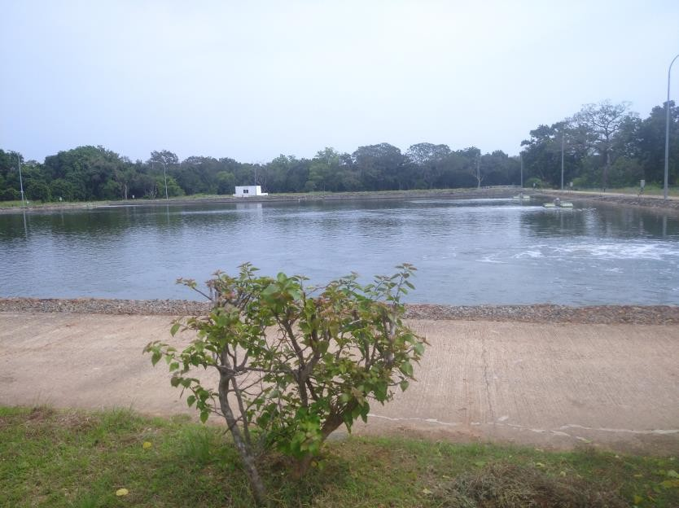
Prepared By: Sector Planning Section
Regional Support Center (Southern) &
Regional Managers office Hambanthota
National Water Supply and Drainage Board

May 2024

Table of Contents
- PREPARATION OF SANITATION SAFETY PLAN (SSP) 4
  - Objectives 4
  - System Boundary 4
  - Engage the community and assemble an SSP team 12
- SYSTEM DESCRIPTION 23
  - System Map 23
  - Waste Characteristics 44
  - Validation of Data 49
  - Compliance with Legal Requirements and Other Relevant Information 50
- IDENTIFICATION OF HAZARDOUS EXPOSURE EVENTS, ASSESSMENT OF EXISTING CONTROL MEASURES AND EXPOSURE RISKS 51
  - Identification of Hazard and Hazardous Exposure Events 51
  - Identification of Exposure Groups and Exposure Routes 51
  - Identification and Assessment of Existing Control Measures 52
  - Assessment and Prioritization of the Exposure Risks 53
- DEVELOPMENT AND IMPLEMENTATION OF AN INCREMENTAL IMPROVEMENT PLAN 68
- MONITORING OF CONTROL MEASURES AND VERIFICATION OF PERFORMANCE 73
  - Definition and Implementation of Operational Monitoring 73
  - Verification of System Performance 74
  - Auditing and External Assessment of the System 75
- DEVELOPMENT OF SUPPORTING PROGRAMS AND REVIEW OF PLANS 76
  - Identification and Implementation of Supporting Programs 76
  - Periodic Review and Update of the SSP Outputs 77

List of Tables

Table 1: List of Activities Included in the SSP 4
Table 2: The SSP Team Members NWS&DB Staff 15

Table 3: Steering committee 18
Table 4: Identification of stake holders for SSP 19

Table 5: Sewage Treatment Plant Components 34
Table 6: Waste Characterization and Potential Health Hazards 44
Table 7 Tolerance limits for the discharge of wastewater or effluent into inland surface waters 46

Table 8: Hazard Identification and Risk Assessment for Kataragama Wastewater Treatment System 57
Table 9: Hazard Identification and Risk Assessment for Kataragama LA’S Wastewater Treatment System 65

Table 10: Definition of Likelihood and Severity for Risk Ranking 54
Table 11 Risk Matrix for Risk Ranking 55

Table 12:Risk Category Description for Team-Based Descriptive Risk Assessment 56
Table 13: NWS&DB development plan 69

Table 14: NWS&DB Monitoring Plan 73
Table 15: NWSDB Monitoring Plan 74

Table 16: NWS&DB Supporting Programs 76

Abbreviation

BOD | Biochemical Oxygen Demand
CEA | Central Environmental Authority
CMR | Compliance Monitoring Report
COD | Chemical Oxygen Demand
DA | Department of Agriculture
FOG | Fat, Oil, and Grease
LA | Local Authority
MOH | Ministry of Health
NWSDB/ NWS&DB | National Water Supply and Drainage Board
PHI | Public Health Instructor
PPE | Personal Protection Equipment
PS | Pump Station
RSC | Regional Support Center
RSCS | Regional Support Center Southern
SSP | Sanitation Safety Plan
SSC | Sewer Service Connection
STP | Septage Treatment Plant
TP | Treatment Plant
TSS | Total Suspended Solids
UDA | Urban Development Authority
VT | Vacuum Truck
VTU | Vacuum Truck Unit
WR | Water Reclamation
WWTP | Wastewater Treatment Plant
WWTS | Wastewater Treatment System

Introduction
In today’s increasing number of challenges brought about by the impacts of human diseases due to the scarce or improper use of sanitation facilities, communities must establish a system to address these challenges and limit the effects. Aside from the adequacy of sanitation facilities, situations such as inadequate containment, improper treatment and handling of excreta and wastewater need to be addressed as well as contribute to the problems. The National Water Supply and Drainage Board (NWS&DB) initiates the development of a Sanitation Safety Plan to cover the entire country. In line with this, Kataragama Sanitation Safety Plan is developed to ensure the safety of personnel related to sanitation activities in the Kataragama divisional secretariat.

Within Kataragama divisional Secretariat area wastewater is managed by 1) Kataragama Wastewater Treatment System (WWTS) operated by the National Water Supply and Drainage Board (NWSDB) and 2) Septage Treatment Plant (STP) operated by Kataragama Local Authority (LA). The coverage area includes Kataragama, Sellakataragama, Detagamuwa, Kandasurindugama, and Karavile Gramanialadhari divisions. This SSP was done for the above two wastewater management systems.

Kataragama WWTS is a combined sewerage and septage treatment facility, which receives sewage coming from the sewered areas of Detagamuwa, Kataragama, and Kandasurindugama areas and septage from the unsewered areas. The effluent processed in this facility is received by the Manik River, which eventually drains into the Indian Ocean. A proposal is made to sell the bio-solids to a third-party contractor in the future, which is currently used as fertilizer in the plant premises.

STP owned by the Kataragama LA accepts the septage transported from Vacuum Truck Units (VTU) from unsewered areas of the Kataragama division. Biosolids generated from the treatment process are sold as fertilizer to third-party buyers. Treated effluent is used to wet the solid waste in the adjacent composting plant.

With this SSP, NWS&DB aims to identify all potential hazards and quantify the risk associated with exposure to the sewage and septage collected as well as exposure to the end-products produced by the treatment facility, particularly the effluent and the dried bio-solids.

Definition of Terms

Biosolids – organic materials resulting from the treatment of sewage and septage sludge; residue generated during the treatment of domestic sewage and septage in a treatment facility
NWS&DB – National Water Supply and Drainage Board
Desludging — the process of cleaning or removing the accumulated domestic sludge or septage.
Dewatering — this is the process of reducing the moisture content of sludge to lessen the volume and odor, e.g. vacuum, filter, centrifuge, belt filter press, filter press, sludge drying beds, and lagoons.
Disinfection — this is the process of destroying pathogenic organisms either by physical (e.g. application of heat) or chemical (e.g. chlorine application) means.
Effluent – a general term denoting any wastewater, partially or completely treated, or in its natural state, flowing out of a manufacturing plant, industrial plant, or treatment plant.
Exposure— Contact of a chemical, physical or biological agent with the outer boundary of an organism (e.g. through inhalation, ingestion, or dermal [skin] contact).
Hazard—A biological, chemical, or physical constituent that can cause harm to human health Helminth— Helminths are a broad range of organisms that include intestinal parasitic worms: trematodes (flatworms, also commonly known as flukes, e.g. Schistosoma), nematodes (roundworms, e.g. Ascaris, Trichuris and the human hookworms) or cestodes (tapeworms, e.g. Taenia solium, the "pork tapeworm")
Influent – waste water flowing through the sewer lines/conveyance into a treatment plant
Pathogens – Disease-causing organisms (e.g. bacteria, helminths, protozoa, or viruses).

Risk – The likelihood and consequences that something with a negative impact will occur.
Septage - also known as Domestic Sludge or the solid particle of domestic sewage, which settles at the bottom of the sedimentation tank and is digested by anaerobic bacteria, purely from domestic sources, exclusive of industrial and hazardous wastes.
Sewage - or also known as Domestic Sewage — wastewater composed of raw liquid and solid waste coming from residential and commercial uses, exclusive of industrial and hazardous waste.

Wastewater – Septage and Sewage

PREPARATION OF SANITATION SAFETY PLAN (SSP)

Objectives

The NWS&DB SSP aims to mitigate any adverse health effects upon the exposure of workers, users, and community to the wastewater (sewage and septage) during collection and transport, treatment and disposal including maintenance activities.

System Boundary

The WWTS handles both sewage and septage from its customers. The sanitation system for this SSP is described in Figure 1. In this figure, the sanitation boundary is divided into 5 main components. Each of these components and the resulting waste streams are examined.
Within the identified boundary, all exposed groups and the associated health-risks are also identified. Table 1 lists the components and activities that define the SSP boundary.

Table 1: List of Activities Included in the SSP

Components/Activities | Lead Organization
1. Collection of sewage through the sewer lines | SSP Team (NWS&DB)
2. Receive septage through vacuum truck units  (VTUs) | Kataragama LA /Third-party vacuum  truck Owners
3. Treatment of wastewater at the TP | SSP Team (NWS&DB)
4. Repair and maintenance of sewer network | SSP Team (NWS&DB)
5. Repair and maintenance of VTUs | Kataragama LA /Third-party vacuum  truck Owners
6. Processing of biosolids | rd  SSP Team / Kataragama LA /3 party  contractor
7. Reuse of treated effluent | Kataragama LA

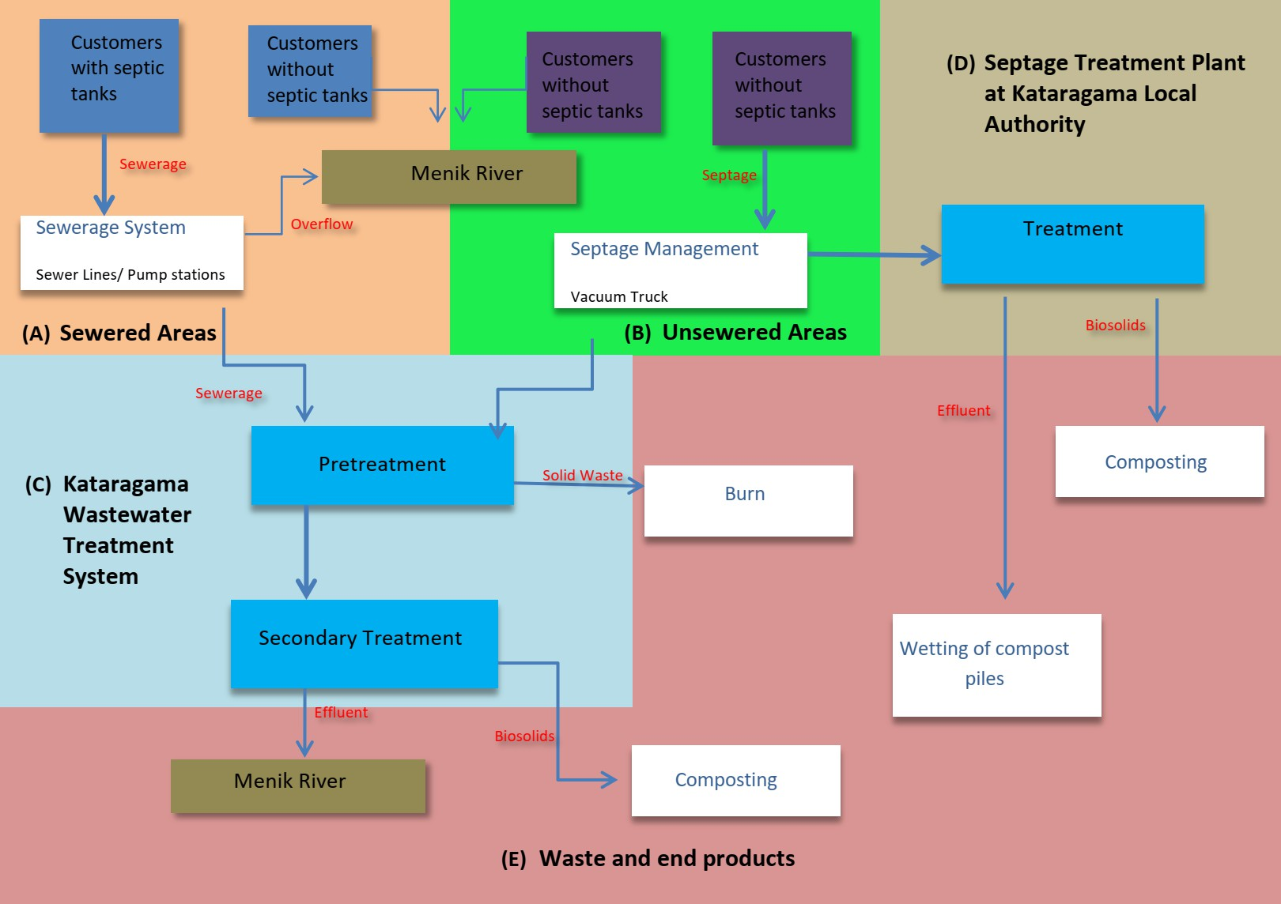

Figure 1: System Boundary for the Kataragama Sanitation Safety Plan

Sewered Areas

A total of 526 accounts are connected to the sewer lines of the Kataragama WWTS. Details of the consumers are attached in Annex II. These sewer lines are connected to 7 pump stations and 545 manholes spanning 8 kilometers of the sewer line. Figure 5 shows the new sewer network of sewered areas served by the WWTS. The old sewer network is under the mapping stage. A set of detailed drawings of the sewerage pipes network is attached in Annex IV.

However, given the extensive network of sewer lines in the area, there are still households in the area that are not connected to the system. These households were constructed after the sewer lines have been laid out and the households use temporary toilet facilities.

Unsewered Areas

In most unsewered areas, sewage is handled by septic tanks. Houses with septic tanks located in these areas are served by the 3rd party Vacuum Truck Unit (VTU) owners on request. As for households that have no septic tanks, the sewage is discharged directly to drainage Figure 3 shows the map of the served septage collection areas.

Kataragama WWTS does not provide the service of VTUs. However, it accepts loads from 3rd party VTU owners at a price. Kataragama LA owns two VTUs which transport septage to the treatment plant. The septage collection is not a routine process. Consumers request to empty their septic tanks when required.

Once the VTUs have reached the area, the personnel prepare the hose to be used, open the septic tank, and proceed with the desludging. Once desludging is finished, the personnel cover the septic tank. Sealing of the cover of the septic tank falls within the responsibility of the customer. The personnel moves to

desludging another septic tank until the VTU has reached its maximum capacity. The VTUs then proceed to the treatment plant where septage will be treated for proper disposal.

In addition to the Kataragama wastewater treatment plant, the septage treatment plant owned by Kataragama LA collects the septage from the above area using VTU owned by them.

Kataragama Wastewater Treatment System

The Kataragama Wastewater Treatment System (Figure 2) is a joint sewage and septage treatment plant located bound by the Yala forest. The treatment facility is designed to handle a total flow of 3,000m³/day of sewage coming from the 592 Square kilometers of sewerage area. Septage is treated along with the sewerage in the same process.

The facility is a waste stabilization pond system designed to treat incoming sewage and septage following the standards specified in The National Environmental Act, no. 47 of 1980.

Septage Treatment plant at Kataragama Local Authority

Kataragama LA manages the solid waste and the septage in two different plants located on the same premises. Solid waste is further categorized into groups at the solid waste treatment plant. Details of each category are given in Annex I. STP (Figure 3) treats septage from Kataragama into bio solids and treated effluent which is reused for wetting of compost piles.

Wastes and End-Products

Treatment Plant Effluent

The outfall of the facility is the Manik River downstream to the water intake for of Kataragama water treatment plant and bathing point of pilgrims of Kataragama Dewalaya.

An intake point for the drinking water treatment facility for The Sithulpawwa temple during the festival season is found 17 kilometers downstream of the effluent discharge point.

Dried Biosolids

The dried biosolids are used as fertilizer in the Wastewater Treatment Plant premises. There is a proposal to sell the bio-solids to a 3rd party contractor. The contractor will be selected through a tendering process. The selected contractor will transport the biosolids to make fertilizer.

Screenings and other Wastes

The screenings and other solid wastes that were removed from the mechanical pretreatment unit were collected in a bucket and burnt in a large pit within the premises. Grit and oil removed from primary treatment are disposed of directly into the ground.

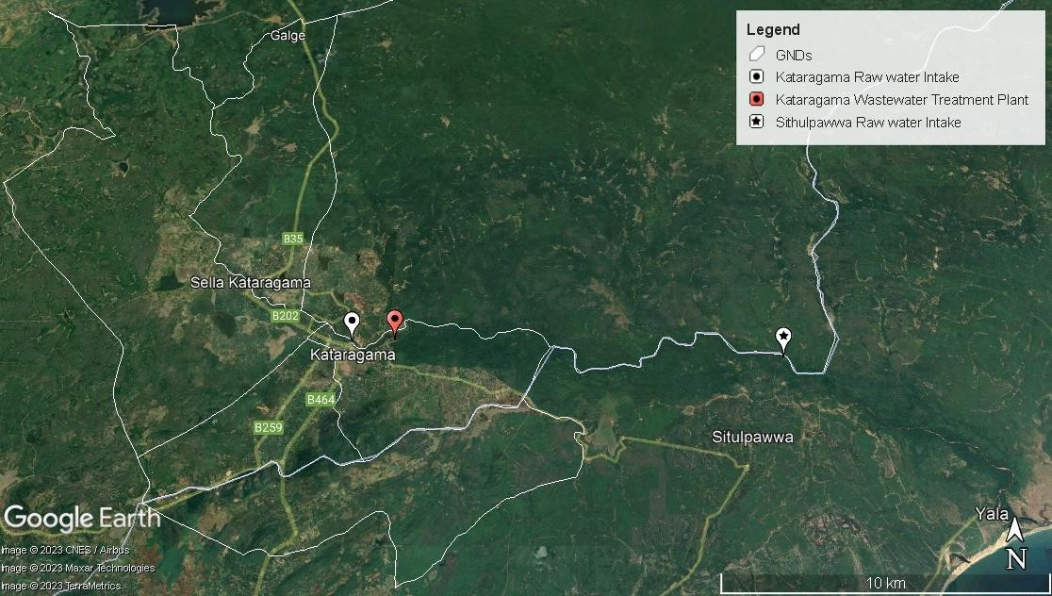
Figure 2: Location of Kataragama Wastewater Treatment Plant

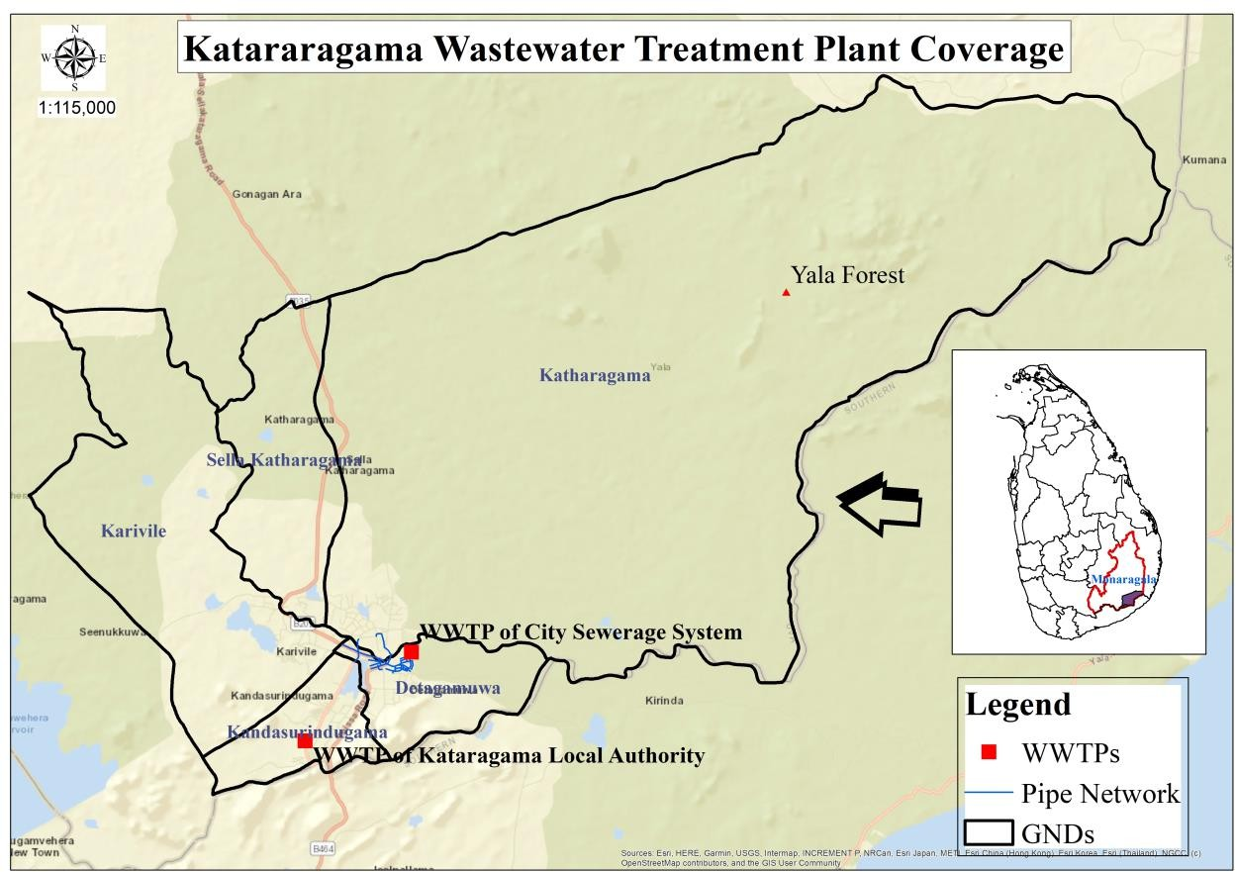
Figure 3: Coverage Area of Kataragama Wastewater Treatment System

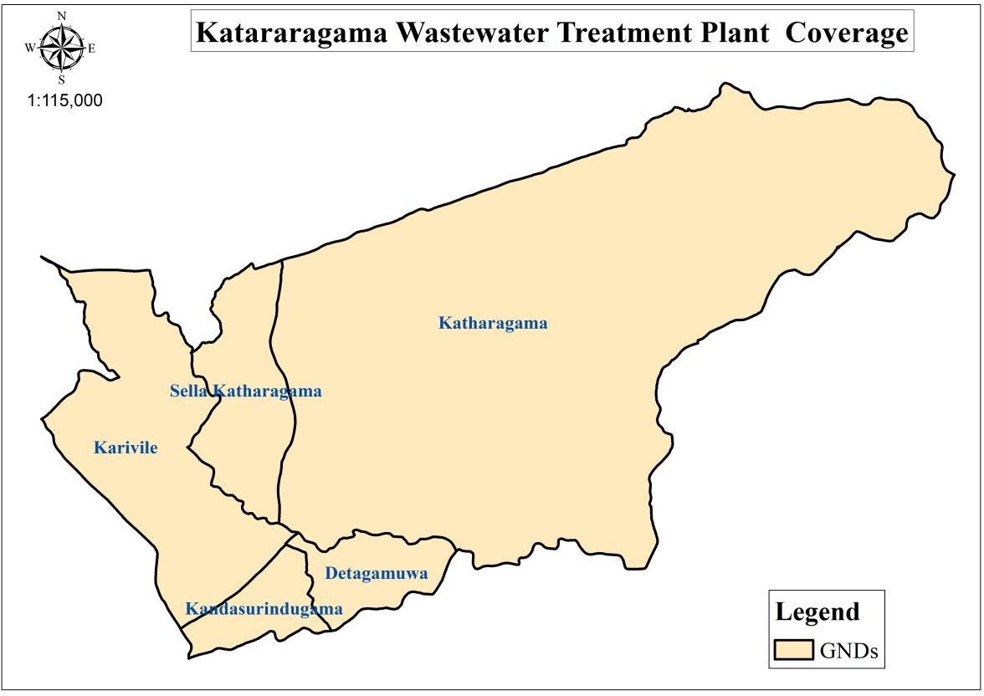
Kataragama Wastewater Coverage
Figure 4: Kataragama WWTS’s Septage Management Collection Area

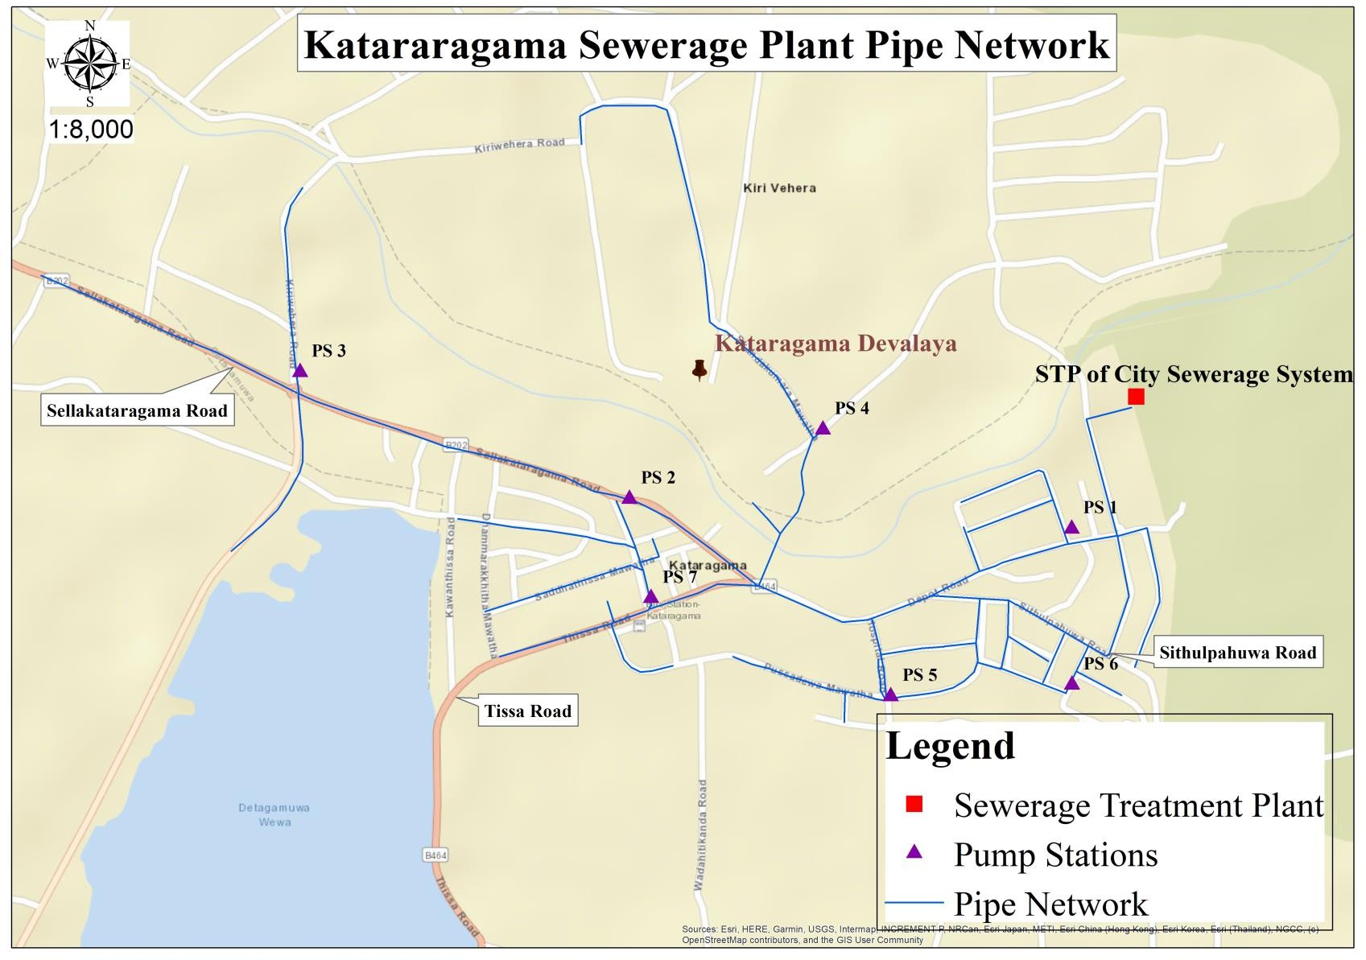

Figure 5: Sewer Network of Kataragama Wastewater Treatment System

(E) Exclusions in the System Boundary

The SSP has excluded some components that lack information. The leach field, internal house drains, and municipal drainage where the effluent of individual septic tanks discharges are not included.

The sizes, configurations, and conditions of the septic tanks in Kataragama are highly variable. Although there are existing prescribed national standards for septic tank design and construction, most tanks constructed in Kataragama are under-designed and not according to specifications. Most have leaching chambers while some still use leach drains for effluents, posing risks of contamination to groundwater, which is a source of water supply.

In addition, the third-party contractor who will buy the biosolids to make fertilizer and the users of the above fertilizer is not involved in the preparation of the SSP, and information on the products on which the fertilizer was used is limited. This will later be considered in the SSP once the contractor has been selected.

These compartments inside the SSP system boundary will not be included at this stage, but this may be re-visited in the future when enough information is collected and a wider range of participation is achieved.

Engage the community and assemble an SSP team
To ensure broad stakeholder commitment to design and implement the entire SSP process, the SSP team is assembled. In sanitation systems, this is particularly important, as responsibility along the sanitation chain is seldom the purview of one organization.

History of the team development

Since the SSP considers multiple exposure groups for microbiological, physical, and chemical hazards, NWS&DB alone could not guarantee proper implementation and execution of SSP. Hence, three teams were formed to coordinate SSP development, monitoring, and implementation.

1.3.2. Roles and responsibilities

Relevant officers of the NWS&DB were selected based on their field expertise for the preparation, monitoring implementing, and reviewing of the SSP for Kataragama WWTS as shown in table 2.

Assembling the SSP working team from NWS&DB

To ensure the continuous implementation and improvement of the SSP, an established SSP Team Hierarchy (shown in Figure 6) has been formed. The team is composed of regular staff from the various units of NWS&DB.

SSP Team

Advisory Committee

Internal External

WWTP of NW&SDB
SSP Team

Advisor
Stake Holders

Team Leader
District secretariat Grama Niladari
Medical officer of Health Wildlife Conservation Department
Forest Conservation Department
Police PSD
Team Leader of Kataragama LA’S SSP Team

Supervisors Special team Supervisors during Festival Season
Team

Team
Special team During Festival Season

Figure 6: SSP Team

Table 2: The SSP Team Members NWS&DB Staff

Name | Section | Title | Expertise | Strength to the  team | Contact  information
M. K. J.  Prabodini | Sector Planning Regional Support Center  Southern | Chief Engineer | -Planning of water distribution systems.  -Wastewater and  sanitation Engineering. | -Advisor of the team  -Leadership in the implementation of SSP | 0777707540
M.R.Malinda | Regional Manager’s Office, Hambantota | Manager (O&M) | -Expertise knowledge in saving energy expenses.  - Technical aspects of water supply, wastewater and drainage contextual  information. | -Team Leader  -Leadership in implementing SSP. | 0773364278
H.K.J.S. Lal | Regional Manager’s Office, Hambantota | Area Engineer (Hambantota) | Technical aspects of water supply, wastewater and drainage contextual  information | Technical guidance and supports to implementation of SSP and operation and Maintenance  of sewerage | 0712347444

Name | Section | Title | Expertise | Strength to the  team | Contact  information
 |  |  |  | scheme
M.A.C.  Piumika | Sector Planning, Regional Support Center  Southern | Engineer (WR- SP RSCS) | Sewerage Activities | Coordination among team members and preparation of SSP. | 0717588131
B. M. G.  Sasinda | Regional Office, Hambantota | Officer In Charge (Kataragama) | Operation and Maintenance of sewerage scheme | Operation and Maintenance of WWTP  (monitoring, recording,  reporting) | 0710470285
Namal Kulasekara | Regional Office, Hambantota | Officer In Charge (Thissa) | Operation and Maintenance of water supply scheme, Thissa | Monitoring overflow conditions and taking necessary actions to ensure the safety of downstream water  utilizers | 0762032514
K.A. C. M  Dulshika | Regional Office, Hambantota | Senior Chemist | Water Quality Management | -Wastewater Quality Specialist.  -Treatment process monitoring and controlling. | 0764193278

Name | Section | Title | Expertise | Strength to the  team | Contact  information
-Effluent quality
surveillance.
M. S.  Priyangani | Regional Office, Hambantota | Senior Sociologist | Social Coordination | Organizing awareness programs, meeting arrangements and building up a social  relationships. | 0718382356
K.K. Didulanka | Kataragama Wastewater Treatment plant | Plant Technician | Plant technical aspects | Handling day-to- day operations of the scheme and technical matters of the plant. | 0702996245
W.A. P. Lakmal | Kataragama Wastewater Treatment plant | Plant Technician | Plant technical aspects | Handling day-to- day operations of the scheme and technical matters of the plant. | 0711465375
L.W. M.  Wimukthi | Kataragama Wastewater Treatment plant | Plant Technician | Plant technical aspects | Handling day-to- day operations of the scheme and technical matters of the plant. | 0750995222

Identification of Steering Committee

An advisory committee was nominated (see table 3) to guide and arrange necessary financial support and higher management attention.

Table 3: Steering committee

Name | Section | Designation | Action | Contact  information
D. N. D. S.  Gunatileke | Water Reclamation Section | Additional General Manager | Provide expertise and knowledge of Arrange auditing  of SSPs. | 0773856724
K.G.N. Saman Kumara | Regional Support Center Southern | Deputy General Manager (Southern) | Auditing, Reporting for high management, and  guiding SSP. | 0777713294
G. D. N. Neville | Water Reclamation Section | Deputy General Manager (Water  Reclamation) | Provide expertise and knowledge of Arrange auditing of SSPs. | 0772918534
S. K. Samantha Kumara | Regional Support Center Southern | Assistant General Manager | Provide management assurance for the implementation of  SSP. | 0773493011
G.G. Sutharsan | Water Reclamation Section | Assistant General Manager | Auditing, Reporting for high management, and  guiding SSP. | 0777563656
L. K. M. C. B | Water | Specialist | Provide expert | 0764503487

Name | Section | Designation | Action | Contact  information
Jayawardana | Reclamation  Section | (Sewerage) | knowledge
M.K.J. Prabodini | Regional Support Center Southern | Chief Engineer Sector Planning | -Coordination with regional staff and higher management.  -Progress  reporting. | 0777707540

Identification of stakeholders

Since there is no neighboring community has SSP experience, we arranged the meetings with external supporters and ask about their experience. Furthermore, we arranged meetings with the relevant stakeholders to make them aware of the SSP.

Table 4: Identification of stake holders for SSP

Stakeholder’s organization | Job Title | Role with Team | Interaction Mechanism | Reference to contact details and record of the  interaction
District | Assistant | Coordination with the | Regular
Secretariat- | Commissioner | regional authorities | Meetings
Kataragama |  | regarding the | and field
 |  | implementation of SSP. | Inspections
District | Secretary | Coordination with the | Regular
Secretariat- |  | regional authorities | Meetings | Reference file no:
Kataragama |  | regarding the | and field | Projects/SSP/97

Stakeholder’s organization | Job Title | Role with Team | Interaction Mechanism | Reference to contact details and record of the  interaction
 |  | implementation of SSP. | Inspections
Local Authority- Kataragama | Secretary | Identification of sanitary requirements, especially in festival season, and provide facilities including assigning special teams during the festival  season. | Regular Meetings and field Inspections
SSP formulation (hazard and risk assessments) improvement & monitoring
planning/operation.
Department of wildlife conservation | Wild Life Officer | Complement and monitoring of the effluent quality to be compliance with the  regulations. | Regular Meetings and field Inspections | Reference file no:  RSCS/Projects/SSP/97
District Secretariat- Kataragama | Gramaniladhari | Monitoring and identifying sanitation requirements and providing awareness and support where  necessary. | Regular Meetings and field Inspections

Stakeholder’s organization | Job Title | Role with Team | Interaction Mechanism | Reference to contact details and record of the  interaction
Irrigation | Provincial | Compliance monitoring | Regular
department | Director | of irrigation regulations. | Meetings
 |  |  | and field
 |  |  | Inspections
Medical officer | Medical Health | Provide information and | Regular
of Health(MOH) | Officer | sampling on health- | Meetings
office |  | related issues. | and field
 |  |  | Inspections
Department of | Wild Life | Monitoring and | Regular
Wild Life | Officer | reporting violations of | Meetings
Conservation |  | their rules and | and field
 |  | regulations related to | Inspections
 |  | SSP.
Medical health | Public Health | Provide information and | Regular
officer’s office | Instructor | sampling on health- | Meetings
 |  | related issues. | and field
 |  |  | Inspections
Police - Kataragama | Officer in Charge | Monitoring and reporting violations of their rules and regulations interrelated  to SSP | Field Inspections | Reference file no:  RSCS/Projects/SSP/97
Urban Development Authority(UDA) | Director | Monitoring and reporting violations of their rules and  regulations related to

Stakeholder’s organization | Job Title | Role with Team | Interaction Mechanism | Reference to contact details and record of the  interaction
SSP and making
amendments

SYSTEM DESCRIPTION

The regional manager of Hambantota of NWS&DB district handles the provision of sewer service connections, maintenance and repair of the sewer network, handling of customer complaints, operation and maintenance of the wastewater facilities, and planning for sewerage coverage expansion. For the sanitation services, its main tasks include the provision of regular cleaning services of septic tanks, operation and maintenance of the septage treatment plant, handling customer complaints, fleet maintenance, and planning for sanitation coverage expansion.

Sewered areas are provided with sewerage services that include the installation of new sewer service connections, operation, and maintenance of sewage treatment facilities, conveyance systems, and the sewer network. On the other hand, areas that cannot be connected to the sewer lines, but have septic tanks, are provided with sanitation services that include desludging of septic tanks on request, as well as coordination works with the customers.

System Map

A. Kataragama Wastewater Treatment System

The system starts with households where wastewater is generated. Households are either connected to the sewer line (see Annex IV) or serviced by VTUs to enable the transport of the wastewater to the treatment plant. In addition to households, wastewater from commercial customers is accommodated as long as their waste is domestic in nature. This is verified through a field investigation of the commercial establishment. In areas where sewer lines are available, commercial establishments can be connected to the nearest sewer line and are required to have an oil and grease trap to prevent oil and grease to discharge to the sewer lines.

The treatment system of the Kataragama sewerage treatment Facility is a combination of preliminary treatment, secondary treatment, and disinfection. The capacity of the wastewater treatment system is 3000 m³/day.

The sludge cake is currently used within the premises and solid waste is burnt in a pit. The system map of the aforementioned activities is described in Figure 7 including the identified wastes generated by the system operations.

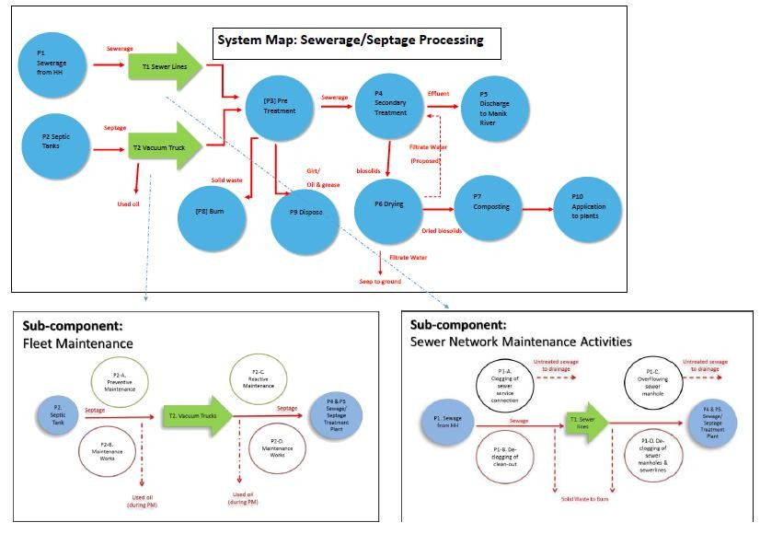
Figure 7: System Map

2.1.1. Septage and Sewerage Treatment

The sewerage flows through sewers to pumping stations under gravity flow. Since the collection to pump stations is free from human engagement, the risk of exposure to raw septage during collection is very unlikely. However, there can be situations of negative flow and the consumers can experience a raw septage flowing back to the houses. To prevent that raw water levels are monitored in real-time at pump stations and pumped the excess raw water to WWTS or another pump station.

During septage collection, both customers and sanitation workers may be exposed to pathogens and helminth risks either through dermal contact or inadvertent ingestion. Inhalation of fumes is also possible and may cause unease to customers and sanitation workers. The same risks may also be present during the overflow of sewer lines, sewer service connections, or sewer manholes.

[T1] Sewer Lines

The sewer network of Kataragama WWTS expands for 8 kilometers. Wastewater generated by consumers flows under gravity to sewer manholes which are connected to a Pumping Station (PS).

Kataragama Sewerage System consists of 7 pump stations as shown in Figure 2. The pump stations consist of an underground sump, a pump house, a generator room (optional), and a biofilter if the PS is located in a crowded location.

The influent is collected in underground sumps. The raw water levels are monitored using sensors and reported in real-time to the STP. When the raw water level rises and the STP requires more time for the treatment process, the pump stations automatically pump the water to the nearby pump PS to maintain the water levels. In case of all the pump stations and the STP are unable to accept the excess water from other pump

stations, an overflow pipe is diverted to the Manik river. Discharging the raw septage to the river leads to many events of risk. However, there are no such events reported in the past.

Pump stations 2 and 7 are located near the town and the PS 5 is near the hospital. To prevent malodors from the sump, biofilters are installed in those PSs. Other PSs provide about 4m high chimneys to expel the gases created in the sump. As an alternative source of power supply, generators were installed at PS 1 and PS 4. In addition to the fixed generators, a mobile generator is available.

In case of an overflow situation, the wastewater is directed to the Manik River to prevent wastewater from flowing back to households. Overflow lines are shown in Annex V. To avoid occurring of such situations water levels are monitored in real-time. By-passing of the baffle wall system for fast discharging of treated effluent is done as a preventive measure.

[P2, T2] Septage Collection

Septage is collected from the households in Kataragama, Sellakataragama, Detagamuwa, Kandasurundugama, and Karavile gramaniladhari divisions by VTU owned by a third party upon request by the households.

[P3 & P4] Wastewater Treatment

Wastewater is accepted by the treatment plant for stabilization and treatment to comply with National Environmental standards. The treatment process is composed of 3 major components; (i) Pretreatment, (ii) Secondary Treatment, and (iii) Disinfection.

- Pretreatment

Before the treatment, the wastewater is subjected to mechanical pretreatment as shown in Figure 8. The pretreatment system consists of two identical compact stations with a fine screen and aerated grit and grease chamber that allows the following functions.

Screening: The screen is designed to remove solids greater than 6 mm. The screenings are automatically transported by the screw to the screening press zone containing a washing facility and dropped into containers. This reduces the volume of screening and the organic matter is washed out from the screenings and gets back into the wastewater flow.

Aerated grit removal: Grit is removed to reduce the risk of damage to the mechanical equipment in the treatment unit. The settled grit is transfered to containers and disposed of to a pit within the premises.

Grease removal: The grease is removed to avoid non-aesthetic conditions caused by the volatile organics and malodorous floating sludge. The grease is scraped off to the grease collector and pumped to the container.

In normal operation, the incoming water flows completely to the compact unit and both units operate simultaneously. In case of failure of one compact unit, an alarm occurs and is automatically switched off.

- Secondary treatment

The pretreated water is led directly into a stabilization pond system consisting of 2 aeration lagoons and 2 maturation ponds as shown in Figure 9.

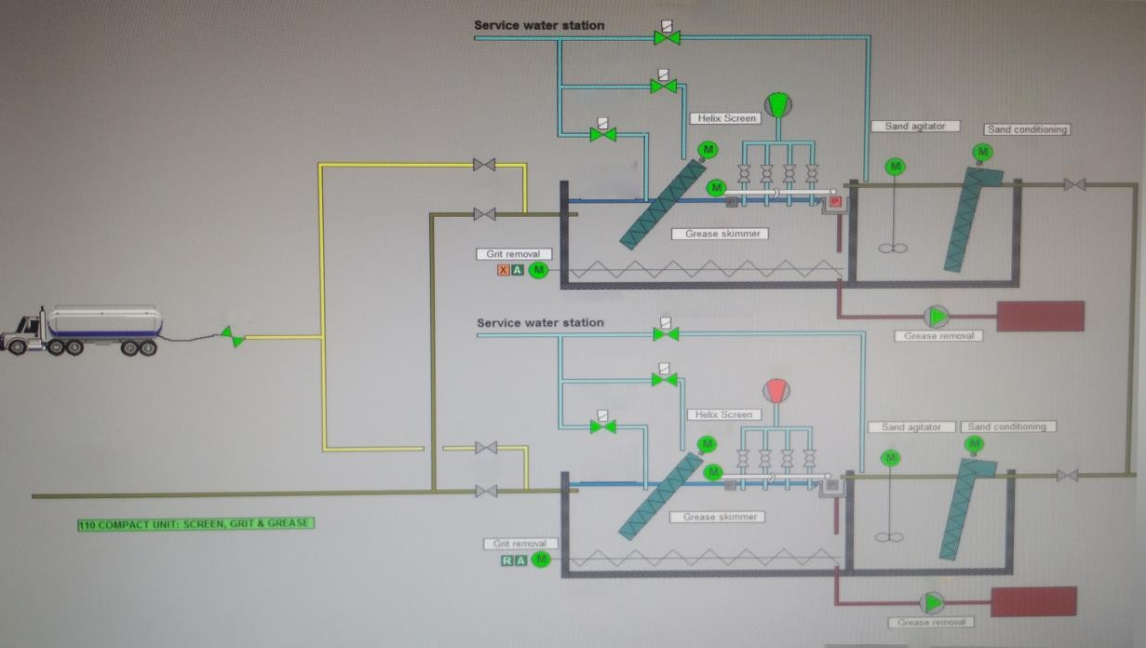
Figure 8: Wastewater Acceptance and Pretreatment

Aeration lagoon: Aeration lagoon 1 receives the effluent from pretreatment units and sludge drying beds. 6 surface aerators are installed along the long sides of the pond. After 1 month, cleared water is then transferred to the aeration lagoon 2 which is smaller in size, and 2 aerators are working.
The aeration lagoon operates under two loading conditions; pilgrimage season and outside the pilgrimage season.

Maturation pond: Downstream the aerated lagoon the effluent is split into two maturation ponds. In normal loading conditions, the retention time of maturation ponds lasts about 2 weeks. The detention time for the maturation pond is chosen to be at least 1 day at maximum flow situation with a removal efficiency of 85%.

To ensure equal inflow to each maturation pond, a distribution chamber is designed in each maturation pond distribution chamber with overflow weirs is designed.

In the inlet area of the maturation ponds, a deepened area further separated into 3 compartments is foreseen to concentrate the biomass at the area of the maturation ponds.

The effluent from the maturation pond is flown under gravity to the disinfection unit.
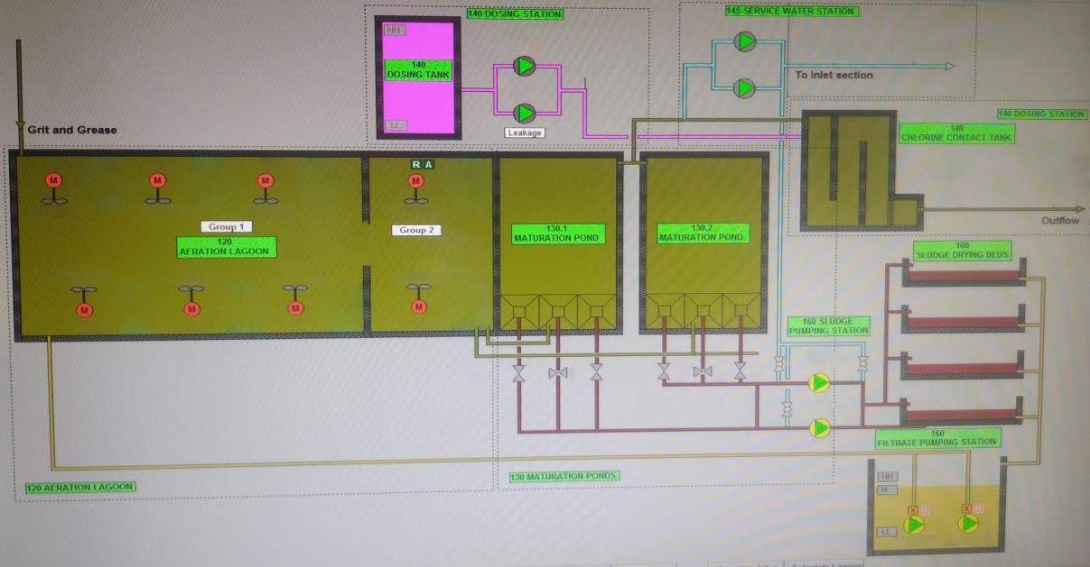
Figure 9: Secondary Treatment
- Disinfection

To achieve the effluent requirements regarding fecal bacteria, the biologically treated effluent is disinfected by dosing sodium hypochlorite. The cleared effluent was then transferred to holding for chlorine application.
The chlorination dosage is controlled by the flow measurement and the residual chlorine instrument. Sanitation workers can be exposed to concentrate NaOCl while adding bulk to the dosing tank.

When NaOCl is not available at the site Ca(OCl)₂ also known as bleaching powder is used for disinfection. Due to the accumulation of Ca in the system, Ca(OCl)₂ is added as a solution in a separate tank. Figure 10 shows the preparation and dosing of Ca(OCl)₂
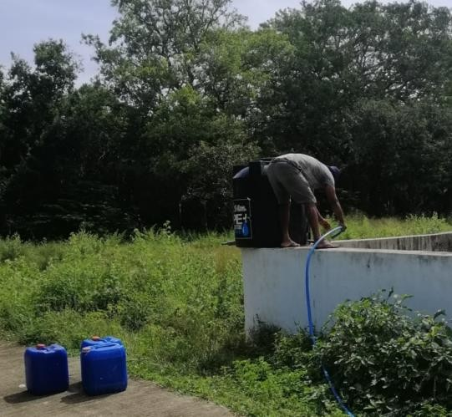
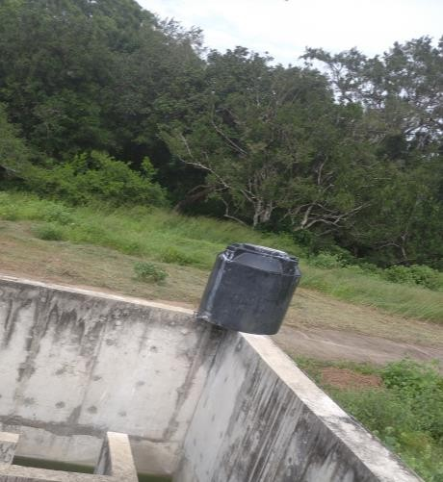
Figure 10: Manual Disinfection

The sludge is pumped to the sludge drying area once every 24 months. Sludge drying beds are not constructed under the first phase of the project. However, an area is allocated to construct the sludge drying beds under phase II of the project. Currently, shallow pits with a larger area dug in the ground are used for the sludge drying. This causes a risk of exposure to sludge while walking nearby.

The dried sludge cake is stored on the ground until they are used as fertilizer. In the future, the biosolids to be sold to a third party contractor to produce fertilizer.

Throughout the treatment, various waste streams can cause potential hazards such as the collected septage during sewer manhole declogging, solid wastes from the wastewater, and used oil from the VTUs as reflected in Table 5.

[P6, P7 & P10] Biosolids

Four sludge drying beds, each 100m² are proposed in the next phase of the project. Each drying bed will be equipped with a sludge feeding pipe and valve for sludge feeding and control of feeding. The filtrate water will be connected to a drainage system, which will be connected to the filtrate pumping station. The filtrate water will be transported back to the aerated lagoons for treatment.

However, the drying bed system is not yet installed in the treatment system. Drying beds are manually desludged once every two years (see Figure 11). Biosolids accumulated at the bottom of the maturation tank are pumped to four shallow pits dug into the ground. Effluent from biosolids soaks into the ground.

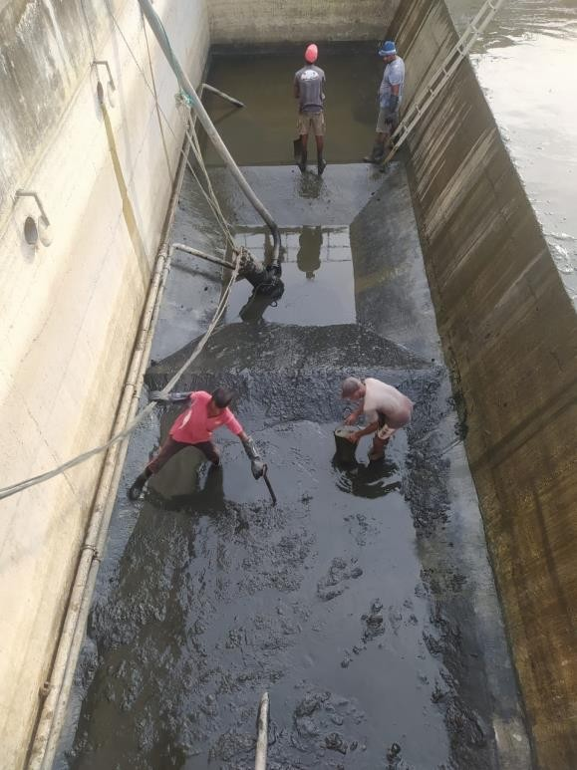
Figure 11: Manual Desludging
[P8] Solid Waste

Solid waste, oil, and grit contained in wastewater are separated in the pretreatment process and collected separately in 3 containers. Screenings collected are burnt in a pit within the plant premises. Collected oil and grit are disposed to a pit dug in the ground.

[P5] Effluent

The treated effluent is then discharged to the Manik River wich is popular as a bathing location among pilgrims of Kataragama Dewalaya before religious activities. Furthermore, the intake water for the Kataragama water supply scheme is taken from the Manik river. The effluent discharge location is located downstream of the above locations and the effluent is regularly monitored to ensure that it complies with the legal requirements for effluent discharge (see Section 2.4)

Table 5: Sewage Treatment Plant Components

Code | Equipment/Process | Purpose | Waste Streams and Potential Hazards
T1 | Sewer System | Sewer system allows wastewater from households to  flow into the treatment system | Exposure to sewerage while cleaning  the system.
T1 | Pumping stations | Sewerage flows under gravity to the pumping stations. The pump stations collect the water in a sump and pump  it to the treatment plant | Exposure to raw sewerage while maintenance
T2 | Vacuum Truck Unit | Equipment that collects and transports septage from | Exposure to raw septage leaks, used
T2 | (VTU) | customer’s septic tank to the treatment plant. This is | oil from VTUs and unsanitized hose
T2 |  | equipped with vacuum pumps that siphon the | may cause pathogen-related and
T2 |  | accumulated septage from the septic tank, and store it | helminth-related risks especially
T2 |  | temporarily in the holding chamber of the truck. | during desludging.
P3 | Mechanical | The pretreatment system used to recover solid wastes | Collected solid wastes, grits, and fine
P3 | Pretreatment Unit | from the septage stream. Macerators are washed and | sands are handled by the personnel,
P3 | (Compact unit) | conveyed into the solid waste bin. Grit, fine sand and | during maintenance operations,
P3 |  | metal chips are similarly recovered in the compact unit. | may contain pathogens.
P3 | Grit Trap | The Grit Trap provides maximum separation of heavy | Contamination with collected
P3 | Grit Trap | mineral solids while rejecting lighter organic solids, | Grit/sand
P3 | Grit Trap | which remain in the wastewater flow.
P3 | Oil and Water | Oil and grease present in the sewage are trapped in | Collected oil & grease Operation of oil

Code | Equipment/Process | Purpose | Waste Streams and Potential Hazards
 | Separator | the oil water separator tank. The floating grease and oil | and water separator is triggered by
 | Separator | are collected through oil pumps. | findings of higher oil and grease in the
 | Separator |  | influent.
P4 | Aeration Lagoon | Allow wastewater to mix with atmospheric air and | Exposure to sewerage while collecting
P4 | Aeration Lagoon | aerobic bacteria to digest the organic material in | samples. The operating personal
P4 | Aeration Lagoon | sewerage. | subjected to a crocodile attack.
P4 | Mixing Pumps | The mixing pumps ensure the oxygen dissolved in the | Exposure to sewerage
P4 | Mixing Pumps | wastewater. | Exposure to sewerage
P4 | Maturation Pond | Maturation ponds allow for further clarification of  biologically treated wastewater. | Exposure to sewerage
P4 & | Chlorine Contact | This is used to address the bacteria & pathogens | Exposure to sewerage and chlorine
P5 | Tank | effluent. | solution (in case of spillage)
P4 & | Chlorine Tank with | Homogenously mix the applied chlorine with the | Chlorine solution (in case of
P5 | Mixer | effluent to effectively disinfect the effluent before | spillage)
 |  | disposal to the receiving bodies of water.
P4 & | Chlorine Metering | The chlorine solution is gradually introduced in the | No waste stream, although some are
P5 | Pumps | system through chlorine metering pumps. | used for processing water. There is  the
 |  |  | the potential of inadvertent ross
P4 & | Transfer Pump | A sludge Transfer Pump is occasionally used to remove | No waste stream

Code | Equipment/Process | Purpose | Waste Streams and Potential Hazards
P5 |  | excess sludge from the maturation pond.
P1-D | Declogging of sewer | Removal of obstructions inside the main sewer pipe | Exposure to raw wastewater;
P1-D | lines | Lines. | inadvertent ingestion, inhalation &
P1-D |  |  | skin infection
P1-D | Declogging of sewer manholes | Removal of obstructions inside the sewer manholes | Exposure to raw wastewater;  inadvertent ingestion, inhalation & skin infection
P1-D | Cleaning of sewer | Removal of accumulated debris, sand, and grits inside | Exposure to raw wastewater;
P1-D | lines | the sewer pipelines to avoid future cloggings | inadvertent ingestion, inhalation &
P1-D |  |  | skin infection
P1-A | Sewer rods/Drain | Used for declogging of sewer lines and sewer service | Exposure to raw wastewater;
& P1- | cleaning machine for | connections | inadvertent ingestion, inhalation &
D | declogging |  | skin infection
T2 | Vacuum truck for | Used for declogging of sewer manholes | Exposure to raw wastewater;
T2 | declogging | Used for declogging of sewer manholes | ingestion, inhalation & skin infection
P2-A,  P2-B,  P2-C, P2- D | Fleet Maintenance | Maintain the Vaccum Truck Units used in the collection and transport of septage | Exposure to used oil, unsanitized hose, grits, and sand

Sewer Network Maintenance Activities
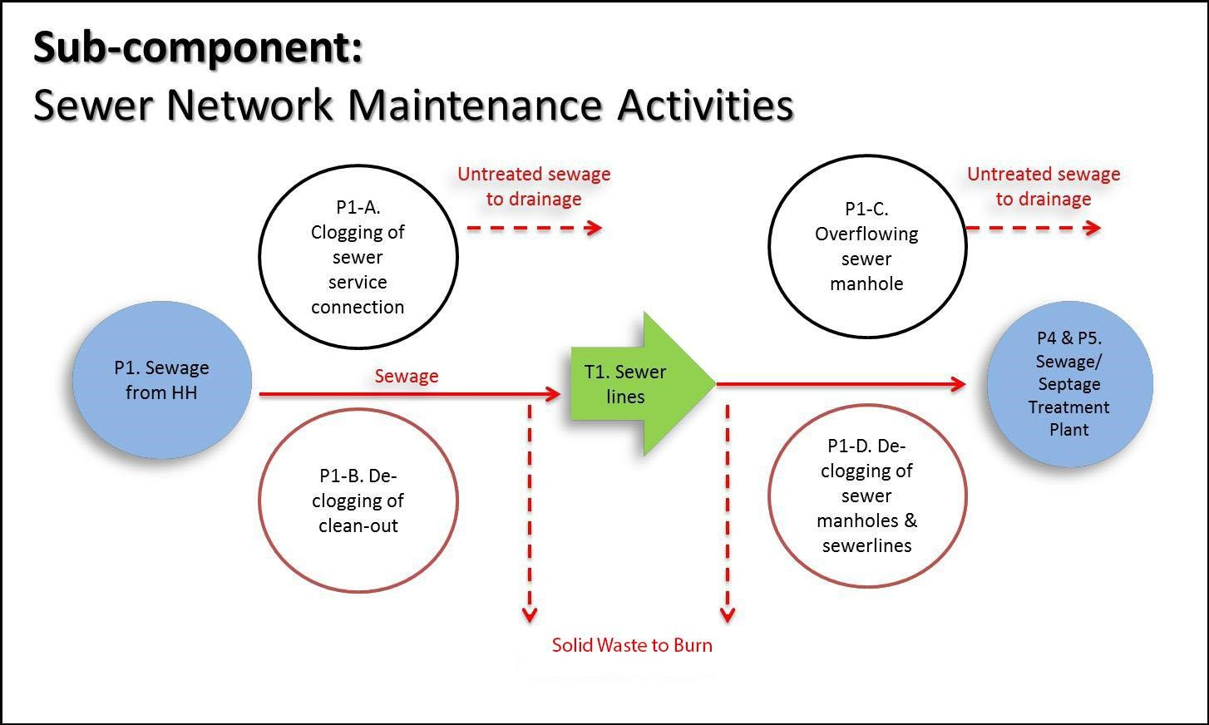
Figure 12: Expanded System Map for the Sewer Network Maintenance

Figure 12 shows the sub-components of the Sewer Network Maintenance Activities. The following maintenance services are provided to customers connected to the sewer lines:

(1) Declogging of their sewer service connection (SSC) from the cleanout outside their property. Customers within the sewered area that are not yet connected to the system are advised to connect to the system to avail of these services.

Clogging of SSCs and sewer lines (P1-A) and overflowing of sewer manholes (P1-C) is usually caused by obstruction inside the sewer system such as debris flushed into the water closet and solid waste dumped into the manholes. Declogging of SSC (P1-D) is carried out by the sewer maintenance personnel. During the same process, the maintenance personnel is exposed to pathogen and helminth risks through contact with

the raw septage present in the SSC. The same is also possible during the declogging of sewer lines and sewer manholes.

Regular preventive maintenance is also conducted to avoid the accumulation of debris inside the pipes. This will also maintain the efficiency and reliability of the existing network.

Fleet Maintenance
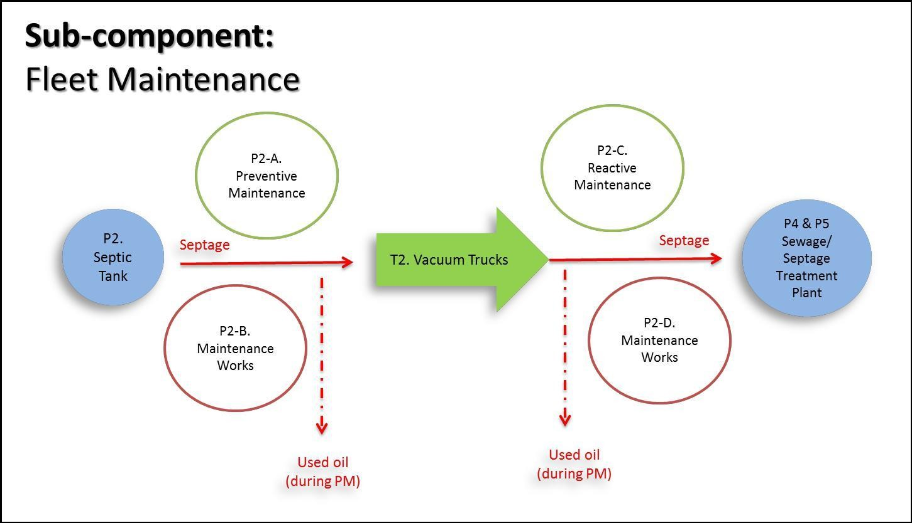

Figure 13: Expanded System Map for the Sewer Network Maintenance

VTUs used in the collection of septage is maintained by an in-house maintenance team (shown in Figure 13). Maintenance of this collection equipment is categorized into 1). preventive maintenance and 2). reactive maintenance.

Preventive maintenance (P2-A) is scheduled maintenance to ensure that the collection equipment is operating in its complete form. Vacuum pumps and engines are checked

together with the brakes, transmission, differential, lights, oils, belts, and other consumable and wear and tear-prone equipment.

Reactive maintenance (P2-C) of the collection equipment as requested by the driver. The driver identifies potential concerns that prevent them from effectively performing their function to collect and transport septage from the customer’s septic tank to the Kataragama septage treatment plant.

In both types of maintenance, personnel is exposed to pathogen and helminth risks due to the raw septage contained in the VTUs.

Kataragama Local Authority’s Septage Treatment Plant

The system starts from households where wastewater is generated that is serviced by VTUs. The capacity of the sewerage system is 30 m³/ day.

The sludge cake is sold as fertilizer and the treated effluent is used to wet the solid waste to support decomposing. The system map of the aforementioned activities is described in Figure 13.

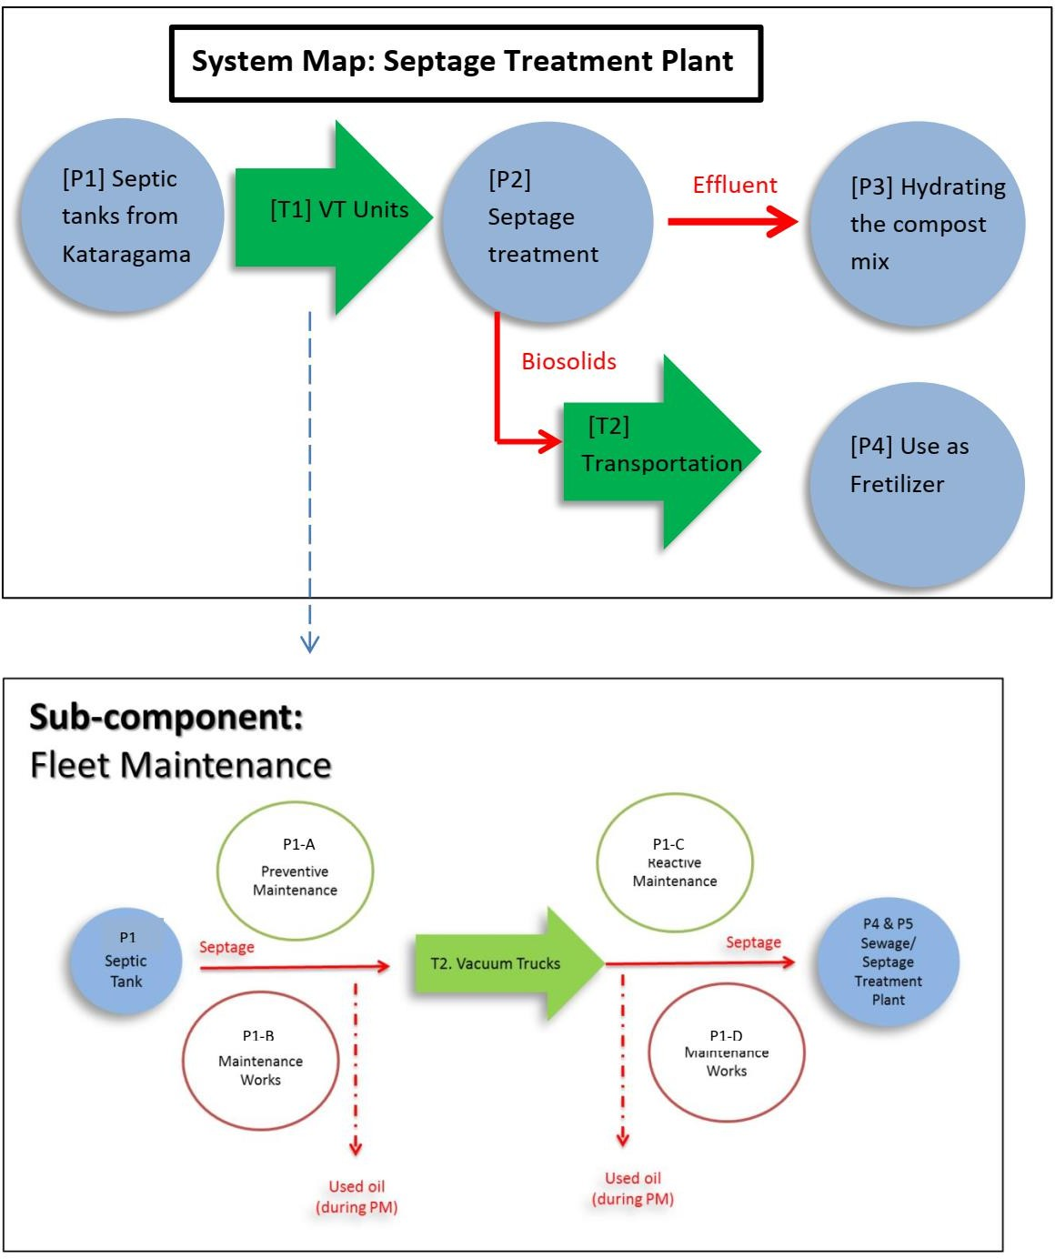
Figure 14 : System Map of Kataragama LA's STP

[P1, T1] Septage Collection

Kataragama Local Authority manages a separate STP that receives the septage from Kataragama, Sellakataragama, Detagamuwa, Kandasurundugama, and Karavile gramaniladhari divisions. Customers are mostly the households and hotels of the above area.

Kataragama Local Authority owns 4m³ and 2 m³ capacity VTUs and provides the service on request. An average of 3-4 loads per month receives at the treatment plant for treatment.

[P2] Septage Treatment

Treatment is done by a waste stabilization pond system as shown in Figure 14. Septage is unloaded to the receiving tank followed by two settling tanks. Effluent is directed to the treatment pond through a V notch. The treatment plant capacity is around 30 m³.

[P3] Treated Effluent

Treated effluent is led to the existing leachate collection pit to be reused to hydrate the compost piles of the solid waste treatment plant.

Seasonal Variation

During the Kataragama festival season around 1,000,000 people visit Kataragama Pooja City. To provide sanitary facilities for the pilgrims, about 100 mobile toilets are installed within the premises and provide a temporary connection to the sewer line connected to the pump station 4.

Every year, before the festival season starts (July/ August), the system is cleaned. Sucker, Jet, and Water bowser along with the operators are borrowed from the Zoysapura sewerage treatment plant for the purpose. All the manholes, sewer lines between, and pump stations are desludging and cleaned in the process which takes about 3 weeks.

During the festival season, Kataragama LA launches a special management plan covering the whole city. Kataragama LA hires around 300 temporary laborers and work supervisors during festival season to manage the crowd including their sanitary facilities. The sanitation team has to ensure there are enough clean sanitary facilities, handle the excess septage load, and watch and prevent open defecation all around the city. Mobile toilets are provided by Kataragama LA.

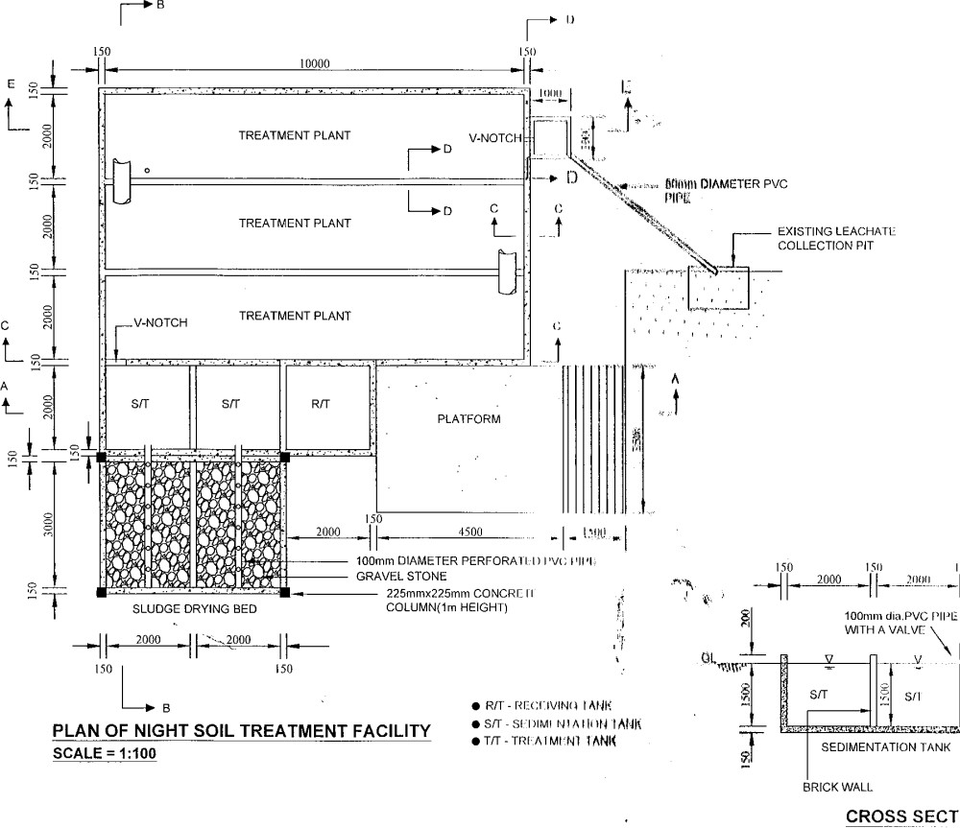

Figure 15: Plan view of Kataragama LA’s STP

Waste Characteristics

Upon completion of the system maps for each of the sanitation steps and based on the results of the characterization, the SSP Team initially identified the potential health hazards. Table 6 shows the summary of the wastes generated in the STP and the associated potential health hazards. The significant hazards are marked √ across the waste fraction identified.

Table 6: Waste Characterization and Potential Health Hazards

 |  |  |  |  |  | Chemical |  | Physical Hazards
 |  | Biological Hazards |  |  |  | Hazards
Component | Viruses | Bacteria | Protozoa | Helminths | Vector related diseases | Toxic chemicals | Heavy metals | Sharp objects | Inorganic material | Malodours
A. Septage and Sewage
Diluted Excreta | √ | √ | √ | √ |  |  |  |  | √ | √
Urine (human) | √ | √ | √ | √ |  |  |  |  |  | √
Solid Waste | √ | √ | √ | √ | √ |  |  | √ | √ | √
FOG (from | √ | √ | √ | √ |  |  |  |  | √ | √
domestic)
B. End Products (After Treatment)
Effluent | √ | √ | √ | √ | √ |  | √ |  | √ | √
Biosolids | √ | √ | √ | √

Influent

Average influent quality is presented in Table 7. These values will undergo treatment to comply with the prescribed limits of discharge of wastewater or effluent into Inland Surface Waters.

Effluent and End-Products

Kataragama STP’s wastewater samples are collected and analyzed at the in-house Process Laboratory located within the facility. Influent and effluent from the sewage treatment plant and raw septage and filtrate samples from the septage treatment plant are subjected to weekly analysis on the following parameters:

    - Biochemical Oxygen Demand (BOD)
    - Chemical Oxygen Demand (COD)
    - Total Suspended Solids
    - pH
    - Temperature

Biosolids produced from the septage treatment plant are subjected to moisture content analysis. In addition, analysis for risk factors such as soil conditioners is included in the verification monitoring plan.

The wastewater effluent characteristics are also tested monthly for compliance and reporting to the regulatory office/s.

Table 7 Tolerance limits for the discharge of wastewater or effluent into inland surface waters

Parameters | Influent quality | The National  Environmental Act
Biochemical Oxygen | 178 | <30 mg/L
Demand, mg/l BOD5 | 178 | <30 mg/L
Chemical Oxygen | 545 | <250 mg/L
Demand, mg/l COD | 545 | <250 mg/L
Total Suspended | 523 | 50
Solids, mg/l TSS | 523 | 50
Oil and Grease, mg/l |  | 10
pH | 7.3 | 6.0 – 8.5
Total Coliform, | >110000 | <150
MPN/100 mL | >110000 | <150
Residual Chlorine | - | 0.5 mg/L (min)

In terms of compliance, Kataragama STP consistently conforms to the National Environmental Act effluent standards for the discharge of wastewater or effluent into Inland Surface Waters (Figures 16 to 19). Regular proactive monitoring of wastewater quality is conducted to ensure environmental compliance.

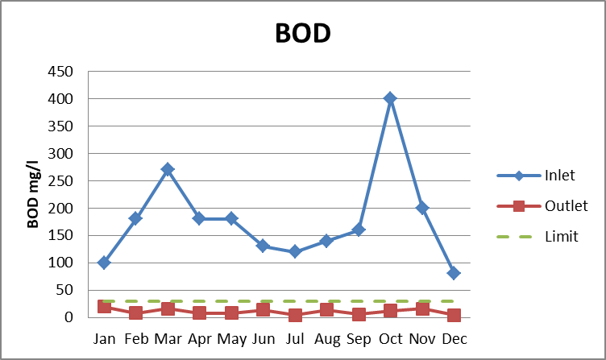
Figure 16: Monthly BOD Levels for Influent and Effluent

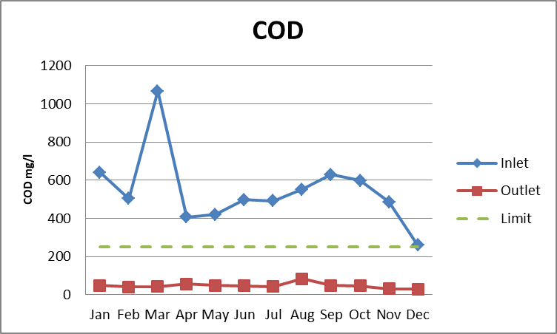
Figure 17: Monthly COD Levels for Influent and Effluent

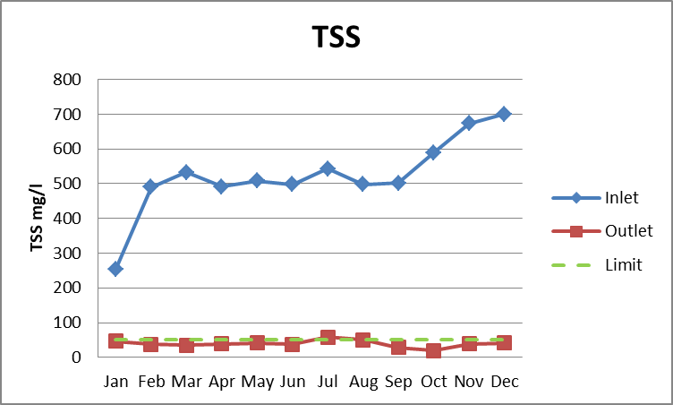
Figure 18: Monthly TSS Levels for Influent and Effluent

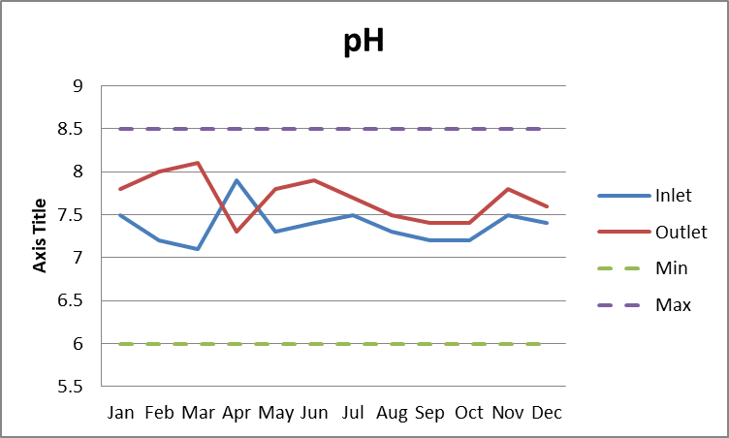
Figure 19: Monthly pH Levels for Influent and Effluent

Validation of Data

Sewer Network Validation

Field investigation is conducted to validate the conditions of the sewer network in the Kataragama Sewerage treatment facility. A walk-the-line inspection of the 8km of sewer line and 545 manholes are carried out by the maintenance personnel to see if there are infiltrations, damage, and clogging into the system. Preventive maintenance of the sewer network is carried out every year to ensure and maintain the reliability and efficiency of the system (Requires desludging). Accounts not connected are inspected for possible interconnection to the system while those that cannot be connected are scheduled for the desludging program.

The old pipe network used in the town area has practical problems in validation. Permanent structures like houses are built on top of the manholes of the sewer network making it difficult to maintain the system.

PH meters used in the plant are calibrated monthly. Other equipments used to measure influent and effluent parameters and sensors used to monitor online are not calibrated in a routine process at the moment.

Biosolids Handling

Biosolids generated at the Septage Treatment Plant are kept within the plant area and used as fertilizer for the plants grown within the premises.

Compliance with Legal Requirements and Other Relevant Information

The treated effluent of the Kataragama wastewater treatment system complies with the tolerance limits for the discharge of wastewater or effluent into inland surface waters of the National Environmental act, No 47 of 1980 / No. 1 of 2008 published in the Gazette Extraordinary No. 1534/18 of February 1, and the amendments.

The biosolids comply with Sri Lanka Standard, specifications for compost made from raw materials of agricultural origin (SLS 1635: 2019).

IDENTIFICATION OF HAZARDOUS EXPOSURE EVENTS, ASSESSMENT OF EXISTING CONTROL MEASURES AND EXPOSURE RISKS

Specifying each step in the system is essential in determining potential hazards and hazardous exposure events for the exposure groups. This leads to the assessment of the risks and the extent to which these are controlled. The result of this step in the SSP is to ensure that subsequent efforts and investments in system monitoring and improvements respond to actual rather than perceived health risks.

Identification of Hazard and Hazardous Exposure Events

The hazards and hazardous exposure events are identified for the different processes in the system (sewage collection, septage collection, treatment of septage, handling of biosolids, processing of biosolids into vermicast, and fleet maintenance). Table 5 shows these identified hazards and hazardous exposure events. This helps in identifying who may be placed at risk and how the exposure risk occurs. Also included in Table 12 are the existing controls, validation of control, exposure groups, likelihood, severity, risk score, and risk rating.

Identification of Exposure Groups and Exposure Routes

Identified hazard and hazardous exposure events must be related to their corresponding exposure groups and the routes by which these groups may be affected. For the Kataragama WWTP, a total of eleven (11) exposure groups with four groups considered. Below is the list of exposure groups and their corresponding code.

Exposure Group | No. of personnel
Utilize downstream water (U1) | 10000
Consumers / Households (U2) | 5000
Third-party biosolids Handlers (U4) | -
Sanitary laborers (W1) | 7
VT operators (W2) | -
Plant operators (W3)
Plant monitoring team (W4) | 7
Farmers who use compost made of biosolids (F1) | 7
Local Community in possible spillage area. (L1) | 2000
Live adjacent to WWTP /PS (L2) | 50
Visit and observe WWTP operations(L3) | 50 (ave. yearly)
Consumes crops grown using biosolids (C1) | -

Identification and Assessment of Existing Control Measures

For each of the hazard exposure events identified in Table 5, the SSP team identified existing control measures to mitigate the risk of such hazardous exposure events. The said control measures were then assessed on their effectiveness in reducing the risk of the exposure event.

The risks were assessed based on their likelihood and severity as shown in Table 8 and Table 9. The computed level of risk and likelihood equates to the ranking of risks as shown in Table 10 wherein the risk level was identified. Furthermore, the risk category is described in Table 11 to highlight the actions to be taken upon assessing the risk.

Assessment and Prioritization of the Exposure Risks

Due to the large number of identified hazards and hazard exposure events in the previous section, not all of them will be addressed immediately due to the limited resources available. The team evaluated the risk rating of each before considering those that need an immediate action plan and those that can be planned in the future. Most of the items prioritized by the team are those with high-risk ratings.

Table 8: Definition of Likelihood and Severity for Risk Ranking

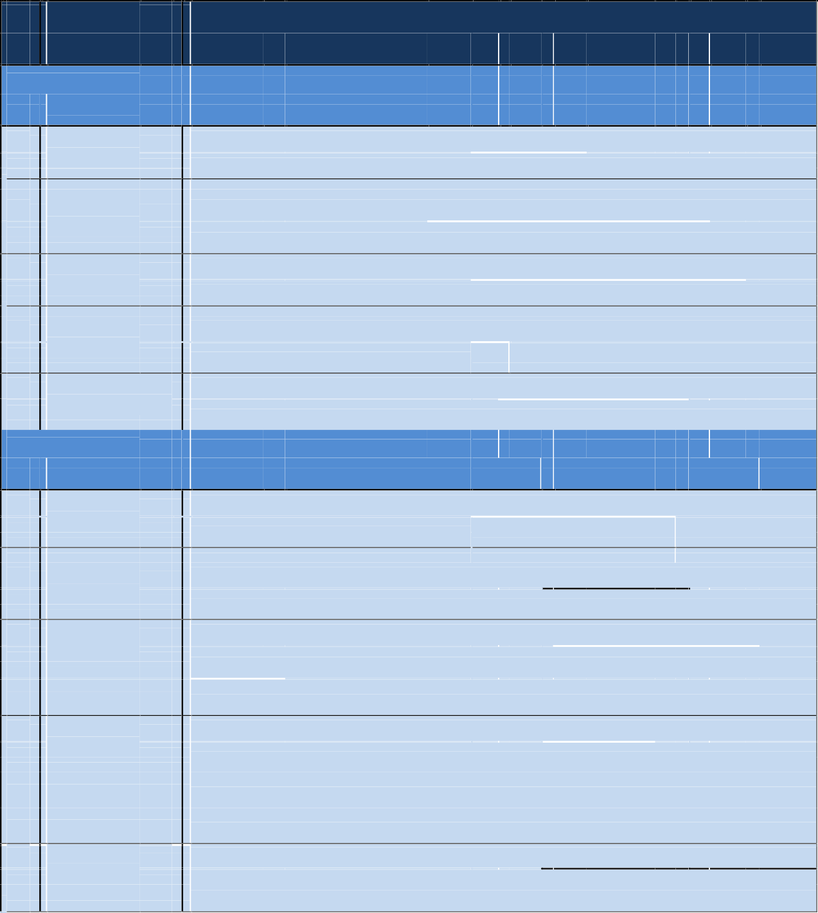
Descriptor Description

Likelihood (L)

1
Very Unlikely
Has not happened in the past and it is highly improbable it will happen in the next 12 months

2
Unlikely

3
Possible
Has not happened in the past but may occur in exceptional circumstances in the next 12 months
May have happened in the past and/or may occur under regular circumstances in
the next 12 months

4
Likely
Has been observed in the past and/or is likely to occur in the next 12 months

5
Almost Certain

Severity (S)
Has often been observed in the past and/or will almost certainly occur in most circumstances in the next 12 months

1
Insignificant
Hazard or hazardous event resulting in no or negligible health effects compared to background levels.

2
Minor
3
Moderate
Hazard or hazardous events potentially resulting in minor health effects (e.g. temporary symptoms like irritation, nausea, and headache).
Hazard or hazardous event potentially resulting in self-limiting health effects or
minor illness (e.g. acute diarrhea, vomiting, upper respiratory tract infection,

4
Major
minor trauma).
Hazard or hazardous event potentially resulting in illness or injury (e.g. malaria, schistosomiasis, food-borne trematodes, chronic diarrhea, chronic respiratory

problems, neurological disorders, bone fracture); and/or may lead to legal

5
Catastrophic
complaints and concerns; and/or major regulatory non-compliance.
Hazard or hazardous event potentially resulting in serious illness or injury, or even
loss of life (e.g. severe poisoning, loss of extremities, severe burns, drowning); and/or will lead to a major investigation by a regulator with prosecution likely.

Table 9 Risk Matrix for Risk Ranking

 |  |  |  | SEVERITY (S)
LIKELIHOOD (L) |  |  | Insignificant | Minor | Moderate |  |  |  | Major |  | Catastrophic
LIKELIHOOD (L) |  |  | 1 | 2 | 4 |  |  |  | 8 |  | 16
LIKELIHOOD (L) | Very unlikely | 1 | 1 | 2 | 4 |  |  |  | 8 |  | 16
LIKELIHOOD (L) | Unlikely | 2 | 2 | 4 | 8 |  |  |  | 16 |  | 32
LIKELIHOOD (L) | Possible | 3 | 3 | 6 | 12 |  |  |  | 24 |  | 48
LIKELIHOOD (L) | Likely | 4 | 4 | 8 | 16 |  |  |  | 32 |  | 64
LIKELIHOOD (L) | Almost Certain | 5 | 5 | 10 | 20 |  |  |  | 40 |  | 80
Risk level |  |  | Low Risk  (1-5) | Medium Ris  12) | k (6- |  | High Risk (13-32) |  |  | Very High Risk  (33-80)

Table 10:Risk Category Description for Team-Based Descriptive Risk Assessment

RISK DESCRIPTOR | NOTES
Very High and High Risk | Actions need to be taken to minimize the risk. Possible options (short,
Very High and High Risk | medium and long-term options) should be documented (as part of
Very High and High Risk | the improvement plan developed in the next Module) and
Very High and High Risk | implemented based on priorities and available resources.
Medium Risk | Currently low or very unlikely impact on exposure groups. The
Medium Risk | the situation can be improved with operational changes or system
Medium Risk | improvement over the medium to long term.
Low Risk | Actions may be taken but not a priority or no action is needed at this
Low Risk | time. The risk should be revisited in the future as part of the review
Low Risk | process.
Unknown priority | Further data is needed to categorize the risk. Some actions can be
Unknown priority | taken to reduce risk while more data is gathered.

Exposure Group
Utilize downstream water (U1)
Consumers / Households (U2)
Third-party biosolids Handlers (U4)
Sanitary laborers (W1)
VT operators (W2)
Plant operators (W3)
Plant monitoring team (W4)
Farmers who use compost made of biosolids (F1)
Local Community in possible spillage area. (L1)
Live adjacent to WWTP /PS (L2)
Visit and observe WWTP operations(L3)
Unauthorized peoples/Animals (L4)
Consumes crops grown using biosolids,fish consumers (C1)

Table 11: Hazard Identification and Risk Assessment for Kataragama Wastewater Treatment System
Overflow¹: Overflow of pumping stations occurs due to heavy rain, blackout, or pump failure situations. To prevent reverse flow into the households, the overflow is directed to the Manik River

Ref. No. | Sanitation Step | Hazard Identification |  |  | Existing controls | RISK ASSESSMENT Allowing for the existing controlL=Likelihood; Se=Severity; Sc=Score; R=Risk Level
 |  | Hazardous Exposure Event | Hazard Type | Exposure Route | Description of existing controls | Validation of control | Exposure group | L | Se | Sc | R
1 | Consumer | Ill Practices and lack of knowledge of using the water closet | Microbial pathogens | Ingestion | No existing control measures at present | Survey | U2 | 2 | 16 | 32 | High
2 |  | Adding an excessive amount of oil and grease to the system | Oil angd grease | Effluent mixed with oil | No existing control measures at present | Visual and survey | W1,U4,U2 | 5 | 2 | 10 | Medium
3 |  | Exposure to raw septage during the repair due to system blocking with polythene,condom,Pads,plastic,shape items,tooth brash,solid particals | Microbial pathogens,hook worm,Chemical,M alodoures | Skin Penetration, Skin congtact,ingestion,I nhalation | Awareness program | Survey and disease history | W1,U4,U2 | 5 | 16 | 80 | Very High
4 |  | Exposure to raw septage during the repair by low skill labours | Microbial pathogens,hook worm,Chemical,M alodoures | Skin Penetration, Skin congtact,ingestion,I nhalation | No existing control measures at present | Survey and disease history | W1,U4,U3 | 4 | 16 | 64 | Very High
6 | Septic tanks from Kataraga ma | Exposure to raw septage during the opening of the septic tank | Microbial pathogens,,Chem ical,Malodoures | Skin congtact,ingestion,I nhalation | Currently, this is not functioning,Currently, this is not functioning |  | W1 | 1 | 1 | 1 | Low
4 |  | Exposure to raw septage during desludging of septic tanks | Microbial pathogens,,Chem ical,Malodoures | Skin congtact,ingestion,I nhalation | Currently, this is not functioning |  | W1 | 1 | 1 | 1 | Low
 | Septage Transporta tion

Ref. No. | Sanitation Step | Hazard Identification |  |  | Existing controls | RISK ASSESSMENT Allowing for the existing controlL=Likelihood; Se=Severity; Sc=Score; R=Risk Level
 |  | Hazardous Exposure Event | Hazard Type | Exposure Route | Description of existing controls | Validation of control | Exposure group | L | Se | Sc | R
5 | Piped sewer | Leakage of the sewer to ground when laekage in pipe | Microbial pathogens,hook worm,Chemical,M alodoures | Skin Penetration, Skin congtact,ingestion,I nhalation | Regular leak survey | Routine inspection/ Inspection Report | W1,W4,L1 | 4 | 16 | 64 | Very High
6 |  | Overflowing of manholes and pump stations due to rainwater seeps into the manholes | Microbial pathogens,hook worm,Chemical,M alodoures | Skin Penetration, Skin congtact,ingestion,I nhalation | Manhole covers | complains | U1, W1, L1,L2 | 2 | 16 | 32 | High
7 |  | Overflowing of pump stations and manholes due to unauthorized unloading VTUs to the sewer manholes | Microbial pathogens,hook worm,Chemical,M alodoures | Skin Penetration, Skin congtact,ingestion,I nhalation | No existing controls |  | U1, W1, L1,L3 | 4 | 16 | 64 | Very High
8 |  | Effluent from vehicle service stations is directed to the sewer manhole | Excessive oil content in the treated effluent | Skin congtact,Inhalation | No existing controls |  | U1, W1,W3,W4, L1,L2 | 2 | 4 | 8 | Medium
9 |  | Overflow of sewers that are entrapped within houses, due to unauthorized construction of houses. | Microbial pathogens,hook worm,Chemical,M alodoures | Skin Penetration, Skin congtact,ingestion,I nhalation | No existing controls |  | U2, W1,L1 | 2 | 4 | 8 | Medium
10 | Pump stations | Overflow of pump stations directed to the river¹ | Microbial pathogens,hook worm,Chemical,M alodoures | Skin Penetration, Skin congtact,ingestion,I nhalation | More frequent pumping from pump stations to the treatment plant. | Real-time monitoring | U1,W1,L1 | 2 | 16 | 32 | High

Ref. No. | Sanitation Step | Hazard Identification |  |  | Existing controls | RISK ASSESSMENT Allowing for the existing controlL=Likelihood; Se=Severity; Sc=Score; R=Risk Level
 |  | Hazardous Exposure Event | Hazard Type | Exposure Route | Description of existing controls | Validation of control | Exposure group | L | Se | Sc | R
11 |  | Disturbance to the radio signals which communicate the water levels of pump stations to the STP causing overflow of PSs. | Microbial pathogens,hook worm,Chemical,M alodoures | Skin Penetration, Skin congtact,ingestion,I nhalation | No existing control measures at present |  | U1,W1,L1,L2 | 3 | 16 | 48 | Very High
12 |  | Exposure to raw septage during the opening of the septic tank | Microbial pathogens,hook worm,Chemical,M alodoures | Skin Penetration, Skin congtact,ingestion,I nhalation | Vaccination for hepatitis & anti-tetanus ,Strict implementation of safety and hygiene practices,ware PPE | Vaccination Record,Visual inspection | W1,W3 | 3 | 4 | 12 | Medium
13 |  | Exposure to raw septage during maintenance | Microbial pathogens,hook worm,Chemical,M  alodoures | Skin Penetration, Skin congtact,ingestion,I  nhalation | Use safety boots and gloves. | Log notes | W1,W3 | 4 | 4 | 16 | High
14 |  | Falling due to Ladder chemical anchoring is loosen | Microbial pathogens,hook worm,Chemical,M alodoures,physic  al injury | Skin Penetration, Skin congtact,ingestion,I nhalation | Use safety boots and gloves. | Log notes | W1,W4 | 2 | 16 | 32 | High
15 |  | Falling due to unbalance or loss of grip | Microbial pathogens,hook worm,Chemical,M alodoures,physic al injury | Skin Penetration, Skin congtact,ingestion,I nhalation | Use safety boots and gloves. | Log notes | W1,W5 | 2 | 8 | 16 | High
16 |  | Leakage of gasses to surrounding | Malodors | Inhalation | In-built chimneys release gasses to higher levels. | Visual inspection | L2 | 2 | 8 | 16 | High
17 |  | Leakage of gasses without filtration due to malfunctioning of biofilters | Malodors | Inhalation | No existing control measures at present | N/A | L2 | 2 | 8 | 16 | High
18 |  | Falling due to Leakage of elecric current due to animals (rats) damaging the wires | Microbial pathogens,hook worm,Chemical,M alodoures,physic al injury | Skin Penetration, Skin congtact,ingestion,I nhalation | Reroute the wires through more open areas and immediate action. | Visual inspection and testing | W1, W3, W4 | 2 | 16 | 32 | Very High

Ref. No. | Sanitation Step | Hazard Identification |  |  | Existing controls | RISK ASSESSMENT Allowing for the existing controlL=Likelihood; Se=Severity; Sc=Score; R=Risk Level
 |  | Hazardous Exposure Event | Hazard Type | Exposure Route | Description of existing controls | Validation of control | Exposure group | L | Se | Sc | R
 |  |  |  |  | Existing conduits are to be replaced with metal conduits.
19 | Transport of Septage through VTU | Exposure to raw septage due to spillage during a vehicular accident | Microbial pathogens,hook worm,Chemical,M alodoures,physic al injury | Skin Penetration, Skin congtact,ingestion,I nhalation | No existing control measures at present |  | W2, L1 | 2 | 4 | 8 | Medium
20 |  | Exposure to raw septage due to spillage during loose fittings | Microbial pathogens,hook worm,Chemical,M alodoures,physic al injury | Skin Penetration, Skin congtact,ingestion,I nhalation | No existing control measures at present |  | W2, L2 | 2 | 4 | 8 | Medium
21 | Treatment of Raw Septage | Exposure to raw septage during sampling and testing | Microbial pathogens,Chemi cal,Malodoures | Skin Penetration, Skin congtact,ingestion,I  nhalation | Strict implementation of safety and hygiene practices,ware PPE |  | W3,W4 | 2 | 4 | 8 | Medium
22 | Primary Treatment | Exposure to raw septage due to leak during pumping to the preliminary treatment unit | Microbial pathogens,Chemi cal,Malodoures | Skin Penetration, Skin congtact,ingestion,I nhalation | Clean-up procedure for spilled material | Routine inspection/ Inspection Report | W1, W3 | 2 | 4 | 8 | Medium
23 |  | Exposure to raw septage due to Penetration with residue during maintenance and repair activities | Microbial pathogens,hook worm,Chemical,M alodoures,physic al injury | Skin Penetration, Skin congtact,ingestion,I nhalation | Strict implementation of safety and hygiene practices | Visual inspection | W1 | 4 | 4 | 16 | Medium

Ref. No. | Sanitation Step | Hazard Identification |  |  | Existing controls | RISK ASSESSMENT Allowing for the existing controlL=Likelihood; Se=Severity; Sc=Score; R=Risk Level
 |  | Hazardous Exposure Event | Hazard Type | Exposure Route | Description of existing controls | Validation of control | Exposure group | L | Se | Sc | R
24 |  | Exposure to raw septage due to animals(monkeys) removing the covers of the preliminary treatment unit | Microbial pathogens,hook worm,Chemical,M alodoures | Skin Penetration, Skin congtact,ingestion,I nhalation | Clean-up procedure for spilled material | Visual inspection | W1 | 2 | 2 | 4 | Low
26 |  | Exposure to screened trashes due to Penetration during transfer to the burning pit | Microbial pathogens,hook worm,Chemical,M alodoures | Skin Penetration, Skin congtact,ingestion,I nhalation | Strict implementation of safety and hygiene practices,ware PPE | Visual inspection | W1 | 3 | 4 | 12 | Medium
27 |  | Exposure to removed grit due to Penetration during transfer to disposal | Microbial pathogens,hook worm,Chemical,M alodoures | Skin Penetration, Skin congtact,ingestion,I nhalation | Strict implementation of safety and hygiene practices,ware PPE | Visual inspection | W1 | 3 | 4 | 12 | Medium
28 |  | Exposure to removed oil and grease due to Penetration during transfer to disposal | Microbial pathogens,hook worm,Chemical,M alodoures | Skin Penetration, Skin congtact,ingestion,I nhalation | Strict implementation of safety and hygiene practices,ware PPE | Visual inspection | W1 | 3 | 4 | 12 | Medium
29 |  | Exposure to pre-treated effluent due to Penetration during the collection of the sample | Microbial pathogens,hook worm,Chemical,M alodoures | Skin Penetration, Skin congtact,ingestion,I nhalation | Strict implementation of safety and hygiene practices,ware PPE | Visual inspection | W1 | 3 | 4 | 12 | Medium
30 |  | Accidental falling into the tank during operation, monitoring, and maintenance | Microbial pathogens,hook worm,Chemical,M alodoures,physic al injury | Skin Penetration, Skin congtact,ingestion,I nhalation | Installed a guard rail in the areas of sample collection | Visual inspection | W1, W3, W4 | 2 | 4 | 8 | Medium

Ref. No. | Sanitation Step | Hazard Identification |  |  | Existing controls | RISK ASSESSMENT Allowing for the existing controlL=Likelihood; Se=Severity; Sc=Score; R=Risk Level
 |  | Hazardous Exposure Event | Hazard Type | Exposure Route | Description of existing controls | Validation of control | Exposure group | L | Se | Sc | R
31 | Secondary Treatment | Attack by the crocodiles living in sewerage pond | Microbial pathogens,hook worm,Chemical,M alodoures,physic al injury | Skin Penetration, Skin congtact,ingestion,I nhalation | A request is made to the department of wildlife conservation to remove the crocodiles | N/A | W1, W2, W3, W4, L2,L3 | 4 | 16 | 64 | Very High
33 |  | Accidental falling into the tank during operation, monitoring, and maintenance | Microbial pathogens,hook worm,Chemical,M alodoures,physic al injury | Skin Penetration, Skin congtact,ingestion,I nhalation | No existing control measures at present | N/A | W1, W3, W4, | 2 | 4 | 8 | Medium
34 |  | Exposure to pre-treated effluent due to Penetration during the cleaning of tanks | Microbial pathogens,hook worm,Chemical,M alodoures,physic al injury | Skin Penetration, Skin congtact,ingestion,I nhalation | Safety practices.,i.e.: Using gloves and boots | Visual inspection | W1 | 3 | 4 | 12 | Medium
35 |  | Exposure to pre-treated effluent due to Penetration during inspection and monitoring of operation | Microbial pathogens,hook worm,Chemical,M alodoures | Skin Penetration, Skin congtact,ingestion,I nhalation | Safety practices., i.e.: Using gloves and a mask | Visual inspection | W1, W3 | 2 | 4 | 8 | Medium
36 |  | Exposure to pre-treated effluent due to during unaghorized fishing activities | Microbial pathogens,hook worm,Chemical,M alodoures,physic al injury | Skin Penetration, Skin congtact,ingestion,I nhalation | Inspection by security gurds | Visual inspection | L3,C1 | 4 | 16 | 64 | Very High

Ref. No. | Sanitation Step | Hazard Identification |  |  | Existing controls | RISK ASSESSMENT Allowing for the existing controlL=Likelihood; Se=Severity; Sc=Score; R=Risk Level
 |  | Hazardous Exposure Event | Hazard Type | Exposure Route | Description of existing controls | Validation of control | Exposure group | L | Se | Sc | R
37 | C.  Disinfectio n | Exposure to effluent due to Penetration during the collection of the sample | Microbial pathogens,hook worm,Chemical,M alodoures | Skin Penetration, Skin congtact,ingestion,I nhalation | No existing control measures at present | N/A | W1 | 2 | 4 | 8 | Medium
38 |  | Blasting of plastic containers containing the NaOCl while storage due to increased pressure created by evaporation | Chemical,physica l injury | injury,Skin congtact | Store under trees/a cool dark place | Visual inspection | W1, W3 | 3 | 8 | 24 | High
39 |  | Projecting the lid of the NaOCl container at very high speed. | Chemical,physica l injury | injury,Skin congtact | Make a small hole to expel the vapor before opening. | awareness programs | W1, W3 | 3 | 4 | 12 | Medium
40 |  | Exposure to effluent due to Penetration during inspection and monitoring | Microbial pathogens,hook worm,Chemical | Skin Penetration, Skin congtact,ingestion,I nhalation | Safety practices.,i.e.: Using gloves and boots | Visual inspection | W1, W3, W4 | 2 | 4 | 8 | Medium
41 |  | Falling in while collecting samples | Microbial pathogens,hook worm,Chemical,M alodoures,physic al injury | Skin Penetration, Skin congtact,ingestion,I nhalation | No existing control measures at present | N/A,Routine inspection | W1 | 2 | 4 | 8 | Medium
42 |  | Elephant attack and exposure to effluent while intrusion the premises | Microbial pathogens,hook worm,Chemical,M alodoures,physic  al injury | Skin Penetration, Skin congtact,ingestion,I nhalation,by attack | Constructing a fence around the premises | Visual inspection | W1, W2,W3,W4 | 4 | 16 | 64 | Very High
43 |  | Down stream river users expose to undisinfected effuluent during low strenth of NaOCl | Microbial pathogens | ingestion | Maintaining RCl level by adding bleaching powder | Testing | U1 | 3 | 16 | 48 | Very High
 | Waste handling

Ref. No. | Sanitation Step | Hazard Identification |  |  | Existing controls | RISK ASSESSMENT Allowing for the existing controlL=Likelihood; Se=Severity; Sc=Score; R=Risk Level
 |  | Hazardous Exposure Event | Hazard Type | Exposure Route | Description of existing controls | Validation of control | Exposure group | L | Se | Sc | R
44 | De- sludging | Exposure to sludge while manual de- sludging | Microbial pathogens,hook worm,Chemical,M alodoures | Skin Penetration, Skin congtact,ingestion,I nhalation | Safety practices.,i.e.: Using gloves and boots | Visual inspection | W1,W3,W4 | 4 | 4 | 16 | High
45 | Sludge cake draining | Exposure to sludge cake due to Penetration during the transfer from the catchment at the dewatering machine to the sludge draining area | Microbial pathogens,hook worm, | Skin Penetration, Skin congtact,ingestion | Safety practices.,i.e.: Using gloves and boots | Visual inspection | U1,W1,W3,W5 | 4 | 4 | 16 | High
46 | Sludge cake as a farmers soil conditione r | Exposure to sludge cake due to Penetration during application to farming activities | Pathogens in sludge cake,Malodors | Skin Penetration,Inhalati on | Currently, the sludge cake is used only for trees within the treatment plant premises, and no existing control measures | N/A | W1,W4 | 4 | 1 | 4 | Low
47 | Consumpti on of crops harvested using sludge  cake | Consumption of contaminated crops | Pathogens in sludge cake | Ingestion | Currently, the sludge cake is used only for trees within the treatment plant premises, and no existing control measures | N/A | C1 | 3 | 1 | 3 | Low
48 |  | Mixing of water Hyacinth seeds which multiply rapidly to the effluent | Reduction of biodiversity | Mixing matured seeds into the affluent and | No existing control measures at present | N/A | U1 | 2 | 4 | 8 | M

Table 12: Hazard Identification and Risk Assessment for Kataragama LA’S Wastewater Treatment System ( Temporary not functioning )
 | Sanitation Step | Hazard Identification |  |  | Existing controls | RISK ASSESSMENT  Allowing for the existing control  L=Likelihood; Se=Severity; Sc=Score; R=Risk Level
 | Sanitation Step | Hazardous Exposure Event | Hazard Type | Exposure Route | Description of existing controls | Validation of control | Exposure group | L | Se | Sc | R
1 | Consumer | Ill Practices and lack of knowledge of using the water closet | Exposure to raw septage | Skin Contact, ingestion | No existing control measures at present | awareness programs | U2 | 3 | 4 | 12 | M
2 | Septic tanks from Kataragama | Exposure to raw septage during the opening of the septic tank | Pathogens in raw septage | Skin contact | Currently, this is not functioning | Vaccination Record | W1 | 2 | 4 | 8 | M
2 | Septic tanks from Kataragama |  | Malodors | Inhalation | Currently, this is not functioning | Wearing face mask |  | 3 | 2 | 6 | M
3 | Septic tanks from Kataragama | Exposure to raw septage during desludging of septic tanks | Pathogens in raw septage | Skin contact | Currently, this is not functioning |  | W1 | 2 | 2 | 4 | L
 | Septage Transportation
4 | Transport of Septage through VTU | Exposure to raw septage due to spillage during a vehicular accident | Pathogens in raw septage | Skin contact | Currently not functioning. | N/A | W3, L6 | 2 | 2 | 4 | L
4 | Transport of Septage through VTU |  | Malodors | Inhalation |  |  |  |  |  |  | L
 | Treatment of Raw Septage
5 |  | Exposure to raw septage due to contact with residue during maintenance and repair activities | Pathogens in raw septage | Skin contact | Strict implementation of safety and hygiene practices | Visual inspection | W1 | 4 | 2 | 8 | M
5 |  |  | Malodors | Inhalation
6 |  | Exposure to screened trashes due to contact  during transfer to the burning pit | Pathogens in screened trashes | Skin contact | Safety practices. | Visual inspection | W1 | 3 | 1 | 3 | L
7 |  | Accidental falling into the tank during operation, monitoring, and maintenance | Physical injury | Physical injury | Installed a guard rail in the areas of sample collection | Visual inspection | W1, W3, W4 | 2 | 4 | 8 | M
7 |  |  | Pathogens in raw septage | Skin contact
 |  |  |  | Ingestion

 | Sanitation Step | Hazard Identification |  |  | Existing controls | RISK ASSESSMENT  Allowing for the existing control  L=Likelihood; Se=Severity; Sc=Score; R=Risk Level
 | Sanitation Step | Hazardous Exposure Event | Hazard Type | Exposure Route | Description of existing controls | Validation of control | Exposure group | L | Se | Sc | R
8 |  | Accidental falling into the tank during operation, monitoring, and maintenance | Pathogens in pretreated water | Skin contact | No existing control measures at present | N/A | W1 | 2 | 4 | 8 | M
 |  |  |  | Ingestion
9 |  | Exposure to pre-treated effluent due to contact during the cleaning of tanks | Pathogens in pretreated effluent | Skin contact | Safety practices.  i.e.: Using gloves and boots | Visual inspection | W1 | 3 | 4 | 12 | M
10 |  | Exposure to pre-treated effluent due to contact during inspection and monitoring of operation | Pathogens in pretreated effluent | Skin contact | Safety practices.  i.e.: Using gloves and a mask | Visual inspection | W1, W3 | 2 | 2 | 4 | L
11 | C. Disinfection | Exposure to effluent due to contact during the collection of the sample | Pathogens in effluent | Skin contact | No existing control measures at present | N/A | W1 | 2 | 2 | 4 | L
12 | C. Disinfection | Blasting of plastic containers containing the NaOCl while storage due to increased pressure created by evaporation | Chemical vapor, pieces of the container | Inhalation, physical injury | Store under trees/a cool dark place | Visual inspection | W1, W3 | 3 | 4 | 12 | M
13 | C. Disinfection | Projecting the lid of the NaOCl container at very high speed. | Chemical vapor, pieces of the container | Inhalation, physical injury | Make a small hole to expel the vapor before opening. | awareness programs | W1, W3 | 3 | 4 | 12 | M
14 | C. Disinfection | Exposure to effluent due to contact during inspection and monitoring | Pathogens in effluent | Skin contact | Safety practices.  i.e.: Using gloves and boots | Visual inspection | W1, W3, W4 | 2 | 2 | 4 | L
 | Waste handling

 | Sanitation Step | Hazard Identification |  |  | Existing controls | RISK ASSESSMENT  Allowing for the existing control  L=Likelihood; Se=Severity; Sc=Score; R=Risk Level
 | Sanitation Step | Hazardous Exposure Event | Hazard Type | Exposure Route | Description of existing controls | Validation of control | Exposure group | L | Se | Sc | R
15 | De-sludging | Exposure to sludge while manual de-sludging | Pathogens in sludge | Skin contact | Safety practices.  i.e.: Using gloves and boots | Visual inspection | W1 | 4 | 2 | 8 | M
16 | Sludge cake draining | Exposure to sludge cake due to contact during the transfer from the catchment at the  dewatering machine to the sludge draining area | Pathogens in sludge cake | Skin contact | Safety practices.  i.e.: Using gloves and boots | Visual inspection | W1 | 4 | 2 | 8 | M
17 | Sludge cake draining |  | Malodors | Inhalation | Safety practices. |  |  |  |  |  | L
17 | Sludge cake as a farmers soil conditioner | Exposure to sludge cake due to contact during application to farming activities | Pathogens in sludge cake | Skin contact | Currently, the sludge cake is used only for trees within the treatment plant premises, and no existing control measures | N/A | W1,W4 | 4 | 1 | 4 | L
20 | Sludge cake as a farmers soil conditioner |  | Malodors | Inhalation
20 | Consumption of crops harvested using sludge cake | Consumption of contaminated crops | Pathogens in sludge cake | Ingestion | Currently, the sludge cake is used only for trees within the treatment plant premises, and no existing control measures | N/A | C1 | 3 | 1 | 3 | L
21 | Disposal of effluent To the river | Exposure to effluent due to river water usage | Pathogens in effluent | Skin contact | No existing control measures at present | N/A | U1 | 5 | 1 | 5 | L
22 | Disposal of effluent To the river | Exposure to effluent due to river water usage | Pathogens in effluent | Ingestion

DEVELOPMENT AND IMPLEMENTATION OF AN INCREMENTAL IMPROVEMENT PLAN

To ensure that hazards and hazard exposure events with high-risk ratings are properly addressed an improvement plan has been established and this is reflected in Table 13.

Stakeholder meetings are conducted to make them aware of the SSP. The minutes of the stakeholder meetings are attached in Annex VII.
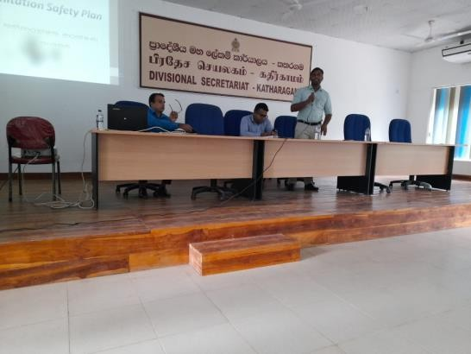
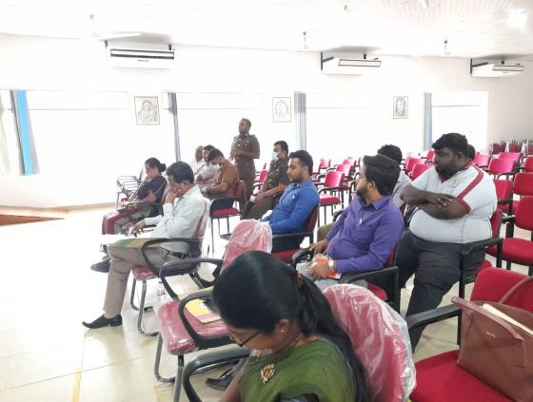

Figure 20: Stakeholder meetings

Table 13: NWS&DB development plan

Ref. No. | HAZARDO US EXPOSUR E EVENT | IMPROVEMENT/ ACTIONS (New  Improved Control Measure) | PRIORITY  (High, Medium, Low, unknown) | RESPONSIBLE AGENCY/ PERSON | ESTIMA TED COST  (Million  ) | STATUS
1,2,3,5,6 | Consumer | Awareness program for consumers | High | NWS&DB | 0.03 | Planing
5 | Consumer | plumbers training,Relaying Old pip[e lines | Very High | NWS&DB | 1 | Planing
5,12,13,14,15,21,22,23,  26,27,28,29,33,34,35,4  0,44,45 | Septage Transport ation | Purchase PPE for workers | Very High,High | NWS&DB | 0.5 | Planing
6 | Septage Transport ation | Rehabilitation of Old manholes | High | NWS&DB | 1 | Planing
6,7 | Septage Transport ation | Awareness program for  surrounding peoples during floding and overflowring | High | NWS&DB | 0.05 | Planing
7,8 | Septage Transport ation | Provide locks to the manhole covers | Very High,Mediu m | NWS&DB | 0.8 | Planing

Ref. No. | HAZARDO US EXPOSUR E EVENT | IMPROVEMENT/ ACTIONS (New  Improved Control Measure) | PRIORITY  (High, Medium, Low, unknown) | RESPONSIBLE AGENCY/ PERSON | ESTIMA TED COST  (Million  ) | STATUS
 |  | Awareness program for surrounding peoples to informed NWS&DB on unauthorized unloading VTUs to  the sewer manholes Pumping |  | NWS&DB | 0.1 | Planing
 |  | Awareness board at pump stations and manholes for control unauthorized unloading VTUs to the sewer manholes  Pumping |  | NWS&DB | 0.5 | Planing
9 |  | Identify and Shifting the pipe lines | Medium | NWS&DB | 2 | Planing
10,11 | Pump stations | Purchase extra spare parts for avoid breakdowns of pump house and to keep continuous radio signals | High | NWS&DB | 3 | Planing
13,21 | Pump stations | Awareness program for workers | Medium | NWS&DB | 0.1 | Planing

Ref. No. | HAZARDO US EXPOSUR E EVENT | IMPROVEMENT/ ACTIONS (New  Improved Control Measure) | PRIORITY  (High, Medium, Low, unknown) | RESPONSIBLE AGENCY/ PERSON | ESTIMA TED COST  (Million  ) | STATUS
14,15 |  | Purchase safety belt when climbing down to the sump | High | NWS&DB | 0.2 | Planing
16 |  | Use a safety belt when climbing down to the sump | High | NWS&DB | 0.5 | Planing
18 |  | Provide a metal conduit for  wires | Very High | NWS&DB | 0.5 | Ongoing
19,20 | Transport of Septage through VTU | Awareness program for VT workers | Medium | NWS&DB | 0.05 | Planing
26 | Primary Treatment | Installation of proper burning  point | Medium | NWS&DB | 5 | Planing
30 | Secondary Treatment | Shifting the crocodiles to a different place with the help of the wildlife conservation department,awareness board on crockadile attack | Very High | NWS&DB &  Wildlife Conservation Department | 0.1 | A  request is made to Wildlife Conserva tion Departm ent and necessar  y

Ref. No. | HAZARDO US EXPOSUR E EVENT | IMPROVEMENT/ ACTIONS (New  Improved Control Measure) | PRIORITY  (High, Medium, Low, unknown) | RESPONSIBLE AGENCY/ PERSON | ESTIMA TED COST  (Million  ) | STATUS
 |  |  |  |  |  | payment s are done
36 |  | Remove fishes form ponds with the help of stakeholders, awareness board on crockadile attack | Very High | NWS&DB and stakeholders | 0.5 | Planing
38 | Disinfectio n | Installation of proper chemical storage for sodium hypochloride storing with air conditioner and  exhoust fan | High | NWS&DB | 2.5 | Planing
41 | Disinfectio n | Provide elephant fence | Very High | NWS&DB and Wild Life department | 5 | Planing
43 | Disinfectio n | Install a NaOCl onsite generator | Very High | NWS&DB | 2.5 | Planing

MONITORING OF CONTROL MEASURES AND VERIFICATION OF PERFORMANCE

Definition and Implementation of Operational Monitoring

NWS&DB Monitoring Plan is presented in Table 14.

Table 14: NWS&DB Monitoring Plan

KATARAGAMA WWTS MONITORING PLAN
Operational Plan For | Monitoring Operational Procedures for Collection, Transport, and Treatment of Raw Septage and Sewage, and Disposal of End Products/By-  products
Operation Limit | Operational Monitoring of the Control Measure:  Control Measure: Compliance to Operational Procedures, Work  Instructions and CEA Guidelines |  | Corrective Action when the Operational Limit is Not Met
 | What is Monitored | Practice & Procedure | What Action is to be taken | Verbal reminder, issuance of System Improvement  Request (SIR) form
 | How It is Monitored | Observation, Inspection and Review of Submitted  Accomplishment Report | Who Takes The Action | On-site Safety Officer Plant Head /  Supervisor
 | Who Monitors it | On-site Safety Officer, Desludging Officer, Plant  Head / Supervisor | When it is Taken | Within 1 to 3 days
 | When it is monitored | Daily plant inspection, on- site inspection, and daily review of accomplishment  report | Who Needs to be informed of  the action | Plant Head, Reagional manager Hambantota

Verification of System Performance

The NWSDB Verification Monitoring Plan is shown in Table 15.
Table 15: NWSDB Monitoring Plan
SANITATION STEP | VERIFICATION MONITORING
SANITATION STEP | WHAT | LIMIT | WHEN | WHO | METHOD OF  MONITORING
Effluent Discharge | Quality of Effluent to be dispose of inland water body | CEA Limit | Monthly | NWS&DB Process Control and Monitoring Unit | Sampling and testing
Sludge cake Disposal | Quality of sludge cake to be disposed | Fertilizer Secretariat Limit | Annually | NWS&DB Process Control and Monitoring Unit | Sampling and testing
Sludge cake Application | Pathogens in soil | Fertilizer Secretariat Limit | Quarterly | Central laboratory, Department of Agriculture | Sampling and testing

Auditing and External Assessment of the System

Aside from the compliance of the treatment plant to legal requirements such as submission of a Self-Monitoring Report (SMR) and Compliance Monitoring Report (CMR), the site, is annually audited by a 3rd party certifying body to verify the effectiveness of the operation of its different facilities including the Veterans Water Reclamation Facility. The audit is conducted based on international management system standards as follows: ISO 9001:2008 (Quality Management Systems), ISO 14001:2004 (ISO Environmental Management Systems), and OHSAS 18001:2007 (Occupational Safety and Health Management Systems).

DEVELOPMENT OF SUPPORTING PROGRAMS AND REVIEW OF PLANS

Identification and Implementation of Supporting Programs

Supporting programs are organization-wide activities that should be in place in support of mitigating the health effects of wastewater and its by-products. These activities do not directly affect the quality of the wastewater and biosolids but are meant to ensure that no additional source of potential hazards will come from the operating / surrounding environment, the equipment used, and the people themselves, employees, and visitors alike. The types of supporting programs that Kataragama SSP has in aid of the realization of its mission are provided in Table 16. Management commitment entails constant assessment that shall lead to updating existing programs and developing new ones.

Table 16: NWS&DB Supporting Programs

Supporting Program | Group Responsible
Conduct of Health Forum for the employees | Ministry of Health
on proper hygiene. | Ministry of Health
Yearly evaluation and accreditation of service | Local Authority
providers (for treatment of biosolids) | Local Authority
Review of existing Environment, Safety and | Central Environmental Authority
Health (ESH) –related operational procedures | Central Environmental Authority
and work instructions | Central Environmental Authority
Training on Emergency Response, Hazardous | Environmental Management Dept., Safety
Waste Handling and Chemical Handling | Dept. (Corporate QESH Division)
Annual review of the sanitation and | NWS&DB RSC(S) and Water Reclamation
sewerage system | Division)

Periodic Review and Update of the SSP Outputs

To ensure the SSP covers emerging hazards and issues, the SSP Team shall review it periodically. The implementation of the SSP framework reduces the number and severity of incidents, emergencies, or near misses affecting or potentially affecting the health of the workers, users, and community. However, such incidents/events may still occur. Hence, in addition to the periodic review of the SSP, a review of the SSP following every emergency, incident, or unforeseen event irrespective of new hazards will be conducted. This will ensure the same incident/emergency will be less likely to recur in the future and also determine whether the response was effective or need to be improved.

The result of a post-incident review will identify areas for improvement; whether it is a new hazard, a revised risk for the risk assessment, a revision for an operating procedure, or a training issue. The SSP must be revised to reflect the change and incorporate the lessons learned into the SSP documentation, procedures, and supporting programs.

Annex I: Solid waste recycling method at solid waste recycle plant of Kataragama Local Authority.

No | Waste Type | Recycle Disposal method
1 | Glass  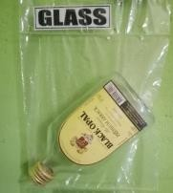 | Crush in the yard and sold to 3rd party buyer.
2 | Food Cans  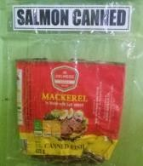 | Compressed and sold to a third-party buyer.
3 | Bushy Polythene   | Compressed and sold to a third-party buyer.
4 | Plastic   | Compressed and sold to a third-party buyer.
5 | Card Board  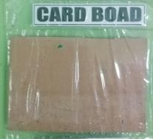 | Compressed and sold to a third-party buyer.
6 | Iron  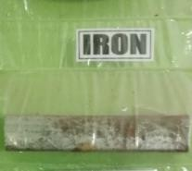 | Sold to a third-party buyer.

7 | Polythene  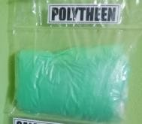 | Compressed and sold to a third-party buyer.
8 | Electrical Items   | Sold or buried.
9 | Brass  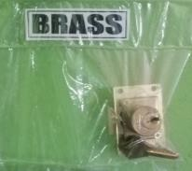 | Sold to a third-party buyer.
10 | Beer Cans  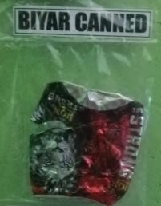 | Compressed and sold to a third-party buyer.
11 | Pet Bottles  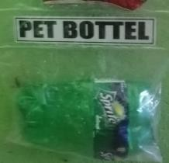 | Compressed and sold to a third-party buyer.
12 | Plate  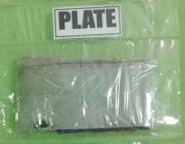 | Sold to a third-party buyer.

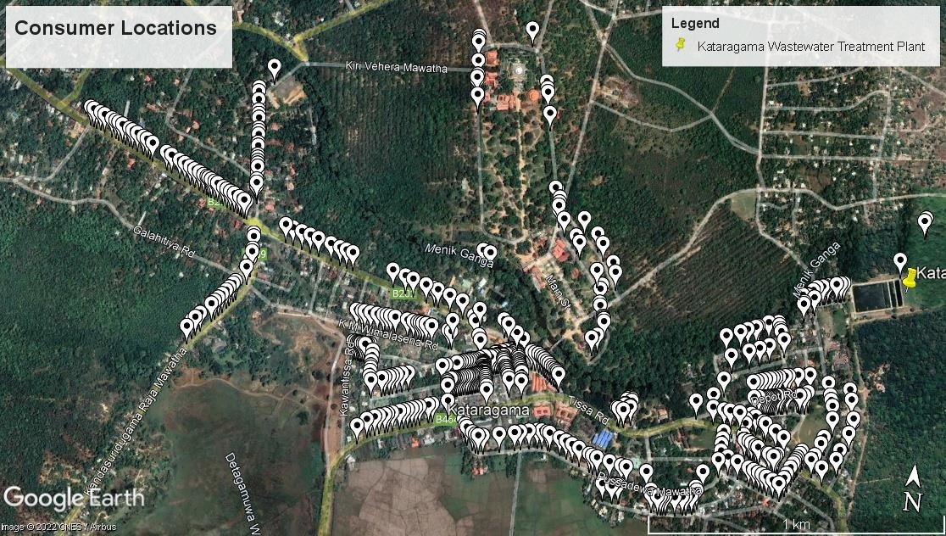
Annex IIA: Consumer location

Annex IIB: Consumer Details

National Water Supply & Drainage Board Commercial Operations Management System
Customer Account Number List (Sewerage).
Region: 32 - Hambantota Area: 7 - Kataragama Billing Cycle: All
Customer Category Code | Connection Status | Account No | Name | Address
10 | Active | 32/07/001/030/15 | T W K SUNIL | NO 302, "SUNIL REST", TISSAMAHARAMA ROAD,  KATHARAGAMA
10 | Active | 32/07/001/032/13 | D A NIMAL ROHANA | NO 1,NEAR WEWA, NEW TOWN, KATARAGAMA
10 | Active | 32/07/001/033/12 | R. N. PALIHAKKARA | NO 1, NEW TOWN, KATARAGAMA
10 | Active | 32/07/004/002/13 | W.A SRIYALATHA | NO. 10, DAMMARAKKITHA MAWATA, KATARAGAMA
10 | Active | 32/07/004/003/12 | H N KARUNAWATHIE | NO 09 NEW TOWN, KATARAGAMA, KATARAGAMA
10 | Active | 32/07/004/006/19 | B G MAHINDADASA | NO 01, V C ROAD, KATARAGAMA
10 | Active | 32/07/004/007/18 | K G DEVIKA | NO 6, NEW TOWN, KATARAGAMA
10 | Active | 32/07/004/008/17 | G. A. T. DARSHANA  KUMARA | NO. 11, DHAMMARAKKITHA MAWATHA, NEW TOWN,  KATARAGAMA
10 | Active | 32/07/004/009/16 | H R K PADMINI | NO "PASINDU", DAMMARAKKITHA MAWATA,  KATARAGAMA
10 | Active | 32/07/004/013/10 | H R K DHARMASENA | V C QUARTERS ROAD, KATARAGAMA, KATARAGAMA
10 | Active | 32/07/004/016/17 | W.Y.G WIMALAWATHE | U.C.QUARTERS, DAMMA RAKKITHA MW ,, KATARAGAMA
10 | Active | 32/07/004/018/15 | M J KUSUMAWATHIE | V C QUARTERS, KATARAGAMA, KATARAGAMA
10 | Active | 32/07/004/022/19 | W H AGORIS | V C BUNGALOW, KATARAGAMA, KATARAGAMA
10 | Active | 32/07/004/028/13 | W.A PIYADASA | NO 09, V.C. HOUSING, KATHARAGAMA, KATHARAGAMA
10 | Active | 32/07/004/031/18 | K.G. S .K. PREMARATHNA | NO 19/ B,, SADDA TISSA MAWATHA, KATARAGAMA
10 | Active | 32/07/004/032/17 | R P ARIYAWANSA | NO 19 C,, SADDA TISSA MAWATHA, KATARAGAMA
10 | Active | 32/07/004/033/16 | D A KARAWITA | NO 41 NEW TOWN, KATARAGAMA, KATARAGAMA
10 | Active | 32/07/004/034/15 | T R SEELAWATHIE | NO 12 V.C. QUARTERS, KATARAGAMA, KATARAGAMA
10 | Active | 32/07/004/035/14 | AP AJITHWICKRAMA  SINGHA | NO 13, V.C.HOUSE, KATARAGAMA
10 | Active | 32/07/004/046/11 | S.P.T. RATHNAYAKA | NO 15/16,, NAGASENA PLACE, KATARAGAMA
10 | Active | 32/07/004/047/10 | P UPALI DISANAYAKA | NO 18,, NEW TOWN, KATARAGAMA
10 | Active | 32/07/004/048/19 | J SAMARASINGHA | NO 08, DAMMARAKKITHA MAWATA, KATARAGAMA
10 | Active | 32/07/004/052/12 | K. T. MAGRAT | NO. 02, DHAMMARAKKITHA MAWATHA, NEW TOWN,  KATARAGAMA
10 | Active | 32/07/004/055/19 | H A WIJETHILAKA | NO 10, V.C.BUNGALOW, KATARAGAMA
10 | Active | 32/07/004/058/16 | A.P GANNAWATHI | NO:13,V.C NIWASA,, NEW TOWN, KATARAGAMA
10 | Active | 32/07/004/060/12 | LESLI DISSANAYAKE | 14, DHAMMARAKKITHA MW, KATARAGAMA
10 | Active | 32/07/004/061/11 | S. KARAVITA | 11, DHAMMA RAKKIHA MAWATHA, KATARAGAMA
10 | Active | 32/07/004/062/10 | S.P. PREMASIRI | 28,, KAWANTHISSA MAWATHA, KATARAGAMA
10 | Active | 32/07/004/065/17 | B.G NIMALAWATHI | 248, POLICE NIWASA ROAD, KATARAGAMA
10 | Active | 32/07/004/067/15 | R DULANI PRIYANGIKA | KAWANTHISSA MAWATHA,, V.C.HOUSE, KATARAGAMA
10 | Active | 32/07/004/068/14 | H.K DOREEN DUSANTHA | BARNIS APPUHAMI MAWATHA, SELLA KATARAGAMA  ROAD, KATARAGAMA
10 | Active | 32/07/004/069/13 | H.A.N WIJETHILAKA | 10/01, DHAMMA RAKKITA MAWATA,, NEW TOWN,  KATARAGAMA

National Water Supply & Drainage Board Commercial Operations Management System
Customer Account Number List (Sewerage).

Region: 32 - Hambantota Area: 7 - Kataragama Billing Cycle: All
Customer Category Code | Connection Status | Account No | Name | Address
 |  | 32/07/004/083/15 | C W WICKRAMASINGHA | NO 20, SADDATISSA ROAD, NEW TOWN, KATARAGAMA
 |  | 32/07/004/084/14 | D D PALIHAKKRA | D.D. PALIHAKKARA, NEW TOWN, KATARAGAMA
 |  | 32/07/004/086/12 | J. A. PRIYANKA | NO. 19, SADDHATHISSA MAWATHA,, NEW TOWN,,  KATARAGAMA.
 |  | 32/07/005/019/11 | K M SIRIPALA | NO 30 , POWER STATION RD.,, NEW TOWN, KATARAGAMA
 |  | 32/07/005/020/18 | L.C EDIRIWEERA | NO.5,, KAWANTHISSA MAWATHA, KATARAGAMA
 |  | 32/07/005/021/17 | . TENISON JAYAWEERA | POWER HOUSE ROAD, NEW TOWN, KATARAGAMA
 |  | 32/07/005/022/16 | H M SUGATHADASA | NO 31 NEW TOWN, KATARAGAMA, KATARAGAMA
 |  | 32/07/007/002/16 | W G SAMARAWATHI | NO- 112/C NEW TOWN, KATARAGAMA, KATARAGAMA
 |  | 32/07/007/019/17 | N. S. M. DHARMAPALA | C 89,, NEW TOWN, KATARAGAMA
 |  | 32/07/007/020/14 | T A GALAPATHTHY | C 90 NEW TOWN, KATARAGAMA, KATARAGAMA
 |  | 32/07/007/021/13 | K.M. ARIYASENA | C 91 NEW TOWN, KATARAGAMA, KATARAGAMA
 |  | 32/07/007/022/12 | . PETER JAYAWARDENA | NEW TOWN, KATARAGAMA, KATARAGAMA
 |  | 32/07/007/024/10 | H.K.D DUSHANTHA | NO. C/1, KANDULA PLACE,, NEW TOWN, KATARAGAMA
 |  | 32/07/007/025/19 | W A D TILAK | NO SRI RAMMIYA, KATARAGAMA, KATARAGAMA
 |  | 32/07/007/026/18 | P. H. BANDUPALA | NO 3/C, "SARANGA NIWAHANA",, KANDULA PEDESA, NEW TOWN,, KATARAGAMA.
 |  | 32/07/007/027/17 | H K GUNAPALA | NO C 5, KANDULA PLACE, NEW TOWN, KATARAGAMA
 |  | 32/07/007/028/16 | G M NANDASENA | NO 37 NEW TOAN, KATARAGAMA, KATARAGAMA
 |  | 32/07/007/029/15 | R P EMINONA | NO ., KANDULA PLACE, KATARAGAMA
 |  | 32/07/007/030/12 | K T ALIS NONA | NO 08 C,, NEW TOWN, KATARAGAMA
 |  | 32/07/007/031/11 | L.B ANURA | NO C 9,, KANDULA PLACE, KATARAGAMA
 |  | 32/07/007/032/10 | E WICKRAMARATHNE | C/10 NEW TOWN, KATARAGAMA, KATARAGAMA
 |  | 32/07/007/033/19 | P G H DE SILVA | NO 138,, NEW TOWN, KATARAGAMA
 |  | 32/07/007/034/18 | A S P RAMANIE RENUKA | NO 12/C,, KANDULA PLACE, KATARAGAMA
 |  | 32/07/007/035/17 | H G WIJEPALA | NO C 13,, KANDULA PLACE, KATARAGAMA
 |  | 32/07/007/036/16 | S P KARATHELIS | NEW TOWN, KATARAGAMA, KATARAGAMA
 |  | 32/07/007/037/15 | W A DAYANANDA | NO 15 C,, KANDULA PLACE, KATARAGAMA
 |  | 32/07/007/038/14 | K.M.B KITHSIRI | NO 17, KANDULA PLACE, KATARAGAMA
 |  | 32/07/007/039/13 | K.G.P,M PREMARATHNA | C 18, KANDULA PEDESA, KATARAGAMA
 |  | 32/07/007/040/10 | H R K NANDASEELI | C19 NEW TOWN, KATARAGAMA, KATARAGAMA
 |  | 32/07/007/041/19 | K . H SUMITHRA | RENUKA NIWASA , C/20, KANDULA PEDESA ,NEW TOWN,,  KATARAGAMA
 |  | 32/07/007/042/18 | W M PIYADASA | NEW TOWN, KATARAGAMA, KATARAGAMA
 |  | 32/07/007/043/17 | M M NIRMALA DARSHANEE | NO 23 C,, KANDULA PLACE, KATARAGAMA
 |  | 32/07/007/044/16 | D. V. G. ASANKA SUBODHA | NO. 24, "ISURU STUDIO",, KANDULA PEDESA, NEW TOWN,, KATARAGAMA.
 |  | 32/07/007/048/12 | W.M MANJULA KUMARA | NO 21,KANDULA PEDESA, NEW TOWN, KATARAGAMA

National Water Supply & Drainage Board Commercial Operations Management System
Customer Account Number List (Sewerage).

Region: 32 - Hambantota Area: 7 - Kataragama Billing Cycle: All
Customer Category Code | Connection Status | Account No | Name | Address
 |  | 32/07/007/058/19 | T RAJAPAKSHA | NO B21, NEW TOWN, KATARAGAMA, KATARAGAMA
 |  | 32/07/007/059/18 | W NANDALAL DE SILVA | NO 19 B,, SADDA TISSA MAWATHA, KATARAGAMA
 |  | 32/07/007/060/15 | D V JAYADASA | NO 18/B, SADDA TISSA MAWATHA, KATARAGAMA
 |  | 32/07/007/061/14 | H.Y THILAKARATHNA | "SALINDA" ,17/B, SADDATISSA ROAD, KATARAGAMA
 |  | 32/07/007/062/13 | M N L HANIL | NO B 16, SADDATISSA MAWATHA, KATARAGAMA
 |  | 32/07/007/063/12 | W A P OLIVER | B15 NEW TOWN, KATARAGAMA, KATARAGAMA
 |  | 32/07/007/070/13 | PAEP FERNANDO | NO 01 B,, SADDA TISSA MAWATHA, KATARAGAMA
 |  | 32/07/007/079/14 | R M DISSANAYAKE | 20-B, T.R DAWIJH APPU MW, KATARAGAMA
 |  | 32/07/007/080/11 | K. G. MALANI | NO. 14/B, T R DAVITH APPUHAMI MAWATHA,  KATARAGAMA
 |  | 32/07/007/081/10 | KHDB MALANIE | NO 12 B,, SADDA TISSA MAWATHA, KATARAGAMA
 |  | 32/07/007/083/18 | K. I. U. KAHATAPITIYA | NO . 127, SADDATISSA MAWATHA, KATARAGAMA
 |  | 32/07/008/002/14 | S. ASHAN PREMANATH | NO C-35, NEW TOWN, KATARAGAMA
 |  | 32/07/008/004/12 | R.K. NANDAWATHIE | C/38 NEW TOWN, KATARAGAMA, KATARAGAMA
 |  | 32/07/008/005/11 | K G A KUSUMAWATHIE | NO 39 C,, KANDULA PLACE, KATARAGAMA
 |  | 32/07/008/006/10 | H. R. K. GAYAN  MADHUSHANKA | NO 40 C,, NEW TOWN,, KATARAGAMA.
 |  | 32/07/008/007/19 | S K ANANDA | NO C/41, NEW TOWN, KATARAGAMA
 |  | 32/07/008/008/18 | G. LAKSHAN DINUDHA | NO. 42/C, PRAMODYA STORES, GOTAIMBARA MAWATHA, NEW TOWN, KATARAGAMA
 |  | 32/07/008/009/17 | E. J. CHAMILA KUMUDUNI | NO. 58/C,, NEW TOWN,, KATARAGAMA.
 |  | 32/07/008/010/14 | H G SIRISENA | NO 66 , MARKET ROAD, NEW TOWN, KATARAGAMA
 |  | 32/07/008/011/13 | H M ROSLIN NONA | DAYASIRI HOTEL, NEW HOTEL, KATARAGAMA
 |  | 32/07/008/012/12 | A M P PETER SILVA | NO 64,, NEW TOWN, KATARAGAMA
 |  | 32/07/008/013/11 | V. G. PIYADASA | NO. C/63,, NEW TOWN,, KATARAGAMA.
 |  | 32/07/008/015/19 | P M ARIYADASA | NO. 61 C, NEW TOWN, KATARAGAMA
 |  | 32/07/008/027/15 | N W RAJAPAKSE | C51 NEW TOWN, KATARAGAMA, KATARAGAMA
 |  | 32/07/008/028/14 | K A PIYADASA | NO 52, NEW TOWN, KATARAGAMA
 |  | 32/07/008/030/10 | W.G SARATH | NO C/54, NEW TOWN, KATARAGAMA
 |  | 32/07/008/031/19 | H PANIS SILVA | NO 55, NEW TOWN, KATARAGAMA
 |  | 32/07/008/033/17 | E H A PIYADASA | NO 57, NEW TOWN, KATARAGAMA
 |  | 32/07/008/036/14 | H LIYANARAHHIE | 48 C, NEW TOWN, KATARAGAMA
 |  | 32/07/008/037/13 | . SUGATH JAYASINGHE | NO 47, NEW TOWN, KATARAGAMA
 |  | 32/07/008/038/12 | J L Y LANTIS | NO 45, SUMANA MAWATA, KATARAGAMA, KATARAGAMA
 |  | 32/07/008/039/11 | T L P MALLIKA | NO 45 NEW TOWN, KATARAGAMA, KATARAGAMA
 |  | 32/07/008/040/18 | N P G PETER | NO 7 KANDA ROAD, KATARAGAMA, KATARAGAMA
 |  | 32/07/008/041/17 | G JAYASENA | NO 43,, NEW TOWN, KATARAGAMA
 |  | 32/07/008/043/15 | H H SIRISENA | NO 33,SADDATHISSA MW, NEW TOWN, KATARAGAMA

National Water Supply & Drainage Board Commercial Operations Management System
Customer Account Number List (Sewerage).

Region: 32 - Hambantota Area: 7 - Kataragama Billing Cycle: All
Customer Category Code | Connection Status | Account No | Name | Address
 |  | 32/07/008/044/14 | H M KARUNAWATHIE | NO ., SADDA TISSA MAWATHA, KATARAGAMA
 |  | 32/07/008/046/12 | . THILAKASIRI RANASINGHA | NO C 29, NEW TOWN, KATARAGAMA
 |  | 32/07/008/047/11 | K,M,S SAMAN | NO.C/28,, SADDATISSA MAWATHA, KATARAGAMA
 |  | 32/07/008/048/10 | A. SOMASIRI | NO 60,, NEW TOWN,, KATARAGAMA.
 |  | 32/07/008/049/19 | R.J.H. HEMANTHA KUMARA | NO. 59 C,, NEW TOWN ,, KATARAGAMA
 |  | 32/07/008/050/15 | G W P SILVA | THUSITHA TRADE CENTRE, NO 58, KATARAGAMA
 |  | 32/07/008/051/14 | M. S. HAMIDU | NO. 57C, NEW TOWN, KATARAGAMA
 |  | 32/07/008/052/13 | S CHANDRASIRI | NO 56, NEW TOWN, KATARAGAMA
 |  | 32/07/008/054/11 | L Y SOMADASA | PREMA CYCLE WORKS,NO C/53, NEW TOWN,  KATARAGAMA
 |  | 32/07/008/056/19 | S H KARUNASEELI | NO 51 /C, NEW TOWN, KATARAGAMA
 |  | 32/07/008/057/18 | W.P PREMADASA | NO 50, NEW TOWN, KATARAGAMA
 |  | 32/07/008/058/17 | H. H. Y. PUSHPA KUMARA HETTIHEWA | NO C-49, NATIONAL HOUSE, NEW TOWN, KATARAGAMA
 |  | 32/07/008/060/13 | D B PRIYANANDANI | NO 47 C , NANDIMITHRA MW, KATHARAGAMA,
 |  | 32/07/008/061/12 | S.P PREMA KANTHI | NO.46/C,, NEW TOWN, KATARAGAMA
 |  | 32/07/008/062/11 | T R MANAWASINGHE | NO 45 B, NEW TOWN, KATARAGAMA
 |  | 32/07/008/069/14 | S. K. VINDIKA | NO. B-39, NEW TOWN, KATARAGAMA
 |  | 32/07/008/072/19 | K MRS SINNATUREI K | NO 36 LAKSMI BHAVAN, NEW TOWN, KATARAGAMA
 |  | 32/07/008/075/16 | P RANASINGHA | NO 33 B, SUMANA ROAD, NEW TOWN, KATARAGAMA
 |  | 32/07/008/086/13 | A .M.B.P. GUNASEKARA | NO 22, KATARAGAMA, KATARAGAMA
 |  | 32/07/008/087/12 | K G KUSUMAWATHIE | SHOP NO 21, NEW TOWN, KATARAGAMA
 |  | 32/07/008/090/17 | J SAMARASINGHA | SAMARASINGHE STORES, NO 18 NEW TOWN,  KATARAGAMA
 |  | 32/07/008/107/18 | H R K NANDASIRI | NO 01,NEW TOWN, KATHARAGAMA, KATHARAGAMA
 |  | 32/07/008/108/17 | K G SOBA DAMAYANTHEE  DE SILV | NO 01,, NEW TOWN, KATARAGAMA
 |  | 32/07/008/123/18 | H.M SUGATHADASA | NO 85, NEW TOWN, KATARAGAMA
 |  | 32/07/008/150/14 | K G SUDESH CHAMARA | NO. C 54, NEW TOWN, KATARAGAMA
 |  | 32/07/008/155/19 | T.R MANAWASINGHE | NO 30, NEW TOWN, KATARAGAMA
 |  | 32/07/010/005/17 | G W AMARAWATHI | BEHIND THE HOSPITAL, NO ., KATARAGAMA
 |  | 32/07/010/006/16 | V KANGARAJA | NO 24/4, HOSPITAL ROAD, KATARAGAMA
 |  | 32/07/010/007/15 | V SUPPAYYA | BEHIND HOSPITAL, HOSPITAL ROAD, KATARAGAMA
 |  | 32/07/010/008/14 | J SENADIRAJA | NO 77 KATAGAMUWA, KATARAGAMA, KATARAGAMA
 |  | 32/07/010/009/13 | A LIYANAARACHCHI | NO ., HOSPITAL ROAD, KATARAGAMA
 |  | 32/07/010/010/10 | K M A ALADIN | HOSPITAL ROAD, KATARAGAMA, KATARAGAMA
 |  | 32/07/010/012/18 | L GNANASENA | NO ., HOSPITAL ROAD, KATARAGAMA
 |  | 32/07/010/064/15 | K PREMAKUMARA | BEHIND THE HOSPITAL, LABIYA WASAMBA MAWATA,  KATARAGAMA

National Water Supply & Drainage Board Commercial Operations Management System
Customer Account Number List (Sewerage).

Region: 32 - Hambantota Area: 7 - Kataragama Billing Cycle: All
Customer Category Code | Connection Status | Account No | Name | Address
 |  | 32/07/010/065/14 | S THIRUKUMAR | BEHIND HOSPITAL ROAD, NO ., KATARAGAMA
 |  | 32/07/010/066/13 | D C NANDASIRI | NO ., LABIYA WASAMBA MAWATHA, KATARAGAMA
 |  | 32/07/010/069/10 | U.W.A RASIKA DAMSIRI | NO "RASIKA", HOSPITAL ROAD, KATARAGAMA
 |  | 32/07/010/070/17 | A SUMANADASA | KANATHTHA ROAD, KATARAGAMA, KATARAGAMA
 |  | 32/07/010/071/16 | R. PRASANNA DE SILVA | NO. 22, LABIYA WASAMBA MW, KATARAGAMA
 |  | 32/07/010/073/14 | P H AMARAPALA | NO 06,, BARANA MAWATHA, KATARAGAMA
 |  | 32/07/010/082/13 | M.H KUSUMAWATHI | NEAR THE RESTHOUSE,, DEPOT ROAD, KATARAGAMA
 |  | 32/07/010/094/19 | M.P TIULI COORAY | PUSSADEWA MAWATHA,, NEW TOWN, KATARAGAMA
 |  | 32/07/010/097/16 | M.M.S NIRANJALA | NO. 12, LABIYA WASABA MAWATHA, NEW TOWN,  KATARAGAMA
 |  | 32/07/010/106/15 | I.D NANDA ROHINI | 20,, LABIYA WASAMBA MAWATHA, KATARAGAMA
 |  | 32/07/010/115/14 | M.M. SUMATHIPALA | NO. 14, LABIYAWASAMA MAWATHA,, BEHIND THE HOSPITAL,, KATARAGAMA.
 |  | 32/07/010/119/10 | M.L.D.P KUMARI | "TEDASARI", SITHULPAWWA ROAD, KATARAGAMA
 |  | 32/07/010/121/16 | W K SANTHASIRI KUMARA | NEAR SURANI HOTEL, VIHARA MAHA DEVI MAWATHA,  KATARAGAMA
 |  | 32/07/010/122/15 | W.K.S JAYANTHI DE SILVA | NO. 190/B, VIHARAMAHADEVI PEDESA., SITULPAWWA ROAD, KATARAGAMA
 |  | 32/07/010/123/14 | M.L.D.P. KUMARI | ROAD NEAR SURENI REST, KATAGAMUWA ROAD,  KATARAGAMA
 |  | 32/07/010/126/11 | K. G. A. ARUNA SHANTHA | NO. 09, VIHARA MAHA DEVI PEDESA,, NEW TOWN,,  KATARAGAMA.
 |  | 32/07/011/005/15 | J P SARATH | NO ., REVATHA NAHIMI ROAD, KATARAGAMA
 |  | 32/07/011/019/19 | E W KUSUMALATHA | BEHIND HOSPITAL ROAD, NEW TOWN, KATARAGAMA
 |  | 32/07/011/021/15 | N L SUGATHADASA | NO ., HOSPITAL ROAD, KATARAGAMA
 |  | 32/07/011/029/17 | W G GIRI | HOSPITAL ROAD, KATARAGAMA, KATARAGAMA
 |  | 32/07/011/030/14 | A G WIMALADASA | NO ., HOSPITAL ROAD, KATARAGAMA
 |  | 32/07/011/031/13 | Y G DAVID | HOSPITAL ROAD, KATARAGAMA, KATARAGAMA
 |  | 32/07/011/038/16 | S THE OCCUPIER | EASHWARA DEVALAYA, HOSPITAL CIRCULAR ROAD,  KATARAGAMA
 |  | 32/07/011/042/10 | A S N KADIRESHAN | NO B,, PUSSADEWA MAWATHA, KATARAGAMA
 |  | 32/07/011/043/19 | C. MUTHUKUDA | NO. 01, HOSPITAL CIRCULAR RD., NEW TOWN,  KATARAGAMA
 |  | 32/07/011/057/12 | A.S.A KADIRESHAN | B.HOSPITAL ROAD ,, ., KATARAGAMA
 |  | 32/07/011/061/16 | K ARUNAWATHIE | BLOCK B/1, HOSPITAL ROAD, KATARAGAMA
 |  | 32/07/011/063/14 | K SELWAKUMAR | NO B,BEHIND THE HOSPITAL ROAD, NEW TOWN,  KATARAGAMA
 |  | 32/07/011/066/11 | A.M.P JAYATHILAKA | REWATHA NAHIMI MAWATHA,, NEW TOWN,  KATARAGAMA
 |  | 32/07/011/067/10 | A.M.P.D NISHANTHA | REWATHA HIMI MAWATHA,, NEW TOWN, KATARAGAMA
 |  | 32/07/011/070/15 | D.P.R SIRIWARDANA | ., PUSSADEWA MAWATHA, KATARAGAMA
 |  | 32/07/011/071/14 | G.H.C THUSHANI RENUKA | PUSSADEWA MAWATHA, BEHIND THE HOSPITAL,  KATARAGAMA

National Water Supply & Drainage Board Commercial Operations Management System
Customer Account Number List (Sewerage).

Region: 32 - Hambantota Area: 7 - Kataragama Billing Cycle: All
Customer Category Code | Connection Status | Account No | Name | Address
 |  | 32/07/011/085/18 | M.M.T PREMAKUMARA | NO.15/2, PUSSADEWA MAWATHA,, NEW TOWN,  KATARAGAMA
 |  | 32/07/011/086/17 | M.M.A PREMAKUMARA | NO.15/1, PUSSADEWA MAWATHA,, NEW TOWN,  KATARAGAMA
 |  | 32/07/013/009/17 | G W GUNAPALA | NO SOURU SEWANA, HOSPITAL ROAD, KATARAGAMA
 |  | 32/07/013/010/14 | K HETLIARACHCHI | NO 57, NEW TOWN, KATARAGAMA
 |  | 32/07/013/012/12 | P L GNANASEELI | NO 46,, DUTUGEMUNU MAWATA, KATARAGAMA
 |  | 32/07/013/015/19 | R M GUNASEKARA | NO ., DUTUGEMUNU MAWATA, KATARAGAMA
 |  | 32/07/013/020/12 | G W NANDASENA | NO 37 DEPOT.ROAD, KATARAGAMA, KATARAGAMA
 |  | 32/07/013/021/11 | P K GUNAPALA | HOSPITAL ROAD, KATARAGAMA, KATARAGAMA
 |  | 32/07/013/022/10 | A BANDARA | SIRIKETA, NO 34, DEPOT ROAD, KATARAGAMA
 |  | 32/07/013/023/19 | H. W. NILANI DARSHIKA | NO 33,, DEPOT ROAD,, KATARAGAMA.
 |  | 32/07/013/025/17 | . DAYAWATHIE PITAWELA | NO 31 KATAGAMUWA ROAD, KATARAGAMA,  KATARAGAMA
 |  | 32/07/013/034/16 | B.G JANAKA  CHANDRANATH | NO 49, DUTUGAMUNU ROAD, KATARAGAMA
 |  | 32/07/013/038/12 | P. H. THARANGA | NO. 33/1, SURANJI NAWAHANA, BM BANDARA MAWATHA, NEW TOWN, KATARAGAMA
 |  | 32/07/013/039/11 | W.A.K.S.K. SANJEEWANA | NO. 39/C, VIHARAMAHA DEVI PEDESA,, DIPOT ROAD,  KATARAGAMA
 |  | 32/07/014/018/14 | M A SOMASIRI | NO 3,UGALA NIWASA, DEPOT ROAD, KATARAGAMA
 |  | 32/07/014/019/13 | S K ANANDA | NO 04, UDA NIVASA ROAD, KATARAGAMA
 |  | 32/07/014/020/10 | M DANASIRI SILVA | NO 9,, DEPOT CROSS ROAD, KATARAGAMA
 |  | 32/07/014/021/19 | R SAMARAWICKRAMA | NO 08, UDA NIVASA, DEPOT ROAD, KATARAGAMA
 |  | 32/07/014/022/18 | D C LIONAL | NO 02, UDA NIVASA, DEPOT ROAD, KATARAGAMA
 |  | 32/07/014/023/17 | W RANI | NO 01,, UDA NIVASA, KATARAGAMA
 |  | 32/07/014/028/12 | E.P.R. PRIYANTHA | NO 5, L.R.H.SCHEME, KATARAGAMA
 |  | 32/07/014/029/11 | H R SIRIPALA | NO 4, L.R.H.SCHEME, KATARAGAMA
 |  | 32/07/014/030/18 | C P PILAWELA | NO 02 SANASUMANA, L R H SCHEME, KATARAGAMA
 |  | 32/07/014/031/17 | G SADIRIS | NO 1, L.R.H.SCHEME, KATARAGAMA
 |  | 32/07/014/032/16 | V PALANI ADERVER | NO-6 DEPORT ROAD, ., KATARAGAMA
 |  | 32/07/014/033/15 | . VIJITHA T. RATNAYAKE | NO C-5,, BEHIND DEPOT, KATARAGAMA
 |  | 32/07/014/034/14 | . ANURA WEERASINGE | NO A/3,, DEPOT ROAD, KATARAGAMA
 |  | 32/07/014/037/11 | . SRIYANIE VIDANAGE | NO "SADAMALI", DEPOT ROAD, KATARAGAMA
 |  | 32/07/014/038/10 | H N PATHMAWATHIE | NO A1,, DEPOT CROSS ROAD, KATARAGAMA
 |  | 32/07/014/043/13 | C GAWASINGHA | ., BEHIND DEPOT, KATHARAGAMA
 |  | 32/07/014/052/11 | L JAYASEKARA | BEHIND DEPOT, UDA NIVASA, KATARAGAMA
 |  | 32/07/014/058/15 | M.L OSMAN PRIYANKARA | NO 03/1, DEPOT ROAD, KATARAGAMA
 |  | 32/07/014/064/17 | . GAMINI WEERASINGHE | NO: A/02 ,, DEPOT ROAD, KATARAGAMA
 |  | 32/07/015/005/16 | G W SUMANASENA | NO ., DEPOT ROAD, KATARAGAMA

National Water Supply & Drainage Board Commercial Operations Management System
Customer Account Number List (Sewerage).

Region: 32 - Hambantota Area: 7 - Kataragama Billing Cycle: All
Customer Category Code | Connection Status | Account No | Name | Address
 |  | 32/07/015/006/15 | G H AMARAWEERA | NO B 5,, DEPOT ROAD, KATARAGAMA
 |  | 32/07/015/008/13 | W H UBEPALA | DEPOT ROAD, KATARAGAMA, KATARAGAMA
 |  | 32/07/015/009/12 | . SARATH WANNIGAMA | NO 7 B, DEPOT ROAD, KATARAGAMA, KATARAGAMA
 |  | 32/07/015/010/19 | P A WIJESIRI | NO 09 - B,, DEPOT ROAD, KATARAGAMA
 |  | 32/07/015/011/18 | R M DARMADASA | NO 10 B, DEPOT ROAD, KATARAGAMA, KATARAGAMA
 |  | 32/07/015/012/17 | . CHANDRIKA PALLEWELA | NO 11 B,, DEPOT ROAD, KATARAGAMA
 |  | 32/07/015/013/16 | K MUNASINGHA | NO 12, DEPOT ROAD, KATARAGAMA
 |  | 32/07/015/019/10 | D.S SAMARAWEERA HETTI | NO 20 B DEPOT ROAD, KATARAGAMA, KATARAGAMA
 |  | 32/07/015/020/17 | W A P GUNASEKARA | NO 21 B,, DEPOT ROAD, KATARAGAMA
 |  | 32/07/015/021/16 | . WIMAL T. RATHNAYAKA | NO 24 B,, DEPOT ROAD, KATARAGAMA
 |  | 32/07/015/022/15 | N BALASOORIYA | NO 13/23, DEPOT ROAD, KATARAGAMA
 |  | 32/07/015/023/14 | W.G.D DHARMASENA | NO 25, DIPOT ROAD, KATARAGAMA
 |  | 32/07/015/024/13 | D SAMA SUNDARA | NO 31 DEPOT ROAD, KATARAGAMA, KATARAGAMA
 |  | 32/07/015/025/12 | . SAMANTHI  KODITUWAKKU | NEW TOWN, KATARAGAMA, KATARAGAMA
 |  | 32/07/015/026/11 | N L PERERA | DEPOT ROAD, KATARAGAMA, KATARAGAMA
 |  | 32/07/015/027/10 | . SOMAWATHIE  SENEVIRATHNA | NO 19,, DEPOT ROAD, KATARAGAMA
 |  | 32/07/015/028/19 | D KOSAL WIJEWARDANA | NO 27 B, DEPOT ROAD, KATARAGAMA, KATARAGAMA
 |  | 32/07/015/029/18 | K H AMARASENA | B/22, DEPOT ROAD, KATARAGAMA
 |  | 32/07/015/047/16 | S.G.K KARUNAWATHI | NO 15, DEPOT ROAD, KATARAGAMA
 |  | 32/07/015/048/15 | . PRIYANTHA EDIRISOORIYA | NO 34, DEPOT ROAD, KATARAGAMA
 |  | 32/07/015/050/10 | D.C. KODAGODA | NO 28/B, DEPOT ROAD, KATARAGAMA
 |  | 32/07/015/053/17 | R.A.S.K JAYASINGHE | NO 47,2 nd VEHICLE PARK, DEPOT ROAD, KATARAGAMA
 |  | 32/07/015/069/19 | K. G. SUNITHA PIYASILI  SILVA | NO. 29 B,, DEPORT ROAD, KATARAGAMA
 |  | 32/07/015/070/16 | H.K WINEETHA | B/26,, DIPOT ROAD, KATARAGAMA
 |  | 32/07/015/072/14 | W.A WASANTHA KUMARA | 36/B, DEPO ROAD,, ., KATARAGAMA
 |  | 32/07/015/076/10 | JAYALATH NILANTHI | NO. 35/B,, DEPOT ROAD,, KATARAGAMA.
 |  | 32/07/016/002/17 | U G SRIYANI MALLIKA | C/72 DEPOT ROAD, KATARAGAMA, KATARAGAMA
 |  | 32/07/016/011/16 | . SUPPAIYA ADIKKALAM | NO C 71,, ASELA MAWATHA, KATARAGAMA
 |  | 32/07/016/012/15 | R. M. S. KAVINDA  GUNATHILAKA | NO 70/C,, VIHARA MAHA DEVI PEDESA,, KATARAGAMA.
 |  | 32/07/016/013/14 | MHMT GUNASEKARA | C- 69,, DEPOT ROAD, KATARAGAMA
 |  | 32/07/016/014/13 | W.G DHARMASENA | NO C 68,, DEPOT ROAD, KATARAGAMA
 |  | 32/07/016/015/12 | H W SUMANARATHNA | NO ., KATAGAMUWA ROAD, KATARAGAMA
 |  | 32/07/016/017/10 | H. A. N. ROOPA NANDA  DIAS | NO. C/63, DEPORT ROAD, KATARAGAMA
 |  | 32/07/016/019/18 | L.P DEEPA CHANDANI | NO 17,, DEPOT ROAD, KATARAGAMA

National Water Supply & Drainage Board Commercial Operations Management System
Customer Account Number List (Sewerage).

Region: 32 - Hambantota Area: 7 - Kataragama Billing Cycle: All
Customer Category Code | Connection Status | Account No | Name | Address
 |  | 32/07/016/021/14 | U H NIMAL | NO C 62,, DEPOT ROAD, KATARAGAMA
 |  | 32/07/016/022/13 | S P MALANEE | NO 61, DEPOT ROAD, KATARAGAMA
 |  | 32/07/016/023/12 | K. A. SUJANI IRESHA  PERERA | NO:60 C, ASELA MAWATHA, KATARAGAMA
 |  | 32/07/016/024/11 | . SUPPAYYA ADAMKULAM | NO ., NEW TOWN, KATARAGAMA
 |  | 32/07/016/026/19 | H A INDRASIRI | NO C 57,, ASELA MAWATHA, KATARAGAMA
 |  | 32/07/016/027/18 | . SEPALA RAJAPAKSHA | NO 51,, DEPOT ROAD, KATARAGAMA
 |  | 32/07/016/028/17 | J H SUNILA RANJNEE | NO C52,BLACK DODOL SHOP, DEPOT ROAD, KATARAGAMA
 |  | 32/07/016/029/16 | D SAMASUNDARA | NO 16,, ASELA MAWATHA, KATARAGAMA
 |  | 32/07/016/030/13 | L GNASEELI | NO 53 C,, DEPOT ROAD, KATARAGAMA
 |  | 32/07/016/032/11 | K.H.L GUNASENA | C 18, ASELA MV,, DEPOT ROAD, KATARAGAMA
 |  | 32/07/016/034/19 | P.H CHANDRALATHA | C 17 ESALA MW, NEW TOWN, KATARAGAMA
 |  | 32/07/016/035/18 | . SUPPAIYA WASANTHI | C19 ESALA MAWATHA, ., KATARAGAMA
 |  | 32/07/016/037/16 | S.P SUSILA | C/64, DEPOT ROAD, KATARAGAMA
 |  | 32/07/016/039/14 | H.A. INOKA | 35/C, EASALA MAWATHA,, DEPT ROAD, KATARAGAMA
 |  | 32/07/016/041/10 | S.G.K KARUNAWATHI | NO. 16/C, NEW TOWN ASALA MAWATHA, KATARAGAMA,  KATARAGAMA
 |  | 32/07/016/042/19 | G.W ATHULA UDAYALAL | 24/C, ASALA MAWATHA, DIPO PARA,, ., KATARAGAMA
 |  | 32/07/016/048/13 | H.R.K RUWAN THARANGA | C 14, ASELA MAWATHA,, DEPORT ROAD, KATARAGAMA
 |  | 32/07/035/005/14 | . CHANDRA PINTHU | NO ., HOSPITAL ROAD, KATARAGAMA
 |  | 32/07/035/006/13 | M L DIYONIS | NO ., KATAGAMUWA ROAD, KATARAGAMA
 |  | 32/07/035/008/11 | . LIYANA GAMAGE  PIYADASA | NO 87, NEW TOWN, SITHULAPAWWA ROAD,  KATARAGAMA
 |  | 32/07/035/009/10 | K DANAPALA | NO ., KATAGAMUWA ROAD, KATARAGAMA
 |  | 32/07/035/010/17 | K. G. B. YASANTHI  KAUSHALYA | NO 89, SITHULPAWWA ROAD,, NEW TOWN,,  KATARAGAMA.
 |  | 32/07/035/011/16 | J L P SRIYA KANTHIE | NO ., KATAGAMUWA ROAD, KATARAGAMA
 |  | 32/07/035/012/15 | W R P SILVA | NO 91 C,, KATAGAMUWA ROAD, KATARAGAMA
 |  | 32/07/035/013/14 | W G WILBERT | NO ., KATAGAMUWA ROAD, KATARAGAMA
 |  | 32/07/035/015/12 | W A PETER | NO 94,, SITHULAPAWWA ROAD, KATARAGAMA
 |  | 32/07/035/016/11 | A R WICKRAMATHILAKA | NO 95,, SITHULAPAWWA ROAD, KATARAGAMA
 |  | 32/07/035/018/19 | M A ROBERT | NO ., KATAGAMUWA ROAD, KATARAGAMA
 |  | 32/07/035/023/12 | M.S WIJEKUMARA PIERIS | 126/C, SITULPAWWA ROAD, KATARAGAMA
 |  | 32/07/035/025/10 | S G ATUKORALA | NO 110, SITHULAPAWWA ROAD, KATARAGAMA
 |  | 32/07/035/028/17 | A B ARIYADASA | KATARAGAMA ROAD, KATARAGAMA, KATARAGAMA
 |  | 32/07/035/029/16 | S M SOMAWATHI | SRI JAYANTHI NIWASA, KATAGAMUWA ROAD,  KATARAGAMA
 |  | 32/07/035/030/13 | G W JANIS APPUHAMY | NO 28 KATAGAMUWA ROAD, KATARAGAMA,  KATARAGAMA
 |  | 32/07/035/032/11 | D. C.L. PUSHPA KUMARA | 219/2, BHARANA MW, NEW TOWN, KATARAGAMA

National Water Supply & Drainage Board Commercial Operations Management System
Customer Account Number List (Sewerage).

Region: 32 - Hambantota Area: 7 - Kataragama Billing Cycle: All
Customer Category Code | Connection Status | Account No | Name | Address
 |  | 32/07/035/034/19 | H B PIYASENA | KATAGAMUWA RD, KATARAGAMA, KATARAGAMA
 |  | 32/07/035/035/18 | A B PREDIRISHAMY | INDUSTRIAL AREAA, KATARAGAMA, KATARAGAMA
 |  | 32/07/035/036/17 | G L KULARATHNA | NO 2, NEAR CEMATRI, KATARAGAMA
 |  | 32/07/035/037/16 | R.M.J.B GUNATHILAKA | NO:4,TECHNICAL AREA,, WALLIMATHA GAMA,  KATARAGAMA
 |  | 32/07/035/038/15 | K SUJIWA NISHANTHA | NO 04, KATAGAMUWA ROAD, KATARAGAMA
 |  | 32/07/035/039/14 | D A SUMATHIPALA | NO 5, KATAGAMUWA ROAD, KATARAGAMA
 |  | 32/07/035/047/14 | W M PIYADASA | KATAGAMUWA ROAD, KATARAGAMA, KATARAGAMA
 |  | 32/07/035/048/13 | J DAYAWATHI | NO 25,, KATAGAMUWA ROAD, KATARAGAMA
 |  | 32/07/035/050/18 | P G PIYASENA | NO 24 KATAGAMUWA ROAD, KATARAGAMA,  KATARAGAMA
 |  | 32/07/035/051/17 | . UPALI JAYAWARDENA | NEW TOWN, KATARAGAMA, KATARAGAMA
 |  | 32/07/035/056/12 | W.A INDIKA  PRIYADARSHANI | 82C,, SITHULPAWWA ROAD, KATARAGAMA
 |  | 32/07/035/057/11 | D. C. DILEEPA PRASAD KUMARA | NO. 219/1, RATHNA GARAGE, KARMIKA PEDESA, KATARAGAMA, KATARAGAMA
 |  | 32/07/212/003/11 | W A SIRIPALA | NO 03, JOINT HOUSES, NO ., KATARAGAMA
 |  | 32/07/212/012/10 | T R KARUNARATNA | SELLA ROAD, KATARAGAMA, KATARAGAMA
 |  | 32/07/212/020/10 | S AGNES | NO ., SELLA ROAD, KATARAGAMA
 |  | 32/07/212/034/14 | H R K WIPULASIRI | IN FRONT OF NILWALA REST, KIRIVEHERA NEW ROAD,NEW TOWN, KATARAGAMA
 |  | 32/07/212/035/13 | K.M JANAKA CHANDANA | NO WIMAHA, NEW TOWN, KATARAGAMA
 |  | 32/07/212/048/18 | T. M. AYOMI RATHNAYAKE | NEAR THE 1ST MILE POST,, SELLA ROA, KATARAGAMA
 |  | 32/07/212/060/11 | T.B ANULAWATHI | 10, NEW TOWN,, SELLA ROAD, KATARAGAMA
 |  | 32/07/212/062/19 | O.P PADMASIRI | RAJA MAWATHA, SELLA ROAD,, NEW TOWN,  KATARAGAMA
 |  | 32/07/212/063/18 | T.D.T RATHNAYAKE | 02, SELLA ROAD, KATARAGAMA
 |  | 32/07/212/064/17 | W A ARIYASENA | NO 18,, HANSA MAWATHA, KATARAGAMA
 |  | 32/07/212/068/13 | L JAYAWEERA | NO 68 NEW TOWN, KATARAGAMA, KATARAGAMA
 |  | 32/07/212/070/19 | S.S RATHNAYAKA | DEVALE GEDARA, SELLA ROAD, KATARAGAMA
 |  | 32/07/220/002/15 | T.R. KARUNARATHNA | KIRIVEHEWRA, ROAD, KATARAGAMA
 |  | 32/07/220/003/14 | A H DHARMASENA | NO ., NEW KIRIVEHERA ROAD, KATARAGAMA
 |  | 32/07/220/005/12 | A H GNANAPALA | NO ., KIRIVEHERA ROAD, KATARAGAMA
 |  | 32/07/220/009/18 | D. G. NISHSHANKA | NEW KIRIVEHERA ROAD, MAILAGAMA, KATARAGAMA
 |  | 32/07/220/016/19 | D G SUGATH | KIRIVAHERA ROAD, KATARAGAMA, KATARAGAMA
 |  | 32/07/220/019/16 | A RANASINGHE | KIRIVEHERA, NEW ROAD, KATARAGAMA
 |  | 32/07/220/072/10 | T.R ANURA | "AMARA NIWASA" KIRIWERA RD, ., KATARAGAMA
 |  | 32/07/220/081/19 | D.G SUBADRA | .., KIRIVEHERA ROAD, KATARAGAMA
 |  | 32/07/221/001/14 | H A AMARASENA | NO ., NEAR BY MAHASEN CIRCULAR, KATARAGAMA
 |  | 32/07/221/015/18 | G JUWANIS | NO ., RAJA MAWATHA, KATARAGAMA

National Water Supply & Drainage Board Commercial Operations Management System
Customer Account Number List (Sewerage).

Region: 32 - Hambantota Area: 7 - Kataragama Billing Cycle: All
Customer Category Code | Connection Status | Account No | Name | Address
 |  | 32/07/221/028/13 | K G SAGARA | RAJAMAWATHA, NEW TOWN, KATARAGAMA
 |  | 32/07/221/031/18 | H G DARMAWANSA | NO 122, SELLA ROAD, KATARAGAMA
 |  | 32/07/221/169/12 | W INDRALATHA | C/O AMARA CAFE,, RAJAMAWATHA, KATARAGAMA
 |  | 32/07/221/238/19 | A.B.D NISSANKA | IN FRONT OF FILLING STATION, RAJAMAWATHA,  KATARAGAMA
 |  | 32/07/226/001/13 | T B CHANDRADASA | NO ., KIRIVEHERA ROAD, KATARAGAMA
 |  | 32/07/226/004/10 | G SARANAPALA | NO 2, RAJA MAWATHA, KATARAGAMA
 |  | 32/07/226/009/15 | A Y MAHINDADASA | NO 7, SELLA ROAD, TISSA
 |  | 32/07/226/010/12 | W H MAHINDADAS | NO ., SELLA ROAD, KATARAGAMA
 |  | 32/07/226/011/11 | B G WIMALASIRI | SELLA ROAD, KATARAGAMA, KATARAGAMA
 |  | 32/07/226/013/19 | . SIRIPALA RUBASINGHA | NO ., SELLA ROAD, KATARAGAMA
 |  | 32/07/226/014/18 | P EDIRIWEERA | SELLA ROAD, KATARAGAMA, KATARAGAMA
 |  | 32/07/226/015/17 | B WIJETHUNGA | NO 875, SELLA ROAD, KATARAGAMA
 |  | 32/07/226/016/16 | R A PREMADASA | SELLA ROAD, KATARAGAMA, KATARAGAMA
 |  | 32/07/226/018/14 | P NEVIL SILVA | NO 14, SELLA ROAD, KATARAGAMA
 |  | 32/07/226/019/13 | B G DHARMASIRI | MAYLAGAMA, SELLA ROAD, KATARAGAMA
 |  | 32/07/226/020/10 | A W NANDASENA | SELLA ROAD, MILAGAMA, KATARAGAMA
 |  | 32/07/226/027/13 | . PREMATHILAKA | HETTIARACHCHI, MILAGAMA, KATARAGAMA
 |  | 32/07/226/028/12 | T D WIJESINGHE | NO 225, SELLA ROAD, KATARAGAMA, KATARAGAMA
 |  | 32/07/226/031/17 | K.M PRABATH KITHSIRI | SELLA ROAD, KATARAGAMA, KATARAGAMA
 |  | 32/07/226/032/16 | A RUWANPATHIRANA | NEAR ANUSHA REST, SELLA ROAD, KATARAGAMA
 |  | 32/07/226/037/11 | K RATHNAYAKA | NO 74 NEW TOWN, KATARAGAMA, KATARAGAMA
 |  | 32/07/226/205/17 | K A PIYADASA | NO 6,, SELLA ROAD, KATARAGAMA
 |  | 32/07/226/207/15 | D.D ABULDENIYA | SELLA ROAD,, MAILAGAMA, KATARAGAMA
 |  | 32/07/226/314/15 | P WANNIARACHCHI | 07, NEAR MAHASEN-ROUND ABOUT,, SELLA ROAD,  KATARAGAMA
 |  | 32/07/226/365/13 | S.H PRIYANTHA KUMARA | ., MAYLAGAMA, KATARAGAMA
 |  | 32/07/226/385/19 | K.V GNANARATHNA | NEAR THE FILLING STATION ,RAJA MAWATHA,  MYLAGAMA, KATARAGAMA
 |  | 32/07/226/406/14 | W.H.D DILSHANTHA | NO.226,, SELLA ROAD, KATARAGAMA
 |  | 32/07/234/012/14 | D.G NIHAL | SAMAGIMAWATHA,, KIRIVEHERA ROAD, KATARAGAMA
 |  | 32/07/234/022/12 | PRIYANTHI DHAMMIKA WEERASINGHE | NEW KIRIWEHERA ROAD ,, MYLAGAMA, KATARAGAMA
 | Total | 332
 | 332
11 | Active | 32/07/013/042/16 | G. A. L. SANJEEWA | QUATERS NO. 01,, DEPOT RD,, KATARAGAMA.

National Water Supply & Drainage Board Commercial Operations Management System
Customer Account Number List (Sewerage).

Region: 32 - Hambantota Area: 7 - Kataragama Billing Cycle: All
Customer Category Code | Connection Status | Account No | Name | Address
 | Total | 1
 | 1
12 | Active | 32/07/015/016/13 | . M/MAHA VIDYALAYA | THE PRINCIPAL, KATARAGAMA, KATARAGAMA
12 | Total | 1
12 | 1
13 | Active | 32/07/004/017/16 | P DEWANARAYANA | NO.1/21, V.C. HOUSE, DAMMARAKKHITHA MAWATHA,  KATARAGAMA
13 | Active | 32/07/004/021/10 | S SUNIL | D C C SUB OFFICE QUARTERS, KATARAGAMA,  KATARAGAMA
13 | Active | 32/07/011/039/15 | . DARMASENA DISANAYAKA | MEDICAL OFFICER BUNGALOW, KATARAGAMA,  KATARAGAMA
13 | Active | 32/07/011/044/18 | . QUARETRS NO 01 | JANADIPATHI CENTRAL COLLAGE, NO ., KATARAGAMA
13 | Active | 32/07/011/053/16 | D.M.O . | NURSES QUARTERS, DISTRICT HOSPITAL, KATARAGAMA
13 | Active | 32/07/011/054/15 | . A.M.O | A.M.O QUARTERS ,, DISTRICT HOSPITAL, KATARAGAMA
13 | Active | 32/07/011/055/14 | . THE DENTIST | DENTIST QUARTERS, DISTRICT HOSPITAL, KATARAGAMA
13 | Active | 32/07/011/056/13 | . A.M.O | QUARTERS NO1 ASST.MEDICAL OFFICER ,, DISTRICT HOSPITAL, KATARAGAMA
13 | Active | 32/07/011/065/12 | . THE DISTRICT MEDICAL  OFFICER | MIDWIFE QUARTERS, HOSPITAL, KATARAGAMA
13 | Total | 9
13 | 9
20 | Active | 32/07/010/084/11 | N.V.G ARIYASENA | NO:23,, LABHIYAWASABA MAWATHA, KATARAGAMA
20 | Active | 32/07/015/014/15 | . NANDASEELI  PATHIRATHNE | NO 13 DEPOT ROAD, KATARAGAMA, KATARAGAMA
20 | Active | 32/07/035/014/13 | . LALITH WANNIARACHCHI | NO 93,, DEPOT ROAD, KATARAGAMA
20 | Total | 3
20 | 3
51 | Active | 32/07/001/001/10 | . SPECIFIED OFFICER | URBAN DEVELOPMENT AUTHORITY, KATARAGAMA,  KATARAGAMA
51 | Active | 32/07/008/500/11 | . RESOURCES OFFICER | PUBLIC TOILET URBAN DEVELOPMENT AUTHORITY, KATARAGAMA, KATARAGAMA
51 | Total | 2
51 | 2
60 | Active | 32/07/001/046/17 | . OFFICER IN CHARGE | AYURWADIC HOSPITAL, KATARAGAMA, KATARAGAMA
60 | Active | 32/07/005/030/16 | . DIVISIONAL SECRETARY | ., NEW TOWN, KATARAGAMA
60 | Active | 32/07/008/501/10 | DIRECTOR GENERAL | NATIONAL PHYSICAL DEPARTMENT, NEW TOWN,  KATARAGAMA
60 | Active | 32/07/010/079/18 | . CHEIF VALUER | VALIVATION DEPARTMENT, BEHIND HOSPITAL,

National Water Supply & Drainage Board Commercial Operations Management System
Customer Account Number List (Sewerage).

Region: 32 - Hambantota Area: 7 - Kataragama Billing Cycle: All
Customer Category Code | Connection Status | Account No | Name | Address
 |  |  |  | KATARAGAMA
 |  | 32/07/011/001/19 | . THE CHAIRMAN | STAND POST, PRADESHIYA SABA, KATARAGAMA
 |  | 32/07/011/003/17 | . THE CARETAKER | TOWN AND COUNTRY PLANNING DEPT, CIRCUIT BUNGALOW, KATARAGAMA
 |  | 32/07/011/018/10 | . THE OCCUPIER | BIULDING ENGINEER, BUILDING DEPARTMENT,  KATARAGAMA
 |  | 32/07/011/060/17 | DIRECTOR OF HELTH SERVICE | DEPUTY DIRECTOR OF HEALTH SERVICE, HOSPITAL ROAD, KATARAGAMA
 |  | 32/07/011/075/10 | CHAIRMAN | PRADESHIYA SABHAWA, KATARAGAMA, KATARAGAMA
 |  | 32/07/012/004/14 | . SECRETARY | NO 21/1,C W E CIRCUIT BENGLOW, WANARAJA PLACE,  KATARAGAMA
 |  | 32/07/012/011/15 | . OFFICER IN CHARGE | NO (KATARAGAMA CIRCUIT BANGLOW, SRI LANKA POLICE COLLAGE, KALUTARA
 |  | 32/07/012/016/10 | . AREA ELEC. ENGINEER | NO . 10, CIRCUIT BUNGALOW PLASE (SOUTH),  KATARAGAMA
 |  | 32/07/012/020/14 | . ARCHAEOLOGICAL COMMR. | ARCHAEOLOGICAL CIRCUIT BUNGALOW, DEPOT CROSS ROAD, KATARAGAMA
 |  | 32/07/012/023/11 | . REGIONAL MANAGER | SRI LANKA INSURANCE CORPORATION, NAHAKMANA  ROAD, MATARA
 |  | 32/07/012/024/10 | . BUNGALOW KEEPER | INS.FOR CONS.TRAN.DEV.CIR.BUNG, KATARAGAMA,  KATARAGAMA
 |  | 32/07/012/027/17 | . BUNGALOW KEEPER | COMMON AMENITIES BOARD, KATARAGAMA,  KATARAGAMA
 |  | 32/07/201/014/11 | . SUPDT. OF HEALTH  SERVICE | DEPT. OF HEALTH SERVICES, CIRCUIT BUNGALOW,  KATARAGAMA
 |  | 32/07/201/052/14 | . OFFICER IN CHARGE | TOWN AND COUNTRY PLANNING DEPARIMENT, SECCRED ARIYA, KATARAGAMA
 |  | 32/07/201/080/10 | DIRECTOR OF REGIONAL HEALTH SERVICE | NAGAHAVEEDIYA ROAD, POOJA NAGARAYA, KATARAGAMA
 | Total | 19
 | 19
61 | Active | 32/07/015/078/18 | . OFFICER IN CHARGE | SRI LANKA ARMY PILGRIMS REST, DEPOT ROAD,  KATARAGAMA
61 | Total | 1
61 | 1
62 | Active | 32/07/001/048/15 | . OFFICER IN CHARGE | NO ., POLICE STATION, KATARAGAMA
62 | Active | 32/07/001/500/16 | . OFFICER IN CHARGE | POLICE STATION, KATARAGAMA, KATARAGAMA
62 | Total | 2
62 | 2
63 | Active | 32/07/011/079/16 | THE D.M.O | DISTRICT HOSPITAL, KATARAGAMA, KATARAGAMA
63 | Active | 32/07/011/080/13 | . DISTRICT MEDICAL  OFFICER | DISTRICT HOSPITAL, KATARAGAMA, KATARAGAMA

National Water Supply & Drainage Board Commercial Operations Management System
Customer Account Number List (Sewerage).

Region: 32 - Hambantota Area: 7 - Kataragama Billing Cycle: All
Customer Category Code | Connection Status | Account No | Name | Address
 | Total | 2
 | 2
65 | Active | 32/07/011/006/14 | . DEPOT MANAGER | C.T.B. DEPOT, KATARAGAMA, KATARAGAMA
65 | Total | 1
65 | 1
70 | Active | 32/07/001/002/19 | . BASNAYAKA NILAME | PILGRIMS REST, RUHUNUMAHA DEVALAYA, KATARAGAMA
70 | Active | 32/07/001/010/19 | H R K CHANDRASENA | NO CHAMELLA JEM, NEW TOWN, KATARAGAMA
70 | Active | 32/07/001/011/18 | R. A. PRIYANTHA | NO 07, NEW TOWN, KATARAGAMA
70 | Active | 32/07/001/012/17 | H C MANGALIKA | RATNADEEPA HOLIDAY INN, NEW TOWN - KATARAGAMA, NEW TOWN - KATARAGAMA
70 | Active | 32/07/001/013/16 | C T RATHNAYAKE | ( M.C.W. REST ) MAHINDA MILL, SELLA ROAD,  KATARAGAMA
70 | Active | 32/07/001/014/15 | R.A NIMAL JAYANTHA | A/2 "NADEEKA GEMS", NEW TOWN, KATARAGAMA
70 | Active | 32/07/001/015/14 | . REGIONAL MANAGER | FILLING STATION, MAIN STREET, KATARAGAMA
70 | Active | 32/07/001/027/10 | . THE MANAGER | HINDU PILGRIMS REST, NO ., KATARAGAMA
70 | Active | 32/07/001/041/12 | . DEPOT MANAGER | C.T.B. PILGRIMS REST, KATARAGAMA, KATARAGAMA
70 | Active | 32/07/001/042/11 | . THE TREASURER | Y M B A, NO 70 D S SENANAYAKA MAWATHA, COLOMBO  08
70 | Active | 32/07/001/043/10 | . THE TREASURER | Y M B A, NO 70 D S SENANAYAKA MAWATHA, COLOMBO 8
70 | Active | 32/07/001/045/18 | . THE MANAGER | PILGRIMS REST, BANK OF CEYLON, KATARAGAMA
70 | Active | 32/07/001/049/14 | . RANIL PRIYANTHA  FERNANDO | NO 04, "MALTS FAX IN REST", DAMMARAKKITHA  MAWATA, KATARAGAMA
70 | Active | 32/07/001/052/18 | S RAMANI | INFRONT OF THE BUS STAND, ., KATARAGAMA
70 | Active | 32/07/004/001/14 | . SUPDT OF SURVEYS | SURVEY. DEPARTMENT CIRCUIT BAN, KATARAGAMA,  KATARAGAMA
70 | Active | 32/07/004/015/18 | M.K DUSHAN ASANGA | "DUSHAN REST " NO 18, DHAMMA RAKKIHA MAWATHA,  KATARAGAMA
70 | Active | 32/07/004/059/15 | THE CHAIRMAN | NO.18, NAGASENA MAWATHA,, NEW TOWN,  KATARAGAMA
70 | Active | 32/07/004/064/18 | W.A HARSHA  WANNIARACHCHI | 10,, DAMMARAKKITHA MAWATHA, KATARAGAMA
70 | Active | 32/07/004/073/17 | MANAGER. | PEOPLE'S BANK, CIRCUIT BANGALOW, KATARAGAMA.
70 | Active | 32/07/004/500/10 | . THE MANAGER | PEOPLE BANK PILGRIMS REST, NO ., KATARAGAMA
70 | Active | 32/07/005/025/13 | K.M ANURA SELTON | RUHUNU HOLIDAY INN NO:28 ,, ILANAGA PLACE,  KATARAGAMA
70 | Active | 32/07/007/045/15 | H R K VIPULASIRI | NO 19, NEW TOWN, KATARAGAMA
70 | Active | 32/07/007/046/14 | K H NADEEKA RANASINGHA | NO 26, KANDULA PLACE, NEW TOWN, KATARAGAMA
70 | Active | 32/07/007/047/13 | N S M DARMAPALA | C 04,, KANDULA MAWATHA, KATARAGAMA
70 | Active | 32/07/007/057/10 | P UPALI JAYAWARDANA | NO 24,, SADDA TISSA MAWATHA, KATARAGAMA
70 | Active | 32/07/008/003/13 | R A PREMADASA | NO "WASANA", SELLA ROAD, KATARAGAMA
70 | Active | 32/07/008/014/10 | M K NANDESENA | DICKWELLA STORES, NEW TOWN, KATARAGAMA

National Water Supply & Drainage Board Commercial Operations Management System
Customer Account Number List (Sewerage).

Region: 32 - Hambantota Area: 7 - Kataragama Billing Cycle: All
Customer Category Code | Connection Status | Account No | Name | Address
 |  | 32/07/008/016/18 | JLPL SILVA | C 150, NEW TOWN, KATARAGAMA
 |  | 32/07/008/017/17 | GH VIJAYSENA | L.Y.HOTEL , NEW TOWN, KATARAGAMA, KATARAGAMA
 |  | 32/07/008/021/11 | C PATHIRATHNA | NO 68, NEW TOWN, KATARAGAMA
 |  | 32/07/008/022/10 | P A BALASOORIYA | BALASOORIYA, GANGASIRI HOTEL, KATARAGAMA
 |  | 32/07/008/023/19 | A G WILSON | SAMAGI STORES, NEW TOWN, KATARAGAMA
 |  | 32/07/008/024/18 | K P G BANDULA | NEW TOWN, KATARAGAMA, KATARAGAMA
 |  | 32/07/008/025/17 | A.M.P DULEEKA | NO.73/C,, NEW TOWN, KATARAGAMA
 |  | 32/07/008/026/16 | H PREMAWARDANA | NO 74, NEW TOWN, KATARAGAMA
 |  | 32/07/008/029/13 | A U AREMANIES  APPUHAMY | NEW TOWN, KATARAGAMA, KATARAGAMA
 |  | 32/07/008/032/18 | W.K.P RANJITH | NO:C-56, KATARAGAMA, KATARAGAMA
 |  | 32/07/008/034/16 | G.A.R.R. DE SILVA | NO 50 NEW TOWN, KATARAGAMA, KATARAGAMA
 |  | 32/07/008/035/15 | L D EDIRIWEERA | C/49 NEW TOWN, KATARAGAMA, KATARAGAMA
 |  | 32/07/008/042/16 | G NILUKA | "NISHADI HOTEL", NO.34/C,, NEW TOWN, KATARAGAMA
 |  | 32/07/008/053/12 | P. WICKRAMASINGHE | NO. 55,, NEW TOWN,, KATARAGAMA.
 |  | 32/07/008/055/10 | H R R THE OCCUPIER | SIRIPALA, NO 52, NEW TOWN - KATARAGAMA
 |  | 32/07/008/059/16 | P DEHIPITIYA | NO 48, NEW TOWN, KATARAGAMA
 |  | 32/07/008/064/19 | K M GUNAPALA | NO 43 NEW TOWN, KATARAGAMA, KATARAGAMA
 |  | 32/07/008/066/17 | R. A. PRIYANTHA | NO. 41 B, NEW TOWN, KATARAGAMA
 |  | 32/07/008/067/16 | Y.T.R WEERAKOON | NO 40, NEW TOWN, KATARAGAMA
 |  | 32/07/008/068/15 | . S K PETER APPU & BR. | S K PETER APPU & CO.LTD., NO 39, KATARAGAMA
 |  | 32/07/008/070/11 | E.A.P CHANDRASIRI | NO. 38, "CHANDRASIRI REST",, KATARAGAMA,  KATARAGAMA
 |  | 32/07/008/071/10 | T W SIRIWARDENA | WEERASIRI HOTEL, NO 37 KATARAGAMA, KATARAGAMA
 |  | 32/07/008/073/18 | K.K SAMANTHA DARSHANA | NO.35/A,, NEW TOWN, KATARAGAMA
 |  | 32/07/008/074/17 | G.W BHATHIYA  MADUSANKA | NO.34/A,, NEW TOWN, KATARAGAMA
 |  | 32/07/008/076/15 | H H KANTHI | NO 32, NEW TOWN, KATARAGAMA
 |  | 32/07/008/077/14 | . ARIYASENA KALUHEWA | RENUKA TEXTILES, NO 31 B, NEW TOWN, KATARAGAMA
 |  | 32/07/008/078/13 | G W TEMAWATHI | SHOP NO 30, NEW TOWN, KATARAGAMA
 |  | 32/07/008/079/12 | I.M.S. DEEPANI  WEERASINGHE | SHOP NO 29, NEW TOWN, KATARAGAMA
 |  | 32/07/008/080/19 | M HETTARACHCHI | NO 28, KUMARI CAFFE, KATARAGAMA
 |  | 32/07/008/081/18 | A P NANDASENA | SHOP NO 27, NEW TOWN, KATARAGAMA
 |  | 32/07/008/082/17 | P.M.K.S SANJEEWA | SHOP NO 26, NEW TOWN, KATARAGAMA
 |  | 32/07/008/083/16 | KA SANDRAN | SHOP NO 25, NEW TOWN, KATARAGAMA
 |  | 32/07/008/084/15 | . THE MANAGER | RUHUNU SALU, NO 24 B NEW TOWN, KATARAGAMA
 |  | 32/07/008/085/14 | W.A. CHAMIN SANJEEWA | NO 23 ,, NEW TOWN ,, KATARAGAMA .

National Water Supply & Drainage Board Commercial Operations Management System
Customer Account Number List (Sewerage).

Region: 32 - Hambantota Area: 7 - Kataragama Billing Cycle: All
Customer Category Code | Connection Status | Account No | Name | Address
 |  | 32/07/008/088/11 | K.M.S SAMANTHA | NO 20 NEW TOWN, KATARAGAMA, KATARAGAMA
 |  | 32/07/008/089/10 | H G KIRIGORIS APPU | HAKKMANA STORES, NO 19 NEW TOWN, KATARAGAMA
 |  | 32/07/008/091/16 | . EGNES SAMARAWEERA | NO 17 PRIYANKA HOTEL NEW TOWN, KATARAGAMA,  KATARAGAMA
 |  | 32/07/008/092/15 | B V VARUNA BIYATRIS | NO 16, "ARADANA", KATARAGAMA, KATARAGAMA
 |  | 32/07/008/093/14 | M G DIENISIYAS | NO 15 NATIONAL HOUSING SCH., NEW TOWN,  KATARAGAMA
 |  | 32/07/008/094/13 | W G SIYANERIS | SHOP NO 14, NEW TOWN, KATARAGAMA
 |  | 32/07/008/095/12 | W.G GNANASIRI | NO 13, NEW TOWN, KATARAGAMA
 |  | 32/07/008/096/11 | H K LISINONA | SHOP NO 12B, NEW TOWN, KATARAGAMA
 |  | 32/07/008/097/10 | E A P UPALI | SHOP NO 11/B, NEW TOWN, KATARAGAMA
 |  | 32/07/008/098/19 | K A LAITAS DE SILVA | NO A 10, NEW TOWN, KATARAGAMA
 |  | 32/07/008/099/18 | M EKANAYAKA | NO 9/A NEW TOWN, KATARAGAMA, KATARAGAMA
 |  | 32/07/008/100/15 | N.A.M.L. NARANGODA | NO 08/A, NEW TOWN, KATARAGAMA
 |  | 32/07/008/101/14 | . THE MANAGER | MARKETING DEPARTMENT, NO 07 NEW TOWN,  KATARAGAMA
 |  | 32/07/008/103/12 | N S DE SILVA | NO 5/4,NEAR THE BETEL SHOP, NEW TOWN,  KATARAGAMA
 |  | 32/07/008/104/11 | . GENARAL MANAGER | NO 04,TISSAMAHARAMA MPCS LTD, ., KATARAGAMA
 |  | 32/07/008/105/10 | J M J SILVA | NO 3,, NEW TOWN, KATARAGAMA
 |  | 32/07/008/106/19 | G C WICKRAMASOORIYA | NO A 2,, NEW TOWN, KATARAGAMA
 |  | 32/07/008/143/14 | . THE OWNER | BITE HOUSE, NO 06 NEW TOWN, KATARAGAMA
 |  | 32/07/008/151/13 | W.H WASANTHA | NO:35/1A ,, NEW TOWN, KATARAGAMA
 |  | 32/07/008/154/10 | H. R. K. GAYAN  MADUSHANKA | NO. 37 A/1, NEW TOWN, KATARAGAMA
 |  | 32/07/008/156/18 | T.R ANANDA | NO 49 SADDHATISSA MW, NEW TOWN, KATARAGAMA
 |  | 32/07/008/175/15 | GHANASIRI  WICKRAMASINGHE | 27/B,, SADDATISSA MAWATHA, KATARAGAMA
 |  | 32/07/008/177/13 | P PRIYANGA EDUNIL | 7/A/1,, NEW TOWN, KATARAGAMA
 |  | 32/07/008/502/19 | K.M ANURA SHELTON | RUHUNU BAKERY, NO 61, KATARAGAMA
 |  | 32/07/010/076/11 | . THE SOLE TRUSTEE | MOSQUE SHRINE & REST, KATARAGAMA MOSQUE,  KATARAGAMA
 |  | 32/07/010/077/10 | . THE TREASURER | MT.LAVINIA BUDDHIST SOCIETY, PILGRIMS REST, HOSPITAL ROAD - KATARAGAMA
 |  | 32/07/010/120/17 | H.D.J.N.I APPUHAMY | SAMIEEPAINN, VIHARAMAHADEVI PLACE, KATARAGAMA
 |  | 32/07/010/124/13 | K G SUMATHIPALA | NO ., VIHARA MAHA DEVI MAWATA, KATARAGAMA
 |  | 32/07/011/002/18 | K G R WEERATUNGA | LEAK HOUSE PILGRIMS REST, NEW TOWN, KATARAGAMA
 |  | 32/07/011/011/17 | . THE SECRETARY | MAHASEN PILGRIMS REST, ABINAWARAMAYA,  KATARAGAMA
 |  | 32/07/011/013/15 | MNJA PERERA | NO "KETHUMATHEE REST", DETAGAMUWA,  KATARAGAMA
 |  | 32/07/011/014/14 | . OFFICER IN CHARGE | RAILWAY PILGRIMS REST, HOSPITAL ROAD, KATARAGAMA
 |  | 32/07/011/020/16 | . CHIEF ACCOUNTANT | EDUCATIONAL EMPLOYEE CO. SOC9, PILGRIM REST,

National Water Supply & Drainage Board Commercial Operations Management System
Customer Account Number List (Sewerage).

Region: 32 - Hambantota Area: 7 - Kataragama Billing Cycle: All
Customer Category Code | Connection Status | Account No | Name | Address
 |  |  |  | KATARAGAMA
 |  | 32/07/011/024/12 | T M REV.GHANAWATHI  MATHAWA | SEELAMITHTHA SILARAMAYA, HOSPITAL ROAD,  KATARAGAMA
 |  | 32/07/011/025/11 | . THE MANAGER | CENTRAL BANKS PILGRIMS REST, PUSSADEWA MAWATHA,  KATARAGAMA
 |  | 32/07/011/027/19 | . THE CARETAKER | DHARMA PILGRIM REST, HOSPITAL ROAD, KATARAGAMA
 |  | 32/07/011/051/18 | . THE MANAGER | LAKE HOUSE PILGRIMES, SRI REWATHA MAWATA,  KATHARAGAMA
 |  | 32/07/011/059/10 | W.D WIMALARATHNA | "SUWASEVANA" HELTH DEPARTMENT CO-OPARATIVE UNION, PUSSADEVA ROAD, KATARAGAMA
 |  | 32/07/011/064/13 | THE CHAIRMAN | PRADESHIYA SABHA PILGRIMS REST, REWATHA NAHIMI MAWATHA, KATARAGAMA
 |  | 32/07/011/081/12 | . THE ADMINIS TRATION  OFFICER | JUNIOR POLICE OFFICER REST, HOSPITAL ROAD,  KATARAGAMA
 |  | 32/07/011/082/11 | . . | COMMANDER OF THE NAVY, NAVY PILGRIMS REST,  KATARAGAMA
 |  | 32/07/011/083/10 | . SUPI. ENGINEER | SRI LANKA PORT AUTHORITY, HOSPITAL ROAD,  KATARAGAMA
 |  | 32/07/012/021/13 | . CHIEF ACCOUNTANT | SRI LANKA ENGINEERING CORP., NO (KATARAGAMA CIRCUIT BUN.), NO 130 W H O RAMANAYAKE MAW.CO
 |  | 32/07/012/026/18 | . THE MANAGER | C.P.S.T.L., NO (CIRCUIT BUNGALOW), KATARAGAMA
 |  | 32/07/012/032/10 | . THE MANAGER | NEW REST HOUSE, KATARAGAMA, NO .
 |  | 32/07/012/058/19 | . THE DIRECTOR | SRI LANKA PORT AUTHORITY, CIRCUIT BUNGALOW,  KATARAGAMA
 |  | 32/07/012/059/18 | MANAGER. | NATIONAL SAVINGS BANK HOLIDAY BUNGALOW, DEPOT ROAD, KATARAGAMA.
 |  | 32/07/013/017/17 | N.G DINESIYAS | NO 41, " RANGA REST", DIPOT ROAD, KATARAGAMA
 |  | 32/07/013/035/15 | E.A SUNIL SILVA | NO 47/A, DUTUGAMUNU ROAD, KATARAGAMA
 |  | 32/07/013/500/11 | . THE INSPECTOR GENERAL OF POLICE | I.G.P CIRCUIT BANGALOW, DUTUGEMUNU MAWATA, KATARAGAMA
 |  | 32/07/014/046/10 | . THE OCCUPER | G.O.B.A REST - SADARAGJE MW, ., KATARAGAMA
 |  | 32/07/015/040/13 | M K DE KOSTA | HOTEL LAKSHITHA, DEPOT ROAD, KATARAGAMA
 |  | 32/07/015/041/12 | D L NISHANTHA SILVA | NO 15, SANGARAJA MAWATHA, KATARAGAMA
 |  | 32/07/015/044/19 | W.G.U SHANTHA | MIHINDU PUJA BHANDA, NEAR 05 MUSLIM PILGRIMS REST, PILGRIMS REST, KATARAGAMA
 |  | 32/07/015/058/12 | S.H SUDHARMA MALANI | NO.55, 2nd PARK,, NEW TOWN, KATARAGAMA
 |  | 32/07/015/080/14 | THE RESORT OFFICER | NATIONAL HOLIDAY RESORT, SRI LANKA TOURISM DEVELOPMENT AUTHORITY, KATARAGAMA
 |  | 32/07/015/081/13 | . DEPOT MANAGER | C T B DEPOT, KATARAGAMA, KATARAGAMA
 |  | 32/07/015/157/12 | S.A BEBYNONA | NO. 49, "2 ND CAR PARK", KATARAGAMA
 |  | 32/07/016/001/18 | K SARANATISSA THERO, | NO 74 C,, DEPOT ROAD, KATARAGAMA
 |  | 32/07/035/002/17 | H.R.K.P.C KUMARA | NO 03 ,, SITULPAWWA ROAD, KATARAGAMA
 |  | 32/07/035/003/16 | THE CHAIRMEN | SANASA SOCIETY,IN FRONT OF SURENI INN, SITHULPAWWA ROAD, KATARAGAMA
 |  | 32/07/035/004/15 | M.H.A GAFAR | NEW TOWN, KATARAGAMA, KATARAGAMA

National Water Supply & Drainage Board Commercial Operations Management System
Customer Account Number List (Sewerage).

Region: 32 - Hambantota Area: 7 - Kataragama Billing Cycle: All
Customer Category Code | Connection Status | Account No | Name | Address
 |  | 32/07/035/026/19 | K ASOKA LAL | NO 01, " ASOKA REST", KATAGAMUWA ROAD,  KATARAGAMA
 |  | 32/07/035/031/12 | H.A. AJITH KUMARA | NO 29,, BARANA MAWATHA, KATARAGAMA
 |  | 32/07/211/001/15 | L E A NIMAL EDIRISINGHA | NO "EDIRISINGHA REST", KATARAGAMA, KATARAGAMA
 |  | 32/07/212/010/12 | K B RATNAYAKE | BEHIND THE RUWAN REST, SELLA ROAD, KATARAGAMA
 |  | 32/07/212/019/13 | . NIHAL SIRIWANSA | VIVEKA INN, SELLAKATARAGAMA ROAD, KATARAGAMA
 |  | 32/07/212/041/15 | HMDK SIRIWARDANA | KAMAL REST, SELLA ROAD, KATARAGAMA
 |  | 32/07/220/255/19 | MANAGER | GANGARAMA PILGRIMS REST,, NEW KIRIWEHERA ROAD,,  KATARAGAMA.
 |  | 32/07/226/029/11 | . CHANDRANI  PADMATHILAKA | INFRONT OF MAHINDA MILL, SELLA ROAD, KATARAGAMA
 |  | 32/07/226/224/14 | J.C SOORIYA ARACHCHI | NO ,, SELLA ROAD, KATARAGAMA
 |  | 32/07/226/339/16 | . THE CHAIRMAN | AIR FORT & AVIATION SERVICES COMPANY (S.L) ,, BANDARANAYAKA AIR FORT, KATUNAYAKA
 |  | 32/07/226/366/12 | G.W CHAMINDA | SELLA ROAD, MAILAGAMA, KATARAGAMA
 |  | 32/07/226/713/12 | R W A LAHIRU UDARA | NO. 33/1, MILAGAMA, KATHARAGAMA
 | Inactive | 32/07/015/038/17 | M M MOHONUDEEN | DELMON REST, DEPOT ROAD, KATARAGAMA
 | Total | 136
 | 136
71 | Active | 32/07/005/500/17 | . GENERAL MANAGER | S.L.R.&.D.C. - HOLIDAY INN, GOTHAIMBARA MW,  KATARAGAMA
71 | Active | 32/07/212/021/19 | K A D SUGATHAPALA | NO "DUMINDA REST", SELLA ROAD, KATARAGAMA
71 | Active | 32/07/226/901/14 | R A WIJERATHNA | NO:34, "VISHAKA HOTEL", MILAGAMA, KATARAGAMA
71 | Total | 3
71 | 3
80 | Active | 32/07/001/039/16 | . THE MANAGER | DUTUGAMUNU PILGRIMS REST., KATARAGAMA,  KATARAGAMA
80 | Active | 32/07/001/040/13 | . THE TREASURER | DUTUGAMUNU PILGRIMS REST, KATARAGAMA,  KATARAGAMA
80 | Active | 32/07/001/047/16 | . THE MANAGER | HINDU PILGRIMAGE REST, NEW TOWN, KATARAGAMA
80 | Active | 32/07/011/036/18 | THE SECRETARY | JANODANA DEVELOPMENT CO-OPERATIVE SOCIETY LTD, BEHIND THE HOSPITAL, KATHARAGAMA
80 | Total | 4
80 | 4
81 | Active | 32/07/001/016/13 | K SARANATISSA THERO | SAMBUDDA JAYANTHI VIHARAYA, INFRONT OF POLICE STATION, KATARAGAMA
81 | Active | 32/07/011/037/17 | REV GNANALANKARA THERO | BUDDHIST CENTRE, HOSPITAL ROAD - KATARAGAMA, HOSPITAL ROAD - KATARAGAMA

National Water Supply & Drainage Board Commercial Operations Management System
Customer Account Number List (Sewerage).

Region: 32 - Hambantota Area: 7 - Kataragama Billing Cycle: All
Customer Category Code | Connection Status | Account No | Name | Address
 | Total | 2
 | 2
82 | Active | 32/07/011/008/12 | . OFFICER IN CHARGE | WATER SUPPLY PILGRIME REST, KATARAGAMA,  KATARAGAMA
82 | Active | 32/07/212/044/12 | . OFFICER IN CHARGE | WATER SUPPLY CIRCUIT BANGLOW, NO ., KATARAGAMA
82 | Total | 2
82 | 2
83 | Active | 32/07/201/015/10 | K SUPPRAMANIYAM | SRI MARI AMMA DEVALAYA, SACRED CITY, KATARAGAMA
83 | Total | 1
83 | 1
Total | 521

Annex III: Hotels registered in Sri Lanka Tourism Development Authority in the Kataragama division
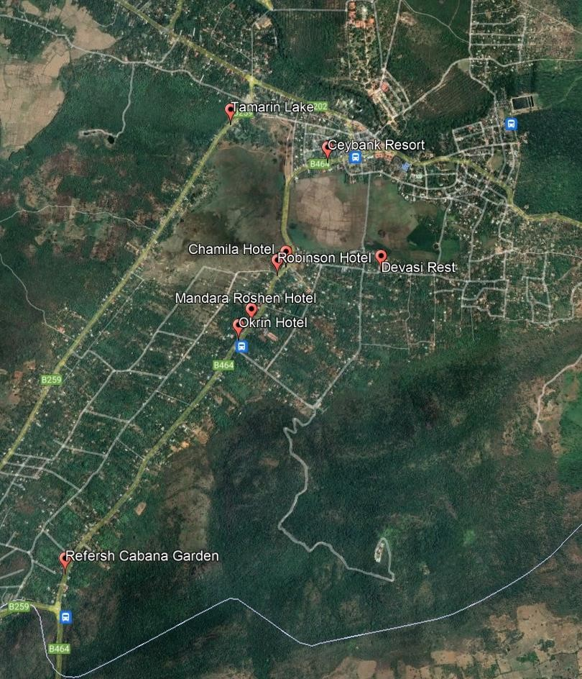

Annex IV: Sewer Network
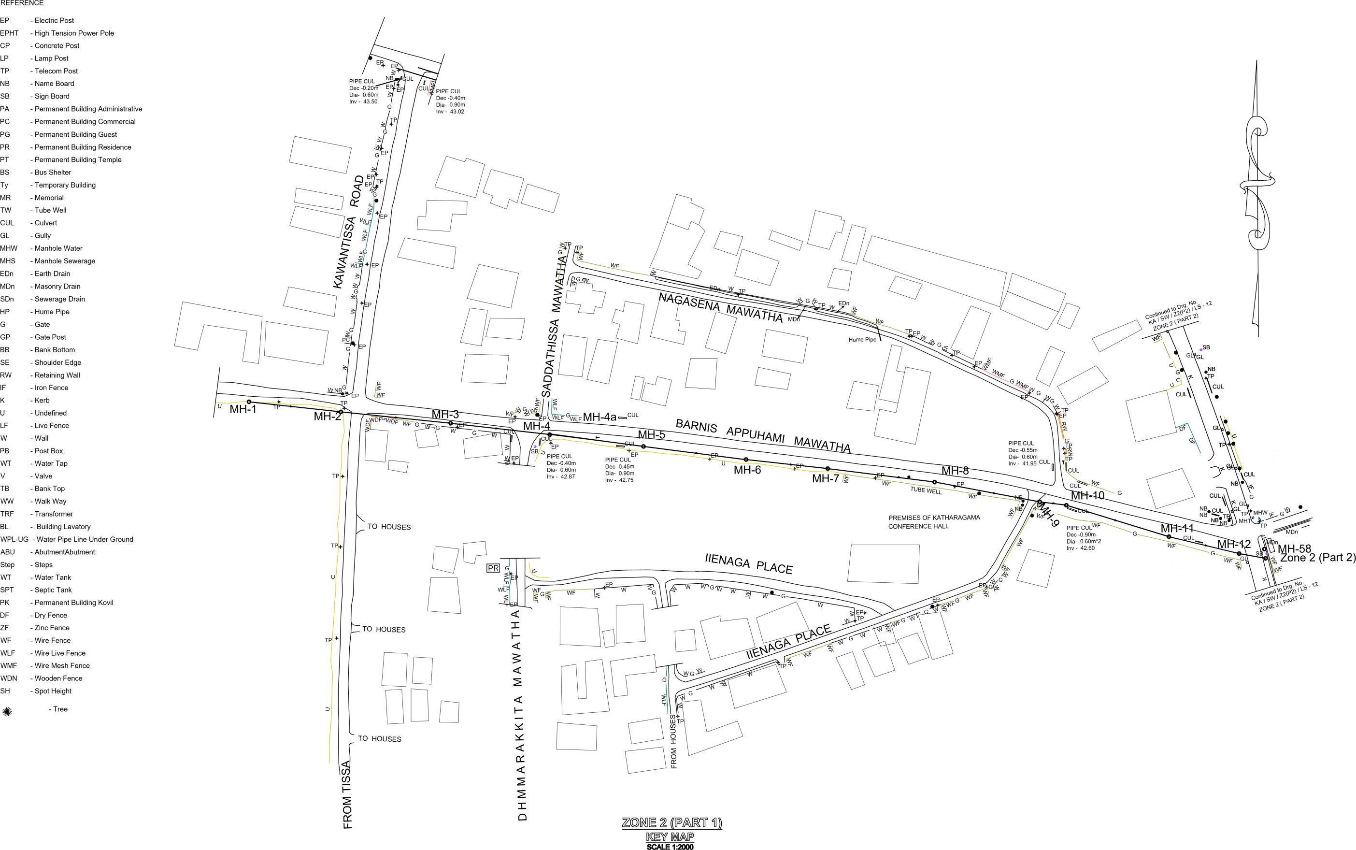

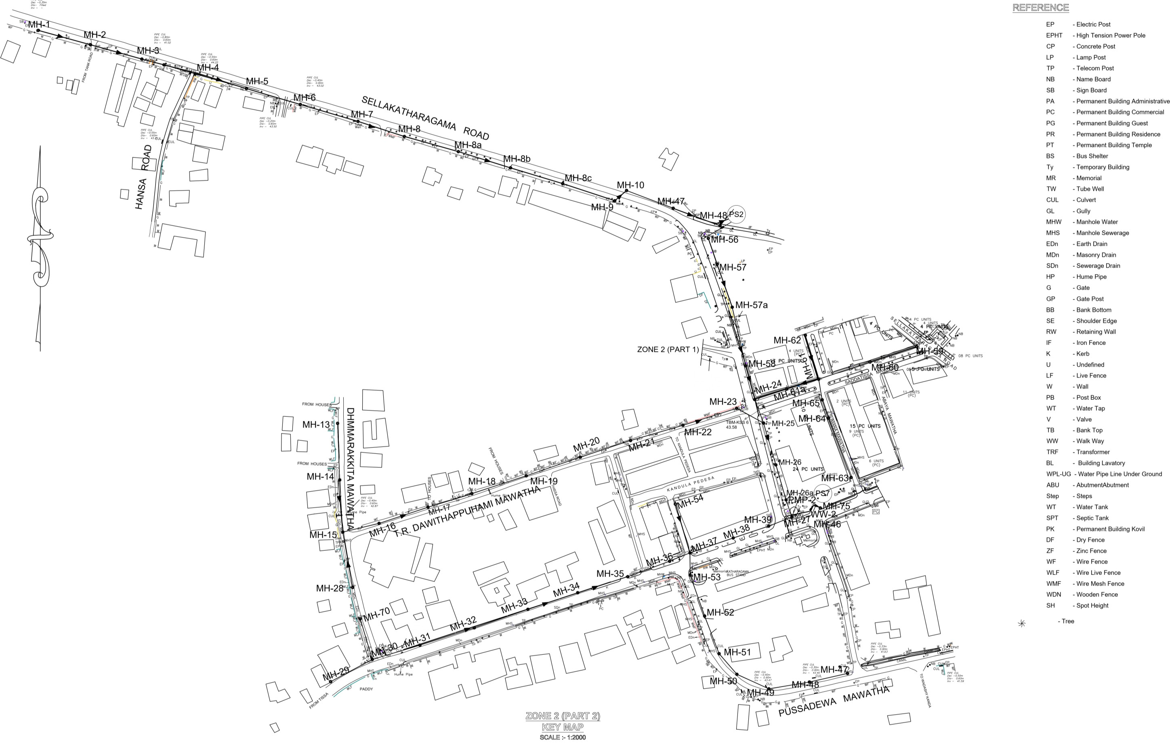

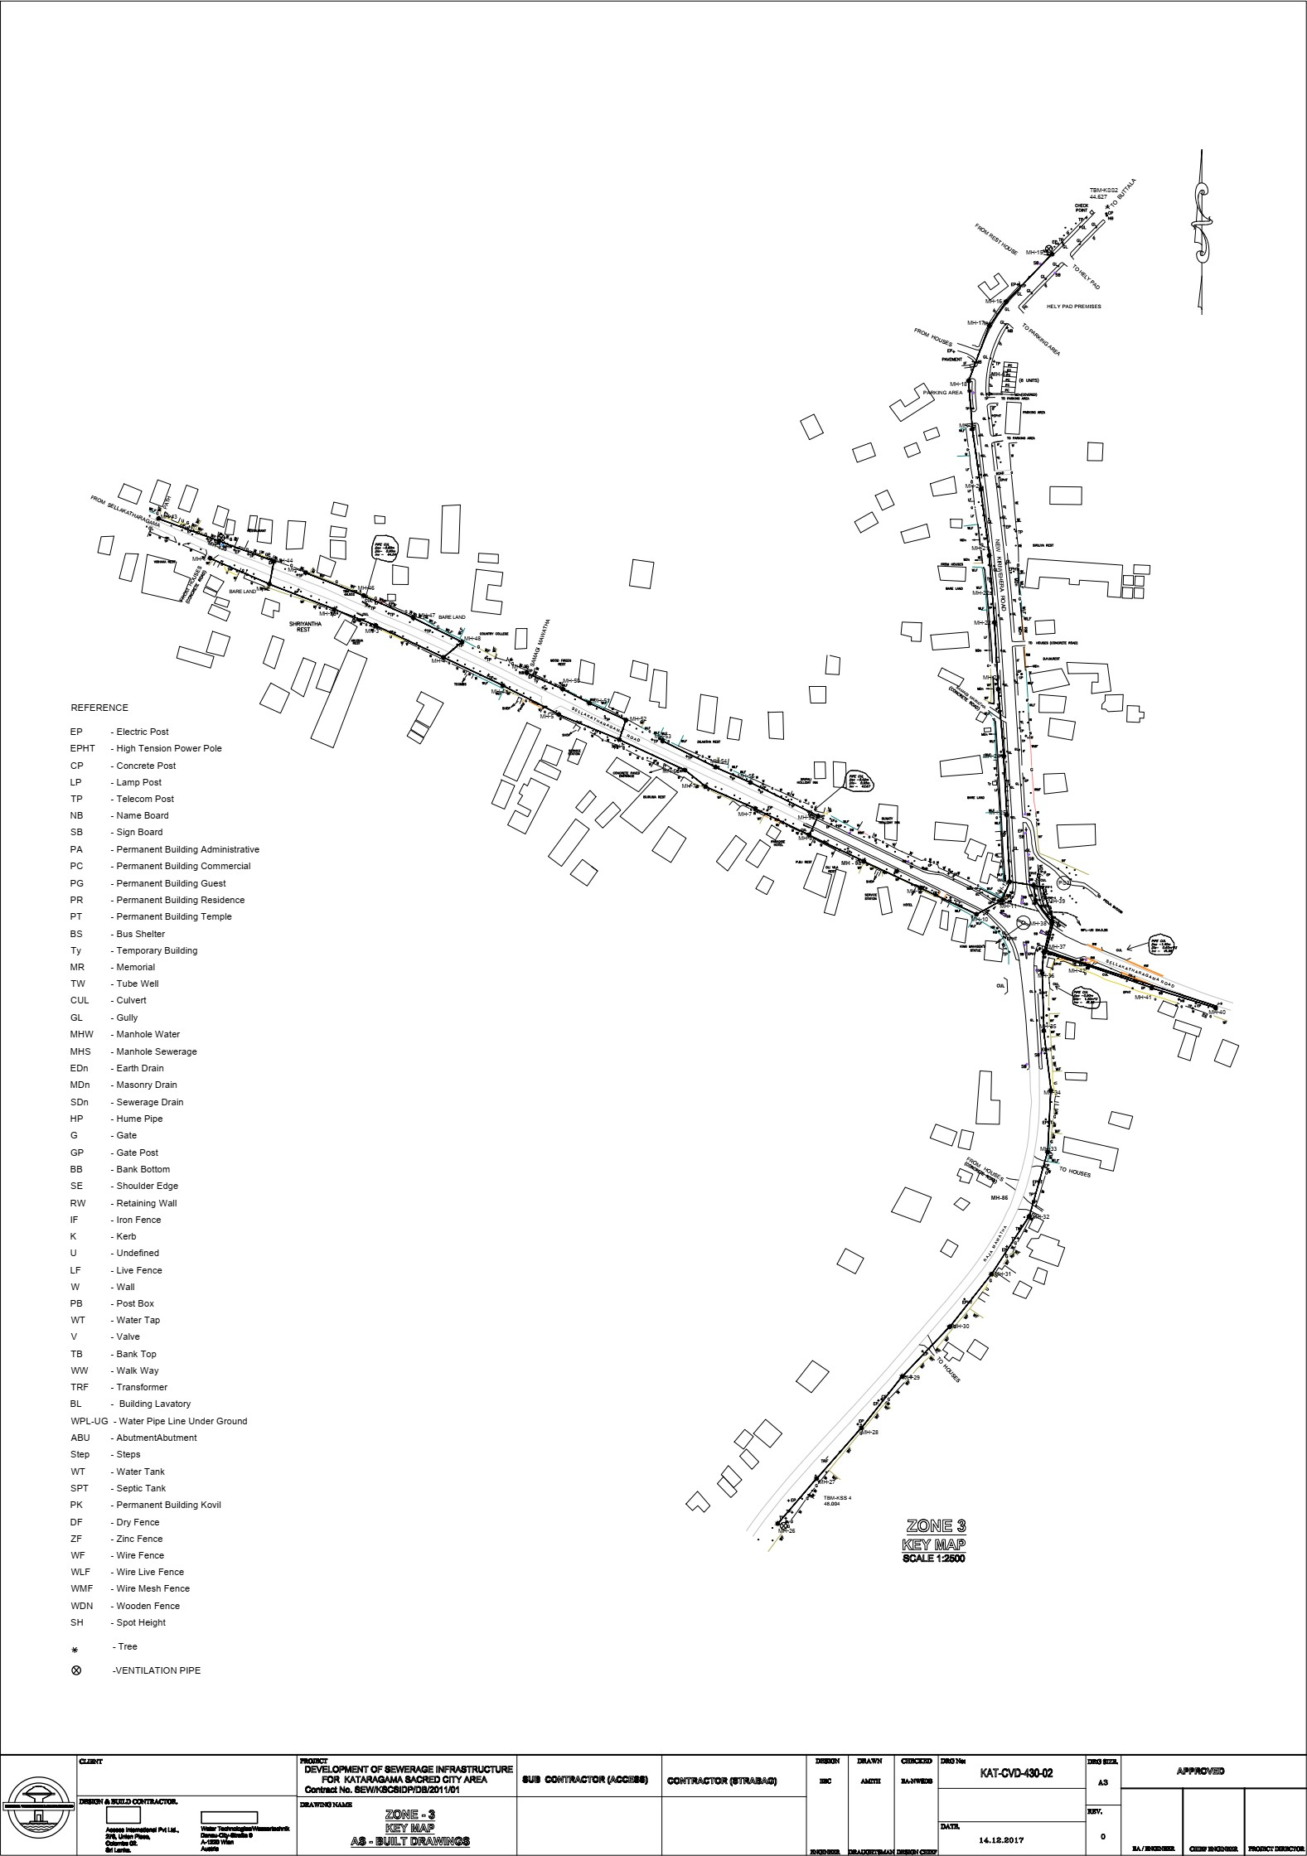

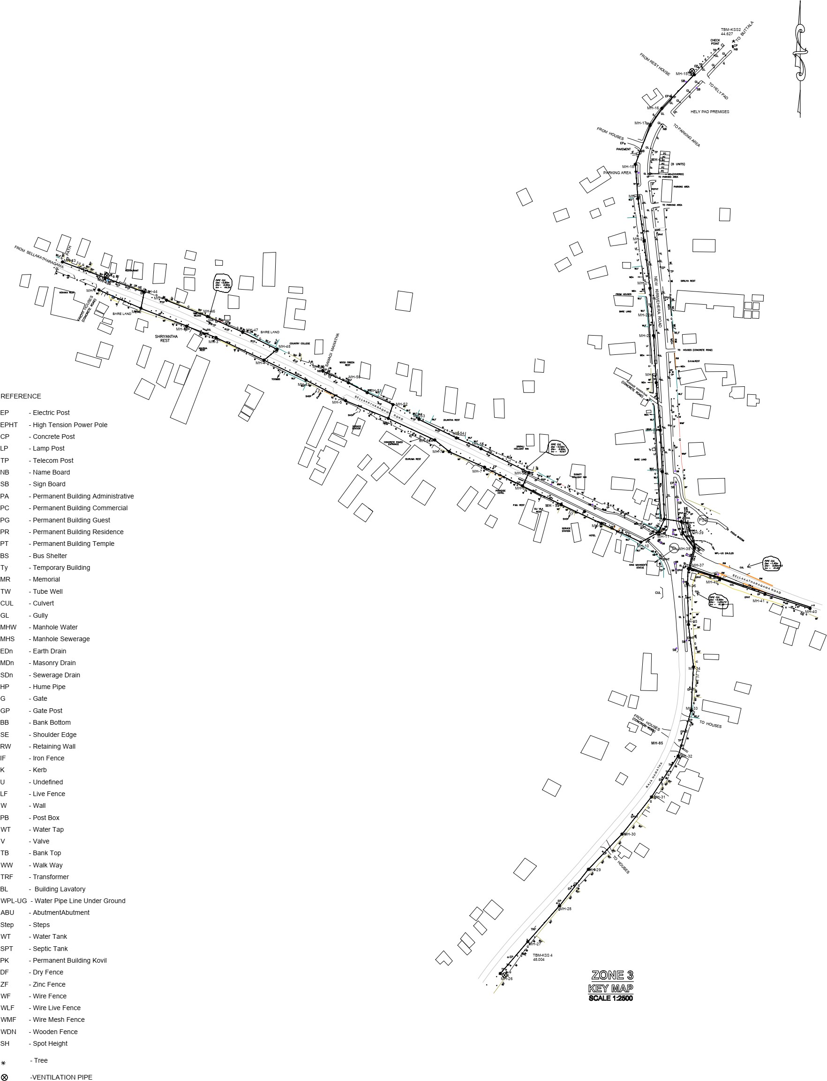

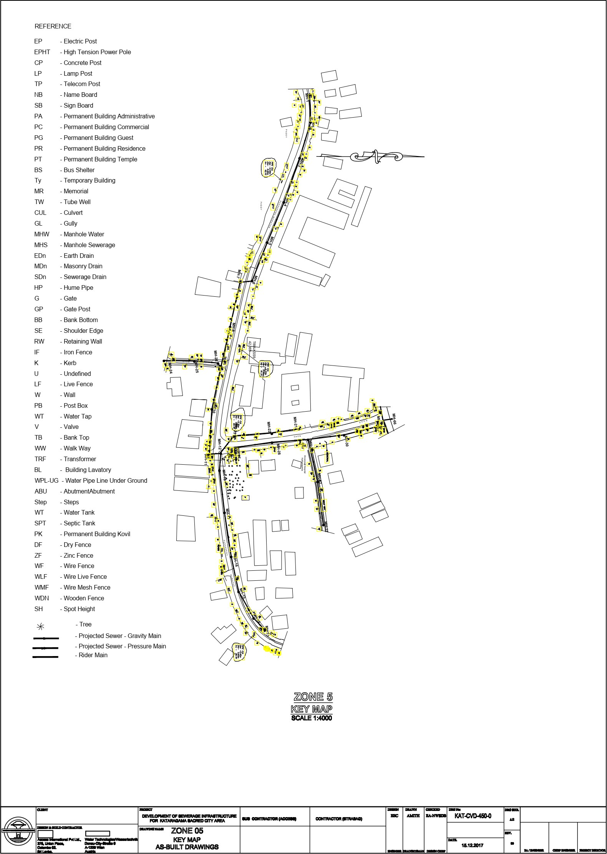

Annex V: Overflow Lines

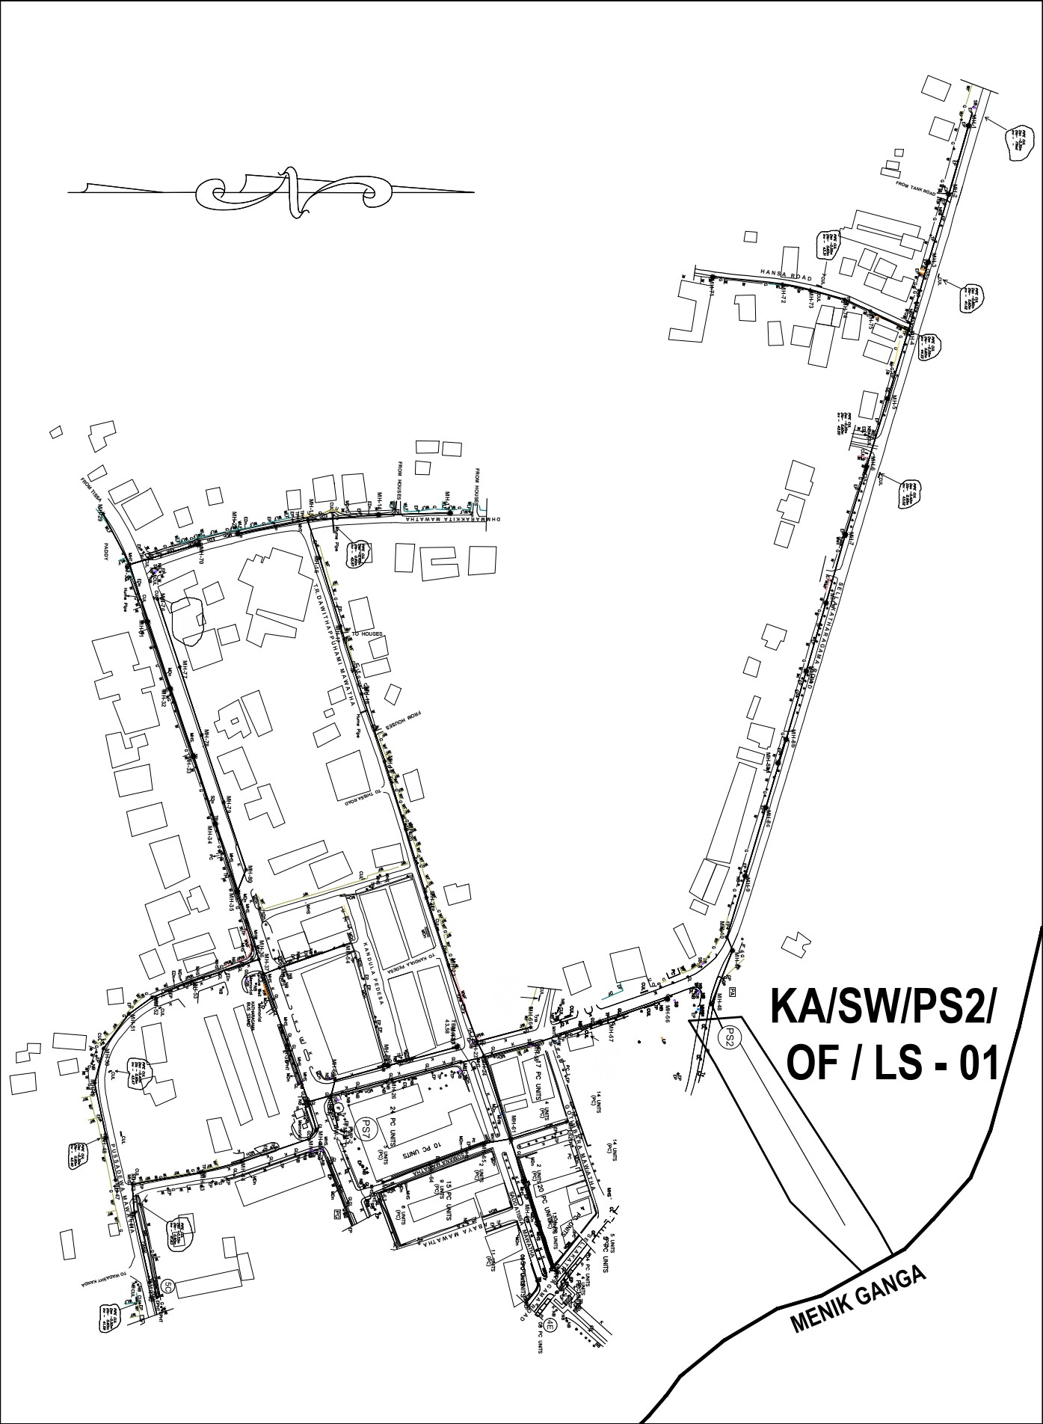

Annex VI.A: plan view of mechanical pretreatment system of Kataragama Wastewater Treatment System
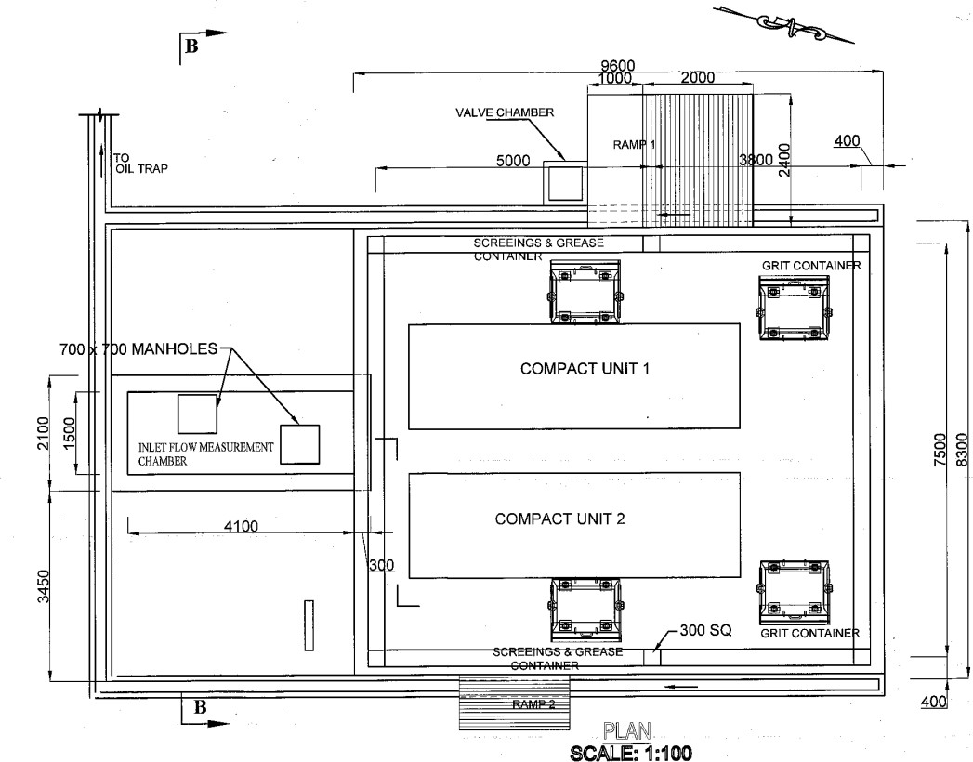

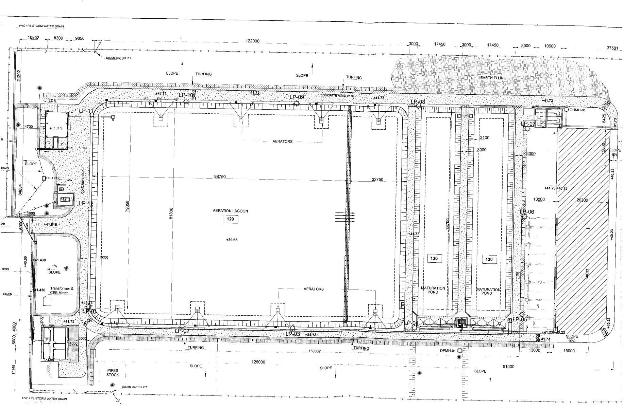
Annex VI.B: Plan view of the Secondary Treatment system of the Kataragama Wastewater Treatment System

Annex VI.C: plan view of the Disinfection system of the Kataragama Wastewater Treatment System
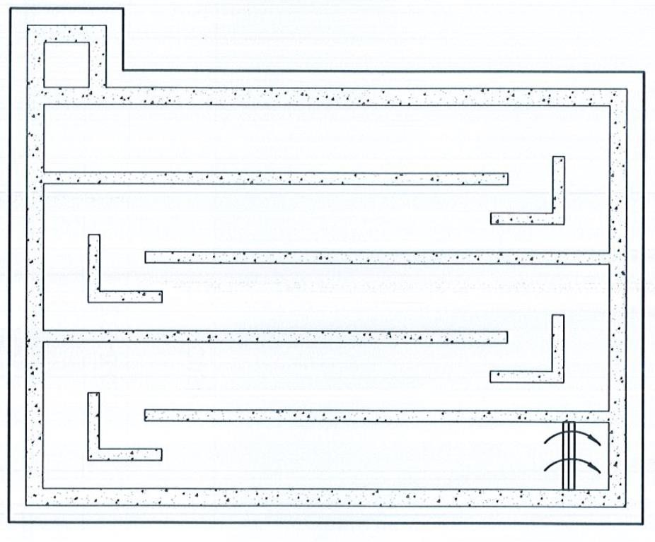

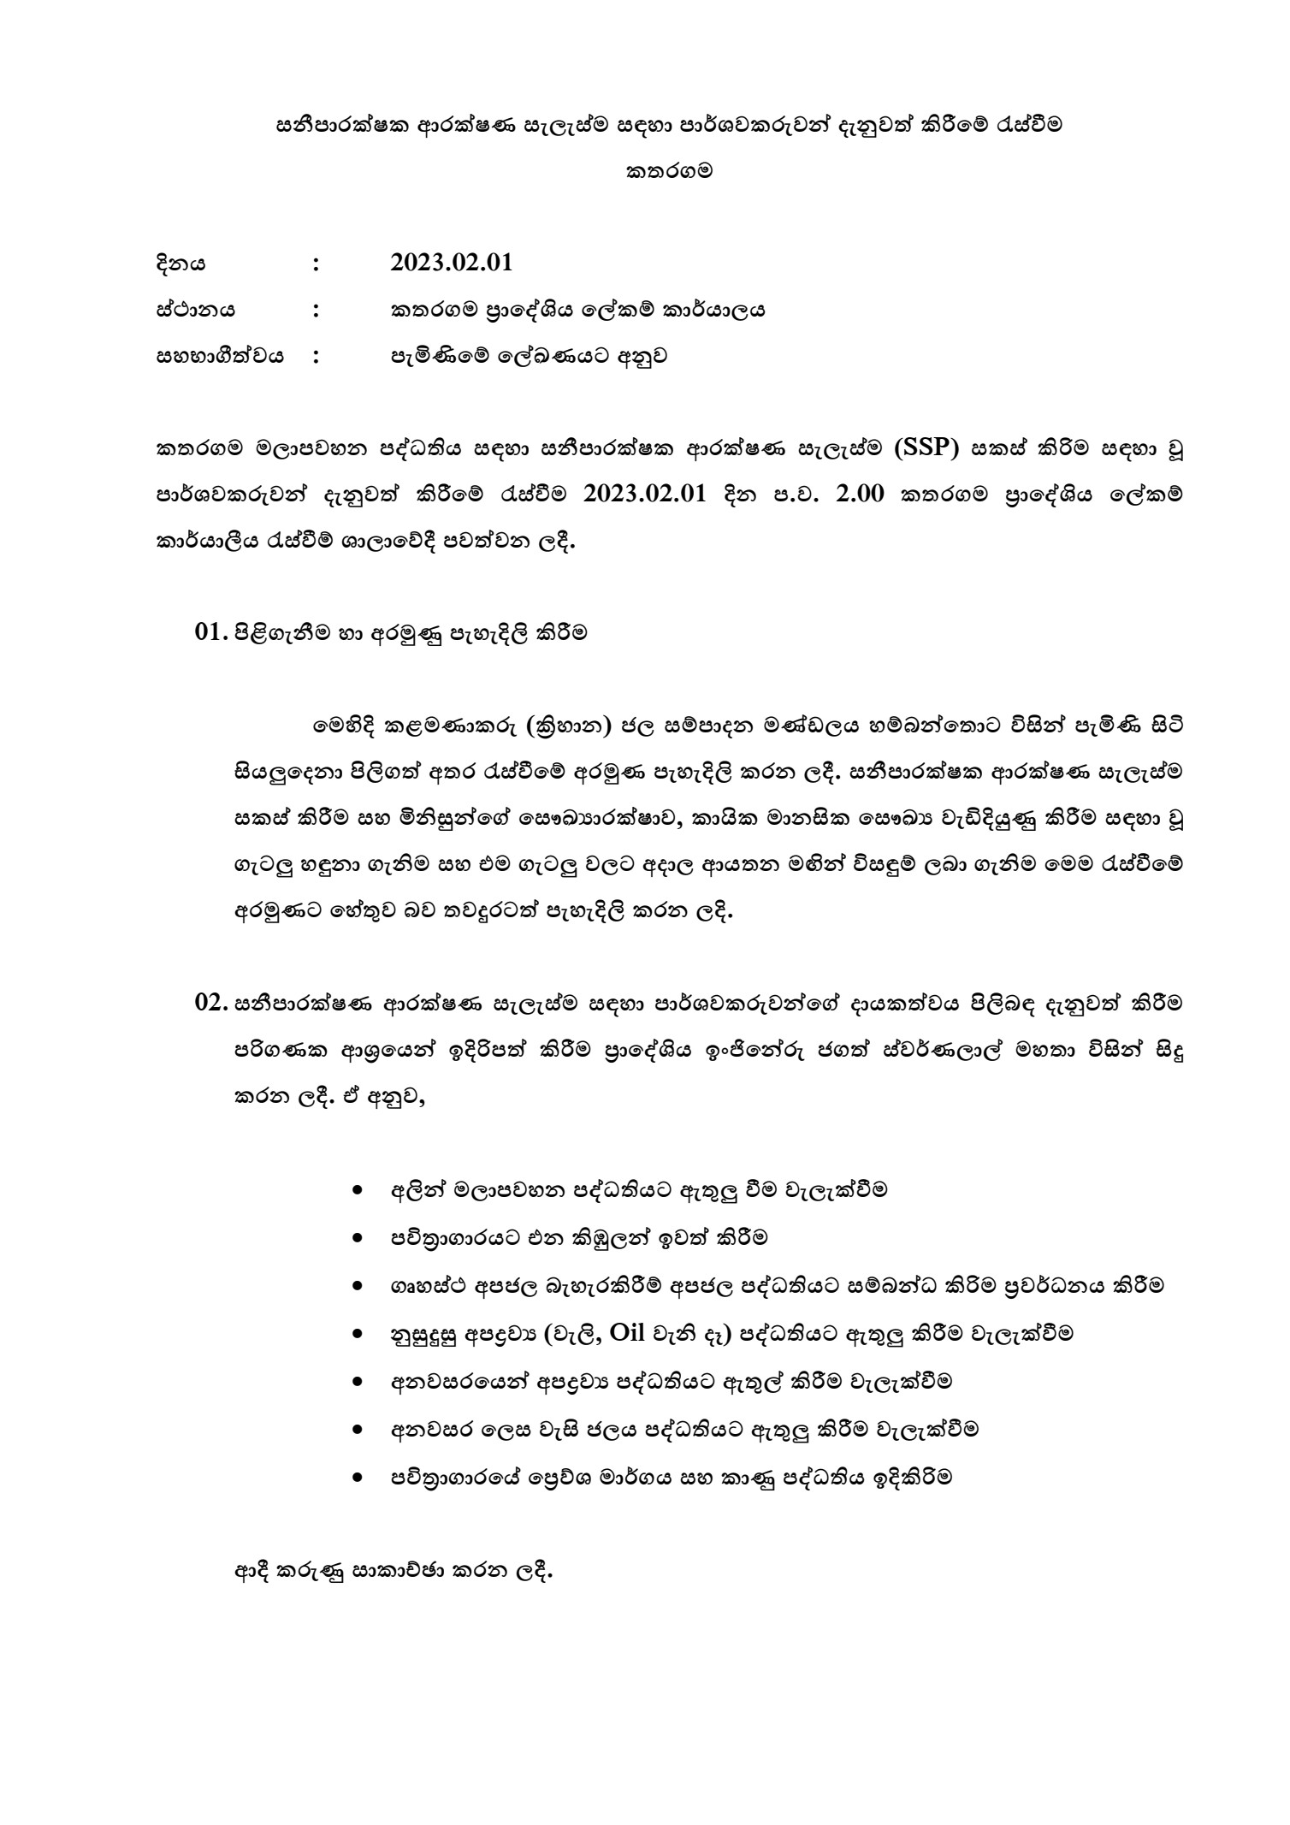
Annex VII: Meeting minutes of the stakeholder meeting

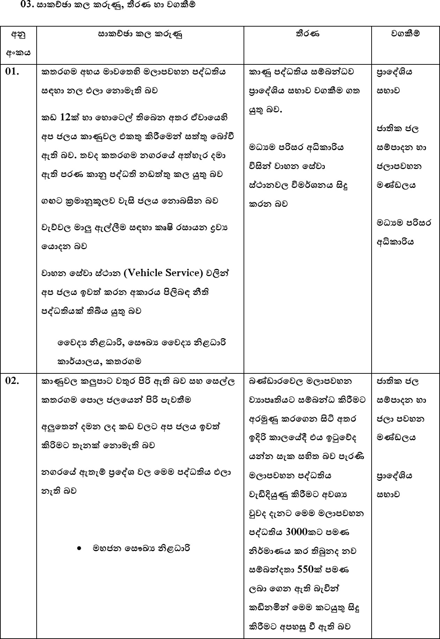

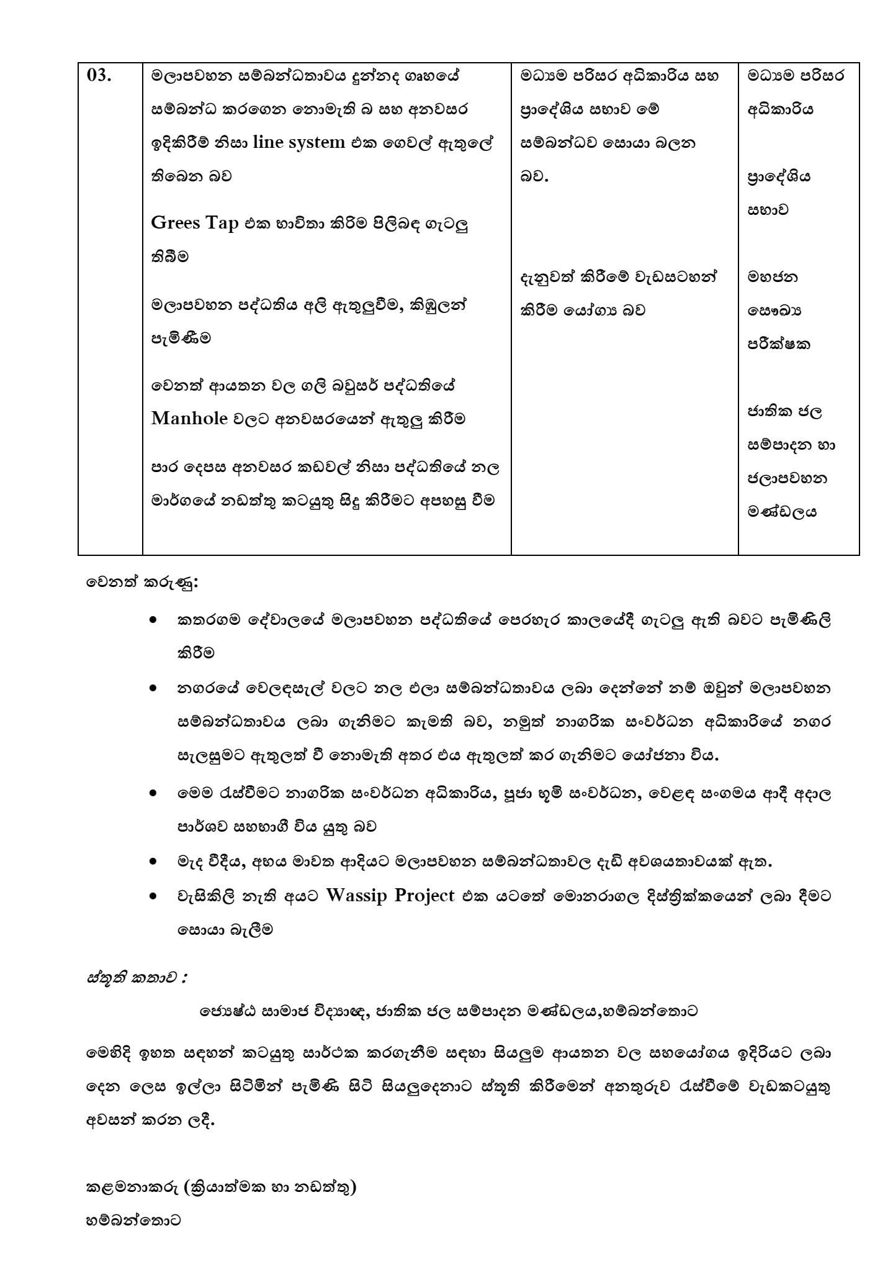

අනු  අංකය | නම | තනතුර | වංවිධළනය | දුරකථන අංකය
1. | ඒ.එම්.නන්දසිරි මයළ | දිවහත්‍රික් ල කමකම් | දිවහත්‍රික් ල කමකම් කළර්යළ඼ය | 0714454441
2. | ටී.ආර්.ඊ. ජයවීර මයළ | කජෙ඿හප ඳරිවර නි඼ධළරි | ඳරිවර අධිකළරිය | 07118163236
3. | ඩබ්.ඒ.ඩී.සී. අකබ්සිරිලර්ධන මයළ | ලනජීවී නි඼ධළරී | ලනජීවී නි඼ධළරි කළර්යළ඼ය | 0718787103
4. | යූ.ජී. කරො඿ළන් වංජීල මයළ | ආඳදළ වශන  කවේලළ නිෂධළරි | ප්‍රළකිය ය කමකම් කළර්යළ඼ය | 0717549036
5. | එවහ.එම.එවහ. වම්ඳත් මයළ | ග්‍රළම නි඼ධළරි | දිවහත්‍රික් ල කමකම් කළර්යළ඼ය - කතරගම | 0768026262
6. | එම.එ.සී. උමයංගනී මයළ | ග්‍රළම නි඼ධළරි | දිවහත්‍රික් ල කමකම්  කළර්යළ඼ය - කතරගම | 0715165191
7. | කක් ල.ජී.එවහ.඼ක් ලමිණි මයළ | ග්‍රළම නි඼ධළරි | දිවහත්‍රික් ල කමකම් කළර්යළ඼ය -  කතරගම | 0712390463
8. | එච්.ඩබ්.චන්දන මයළ | ජ඼ න඼ ශළ විදුලි කළර්මික | කතරගම | 0707875803
9. | එච.එම්.කක් ල.එසහ.රත්නළයක මයළ | ඉංජිකන්රු වශකළර | ලළරිමළර්ග  කදඳළර්තකම්න්තුල | 0707556495
10. | බී.එම්.ජී.වසි඲ මයළ | ඉංජිකන්රු වශකළර | ජළතික ජ඼ වම්ඳළදන ශළ ජ඼ළඳලශන  මණ්ඩ඼ය | 0715267230
11. | අජිත් කුමළර මයළ | කවෞඛ්‍ෙ ෛලදෙ නිෂධළරි | කවෞඛ්‍ෙ ෛලදෙ  නිෂධළරි කළර්යළ඼ය - කතරගම | 0714810986
12. | ඩී.එම්.චතු඿ළන් නිමන්ත මයළ | තළක් ල඿ණික නිෂධළරි | ප්‍රළකිය ය වවළල - කතරගම | 0740241767
13. | එම්.එවහ.ප්‍රියංගනී මිය | කජෙ඿හප වමළජ විදෙළඥ | ජළතික ජ඼ වම්ඳළදන ශළ ජ඼ළඳලශන  මණ්ඩ඼ය | 0718382356
14. | කක් ල.ඒ.සී.එම්.දුමෂිකළ මිය | කජෙ඿හප රවඥ | ජළතික ජ඼ වම්ඳළදන ශළ ජ඼ළඳලශන  මණ්ඩ඼ය | 0764193278
15. | ජී.එන්.ආර්.ඩබ්.එම.ගුණරත්න | මශජන කවෞඛ්‍ෙ නිෂධළරි | කවෞඛ්‍ෙ ෛලදෙ නිෂධළරි කළර්යළ඼ය - කවම඼ කතරගම | 0714193898
16. | කක් ල.ඩී.ටී. මධු඿ළන් මයළ | මශජන කවෞඛ්‍ෙ නිෂධළරි | කවෞඛ්‍ෙ ෛලදෙ නිෂධළරි කළර්යළ඼ය -  කතරගම | 0774911786
17. | නි඾ළන් වීරරත්න මයළ | කෂමනළකරු (ක්‍රියළත්මක ශළ  නඩත්තු) | ජළතික ජ඼ වම්ඳළදන ශළ ජ඼ළඳලශන  මණ්ඩ඼ය | 0773364278
18. | ජගත් වහලර්ණ඼ළම මයළ | ඉංජිකන්රු  (ක්‍රියළත්මක ශළ නඩත්තු) | ජළතික ජ඼ වම්ඳළදන ශළ ජ඼ළඳලශන  මණ්ඩ඼ය | 0761203457

19. | ඩබ්.ඒ.ඩී.එච්.කක් ල. චන්ද්‍රප්‍රිය මයළ | ලනජීවී නි඼ධළරී | ලනජීවී නි඼ධළරි කළර්යළ඼ය | 0714883429

