SANITATION SAFETY PLANING
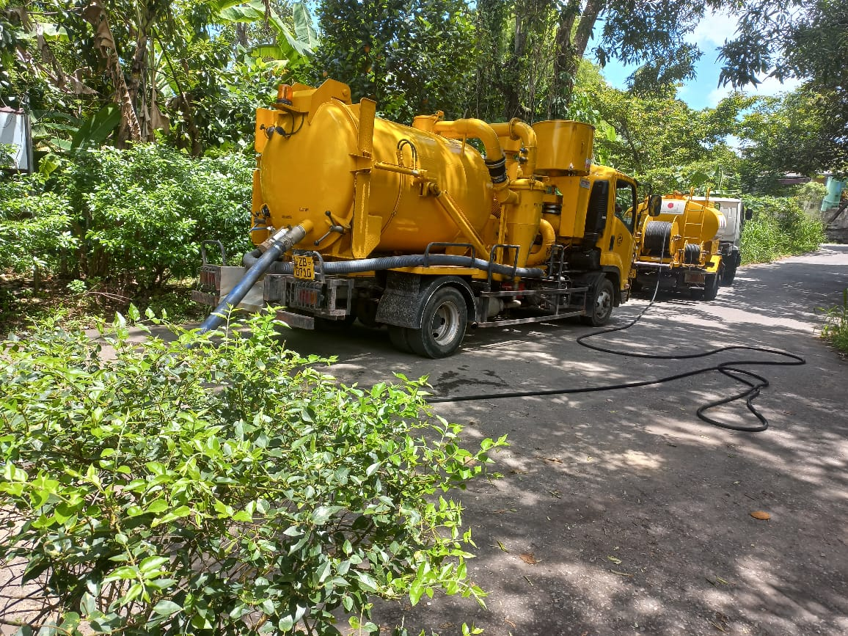

Prepared By :
SANITATION SAFETY PLAN TEAM
WATER RECLAMATION DIVISION - KOLONNAWA
NATIONAL WATER SUPPLY AND DRAINAGE BOARD
August-2024

Table of Contents:
Content of figures………………………………………………………………
Content of tables……………………………………………………………
Abbreviations and Acronyms………………………………………………………
INTRODUCTION………………………………………………………………………………
  - PREPARATION OF SANITATION SAFETY PLAN (SSP The SSP Area and the Lead Organization ……………………………………..
  - The SSP Team…………………………………………………………………
  - Establishment of SSP Priorities………………………………………………..

- SYSTEM DESCRIPTION …………………………………………………………

  - System Map…………………………………………………………………….
  - Characterize System Flows……………………………………………………
  - Identify Exposure Groups………………………………………………………
  - Supporting Information…………………………………………………………
  - Confirmation of System Description……………………………………………

- HAZARDOUS EVENTS, ASSES,ENT OF EXISTING CONTROL MEASURES AND RISK EXPOSURE……………………………………..

  - Identification of Hazards and Hazardous Events……………………………………..
  - Identification and Assessment of Existing Control measures…………………………
  - Assessment and Prioritization of Risk Exposure ……....................................................

Abbreviations and Acronyms

BOD | Biochemical Oxygen Demand
CEA | Central Environmental Authority
CMR | Compliance Monitoring Report
COD | Chemical Oxygen Demand
DA | Department of Agriculture
FOG | Fat, Oil, and Grease
LA | Local Authority
MOH | Ministry of Health
NWSDB/ NWS&DB | National Water Supply and Drainage Board
PHI | Public Health Instructor
PPE | Personal Protection Equipment
PS | Pump Station
RSC | Regional Support Center
SSP | Sanitation Safety Plan
SSC | Sewer Service Connection
STP | Sewage Treatment Plant
TP | Treatment Plant
TSS | Total Suspended Solids
UDA | Urban Development Authority
VT | Vacuum Truck
VTU | Vacuum Truck Unit
WR | Water Reclamation
WWTP | Wastewater Treatment Plant
WWTS | Wastewater Treatment System

Definition of Terms

Bio solids – Organic materials resulting from the treatment of sewage and septage sludge; residue generated during the treatment of domestic sewage and septage in a treatment facility

De-slugging — The process of cleaning or removing the accumulated domestic sludge or septage.

Dewatering — This is the process of reducing the moisture content of sludge to lessen the volume and odor, e.g. vacuum, filter, centrifuge, belt filter press, filter press, sludge drying beds, and lagoons.

Disinfection — This is the process of destroying pathogenic organisms either by physical (e.g. application of heat) or chemical (e.g. chlorine application) means.

Effluent – A general term denoting any wastewater, partially or completely treated, or in its natural state, flowing out of a manufacturing plant, industrial plant, or treatment plant.

Exposure— Contact of a chemical, physical or biological agent with the outer boundary of an organism (e.g. through inhalation, ingestion, or dermal [skin] contact).

Hazard—A biological, chemical, or physical constituent that can cause harm to human health
Helminth— Helminths are a broad range of organisms that include intestinal parasitic worms: trematodes (flatworms, also commonly known as flukes, e.g. Schistosoma), nematodes (roundworms, e.g. Ascaris, Trichuris and the human hookworms) or custodies (tapeworms, e.g. Tania solium, the "pork tapeworm")

Influent – Waste water flowing through the sewer lines/conveyance into a treatment plant
Pathogens – Disease-causing organisms (e.g. bacteria, helminthes, protozoa, or viruses).
Risk – The likelihood and consequences that something with a negative impact will occur.

Septage - Also known as Domestic Sludge or the solid particle of domestic sewage, which settles at the bottom of the sedimentation tank and is digested by anaerobic bacteria, purely from domestic sources, exclusive of industrial and hazardous wastes.

Sewage - or also known as Domestic Sewage — wastewater composed of raw liquid and solid waste coming from residential and commercial uses, exclusive of industrial and hazardous waste.
Wastewater – Sewage and fecal sludge

INTRODUCTION
Personal hygiene is essential to sustain life .An adequate sanitation safety planning(SSP)can be help identify and prioritizing health risk in the sanitation systems, and ensure that control measures target the greatest risks and improve sanitation systems by guiding investments based on actual risk and promoting health benefits. The SSP is a proactive approach recommended by the World Health Organization (WHO) for the management of sanitation systems. It aims to identify potential hazards and implement control measures to minimize risks associated with wastewater management. The plan emphasizes a systematic assessment of the entire sewerage system, from collection to final disposal, ensuring that all potential risks are addressed.
Waterborne diseases remain one of the major health concerns in the world. Diarrheal diseases, such as cholera, typhoid, intestinal worm infections and polio. Which are derived from contaminated waste water and inadequate poor sanitation
Diarrhoea, Leptospirosis and Dengue are common diseases that affect the general public after the rainy season.
In addition to the epidemics that could spread because of animals, diseases could also spread due to fecal matter mixing with water. Skin Diseases and Respiratory disorders are common among them.
sustainable Development Goals (SDG) Target 6.2 | Sanitation and hygiene: By 2030, achieve access to adequate and equitable sanitation and hygiene for all and end open defecation, paying special attention to the needs of women and girls and those in vulnerable situations.
Scop and limitations
Kolonnawa sewerage system is one of the sewerage system in Colombo district of Greater Colombo water reclamation office. This sanitation safety planning(s s p) report outlines the current state of the Kolonnawa sewerage system, identifying key components, potential hazards, and associated risks. It details the methods and processes employed to assess these risks and present a series of control measures designed to mitigate them. The ultimate goal of this SSP is to ensure the continued safety and reliability of the Kolonnawa sewerage system, protecting the residents in the coverage area, sanitation workers of the OIC (Koloanawa) Office and the broader environment.
- Monthly average temperature
Kolonnawa recorded a average annual rainfall of 1500 mm and average annual temperature of 80°F (26.7 °C).
- Climate change scenario projected for the near future.

Policy of NWSDB

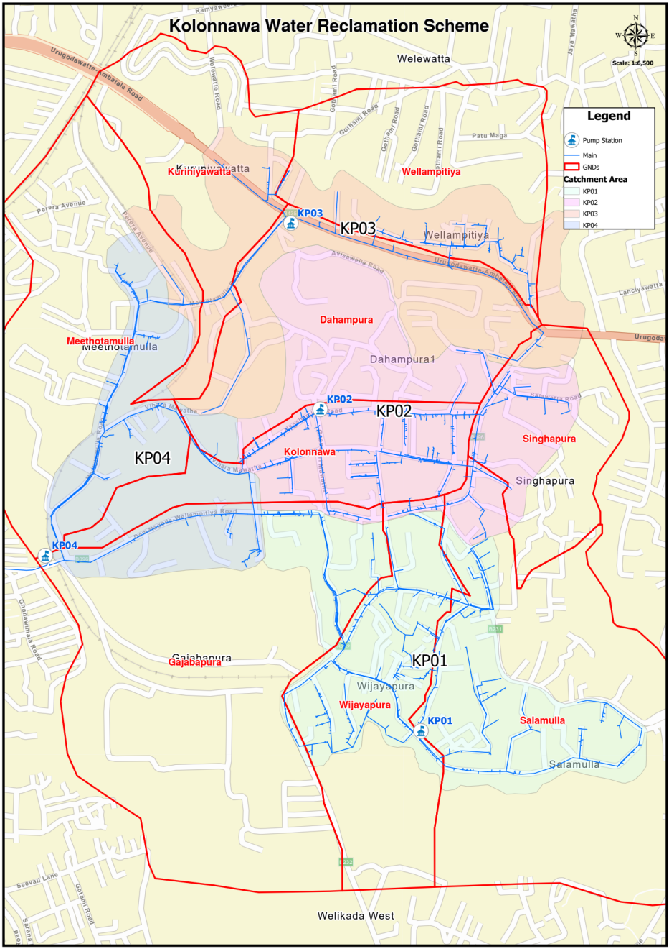
Figure 1: Service area in Kolonnawa UC area

Module 1
.. The Kolonnawa sewerage system is one of the sewerage systems within the Colombo district, under the jurisdiction of the Greater Colombo Water Reclamation Division of National Water Supply and Drainage Board (NWSDB). A Sanitation Safety Planning (SSP) has been developed to meet the policy requirements for the Kolonnawa sewerage system, encompassing the Kolonnawa Municipal Council Area in the Western Province of Sri Lanka. The network details of the Kolonnawa sewerage system are shown in the map.(Figure 1)
  - Lead organization
National Water Supply and Drainage Board is the lead organization. S S P of Kolonnawa is well targeted on field based training programmers, awareness programmers, preventive Maintenance programmers, Monitoring programmers, and Management review programmers.

1.2 The SSP Team
SSP team leader
Regional Manager Jayawadanagama, water reclamation division of NWSDB was appointed as the SSP team leader, having many years of experience in designing sanitation projects, and has resources, knowledge and management skills to lead project implementation.
The SSP core team
SANITATION STEP | SSP TEAM MEMBERS AND REPRESENTATION
Toilet and Containment – (Storage/treatment) | Municipal Councils,  Urban Development Authority  Pradeshiya sabha  (Kolonnwa, Kotikawatta-Mulleriya, Colombo Municipal councils)
Toilet and Containment – (Storage/treatment) | Central Environmental Authority (CEA)
Toilet and Containment – (Storage/treatment) | Medical officer of health (MOH) – Kolonnawa
Toilet and Containment – (Storage/treatment) | Public health innspector (PHI) – Kolonnawa
Toilet and Containment – (Storage/treatment) | Non-governmental organization (NGOs) working with sanitation for vulnerable populations
Conveyance (Emptying and transport of sewage and/or faecal sludge) | SSP team leader  Area Engineer  Mechanical Engineer EA (Civil),  EA (Electrical)  OIC (Kolonnawa)  EA (Mechanical)
Public and private (NWSDB and pradeshiya sabha) vacuum truck operators,
Sanitation workers and service providers
 | Authority for traffic law enforcement and licenses
Treatment and disposal | Mechanical Engineer EA (Civil),  EA (Electrical),  EA (Mechanical)
Treatment and disposal | Central Environmental Authority (CEA)
Entire sanitation service chain | Official of the NWSDB (SSP leader)
Entire sanitation service chain | Public health Inspector
Entire sanitation service chain | Climate change adaptation official or expert
Entire sanitation service chain | Representative of the district secretariat
Entire sanitation service chain | Representative of the divisional secretariat (Kolonnawa)  Sociologist  Chemist  OIC (Kolonnawa),  SSP team leader,  Area Engineer,  GS

Roles of the individuals on the SSP team in NWSDB ……….

NAME /JOB | TITLE | REPRES ENTING | ROLE IN SSP TEAM | Contact information
A.Sivabalan | Regional Manager | NWS&DB | Team Leader | 777883832
H.K.G.K.Alwis | Area Engineer | NWS&DB | Facilitator | 762074945
R.A N K .Ranathunga | Engineer (Civil) | NWS&DB | Facilitator | 714458316
M.P.M.C.Deshapriya | Engineer (Mechanical) | NWS&DB | Supporter in mechanical Section | 777811243
A.S.Weerawardhana | OIC Kolonnawa | NWS&DB | Supporter in operation & maintenance section | 701670558
K.A.prabuddha | TA(Kolonnawa) | NWS&DB | Supporter in operation & maintenance section | 714934488
W.G.Geethananda | EA (Mechanical) | NWS&DB | Supporter in operation & maintenance section | 714446596
A.L Kapila Bandu | EA (Electrical) | NWS&DB | Supporter in operation & maintenance section | 714166611
M.D.Sisira Gunasekara | Pump Operater | NWS&DB | Supporter in operation & maintenance section | 715451571
KP.I.Ariyawansha | Pump Operater | NWS&DB | Supporter in operation & maintenance section
Janaka Uyangoda | Pipe fitter | NWS&DB | Supporter in operation & maintenance section
K.D.T.Prasanna | Driver | NWS&DB | Supporter in operation & maintenance section | 718448532
 | Chemist
H D R P Jayasinghe | Sociology | NWS&DB | Supporter in operation maintenance section | 0773926462

Stakeholders’ analysis
In process of identifying and characterizing stakeholders and planning for their participation, depending their characteristics, such as importance and influence, the SSP core team decided to conduct a stakeholder analysis. After a brainstorming session, a list of state holders representing the entire sanitation service chain identified and analyzed.
Organisation | Job title | Rôle in SSP team
NWSDB-Water Reclamation Section | Convenance (Emptying and transport of sewerage and/or fécal sludge | Monitoring & communication  Coordinats, facilitât effective implémentations
C E A | Entre sanitation service Chain | Monitoring
Heath Département | Inspection, checking, Advice knowledge sharing | Monitoring & Coordinats
A G A office ,M. C ,P.S | Inspection, checking Advice | Monitoring & Coordinats
Education Département | Avayanace | Coordinat
U D A | Enter sanitation service Chain | Facilitât, coordinats

Multi-Stakeholders as Part of the SSP Team:
Equally important members of the SSP Team are the multi-stakeholders, such as individuals or groups that could affect or be affected by the activities carried out in relation to the sewerage management program, including individuals and groups from local government units, and national agencies.
Establishment of steering committee -:
Following the results of the stakeholder analysis, the SSP core team decided to invite the following people to form the SSP steering committee:
- District Secretariat – Colombo
- Head of Water Reclamation Section of NWSDB
- Members of Local Authorities (MCs/UCs/PSs) – Mayor/Chairman/Secretary (Kolonnawa, Colombo, Kotikawatte-Mulleriyawa)
- Divisional Secretaries– Kolonnawa
- Head of CEA – Battaramulla
- Head of UDA – Battaramulla
- Head of Regional Health Department (MOH) – Kolonnawa
- Head of Agricultural Department
- SSP Team Leader in NWSDB
- Road Development Authority - Battaramulla
- Provincial Road Development Authority- Western Province
  - Establishment of SSP Priorities
It was not feasible to develop SSP for all sanitation systems in Kolonnawa area because of limited resources. The SSP core team hosted a kick-off meeting with members of the SSP core team. The main objective of the meeting was to decide which sanitation systems were to be prioritized by SSP and which target systems are likely to pose the greatest health risks.

Members of the SSP core team decided to consider following priority areas in SSP;
- Sewered and unsewered areas in Kolonnawa OIC coverage area
transport
Emptying
containment
transport
Disposal

W.C to sewer
Pump house

Leak
Leakage

Safety emptied
Legally dumped

C M C MAN
HOLE
96%

On site facility
Illegally dumped

Unsafe emptied

Safety abandoned
When full

when
Open defecation

5%

2% 29% 10%

Sewerage areas:
In Kolonnawa Urban Counsel area 35% house householders are connected to the sewer network. The percentage of households connected with the pipe borne sewer system in the coverage area is 90%

There are also instances, interception chambers from households connected to the sewers or manholes overflow due to blockages. The wastewater is leaked into the environment creating nuisance and pollution ending in the loss of the reputation of NWSDB. The public in the area faces inconvenience. The leak repair adds cost to the day-to-day operation and maintenance activities including replacing materials and additional labour costs.

Un-sewerage areas:
The most answered areas within and outside the limits of the sewer network in Kolonnawa is handled by onsite sanitation systems such as septic tanks/pit latrines and soakage pits. Houses with septic tanks and soakage arrangements located in these areas are regularly served at KP III Pump House through vacuum trucks of Kolonnawa MC and Kotikawatte-Mulleriyawa PS registered in NWSDB.
Water reclamation centers utilizes vacuum truck units(VTUs) to collect faecal sludge from customers in unsewered areas.
There are also instances, when customers request immediate de-slugging (e.g., overflowing septic tanks) which are classified as unplanned activities, water reclamation centers will cater to such requests having spare capacity. Such de-sledging requests are handled by either NWSDB or 3rd party vacuum trucks.
Customers have to support the de-slugging activities. Once, VTUs have reached the premises which requires de-sledging, the personnel prepare the hose to be used, opens the septic tank cover slab or MH cover and proceed the de-slugging work.

Module 2

2 SYSTEM DESCRIPTION:
The regional manager relevant to the Water Reclamation Section in Kolonnawa, NWS&DB, oversees the provision of sewer service connections, maintenance and repair of the sewer network, handling customer complaints, and the operation and maintenance of wastewater facilities (sewage and fecal sludge). Additionally, the manager is responsible for planning the expansion of sewerage coverage. The main tasks for sanitation services include sewage and fecal sludge management, handling customer complaints, fleet maintenance, and planning for the expansion of sanitation coverage within the Kolonnawa water reclamation system.
Sewered areas receive sewerage services, including the installation of new sewer service connections and the operation and maintenance of pump houses, conveyance systems, and the sewer network.

Background Information

The Kolonnawa Urban Council (KUC) area has a sewer collection system for 8 priority, 2,933 domestic and 12 commercial sewer connections which covers about 35% of the population in this administrative area. The gravity collection system consists of 701 manholes and 25 km long gravity sewers. The wastewaters is collected to four pump stations (KP1, KP2, KP3 and KP4) with 2.5 km pumping mains and discharge the wastewater to Colombo Municipal Council (CMC) manhole at Dematagoda.

Flow Diagram
MH
MH
MH
MH
MH
MH
MH
KP3
1986
21.4 L/s
5.5 hours/day

KP2
1986
16.4 L/s
9 hours/day

KP1
1986
17.5 L/s
13 hours/day

KP4
1986
33.3 L/s
12.5 hours/day

200 mm DI, 468 m, 1986
200 mm DI, 286 m, 1986
225 mm PVC, 927 m, 2019
200 mm DI,
72 m, 1986
250 mm DI, 410 m, 1986
Legend
NWSDB pumping main
NWSDB gravity main
CMC gravity system

PM No | Start Point | End Point | Material | Type | Dia (mm) | Length (m) | Commissioned Year | Age (years)
PM 23 | KP1 | Kepitipola Vijaya Road main junction and kolonnawa gajaba rd junction KS20-10 MH | PVC | 1000 | 225 | 927 | 2019 | 5
PM 23 | Kepitipola Vijaya Road main junction | Kepitipola Vijaya Road main junction to kolonnawa gajaba rd junction | DI | Socket and spigot | 200 | 72 | 1986 | 38
PM 24 | KP2 | KS23-8 MH at Nagahamulla | DI | Socket and spigot | 200 | 286 | 1986 | 38
PM 25 | KP3 | KS22-3 MH at Perera Mawatha | DI | Socket and spigot | 200 | 468 | 1986 | 38
PM 26 | KP4 | CMC MH at Dematagoda | DI | Socket and spigot | 250 | 410 | 1986 | 38

T1.Sewer Lines
pumping stations


Sewage
P4.Secondary treatment
P3.Pre – treatment of waste water
P1.Households /Commercial Establishment

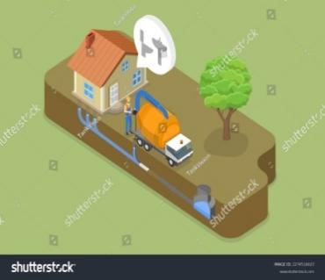
Grit /Sand
P5.Grit Trapped in Grit Channel
P2’.Pre – treatment of faecal sludge
Faecal sludge
T2.Vacuum truck

P2.Toilet and Containment (Storage/treatment with septic tank and soakage pits

T3



Grit storage area

Water Reclamation system - Kolonnawa

P1: Sewage From house hold, and commercial establishments
The system starts with households where wastewater is generated. At present around 2941households are connected to the sewer network. In addition, wastewater from commercial, government institute, board quarters and their establishments are accommodated as long as their wastewater meets the discharge standards to public sewer.

T1: Sewer network and pumping station
The wastewater generated by consumers, flows under gravity to sewer manholes and eventually collected four pump houses. The sewer network comprises with around…2163m of pumping sewer .Further, the system comprises with 706 number of man holes. The pump station consists of an underground sump, a pump house, a generator room. Then pump to CMC manhole at Dematagoda.

P2. Toilet and containment – storage / treatment with septic tank and soakage
At present Water Reclamation Center accepts fecal sludge from Kolonnawa and surrounding local authorities’ areas.

T2. Conveyance of faecal sludge by vacuum trucks
The fecal from household and commercial utilities are transported to WRC through VTU owned by NWSDB or UC Kolonnawa upon request by the households.
P2. Pre-treatment for foecal sludge
There is a bar rack to remove coarse particles (screenings) from the faecal sludge in the collecting well (Lifting unit) at the WRC. The screenings are washed, and eventually incinerated due to unavailability of sanitary landfills in the locality. After the screening of faecal sludge, liquid portion (Wastewater) is collected with sewage in the wastewater collecting well. The screens remove rags, paper and other large particles to prevent clogging in other equipment.

2.1 Characterize System Flows
Based on the information available, the SSP team used tool 2.1 to characterize the system flows and to collect key quantitative information, and information on the microbiological, physical and chemical hazards.
Table 2.1 – Characterization of system flow
Sanitation Step | Description of the System Flow (Excreta-related flow such as ww or sludge, and other waste streams when relevant to sanitation system) | Key Information of the System Flow (Volume, flow, concentration, etc.) | Expected Variations (Seasonal variations or unusual events, such as accidentally mixed components or climate events) | Type of Potential Hazard (Biological, chemical, or physical)
P1: Toilet and IC of houses, commercial establishments | S_{S1}=Receipt of sewage from households, commercial establishments | About 1500 m³ per day WW is collected. BOD could reach 300 mg/l | The sewage (Municipal WW) could contain faeces and urine (Black water), bathing water (Grey water), kitchen WW through grease traps. | Biological  Chemical
T1: Sewer network and pumping stations | S_{S2}=Transfer (Conveyance) of WW from WW generation stage to WWTP via sewer network and pumping stations | About 1500 m³ per day WW is collected. BOD could reach 200 mg/l | Strength of WW is reduced due to dilution | Biological  Physical  Chemical
P2: Toilet and containment-storage/treatment with septic tanks and soak pits | S_{FS1}=Faecal sludge collected in septic tanks and soak pits [Faecal sludge-solids and water that are collected in underground tanks] | About 100 m³ per day WW is collected. BOD could reach 600 mg/l | The sludge could contain anal cleansing materials, menstrual hygiene products, sharp objects and other foreign material. It may also contain chemicals present in grey water.  Depends on the soil type/ ground water table/Climate | Biological  Physical  Chemical
T2: Conveyance FS by vacuum trucks | S_{FS2}=Faecal sludge emptied into vacuum trucks and transported to the WWTP | About 100 m3 of faecal sludge is received every day. | No expected variations. | Biological  Physical

2.3 Identify exposure groups
The SSP team identified the exposure groups and how many are there, where they are and how exposure occurs. According to the 2018 WHO Guidelines on sanitation and health (WHO, 2018), the people most likely to be exposed to hazards during hazardous events at different steps of the sanitation service chain are as follows.
U Sanitation system users: all people who use a toilet.
L Local community: people who live and/or work nearby (who are not necessarily users of the sanitation system) and may be exposed.
W Sanitation workers: all people – formally employed or informally engaged – responsible for maintaining, cleaning or operating (e.g. emptying) a toilet or equipment (e.g. pumps, vehicles) at any step of the sanitation service chain.

Below is the list of exposure groups and its corresponding code.

W | Maintenance workers | W1
W | Pump Operators /Caretakers | W2
W | Machine Operators / Drivers | W3
L | Contractors | L1
L | Local community living | L2
L | visitors | L3

Conveyance
Exposure group ID | Who are the expos ure groups | How many are there | What are they doing there | What are they exposed to | How often are they exposed to this
w | W1-maintenance work  W2-pump operators/care takers | 15  5 | Operation maintantance and repairs in pump houses,manholes and sewer pipe network | Handling of faecal sludge and equipment used in repairs and new connection proses | Daily

Collecting samples
Expo sure group ID | Who are the expo sure groups | How many are there | What are they doing there | What are they exposed to | How often are they exposed to this
w | W1-W2 maintenance staff  W2-pump operators/care takers | 2  2 | Vacum truck monitaring | Collect samples from vacum truck invole staff | Daily

2.4: Supporting information

Information Sources | Summary of Key Observations
Standards and regulations
Central environmental authority (CEA) effluent discharge standards 2022 | BOD, COD, TSS, pH, TDS, E. coli limit, Faecal Coliform (FC), Helminth eggs,
Information Related to system Management and Performance
Demographics and land-use patterns | , Population near low-lying flood-prone areas where sanitation conditions are poor, Population where there are only basic sanitation available with onsite sanitation systems,
Changes relating to weather or other seasonal conditions | Demand for pit emptying also increases during heavy rainfall events, but flooding makes access to some areas difficult. Sewers overflow during severe rain events as a result of high flow and blockages caused by solid waste.

MODULE 3: IDENTIFY HAZARDOUS EVENTS, AND ASSESS EXISTING CONTROL MEASURES AND EXPOSURE RISKS

Descriptor | Description
kelihood (L)
1 | Very Unlikely | Has .t happened in the past and it is highly improbable it will happen in the next 12 months (or another reasonable period).
2 | Unlikely | Has .t happened in the past but may occur in exceptional circumstances in the next 12 months (or another reasonable period).
3 | Possible | May have happened in the past and/or may occur under regular circumstances in the next 12 months (or another reasonable period).
4 | Likely | Has been observed in the past and/or is likely to occur in the next 12 months (or another reasonable period). 5 Almost Certain Has often been observed in the past and/or will almost certainly occur in most circumstances in the next 12 months (or another reasonable period).
5 | Almost Certain | Has been observed in the past and/or is likely to occur in the next 12 months (or another reasonable period). 5 Almost Certain Has often been observed in the past and/or will almost certainly occur in most circumstances in the next 12 months (or anther reasonable period).
Severity (S)
1 | Insignificant | Hazard or hazardous event resulting in . or negligible health effects compared to background levels
2 | Minor | Hazard or hazardous event potentially resulting in minor health effects (e.g. temporary symptoms like irritation, nausea, headache).
3 | Moderate | Hazard or hazardous event potentially resulting in a self-limiting health effects or mi. illness (e.g. acute diarrhea, vomiting, upper respiratory tract infection, mi. trauma).
4 | Major | Hazard or hazardous event potentially resulting in illness or injury (e.g. malaria, schistosomiasis, food-borne trematodiases, chronic diarrhea, chronic respiratory problems, neurological disorders, bone fracture); and/or may lead to legal complaints and concern; and/or major regulatory .n-compliance.
5 | Catastrophic | Hazard or hazardous event potentially resulting in serious illness or injury , or even loss of life (e.g. severe poisoning, loss of extremities, severe burns, , drowning); and/or will lead to major investigation by regulator with prosecution likely

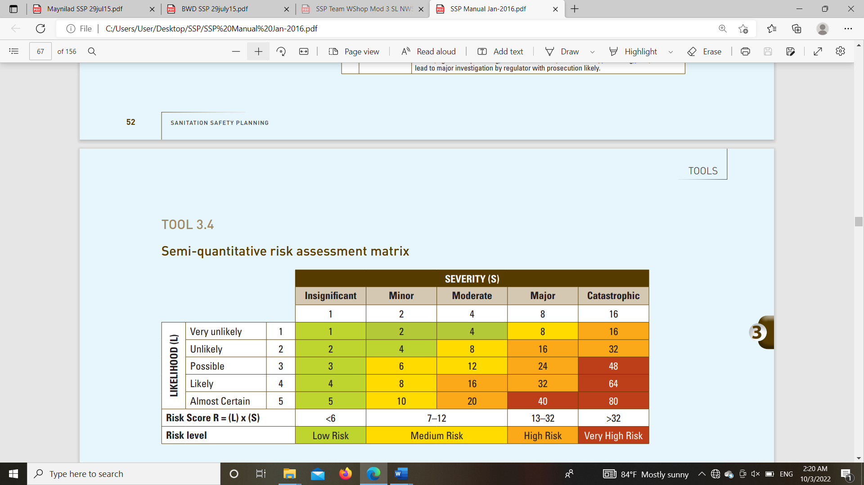

RISK DESCRIPTOR | .TES
Very High and High Risk | Actions need to be taken to minimize the risk. Possible options (short, medium and long term options) should be documented (as part of the improvement plan developed in the next Module) and implemented based on priorities and available resources.
Medium Risk | Currently low or very unlikely impact on exposure groups. The situation can be improved with operational changes or system improvement over the medium to long term.
Low Risk | Actions may be taken but .t a priority, or, action is needed at this time. The risk should be revisited in the future as part of the review process.
Unknown priority | Further data is needed to categorize the risk. Some action can be taken to reduce risk while more data is gathered.

The identification of hazards and hazardous events in the Kolonnawa sanitation system is crucial for ensuring the safety and effectiveness of the sanitation services. The following are potential hazards and hazardous events identified for the Kolonnawa area:

Physical Hazards
- Blockages and Overflows: Blockages in the sewer network or pump stations can cause overflows, leading to exposure to untreated sewage.
- Pump Failure: Mechanical or electrical failure of pumps, leading to the cessation of wastewater conveyance and potential overflows.
- Pipe Bursts: Bursts in sewer pipes can result in leakage of untreated wastewater into the environment.

Biological Hazards
- Pathogenic Microorganisms: Presence of bacteria, viruses, and parasites in sewage and faecal sludge can pose serious health risks to workers and the public.
- Vector Attraction: Accumulation of sludge can attract vectors such as flies and rodents, which can spread diseases.

Chemical Hazards
- Toxic Chemicals: Presence of hazardous chemicals from industrial or commercial discharges can contaminate wastewater and pose risks to workers handling the sludge.
- Disinfectant Residues: Improper use of disinfectants can leave harmful residues in treated water or sludge.

Operational Hazards
- Human Error: Mistakes during operation or maintenance, such as improper handling of equipment or incorrect de-slugging procedures, can lead to accidents or contamination.
- Inadequate Maintenance: Poor maintenance practices can result in equipment failure or leaks in the system.
- Natural Disaster : Blockages due to flood, or fire

3.1 IDENTIFY HAZARDS AND HAZARDOUS EVENTS
Sanitation step | Hazardous  event | Exposure  group | Number of people at risk | Risk | Projection of changer in risk with climate change scenarios | Priority given
Cleaning of collecting well | Sink in the colletin Wells (faeces/urine)  Injury to the body, possible asphyxiation, caused by entering or Slipping, tripping  falling into pump well | W1 | 8 | VHR | Increses in heavy rains | Very High
Conveyance of Sewer through the network ,I. C and Main holes | Ingestion after contact with excreta during the repaire work of blocking pipe lines and damaged pipe lines | W1 | 20 | H R | no effet from climate change | High
Pumping | Ingestion of contaminated groundwater due to infiltration from septic tanks and soak pits into shallow groundwater | U | 20000 | H R | Increses in heavy rains | High
Conveyance of FS by vacuum trucks | Ingestion after contact with raw sewage during vacuum tanker operation  Ingestion after contact  with faecal sludge  caused by spillage during  emptying and transport  Ingestion after contact  with faecal sludge while entering or falling into soak pits or septic tanks | W1  U  W1 | 20  6  20 | H R  HR  HR | Increses in heavy rains  Increses in heavy rains  Increses in heavy rains | High  High  High

Component | Hazard Identification |  |  |  | Existing Control(s) |  | Risk Assessment |  |  |  |  |  | Comments justifying risk assessment, under current conditions or climate change scenarios, or effectiveness of the control
Component |  |  |  |  |  |  | Under current  Conditions |  |  | Under the most likely climate change scenarios:  + means increased risk  - means decreased risk  = means the same risk
Component |  |  |  |  |  |  | L=Likelihood; S=Severity; R=Risk
Sanitation step | Hazardous event | Hazard | Exposure Groups | Number of persons at risk | Description of existing control | Validation of control | L | S | Score | R
Cleaning of collecting well  Conveyance of Sewer through the network, I. C and Main holes  Pumping station  Newconnection given | Sink in the collecting well  Maintenance work of pipe network. Leakages / overflows in pipe and manholes  Accidents due to use of heavy machines, Soil conditions, road accident  Falling in to Manholes  exposure to wastewater during existing  Air vale leaks  infiltration from septic tanks and soak pits into shallow groundwater  Inhalation of raw sewage (odour)  Accidents due to Working in Confined spaces  Accidents during Maintenance of electrical equipment and panels  Conveyance of F S by vacuum trucks operation  by spillage during  emptying and trasport | Injury to the body, possible asphyxiation  Ingestion of contact with excrea  Physical injury,  Dermal contact  Exposure to pathogens  and injuries  Pathogen, Ingestion after contact with excreta  Ingestion of contaminated groundwater  Toxic gases&physical injury  Electrical shock and  Injuries  Ingestion after contact with raw sewage  Ingestion after contact with raw sewage | W1  W1  W1  W1  W1  L2  W2,L2  W1  W2  w3  W1  L1  W1’W2’W3  L2 | 8  20  15  15  500  1000  8  10  20  10 | Manhole fence, Barricades, SOP  Wearing safty iteams  (Wearing masks, gloves and Gumboots..Etc)  PPE  Traffic cones  Barricades  PPE, Manhole fence, Barricades, SOP  PPE,  PPE  safety masks  Ventilators,Exsoces fan,signboard  PPE  Awaness  Monitoring | Inspection and monitoring awareness other party  Awance , Visual inspection, Planning & well monitoring  Safety Awareness programmes  Inspection and monitoring awareness other party  Inspection  Inspection & rectified  Inspection,awaness  Inspection and  monitoring  Inspection and  monitoring  Inspection and  monitoring | 2  3  2  1  3  3  3  2  2  1 | 4  4  8  8  2  1  4  8  6  4 | 8  12  16  8  6  3  12  16  12  4 | M  M  H  M  L  L  M  H  M  L | =  =  +  =  =  =  =  =  =  = |  | Likelihood with increase with rainfall  Likelihood with increase with rainfall  Likelihood will increase with heavy  rainfall and flooding  Likelihood will increase with heavy rain  Likelihood will increase with heavy  rainfall and flooding  Likelihood will increase with heavy  rainfall and flooding  Likelihood will increase with heavy  rainfall and flooding

3.1& 3.2: Identify hazards and hazardous events
3.1 IDENTIFY HAZARDS AND HAZARDOUS EVENTS
3.2 IDENTIFYAND ASSESS EXISTING CONTROL MEASURES

Component | Hazard Identification |  |  |  | Existing Control(s) |  | Risk Assessment |  |  |  |  |  | Comments justifying risk assessment, under current conditions or climate change scenarios, or effectiveness of the control
Component |  |  |  |  |  |  | Under current  Conditions |  |  | Under the most likely climate change scenarios:  + means increased risk  - means decreased risk  = means the same risk
Component |  |  |  |  |  |  | L=Likelihood; S=Severity; R=Risk
Sanitation step | Hazardous event | Hazard | Exposure Groups | Number of persons at risk | Description of existing control | Validation of control | L | S | Score | R
Pipe Network  Maintenance work of pipe network. Leakages / overflows in pipe and manholes. | Potential health risk due to exposure to wastewater during existing sewerage line handling | Exposure to Helminth eggs, Pathogen, Ingestion after contact with excreta  Chemicals Dermal contact | W1 | 15 | Wearing masks, gloves and Gumboots | Visual inspection, Planning & well monitoring construction process | 5 | 2 | 10 | M | + |  | Likelihood will increase with flooding due to climate change.
 | Accidents due to use of heavy machines, Soil conditions,  Road accidents | Physical injury,  Dermal contact | W1 | 15 | PPE  Traffic cones  Barricade  Sign board | Safety Awareness programmes | 2 | 8 | 16 | H | + |  | Likelihood will increase with heavy  rainfall and flooding
 | Falling in to Manholes | Exposure to pathogens  and injuries | W1 | 15 | PPE, Manhole fence, Barricades, SOP | Inspection and monitoring awareness other party | 1 | 16 | 16 | H | = |  | Likelihood with increase with rainfall
 | infiltration from septic tanks and soak pits into shallow groundwater | Ingestion of contaminated groundwater | W1  L1 | 500 | Awareness | Inspection and monitoring awareness other party | 2 | 8 | 16 | H | + |  | Likelihood with increase with rainfall
 | Exposures to the waste water due to manhole overflowing & leaking air valves | Exposure to Helminth eggs, Pathogen, Ingestion after contact with excreta | W1,L1 | 30 | PPE, | Inspection and monitoring | 4 | 2 | 8 | M | + |  | Likelihood will increase with heavy  rainfall and flooding
Pumping stations  Repair and maintenance  work of Pumping stations | exposure to raw wastewater during repairs and screen cleaning | Helminth eggs, Pathogen, Ingestion after contact with excreta. | W1, W2,  W3 | 8 | PPE | Visual inspection  Awareness programmes | 5 | 2 | 10 | M | + |  | Likelihood will increase with heavy  rainfall and flooding
 | Inhalation of raw sewage (odour) | Toxic gases | W1,L1 | 8 | safety masks  Ventilators | Inspection | 3 | 4 | 12 | M | =
 | Accidents due to falling in to wet well, Slipping, tripping | Drowning,  Physical injury, Exposure to  pathogens | W1,L1 | 8 | PPE, Sign boards | Awareness programme, get  Safety preclusions | 2 | 16 | 32 | H | + |  | Likelihood will increase with heavy  rainfall and flooding
 | Accidents due to Working in Confined spaces  Accidents during Maintenance of electrical equipment and panel | Exposed to gases  Electrical shock and Injuries | W1  W1,L1 | 8  8 | Ventilator Fans  PPM,Notes board | Inspection  Awareness programmes  &get safety preclusions | 2  1 | 4  4 | 8  4 | M  L | =  =
 | Conveyance of faecal sludge by vacuum trucks | Ingestion after contact with raw sewage | W1,L1 | 12 | awareness | Inspection and  monitoring | 1 | 4 | 4 | L | =
New connection work | by spillage during  emptying and transport  By spillage during connection work | Ingestion after contact with raw sewerage  Ingestion after contact with raw sewerage | W2,L2  L2 | 20  5 | Awareness  Fellow S O P | Inspection  Monitoring | 1  2 | 4  2 | 4  4 | L  L | =  =

3.3: Assess and prioritize the exposure risk
.
Sanitation step | Hazardous event | Exposure Group | Number of persons at risk | Risk | Projection of changes in risks with climate change scenarios | Priority given
Pipe Network  Maintenance work of pipe network. Leakages / overflows in pipe and manholes |  | W1, W3, L1
 | Out sidères activistes  Soil conditions,  Road accidents | W1, W3, L1 | 17 | High | Incérasse dring heavy rains | High
 | Falling in to Manholes | W1, W3, L1 | 17 | High | Same | High
Pumping stations  Repair, Operation & maintenance |  | W1,W2,W3
Pumping stations  Repair, Operation & maintenance | Accidents due to falling in to wet well, Slipping, tripping | W1,W2,W3 | 18 | High | Increases du ring heavy rains | High
Pumping stations  Repair, Operation & maintenance | Exposed to aerosol gases | W1,W2,W3 | 18 | High | Same | High

MODULE 4:
DEVELOP AND IMPLEMENT AN INCREMENTAL
IMPROVEMENT PLAN

Step of the sanitation service chain: Pipe Network

Description of the hazardous event: Maintenance work & Leak repair work of pipe line -Accidents due to use of power tools, heavy machines, Soil conditions, Road accidents

Exposure group: W1, W3, L1

Improvement options
Option of new or modified control measures for this hazardous event | What is the likely effectiveness of this control measure option?  (High, medium, low) | What is the level of resources required?  (Including financial, human resources, political support: high, medium, low) | To what extent will this control measure be effective under the most likely climate change scenarios?  (Effective, ineffective, detrimental) | Comments/  Discussion | Priority for improvement plan  (Immediate, short term, medium term, long term)
Keep a stand by a vehicle at site for emergency use in pipe network repair.  Engage a full-time traffic controller at site | Medium  Medium | High  Low | Effective  Effective |  | Medium term  Short term

Step of the sanitation service chain: Pipe Network

Description of the hazardous event: Falling in to Manholes

Exposure group: W1, W3, L1

Improvement options
Option of new or modified control measures for this hazardous event | What is the likely effectiveness of this control measure option?  (High, medium, low) | What is the level of resources required?  (Including financial, human resources, political support: high, medium, low) | To what extent will this control measure be effective under the most likely climate change scenarios?  (Effective, ineffective, detrimental) | Comments/  Discussion | Priority for improvement plan  (Immediate, short term, medium term, long term)
Installation of portable manhole railings during maintenance. | High | Low | Effective |  | Medium term

Step of the sanitation service chain: Pumping Station

Description of the hazardous event: Accidents due to falling in to well, Slipping, tripping

Exposure group: W1, W3, L1

Improvement options
Option of new or modified control measures for this hazardous event | What is the likely effectiveness of this control measure option?  (High, medium, low) | What is the level of resources required?  (Including financial, human resources, political support: high, medium, low) | To what extent will this control measure be effective under the most likely climate change scenarios?  (Effective, ineffective, detrimental) | Comments/  Discussion | Priority for improvement plan  (Immediate, short term, medium term, long term)
Install new warning boards for the critical locations.  Fencing around openings | Medium  High | Low  Medium | Effective  Effective |  | Medium term

Step of the sanitation service chain: Pumping Station

Description of the hazardous event: Exposed to aerosol gases

Exposure group: W1, W3, L1

Improvement options
Option of new or modified control measures for this hazardous event | What is the likely effectiveness of this control measure option?  (High, medium, low) | What is the level of resources required?  (Including financial, human resources, political support: high, medium, low) | To what extent will this control measure be effective under the most likely climate change scenarios?  (Effective, ineffective, detrimental) | Comments/  Discussion | Priority for improvement plan  (Immediate, short term, medium term, long term)
Introduce check list to ensure the use of properly fitted masks  Introduce additional manhole ventilators for repair works in confined areas  Fixing new extractor fans for pump house building  Arrange sample checking facilities | Medium  High  High  High | Low  Medium  Low  Low | Effective  Effective  Effective  Effective |  | Medium term  immediate

STEP 4.2: Develop an incremental improvement plan
Use the following Gantt chart to plan the implementation of your improvement measures.

Improvement measure | Cost |  | Source of funds | Lead organization | Year 1 |  |  |  |  |  |  |  |  |  |  |  |  |  | Year 2 |  |  |  |  | Year 3
 |  |  |  |  | 1 |  | 2 |  | 3 | 4 | 5 | 6 | 7 | 8 | 9 | 10 | 11 | 12 | Q1 | Q2 | Q3 | Q4 |  | Q5 |  | Q6 |  | Q7 |  | Q8
Accidents due to falling in to wet well, Slipping, tripping
Install new warning boards for the critical locations in Pumping stations. | Rs.15000.00 |  | O&M | NWSDB
Fencing around openings in Pumping stations. | Rs.30000.00 |  | O&M | NWSDB
Exposed to aerosol gases
Introduce check list to ensure the use of properly fitted masks in Pumping stations. | - |  |  | NWSDB
Introduce additional manhole ventilators during repairs in confined areas in Pumping stations.  Browser Sample Testing arrangement | Rs.30000.00  Rs 200000.00 | O&M  O&M |  | NWSDB  NWSDB

MODULE 5: Monitor control measures and verify performance
STEP 5.1: Define and implement operational monitoring
For each prioritized hazardous event and their improvement measures, choose 1 improvement measure that should have an operational monitoring plan.

Prioritized hazardous event | Sanitation step | Choose one control measure that will have a detailed operational monitoring plan
Accidents due to use of power tools, heavy machines, Soil conditions, Road accidents | Pipe Network | Engage a full-time traffic controlle r at site
Falling in to Manholes | Pipe Network | Installation of portable manhole railings during maintenance in pipe network
Accidents due to falling in to wet well, Slipping, tripping | Pumping Stations | Install new warning boards for the critical locations in Pumping stations.
Exposed to aerosol gases | Pumping Stations | Introduce additional manhole ventilators during repairs in confined areas in Pumping stations.

Operational Monitoring Plan :
Operational monitoring plan for: |  | Engage a full-time traffic controller at site
Operational limits | Operational monitoring of the control measure:  Control measure: |  | Corrective action when the operational limit is exceeded
 | What is monitored? | Availability at site | What action is to be taken? | Engage another suitable person
 | How is it monitored? | Checking the number of workers in the craw. | What action is to be taken? | Engage another suitable person
 | Where is it monitored? | At the site | Who takes the action ? | OIC
 | Who monitors it? | OIC | When is it taken? | At the beginning.
 | When is it monitored? | During the activity | Who needs to be informed of the action? | Engineer

Operational monitoring plan

Operational monitoring plan for: |  | Installation of portable manhole railings during maintenance in pipe network.
Operational limits | Operational monitoring of the control measure:  Control measure: |  | Corrective action when the operational limit is exceeded
 | What is monitored? | Availability of manhole railings. | What action is to be taken? | Immediately arrange railings for manhole openings.
 | How is it monitored? | Observing | What action is to be taken? | Immediately arrange railings for manhole openings.
 | Where is it monitored? | Road | Who takes the action? | OIC
 | Who monitors it? | OIC | When is it taken? | Immediately

STEP 5.2: Verify system performance

What is the control measure? | What is the objective of implementing this control measure? | How would you measure it? | Verification
What is the control measure? | What is the objective of implementing this control measure? | How would you measure it? | What indicator will you use? | What is the maximum value you will accept? | When are you going to measure it? | Who will measure it? | How will it be measured?
Minimize long working hours for heavy equipment operators in pipe network. | To reduce the Increased risk of injuries and accidents due to long working hours. | check the No of hours worked. | The standard work week for heavy equipment operators is 40 hours (8 hours a day, 5 days a week). | 10 hours a day | Activity | OIC | Check the work condition
Keep a stand by vehicle at site for emergency use in pipe network repairs . | Ensures saving lives in critical situations. | Check availability |  | Availability | Before activity | oic | Check the work
Engage a full-time traffic controller at site | Ensures the safety of workers, motorists and pedestrians. | Inspection | Availability at site | Availability at the right location | Before and during the activity | OIC | Check the availability
Installation of portable manhole railings during maintenance in pipe network | Prevent falling into Manholes | I  Inspection | Availability at site | Availability | Before and during the activity | OIC | Check the availability
Install new warning boards for the critical locations in Pumping stations | To draw attention to a nearby hazard | Inspection | Availability at the required locations | Clear, legible, visibly placed sign boards | During routine inspection | OIC,  Pump operator | Check the availability
Fencing around openings in Pumping stations | Stop falling into the pump well : (people and tools.) | Inspection | Availability at the openings | Strong, yellow painted railings | During routine inspection | OIC,  Pump operator | Check the availability
Introduce check list to ensure the use of properly fitted masks during repairs in Pumping stations. | Protect workers from airborne contaminants. | Inspection | Check list markings | Required quality and standards | Before and during the activity | OIC,  EA (mec.). | Check the availability
Introduce additional manhole ventilators during repairs in confined areas in Pumping stations. | Prevents the buildup of potentially dangerous fumes. | Gas detectors | Gas level | H2S Exposure Limit 10 ppm (eight-hour)  Min. O2 level 19.5% | Before and during the activity | OIC,  EA (mec.). | Gas detectors
Fixing new extractor fans for pump house buildings in Pumping stations. | Maintains the proper ventilation inside the pumphouse building | *Inspection  *Check air quality | *Availability  *Check gas level | At least one ventilator fan for each pumping station | Once a month-Check for operation | OIC,  EA (mec.). | Gas detectors

MODULE 6: DEVELOP SUPPORTING PROGRAMMES AND REVIEW PLANS

STEP 6.1: Identify and implement supporting programs
Write in the box below two supporting programs that should be implemented in the framework of Sanitation Safety planning.

 | Supporting program 1 | Supporting program 2
Title of the program | Programme to establish a facility to monitor the basic parameters of the process | Programme to prepare an operational manual for the sanitation scheme.
Objective of the program | Achieving quality standards of treated waste water by careful process control.  Regularly monitoring of process control parameters in waste water is a crucial part of identifying any existing problems, or any issues that could emerge in the future. | Provide system operators with comprehensive guidance, procedures, and the necessary technical references to efficiently operate the facility.  It also provides the necessary detail to assist in the development of specific SOPs.
Description of the program | - Identify the minimum number of tests which needs to be carried out onsite, in order to run the treatment process successfully.  - Provide required analytical and supporting instruments.  - Identify proper spacing and furnishing for mini-Lab.  - provide training for plant operators / laboratory assistant.  - Monitoring and Evaluation of the treatment process and test results. | Collecting data related to the existing system and its operation, including equipment supplier’s manuals.  With the assistance of the P&D section of the water board Prepare an operational manual including staff responsibilities, guidance for emergency situations, Operating procedures, detailed description of each major process with relationship to related units, safe operating procedure for normal opération, Common operating problèmes, safe operating procedures for operating during emergency conditions, and any fail-safe features, A program of regularly Schedule inspection and maintenance, and an emergency plan.
Key Partner to simplement the program | National water supply and drainage board. | .  National water supply and drainage board.

STEP 6.2: Review and update of the SSP output

SSP will be revised annually based on results of the SSP – auditing and performance of the waste water disposal system.

