Worksheet
Preparing for the field visit
On Monday, February 17th, 2025
Questions regarding the description of the system (steps 2.1 and 2.2)
After discussing with your group, write in the first column in the table below what you need to find out tomorrow to map the system and characterize the system flows?
Question | Answer (to be filled during field visit)

Questions regarding the exposure groups and the actual hazards (steps 2.3 and 2.4)
After discussing with your group, write in the box below what you need to find out tomorrow to identify the exposure groups and the actual hazards?
Question | Answer (to be filled during field visit)

Questions regarding possible hazardous events, their probability, severity as well as the control measures in place (module 3)
Tomorrow, after the field visit, you and your group will be preparing the health risk assessment table. This responds to the questions: what could go wrong? (Hazardous event), who could get affected? (Exposure groups), how many of them? And what is in place to control the risk? (Existing control measures).
You will be filling-in the following table:
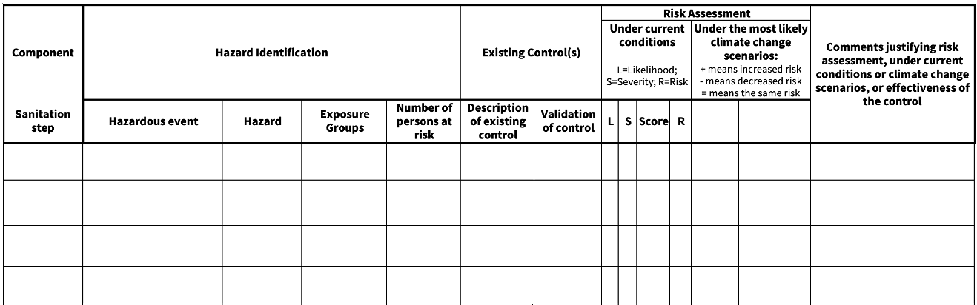
After discussing with your group, write in the box below what you need to find out tomorrow to prepare this table?
Question | Answer (to be filled during field visit)
Space for additional notes:

